**Maker Checker Maintenance**

1. **Screen Flow**

***Step 1:***

1. User access to Maker Checker Maintenance screen.
2. IBAM display listing of action item based on the tab navigation.
3. Administrator can start search for Action Item by clicking the “Search” link or select a specific Action ID from the list on the screen.

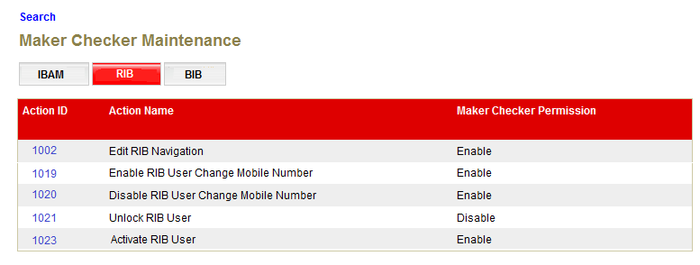

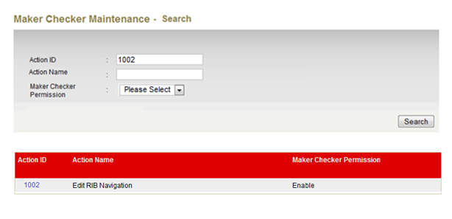

**Display Fields:**

|  |  |  |  |
| --- | --- | --- | --- |
| No | Field | Format | Description |
|  | Action ID | Numeric | Shows the ID of the Action |
|  | Action Name | Text | Shows the action name for each module |
|  | Maker Checker Permission | Text | Shows the permission type either Enable or Disable |

**Action:**

|  |  |  |  |
| --- | --- | --- | --- |
| No | Action | Type | Description |
|  | Search | Button | Contains an action to search the existing ‘Action Item’ in the list. Show ‘Maker Checker Maintenance Enquiry’ page. |
|  | Click on “Action ID” | Hyperlink | Edit the Maker Checker Permission |

**Specification:**

|  |  |  |  |  |  |
| --- | --- | --- | --- | --- | --- |
| No | Field | Field Type | Validation Rule | Description | Compulsory |
| 1. | Action ID | Numeric | Numeric  Max length: 18 | The Action ID | No |
| 2. | Action Name | Text | Max length: 64 | The Action Name for each module | No |
| 3. | Maker Checker Permission | Dropdown List | Optional to select the Maker Checker Permission | The Maker Checker Permission | No |

**List of available messages for the screen**:

|  |  |  |  |
| --- | --- | --- | --- |
| No. | Event | Error Description in English | Error Description in BM |
| 1. | Fill in alphabet to Action ID | Action ID is not numeric. |  |

***Step 2:***

1. User clicks on Action ID hyperlink and can edit the Maker Checker Permission either to enable or disable the action item.
2. Once make changes user click on next button
3. IBAM will leads user to confirm page

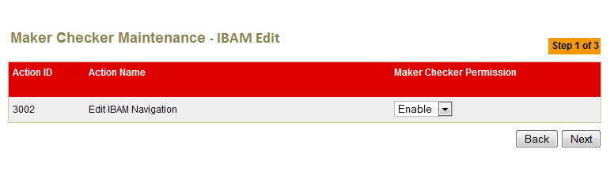

**Display Fields:**

|  |  |  |  |
| --- | --- | --- | --- |
| No | Field | Format | Description |
|  | Action ID | Numeric | Showing the Action ID for the Action |
|  | Action Name | Text | Shows the action name for each module |
|  | Maker Checker Permission | Text | Shows the permission type either Enable or Disable |

**Specification Input:**

|  |  |  |  |  |  |
| --- | --- | --- | --- | --- | --- |
| No | Field | Field Type | Validation Rule | Description | Compulsory |
| 1. | Maker Checker Permission | Drop Down List |  | An action either to Enable or Disable the action for each module | No |

**Action:**

|  |  |  |  |
| --- | --- | --- | --- |
| No | Action | Type | Description |
| 1. | Back | Button | Contains an action to let the IBAM system go back to previous page (Maker Checker Maintenance Screen Page). |
| 2. | Next | Button | Contains an action to let the IBAM system go to confirm page. |

**List of available messages for the screen**:

|  |  |  |  |
| --- | --- | --- | --- |
| No. | Event | Error Description in English | Error Description in BM |
| 1. | Edit the Action ID that waiting for approval | <Action Name> has changes pending for approval, no further change is allowed. |  |

***Step 3:***

1. User click on confirm button once review the changes.
2. IBAM system will save to IB and the action for each module will changes.

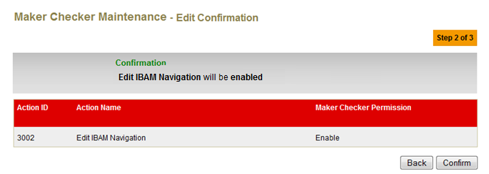

**Display Fields:**

|  |  |  |  |
| --- | --- | --- | --- |
| No | Field | Format | Description |
|  | Action ID | Numeric | Showing the Action ID for the Action |
|  | Action Name | Text | Shows the action name for each module |
|  | Maker Checker Permission | Text | Shows the permission type either Enable or Disable |

**Action:**

|  |  |  |  |
| --- | --- | --- | --- |
| No | Action | Type | Description |
| 1. | Back | Button | Contains an action to let the IBAM system go back to previous page (Maker Checker Maintenance Edit Page). |
| 2. | Confirm | Button | Contains an action to let the IBAM system go to result page. |

***Step 4:***

1. IBAM System shows the successful message, stating that the Maker Checker list has been edited.

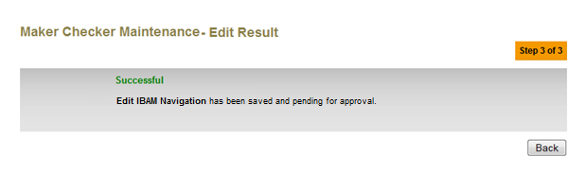

**Action:**

|  |  |  |  |
| --- | --- | --- | --- |
| No | Action | Type | Description |
| 1. | Back | Button | Contains an action to let the IBAM system go back to listing (Maker Checker Maintenance listing Page). |