**Step 1:** Access to Favourite Interbank Giro Transfer (Without any registered favourite Payee)

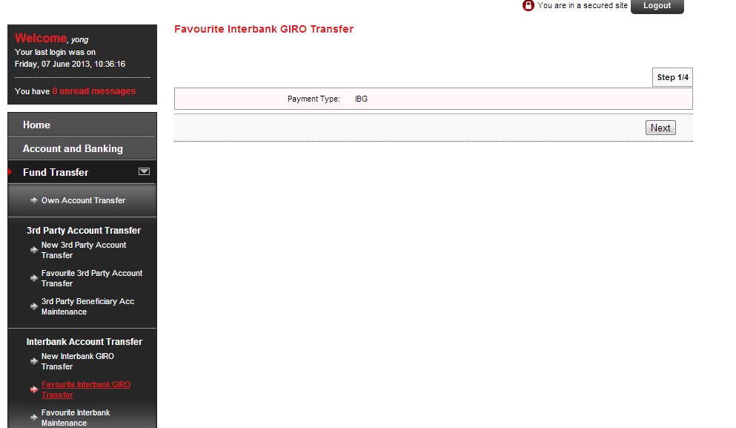

**Error:** System Unavailable

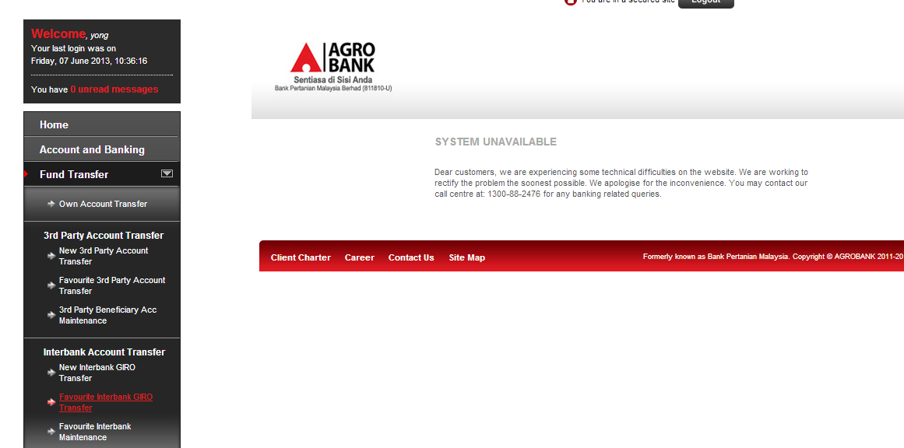

**Expected Result**

When user access to Favourite Interbank Giro Transfer should display the **message: You do not have any favorite interbank account,** should not display the Step 1: Payment type selection. Below is the **example** from Favourite 3rd Party Account Transfer.

