1. Approver click on New Interbank Transfer transaction

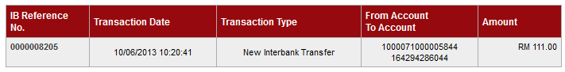

1. Approver approved the transaction

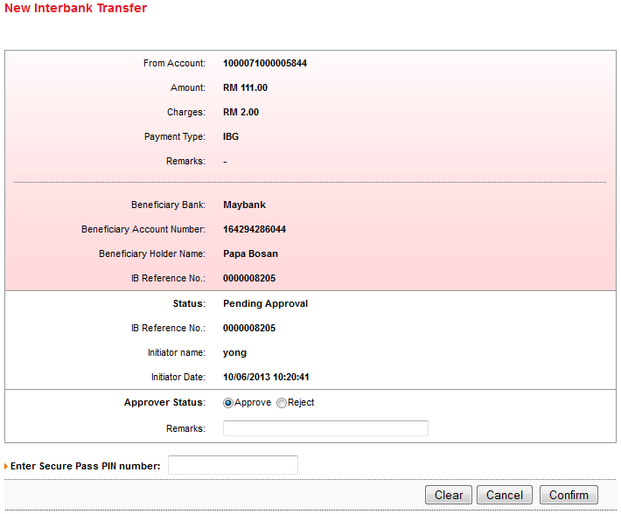

1. System successfully authorize the transaction but the result page it’s shown nothing and the approver status still Pending Approval.

