Originator's Name: Chooi So Fun  Project: Banker’s Chq & Demand Draft  Project Manager: Malarvily Muniandy / Christopher Gunn  Owner: PDM / RCB  Date Raised: 27.08.10  Phase/Process:  Functional Area: Consumer | Issue ID Number: BCA-DDA-UAT-C015  Related ID Number:  Priority: High / Medium / Low  Assigned to:  Target Resolution Date:  Actual Closed Date:
Status : Open / Investigate / Retest / Re-Open / Closed / Sign-Off (Circle one)
Category : Bugs / Set-up / Clarification / Repeated / Internal CR / CR (Circle one)
Description:

Banker’s Cheque & Demand Draft (Step 3/5):
a) Insert asterisks (*) to all mandatory fields.
b) Insert mandatory note - “Note(*): All fields with asterisks (*) are required.”
c) For Banker’s Cheque - Prompt error message if “Collection At” is empty.

(Refer to screen shot for further details).

Impact:

Investigation (Description):

Action:

Estimated Impact:

Recommendation:

Accepted (PENRIL/SA/IT):  Date: | Accepted (KFHMB):  Date:
Associated Risk Report: | Risk Report Accepted Date:
Associated Change Request Form: | Change Control Accepted on:

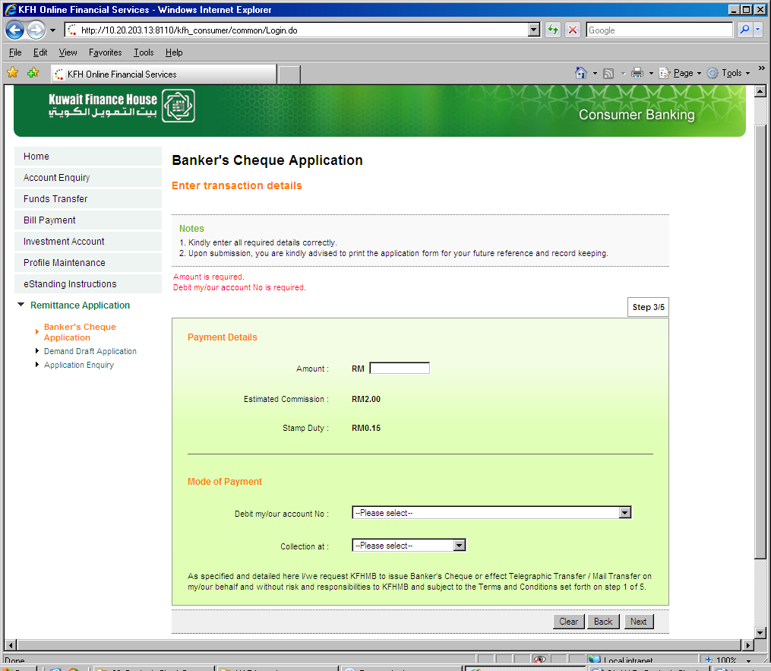
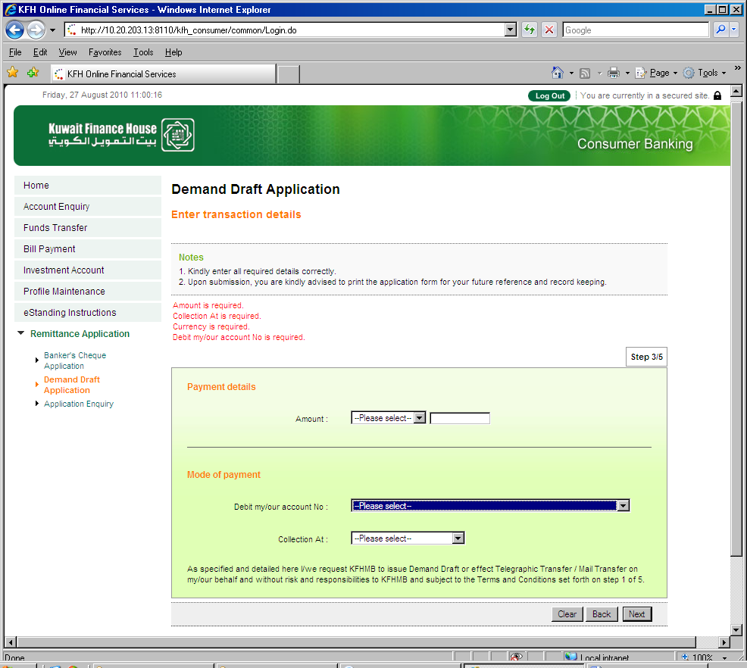
Insert Note for mandatory fields.
Error message for “Collection at”
Insert Note for mandatory fields.

