Issue log dated 05 June 2013

1. There are double fields on the Security Code at trade entry module.

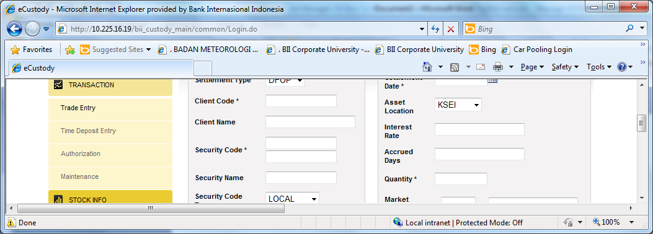

Please check if this issue due to the IE, since currently we had checked either use IE7 or IE8, the same issue still appears on the system

1. Repetition on the Security code, eg is ASII (Astra International) shares.

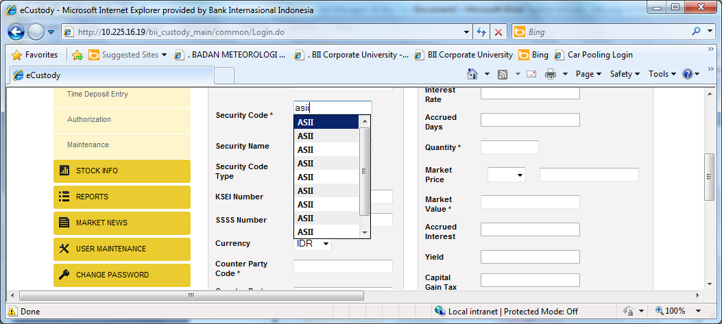

Please check since ASII only have 1 code, this applicable to other shares/Security code.

Also please check for counterparty code repetition

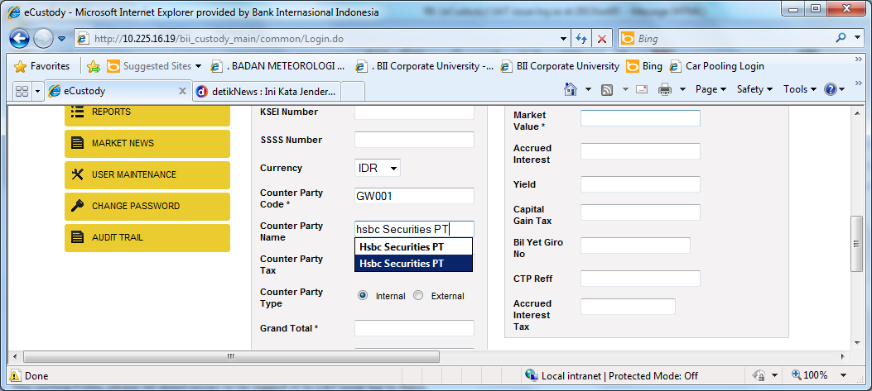

1. When perform the trade activity (for bond trade), after maker input Quantity and market proce (in percentage), then market value should be automatically calculated, but that field still can be edited.

