1. At time deposit entry module, there are no format date information for open date and maturity date, while for the maturity date could not be accessed or input.

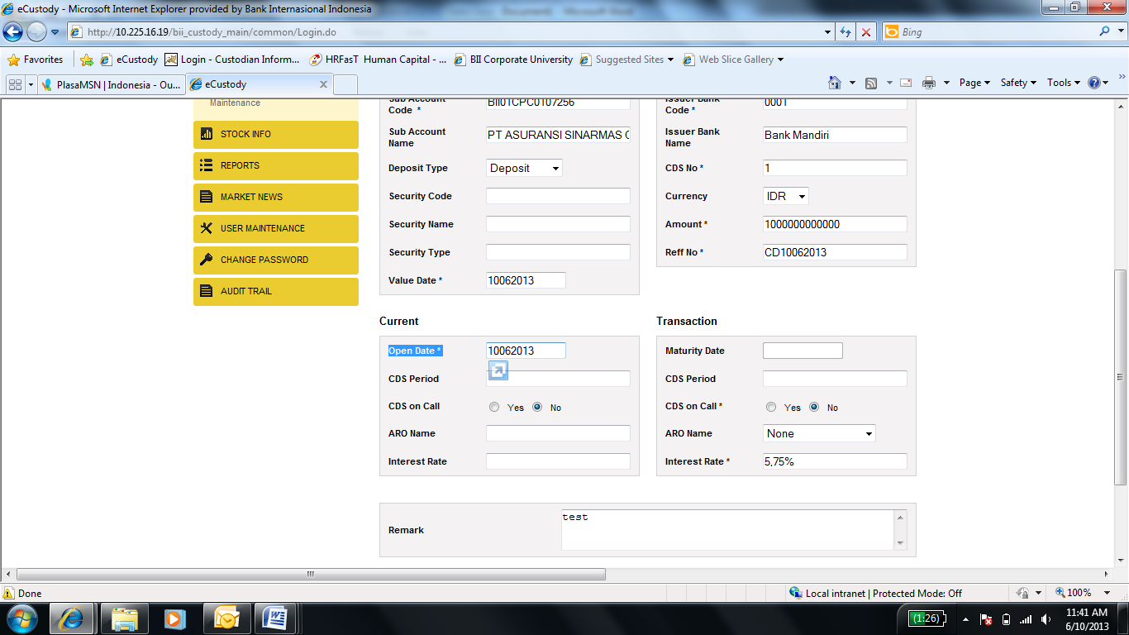

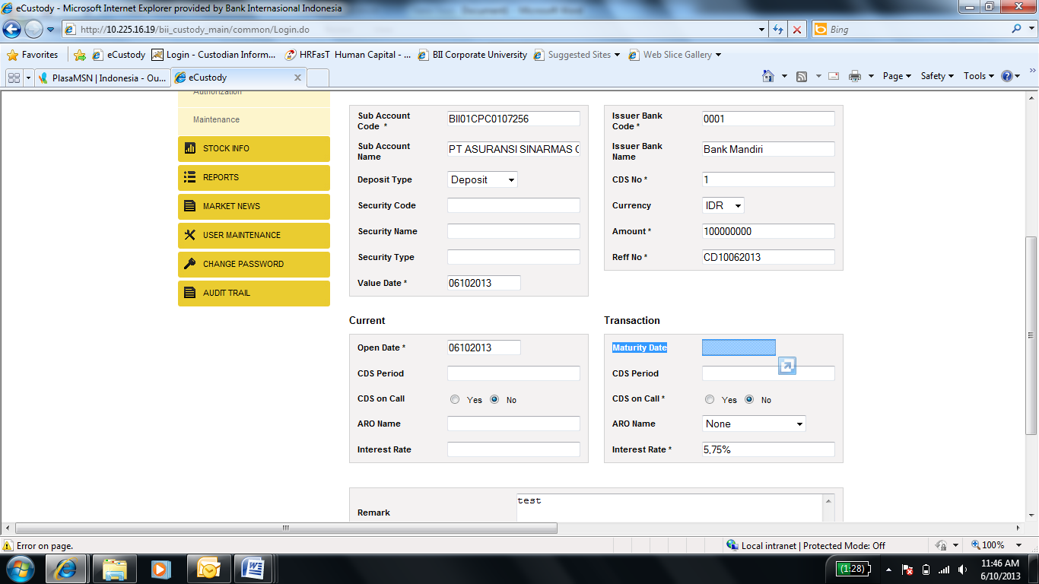

1. Appears an message error while input the time deposit entry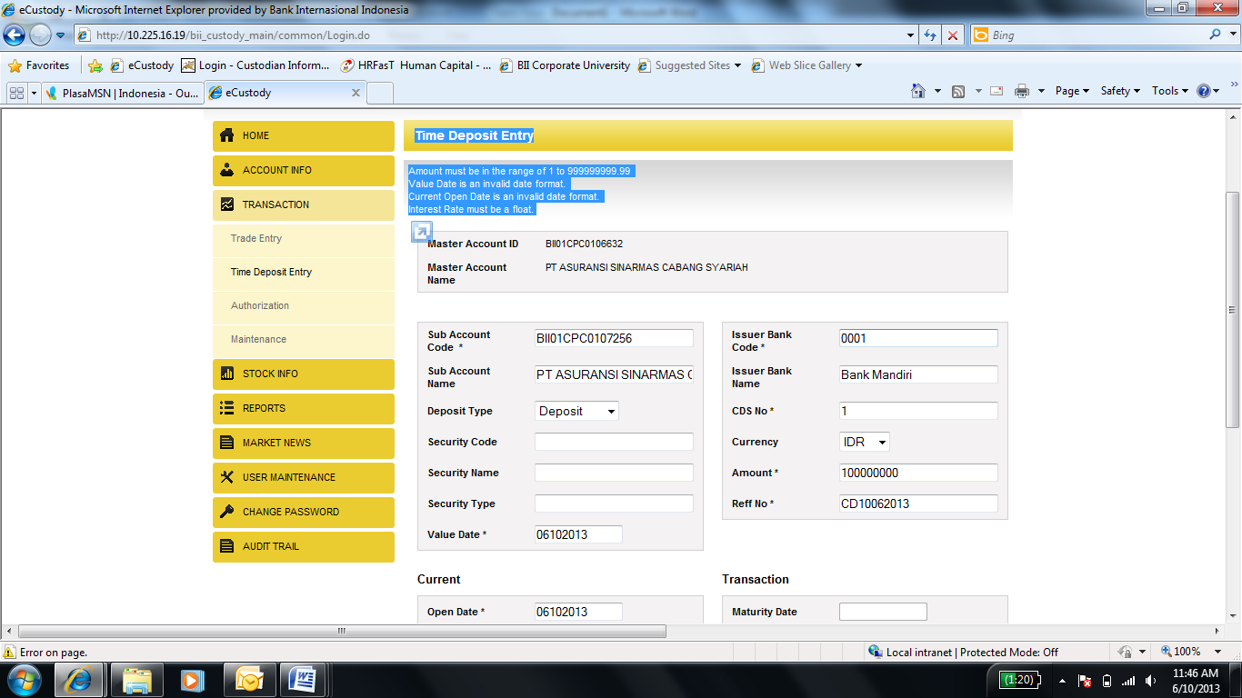
2. At checker screen, what is the meaning of asset location “3”? asset location are GC, KSEI, SCRIPT and SSSS