1. **BIB Transaction Enquiry**

They want to add new fields on the list, to make the details of transactions more clear.

Add Initiator and Approver Username at the screen.

* **Scenario 1: If the transaction not yet approve by the approver, so it just display the Initiator Username and the status still accepted.**

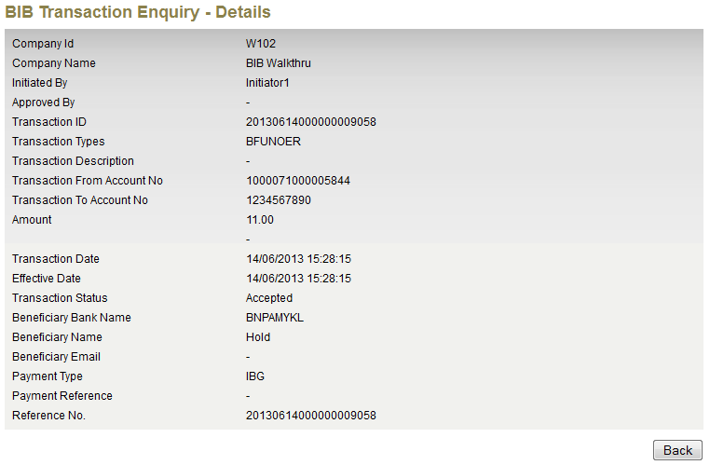

* **Scenario 2: If the transaction have 2 approvers and has been approved by 1 approver. It will show the Initiator and 1st approver username and status still accepted.**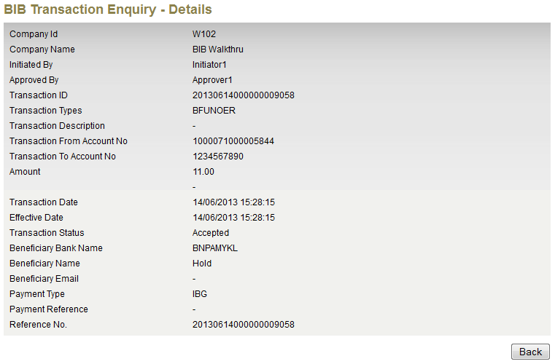
* **Scenario 3: If the transaction have been approved by all approvers and the status change to successful**

