1. Once user click on IBAM Navigation the screen will display as below screen shot. It is have a Search hyperlink in a top of the screen.

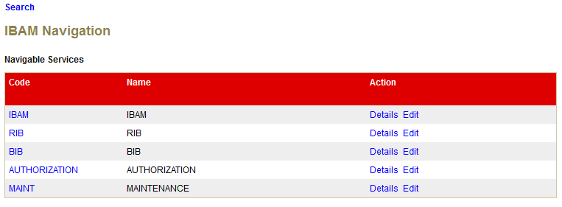

1. When click on Search hyperlink. The searching function screen shot as below.

