Originator's Name: Chooi So Fun  Project: Banker’s Chq & Demand Draft  Project Manager: Malarvily Muniandy / Christopher Gunn  Owner: PDM / RCB  Date Raised: 30.08.10  Phase/Process:  Functional Area: Consumer | Issue ID Number: BCA-DDA-UAT-C023  Related ID Number:  Priority: High / Medium / Low  Assigned to:  Target Resolution Date:  Actual Closed Date:
Status : Open / Investigate / Retest / Re-Open / Closed / Sign-Off (Circle one)
Category : Bugs / Set-up / Clarification / Repeated / Internal CR / CR (Circle one)
Description:
BVMC - Demand Draft and Banker’s Cheque Report
Branch selection is missing in following reports:
- Daily Demand Draft Application Report
- Daily Banker’s Cheque Application Report
- Daily Demand Draft Report
- Daily Banker’s Cheque Report

Impact:

Investigation (Description):

Action:

Estimated Impact:

Recommendation:

Accepted (PENRIL/SA/IT):  Date: | Accepted (KFHMB):  Date:
Associated Risk Report: | Risk Report Accepted Date:
Associated Change Request Form: | Change Control Accepted on:

Banker’s Cheque Application:
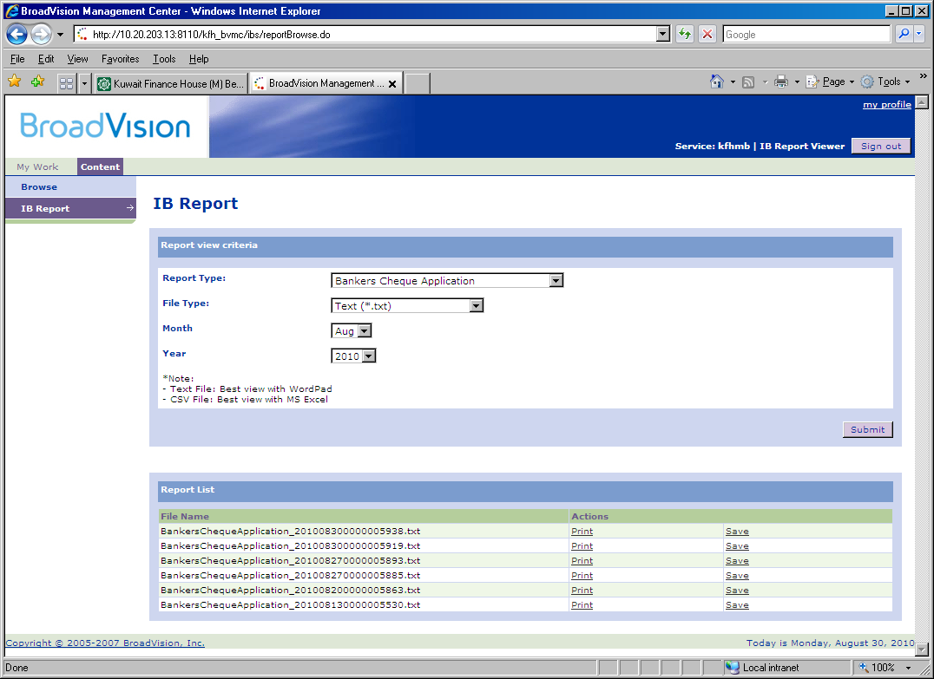
Demand Draft Application:
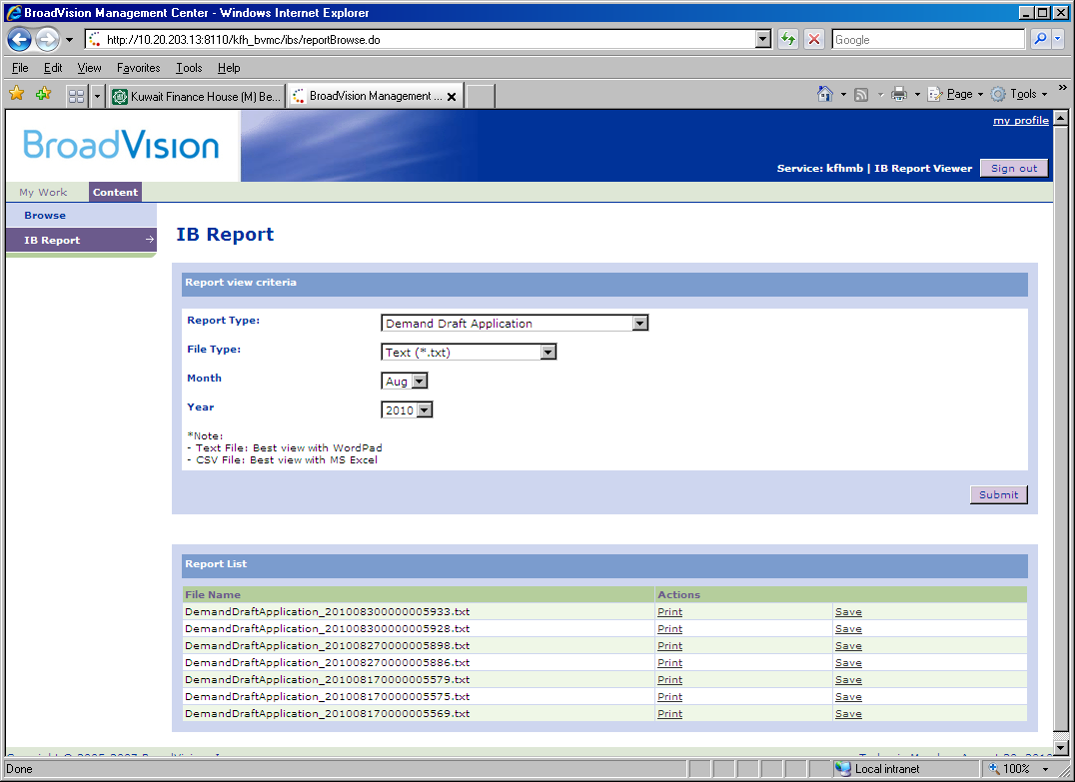
Banker’s Cheque Report:
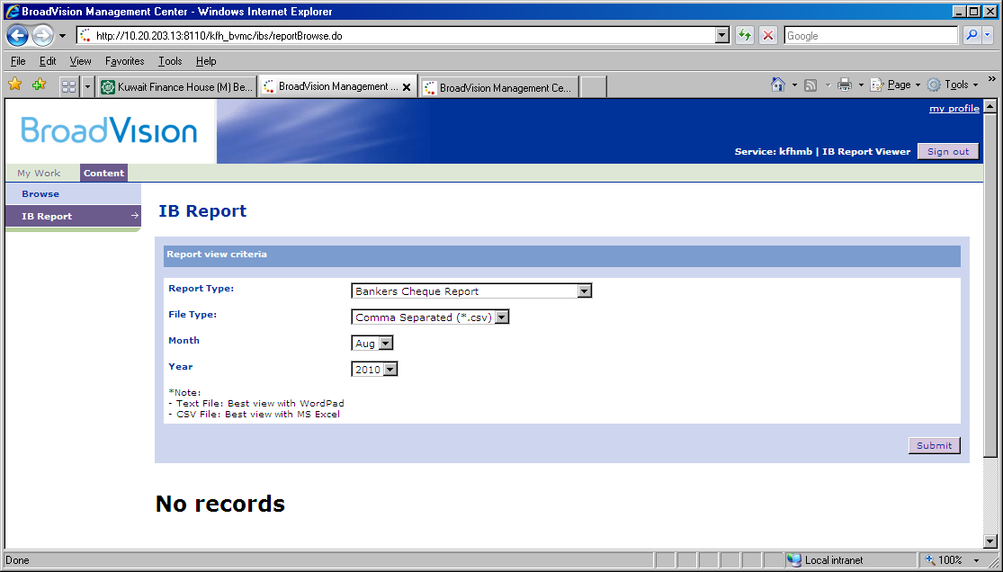
Demand Draft Report:
