# Maker Checker Maintenance

This feature allows administrator to enable and disable the transaction authorization process for IBAM, RIB and BIB action ID.

## Search Maker Checker Action ID

This feature allows administrator to search the IBAM, RIB and BIB action ID in the Maker Checker Maintenance list.

### Process Flow

Diagram xx: Search Maker Checker Maintenance Action ID Process Flow

There are 2 participants involved in this process which is Admin and IBAM. The following are the step to view to search the IBAM, RIB and BIB Action ID.

### Screen Flow

***Step 1:***

1. IBAM Admin can access to Maker Check Maintenance Screen by clicking on the “Maker Check Maintenance” link at the left navigation menu.
2. IBAM System display listing of action item based on the tab navigation.
3. Admin search for Action ID by clicking the “Search” link.

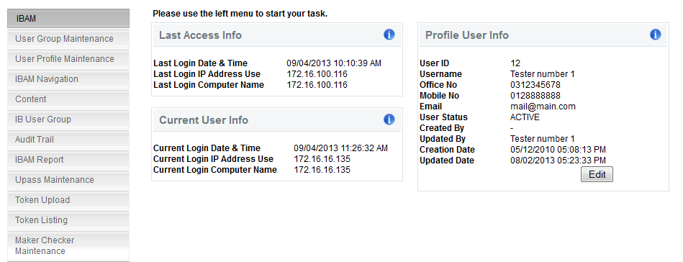

**Figure xx: Maker Checker Maintenance Navigation**

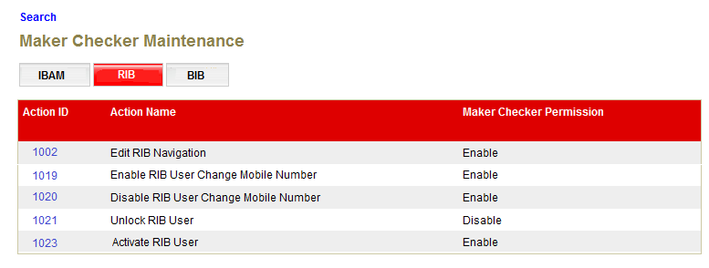

**Figure xx: Maker Checker Maintenance List**

**Action:**

|  |  |  |  |
| --- | --- | --- | --- |
| No | Action | Type | Description |
|  | Search | Button | Contains an action to go to ‘Maker Checker Maintenance Search’ page. |

***Step 2:***

1. IBAM display Maker Checker Maintenance Search screen.
2. Administrator enters specific user information to the required field and click “search” button.

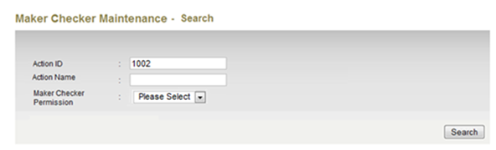

**Figure xx: Maker Checker Maintenance Search Screen**

**Specification:**

|  |  |  |  |  |  |
| --- | --- | --- | --- | --- | --- |
| No | Field | Field Type | Validation Rule | Description | Compulsory |
| 1. | Action ID | Numeric | Numeric  Max length: 18 | The Action ID | No |
| 2. | Action Name | Text | Max length: 64 | The Action Name for each module | No |
| 3. | Maker Checker Permission | Dropdown List | Optional to select the Maker Checker Permission | The Maker Checker Permission | No |

**Action:**

|  |  |  |  |
| --- | --- | --- | --- |
| No | Action | Type | Description |
| 1. | Search | Button | Contains an action to search specific ‘User Profile’ in the list. Show ‘User Profile Maintenance Search’ result page. |

**List of available messages for the screen**:

|  |  |  |  |
| --- | --- | --- | --- |
| No. | Event | Error Description in English | Error Description in BM |
| 1. | Fill in alphabet to Action ID | Action ID is not numeric. |  |

***Step 3:***

1. IBAM display Action Item List Screen of the selected search information.
2. Admin click on the Action ID link to edit on the Action ID Maker Checker Permission details.

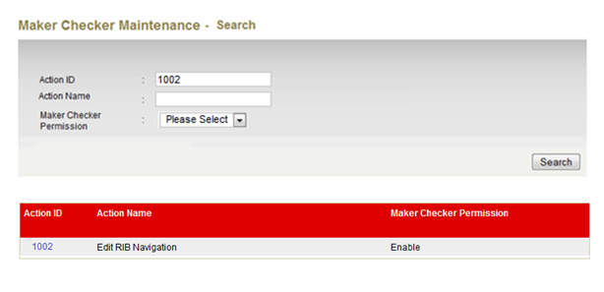

**Figure xx: Maker Checker Maintenance Result Screen**

**Display Fields:**

|  |  |  |  |
| --- | --- | --- | --- |
| No | Field | Format | Description |
|  | Action ID | Numeric | Shows the ID of the Action |
|  | Action Name | Text | Shows the action name for each module |
|  | Maker Checker Permission | Text | Shows the permission type either Enable or Disable |

**Action:**

|  |  |  |  |
| --- | --- | --- | --- |
| No | Action | Type | Description |
| 1. | Click on “Action ID” | Hyperlink | Edit the Maker Checker Permission |

## Edit Maker Checker Permission

This feature allows administrator to edit the IBAM, RIB and BIB action ID in the Maker Checker Maintenance list.

### Process Flow

Diagram xx: Edit Maker Checker Maintenance Action ID Process Flow

There are 2 participants involved in this process which is Admin and IBAM. The following are the step to edit the IBAM, RIB and BIB Action ID Maker Checker Permission:-

### Screen Flow

***Step 1:***

1. IBAM Admin can access to Maker Check Maintenance Screen by clicking on the “Maker Check Maintenance” link at the left navigation menu.
2. IBAM System display listing of action item based on the tab navigation.
3. Admin select the specific Action ID for the (IBAM/RIB/BIB) tab list or search for Action ID by clicking the “Search” link.



**Figure xx: Maker Checker Maintenance Navigation**



**Figure xx: Maker Checker Maintenance List**

**Display Fields:**

|  |  |  |  |
| --- | --- | --- | --- |
| No | Field | Format | Description |
|  | Action ID | Numeric | Showing the Action ID for the Action |
|  | Action Name | Text | Shows the action name for each module |
|  | Maker Checker Permission | Text | Shows the permission type either Enable or Disable |

**Action:**

|  |  |  |  |
| --- | --- | --- | --- |
| No | Action | Type | Description |
| 1. | Search | Button | Contains an action to go to ‘Maker Checker Maintenance Search’ page. ***(refer item 1.5.1)*** |
| 2. | Click on “Action ID” | Hyperlink | Edit the Maker Checker Permission |

***Step 2:***

1. IBAM display Maker Checker Maintenance Editable page.
2. IBAM Admin selects either to enable or disable from the Maker Checker Permission dropdown list and click on “Next” button
3. IBAM validates the updated information and display Maker Checker Maintenance confirmation screen.

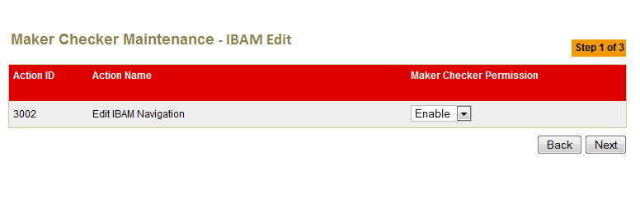

**Figure xx: Maker Checker Maintenance Result Screen**

**Specification:**

|  |  |  |  |  |  |
| --- | --- | --- | --- | --- | --- |
| No | Field | Field Type | Validation Rule | Description | Compulsory |
| 1. | Maker Checker Permission | Drop Down List |  | An action either to Enable or Disable the action for each module | No |

**Action:**

|  |  |  |  |
| --- | --- | --- | --- |
| No | Action | Type | Description |
| 1. | Back | Button | Contains an action to let the IBAM system go back to previous page (Maker Checker Maintenance Screen Page). |
| 2. | Next | Button | Contains an action to let the IBAM system go to confirm page. |

**List of available messages for the screen**:

|  |  |  |  |
| --- | --- | --- | --- |
| No. | Event | Error Description in English | Error Description in BM |
| 1. | Edit the Action ID that waiting for approval | <Action Name> has changes pending for approval, no further change is allowed. |  |

***Step 3:***

1. IBAM system display Edit Maker Checker Maintenance Confirmation page.
2. IBAM User Click on “Confirm” button.

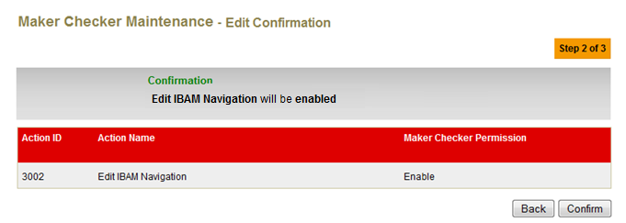

**Figure xx: Edit Maker Checker Maintenance Confirmation Screen**

**Action:**

|  |  |  |  |
| --- | --- | --- | --- |
| No | Action | Type | Description |
| 1. | Back | Button | Contains an action to let the IBAM system go back to previous page (Maker Checker Maintenance Edit Page). |
| 2. | Confirm | Button | Contains an action to let the IBAM system go to result page. |

***Step 4:***

1. IBAM updates the edited details to IB Database and display the result to the IBAM user.
2. IBAM shows successful message and pending for Authorization approval process
3. Once approved IBAM will shows the update info under Maker Checker Maintenance List screen.

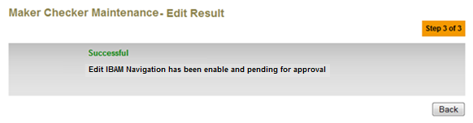

**Figure xx: Edit Maker Checker Maintenance Result Screen with Authorization Process**

If User Profile Maintenance Maker Checker Permission set as ‘Disable’

1. IBAM updates the edited details to IB Database and display the result to the IBAM user
2. IBAM shows successful message and shows the update info under User Profile Details screen.

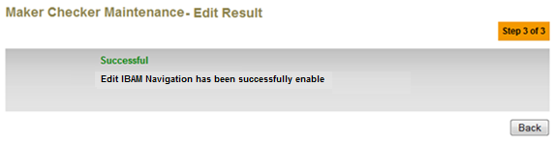

**Figure xx: Edit Maker Checker Maintenance Result Screen without Authorization Process**

**Action:**

|  |  |  |  |
| --- | --- | --- | --- |
| No | Action | Type | Description |
| 1. | Back | Button | Contains an action to let the IBAM system go back to listing (Maker Checker Maintenance listing Page). |