Test Case 1:

* Create content use existing Occupation Code already exist in the list.

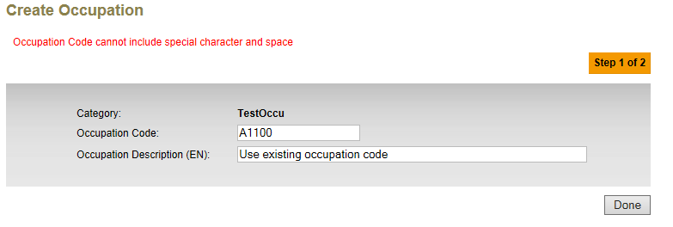

Test Case 2:

* Create content use existing Occupation Code which still pending for approval.

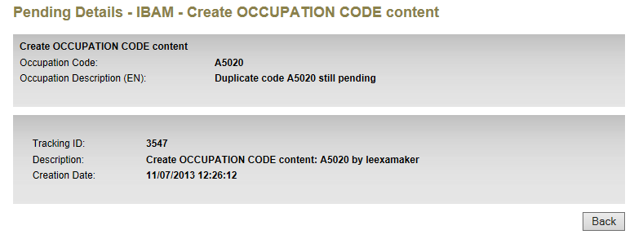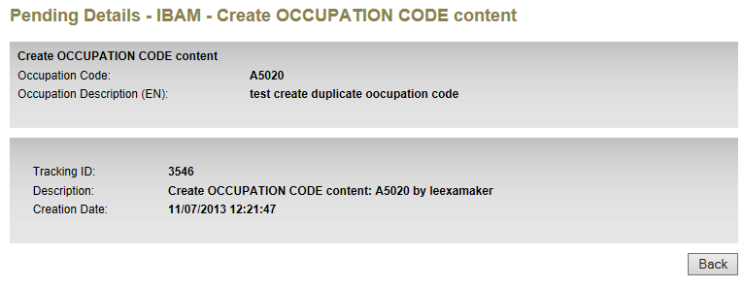

* Go to approval list to approve 1st creation A5020 – Tracking ID 3546

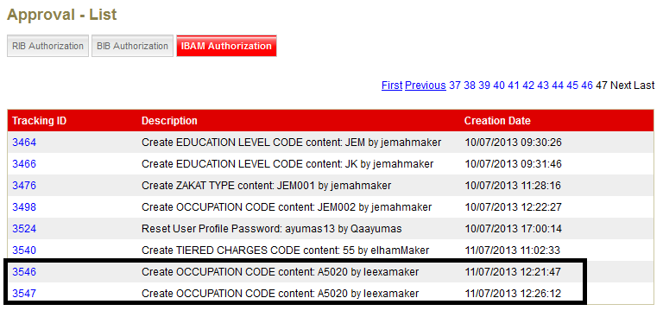

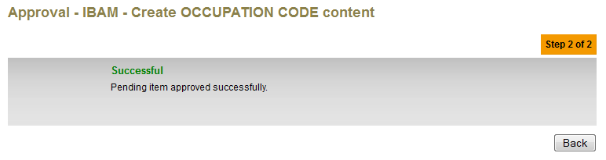

* Go to approval list to approve 2nd creation A5020 – Tracking ID 3547

