Test creation Content with existing Description/Name

>Test using Administrator – Unsuccessful. Error Message throw.

**PASSED**

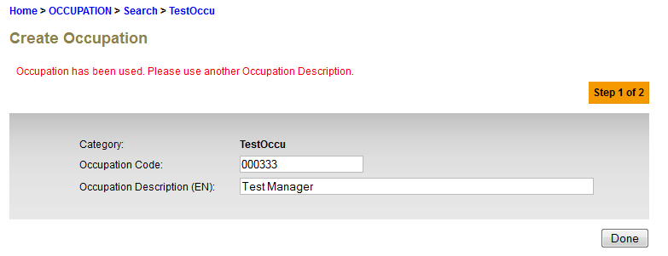

>Test using Maker – Successful.

**FAILED. System shall throw error message as above when Approver want to approve the 2nd creation which has same description/name.**

