Enlarge the foot note as per highlighted.

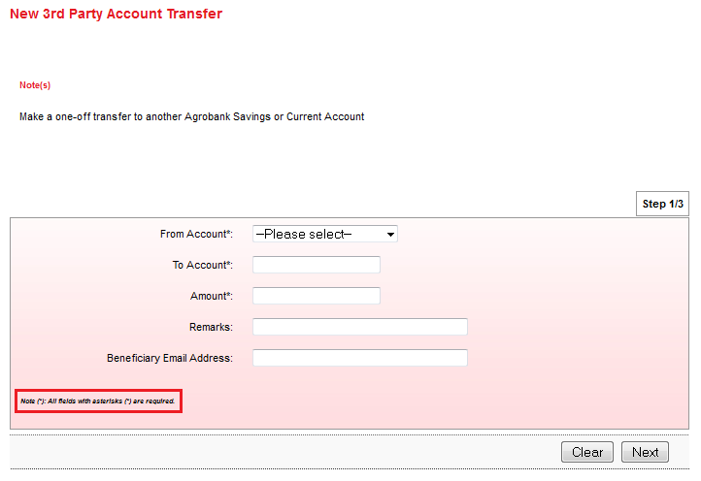

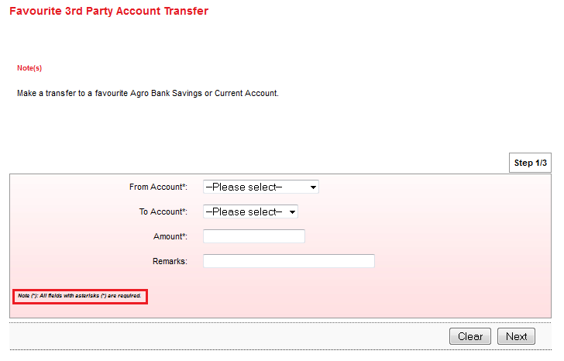

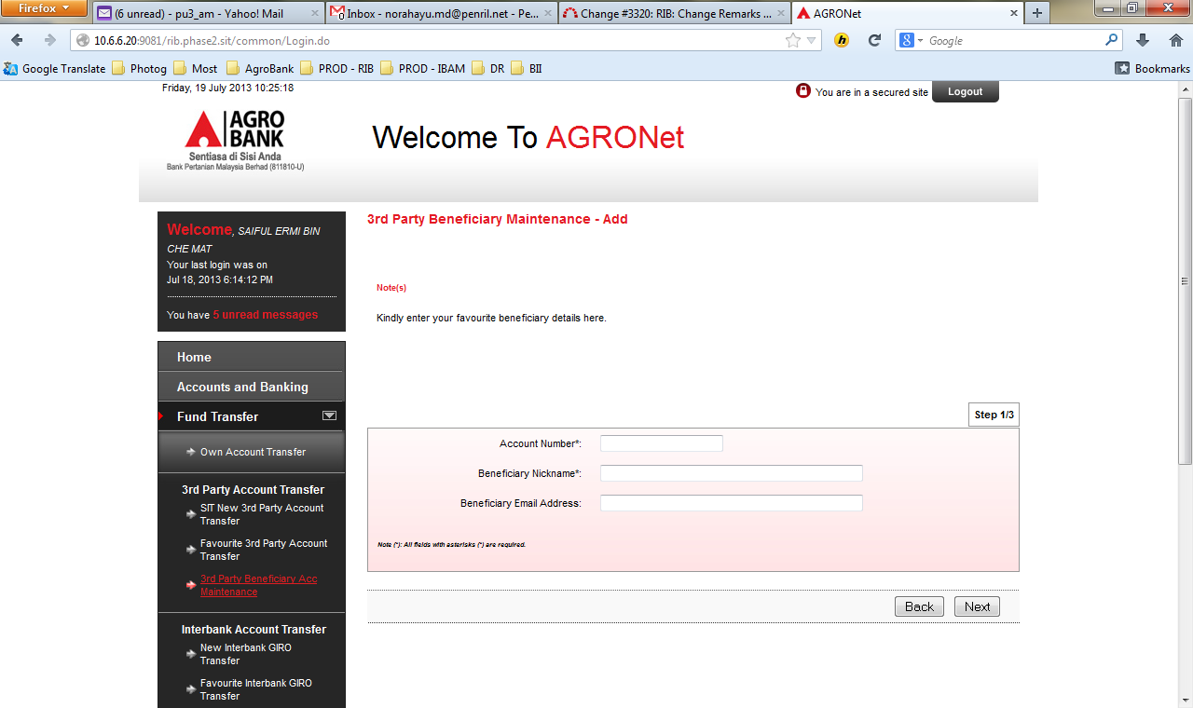

**New Interbank GIRO Transfer**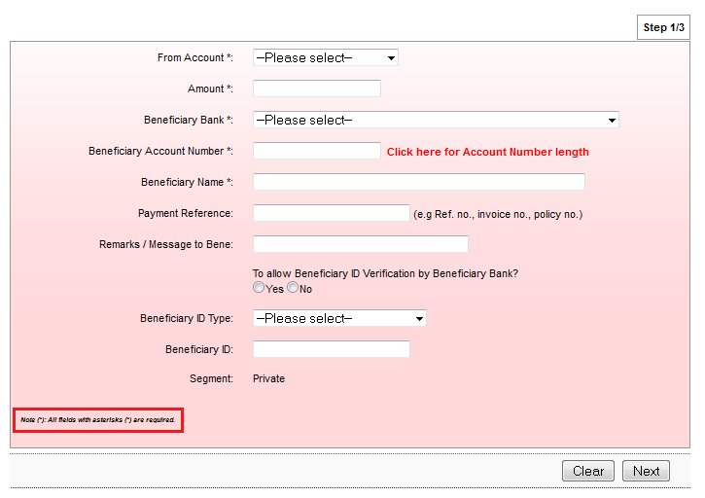

# Favourite Interbank GIRO Transfer

# Interbank Beneficiary Account Registration

# 

# Transfer Limit

# Able to go to Next page without select "New Limit” drop down

# Unreadable message properties under transfer limit title

# 

# Able to confirm transaction even though the transaction is null.

# 