**Agrobank**

**ePrepaid Top Up**

**Business Requirement and System Specification**

30th July 2013

Reference: AGRO/BRS/ePay/Prepaid/20130724/01

Version: 1.1

**Prepared By:**



Penril Datability (SEA) Sdn Bhd (384550-U)

Suite A-07-07 Plaza Mon’t Kiara

No. 2, Jalan Kiara, Mon’t Kiara

50480 Kuala Lumpur, Malaysia

Tel: (603) 6201 2622 Fax: (603) 6201 7622

Document Administration

**Document Amendment Log**

| **Ver.**  **No** | **Date Updated** | **Description of Change** | **Updated By**  **<Name, Dept>** | **Reviewed By**  **<Name, Dept>** | **Approved By**  **<Name, Dept>** |
| --- | --- | --- | --- | --- | --- |
| 1.0 | 24/07/2012 | Initial Release | Yong Man Siew,  Penril Datability | Haida Dasuki, Penril Datability | Tan Lee Yong,  Penril Datability |
| 1.1 | 30/07/2012 | Updated as below:   * Edit and delete product. * Additional field in Payee “Channel” and “ePay” Product code | Yong Man Siew,  Penril Datability |  |  |
|  |  |  |  |  |  |
|  |  |  |  |  |  |
|  |  |  |  |  |  |

Table of Contents

Section 1: Introduction 5

Section 2: Retail Internet Banking 6

2 Mobile/ Internet Reload 6

2.1 Pinless Reload 7

2.1.1 Process Flows 7

2.1.2 Screen Designs 7

2.2 Pin Based Reload 16

2.2.1 Process Flows 16

2.2.2 Screen Designs 16

Section 4: IBAM 24

3 ePay Payee Maintenance 25

3.1 Create Payee 25

3.1.1 Progress Flow 25

3.1.2 Screen Designs 25

3.2 Create Product 39

3.2.1 Progress Flow 39

3.2.2 Screen Designs 39

3.3 Edit Product 44

3.3.1 Progress Flow 44

3.3.2 Screen Designs 44

3.4 Delete Product 48

3.4.1 Progress Flow 48

3.4.2 Screen Designs 48

Section 5: ePrepaid Top Up Reload Limit 52

4 Reload Limit Maintenance 52

4.1 System Reload Limit Maintenance 52

4.2 User Reload Limit Maintenance 52

4.2.1 Process Flows 52

4.2.2 Screen Designs 53

Section 6: Report 56

Section 5: Setting 57

Appendix 1: List of Prepaid Top Up Product 58

Appendix 2: List Bill Payment Payee 66

**Business Requirement Acceptance**

I/We hereby verify that this Business Requirement consist of all the requirements requested by AGROBANK. The implemented system will fulfill ONLY this requirement.

I/We also hereby AGREE that this satisfies our entire requirement for ePrepaid Top Up.

Any future changes to this agreed scope will be treated as an enhancement to the system. Any future changes to the project timeline will be subjected to the final approval of the project steering committee.

**AGROBANK:**

|  |  |  |  |
| --- | --- | --- | --- |
| **Approved by** | **Role** | **Signature** | **Date** |
|  |  |  |  |
|  |  |  |  |
|  |  |  |  |
|  |  |  |  |
|  |  |  |  |
|  |  |  |  |
|  |  |  |  |

**Penril Datability (SEA) Sdn. Bhd.:**

|  |  |  |  |
| --- | --- | --- | --- |
| **Approved by** | **Role** | **Signature** | **Date** |
| Norhaidah Bt Md Dasuki | Project Manager |  |  |
| Vincent Devethas | Team Lead |  |  |

Section 1: Introduction

This document served as the business requirement and system specification for the below:-

1. Retail Internet Banking (RIB)
   1. ePrepaid Top Up via ePay aggregator
   2. Bill Payment via ePay aggregator and also
2. Business Internet Banking (BIB)
   1. Bill Payment via ePay aggregator.

There are no GUI changes for Bill Payment. All the changes are on the backend and IBAM to support the new channel.

This document shall explain all the features and functionalities, which is elaborating with screen captures, process flow, descriptions, input fields specifications and error messages. **All screen designs provided in this document are samples and only illustration purpose for easy understanding. The screen designs are not final.**

Section 2: Retail Internet Banking



# Mobile/ Internet Reload

This feature allows user to reload for mobile and internet through Internet Banking system. There are 2 types of Reload which is:

* Pinless Reload
* Pin Based Reload

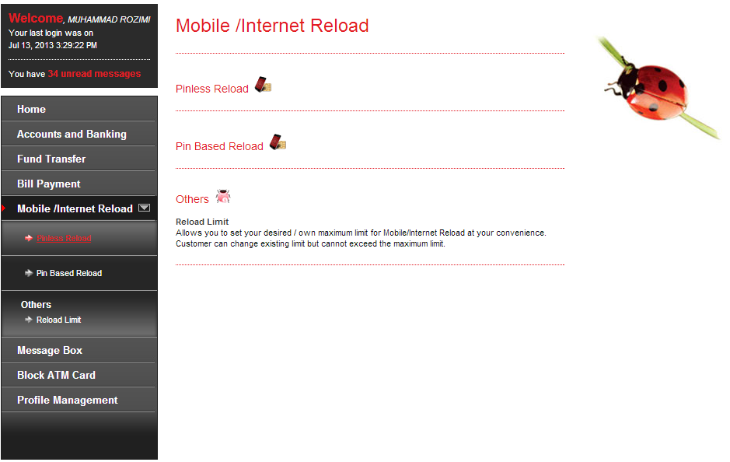

Figure 1: Landing Screen

## Pinless Reload

### Process Flows



Diagram 1: Pinless Reload Flow Diagram

There are 2 participants involved in this process which is IB User and RIB System.

### Screen Designs

***Step 1:***

1. User accesses the Pinless Reload page.
2. User selects the Service Provider.
3. IB User clicks on the ‘Next’ button to go to the next page.

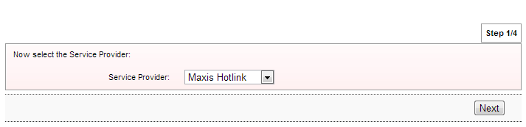

Figure 2: Pinless Reload-Service provider selection screen

**Input Specification:**

| **No** | **Field** | **Field Type** | **Validation Rule** | **Description** | **M/O** |
| --- | --- | --- | --- | --- | --- |
|  | Services Provider | Dropdown List | Must be selected | Telco Services provide to select. | M |

Table 1: Pinless Reload-Service provider selection Input Specification

**Action:**

| **No** | **Action** | **Type** | **Description** |
| --- | --- | --- | --- |
|  | Next | Button | Contains an action to continue to next page |

Table 2: Pinless Reload-Service provider selection Action

**List of available messages for the screen:**

| **No.** | **Event** | **Error Description in English** |
| --- | --- | --- |
|  | Did not fill in or select Service Provider | Service Provider is required. |

Table 3: Pinless Reload-Service provider selection Error Message List

***Step 2:***

1. User accesses the Pinless Reload Details page.
2. User selects the From Account, Value and input Recipient Mobile Number.
3. IB User clicks on the ‘Next’ button to go to the next page or clicks on the ‘Back’ button back to the previous page.

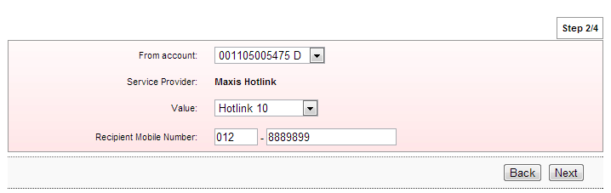

Figure 3: Pinless Reload Details screen

**Display Fields:**

| **No** | **Field** | **Format** | **Description** |
| --- | --- | --- | --- |
|  | Service Provider | Text | Selected service provider. |

Table 4: Pinless Reload Details Display Fields

**Input Specification:**

| **No** | **Field** | **Field Type** | **Validation Rule** | **Description** | **M/O** |
| --- | --- | --- | --- | --- | --- |
|  | From Account | Dropdown List | Must be selected | Account to debit payment | M |
|  | Value | Dropdown List | Must be selected | Product type of the selected service provider. | M |
|  | Recipient Mobile Number | Text box | Match Length : 3  Numeric  Min Length : 7  Max Length: 10  Numeric | Mobile Number to receive the Reload. | M |

Table 5: Pinless Reload Details Input Specification

**Action:**

| **No** | **Action** | **Type** | **Description** |
| --- | --- | --- | --- |
|  | Next | Button | Contains an action to continue to next page |
|  | Back | Button | Contains an action to back to previous page |

Table 6: Pinless Reload Details Action

**List of available messages for the screen:**

| **No.** | **Event** | **Error Description in English** |
| --- | --- | --- |
|  | Did not fill in mandatory fields:   * From Account * Value * Recipient Mobile Number | From Account is required. |
| Value is required. |
| Recipient Mobile Number is required. |
|  | Fill in Recipient Mobile Number others than numeric. | Recipient Mobile Number must be numeric. |
|  | Fill in Recipient Mobile Number less than 7 digits. | Recipient Mobile Number must be at least 7 digits. |

Table 7: Pinless Reload Details Error Message List

***Step 3***

1. IB system will pop up screen to have a reminder message to confirm the Recipient Mobile Number is correct before confirm the transaction.
2. IB user clicks on the “Close” button to close the pop up screen.

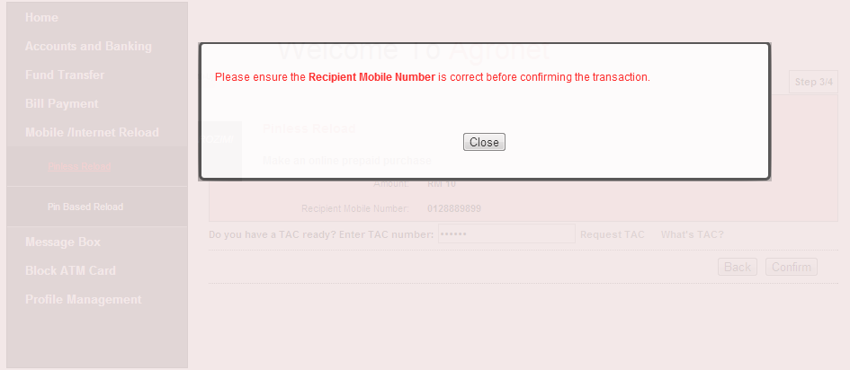

Figure 4: Pinless Reload Confirm- Reminder Pop up screen

**Display Fields:**

| **No** | **Field** | **Format** | **Description** |
| --- | --- | --- | --- |
|  | Reminder Message | Text | Reminder message to remind user to confirm the recipient mobile number is correct . |

Table 8: Pinless Reload Confirm - Reminder Pop up Display Fields

**Action:**

| **No** | **Action** | **Type** | **Description** |
| --- | --- | --- | --- |
|  | Close | Button | Contains an action to close the pop up screen. |

Table 9: Pinless Reload Confirm - Reminder Pop up Action

1. IBS display Pinless Reload Confirmation page.
2. IB User input the TAC number.
3. IB User clicks on the ‘Confirm’ button to confirm the transaction and go to the next page or clicks on the ‘Back’ button back to the previous page.

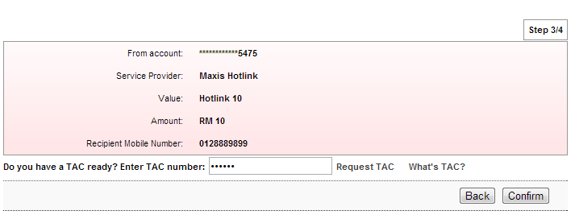

Figure 5: Pinless Reload Confirmation screen

**Display Fields:**

| **No** | **Field** | **Format** | **Description** |
| --- | --- | --- | --- |
|  | From Account | Text | Account to debit payment |
|  | Service Provider | Text | Selected service provider. |
|  | Value | Text | Selected product from user. |
|  | Amount | Numeric | Reload amount. |
|  | Recipient Mobile Number | Number | Mobile Number to receive reload. |

Table 10: Pinless Reload Confirmation Display Fields

**Input Specification:**

|  |  |  |  |  |  |
| --- | --- | --- | --- | --- | --- |
| **No** | **Field** | **Field Type** | **Validation Rule** | **Description** | **M/O** |
|  | TAC Number | Text Box, Masked | * Match Length: 6 * Numeric | A random, temporary generated number sent to mobile phone for transaction verification | M |

Table 11: TAC Request Input Specification

**Action:**

| **No** | **Action** | **Type** | **Description** |
| --- | --- | --- | --- |
|  | Back | Button | Contains an action to go back to previous page |
|  | Confirm | Button | Contains an action to confirm the transaction. |
|  | Request a TAC number | Hyperlink | Contains an action to generate TAC Number and shows the TAC’s Pop-up window. |
|  | What’s TAC | Hyperlink | Contains an action to shows the What’s TAC Pop-up window. |

Table 12: Pinless Reload Confirmation List Action

**List of available messages for the screen:**

|  |  |  |
| --- | --- | --- |
| **No.** | **Event** | **Error Description** |
|  | Did not fill in TAC field. | TAC is required. |
|  | Fill in TAC with other than numeric. | TAC must be numeric. |
|  | Fill in TAC less than 6 digits. | TAC must consist of 6 digits. |
|  | Fill in invalid TAC | Invalid TAC. |
|  | Reach maximum length of attempt. | Your Account has been locked. Please call Agro Bank’s Contact Center. |
|  | Fill in an expired / no longer valid TAC. | TAC is expired. |

Table 13: TAC Request Error message list

***Step 4***

1. RIB System sent Pinless Reload details to host and return result.
2. RIB System display Pinless Reload result page. And user can make another transaction by clicking on the “Perform Another Reload” button

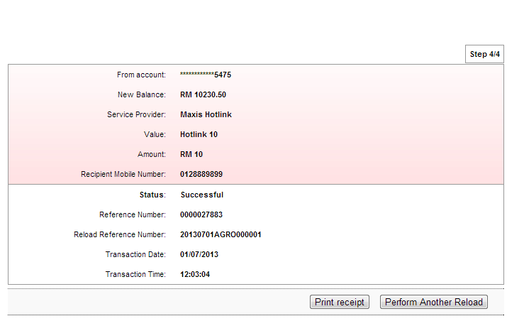

Figure 6: Pinless Reload Result screen

**Display Fields:**

| **No** | **Field** | **Format** | **Description** |
| --- | --- | --- | --- |
|  | From Account | Text | Account to debit payment |
|  | New Balance | Numeric | Available balance after transaction. |
|  | Service Provider | Text | Selected service provider. |
|  | Value | Text | Selected product from user. |
|  | Amount | Numeric | Reload amount. |
|  | Recipient Mobile Number | Number | Mobile Number to receive reload. |
|  | Status | Text | The status of the Transaction. |
|  | Reference Number | Numeric | Reference number of the transaction. |
|  | Reload Reference Number | Text | Reference number return from ePay. |
|  | Transaction Date | DD/MM/YYYY | The date of transaction. |
|  | Transaction Time | HH:MM:SS | The time of transaction. |

Table 14: Pinless Reload Result Display Fields

**Action:**

| **No** | **Action** | **Type** | **Description** |
| --- | --- | --- | --- |
|  | Make Another Transaction | Button | Contain an action to go back to Pinless Reload page |
|  | Print Receipt | Button | Contain an action To generate receipt’s pop-up display |

Table 15: Pinless Reload Result List Action

1. IB user can print a receipt by clicking on the “Print Receipt” button. RIB System displays the print form of Pinless Reload Receipt.

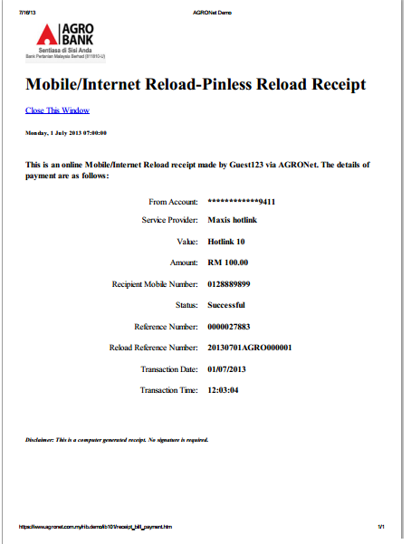

Figure 7: Pinless Reload Receipt screen

**Display Fields:**

| **No** | **Field** | **Format** | **Description** |
| --- | --- | --- | --- |
|  | From Account | Text | Account to debit payment |
|  | Service Provider | Text | Selected service provider. |
|  | Value | Text | Selected product from user. |
|  | Amount | Numeric | Reload amount. |
|  | Recipient Mobile Number | Number | Mobile Number to receive reload. |
|  | Status | Text | The status of the Transaction. |
|  | Reference Number | Numeric | Reference number of the transaction |
|  | Reload Reference Number | Text | Reference number return from ePay. |
|  | Transaction Date | DD/MM/YYYY | The date of transaction. |
|  | Transaction Time | HH:MM:SS | The time of transaction. |

Table 16: Pinless Reload Receipt Display Fields

## Pin Based Reload

### Process Flows



Diagram 2: Pin Based Reload Flow Diagram

There are 2 participants involved in this process which is IB User and RIB System.

### Screen Designs

***Step 1:***

1. User accesses the Pin Based Reload page.
2. User selects the Prepaid Type.
3. IB User clicks on the ‘Next’ button to go to the next page.

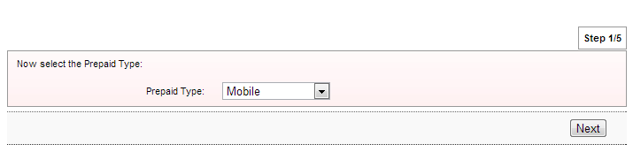

Figure 8:Pin Based Reload-Prepaid Type selection screen

**Input Specification:**

| **No** | **Field** | **Field Type** | **Validation Rule** | **Description** | **M/O** |
| --- | --- | --- | --- | --- | --- |
|  | Prepaid Type | Dropdown List | Must be selected | Available Prepaid type | M |

Table 17: Pin Based Reload- Prepaid Type selection Input Specification

**Action:**

| **No** | **Action** | **Type** | **Description** |
| --- | --- | --- | --- |
|  | Next | Button | Contains an action to continue to next page |

Table 18: Pin Based Reload- Prepaid Type selection Action

**List of available messages for the screen:**

| **No.** | **Event** | **Error Description in English** |
| --- | --- | --- |
|  | Did not select Prepaid Type | Prepaid is required. |

Table 19: Pin Based Reload- Prepaid Type selection Error Message List

***Step 2:***

1. User accesses the Pin Based Reload-Service Provider page.
2. User selects the Service Provider.
3. IB User clicks on the ‘Next’ button to go to the next page or clicks on the ‘Back’ button back to the previous page.

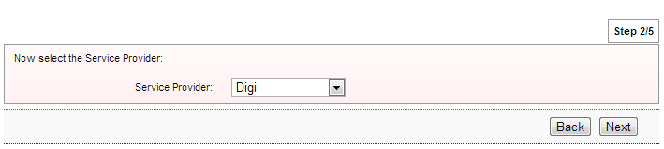

Figure 9:Pin Based Reload-Service provider selection screen

**Input Specification:**

| **No** | **Field** | **Field Type** | **Validation Rule** | **Description** | **M/O** |
| --- | --- | --- | --- | --- | --- |
|  | Services Provider | Dropdown List | Must be selected | Telco Services provide to select. | M |

Table 20: Pin Based Reload-Service provider selection Input Specification

**Action:**

| **No** | **Action** | **Type** | **Description** |
| --- | --- | --- | --- |
|  | Next | Button | Contains an action to continue to next page. |
|  | Back | Button | Contains an action to back to previous page. |

Table 21: Pin Based Reload-Service provider selection Action

**List of available messages for the screen:**

| **No.** | **Event** | **Error Description in English** |
| --- | --- | --- |
|  | Did not fill in or select Service Provider | Service Provider is required. |

Table 22: Pin Based Reload-Service provider selection Error Message List

***Step 3:***

1. User accesses the Pin Based Reload Details page.
2. User selects the From Account and Value.
3. IB User clicks on the ‘Next’ button to go to the next page or clicks on the ‘Back’ button back to the previous page.

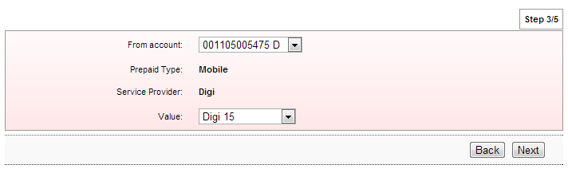

Figure 10: Pin Based Reload Details screen

**Display Fields:**

| **No** | **Field** | **Format** | **Description** |
| --- | --- | --- | --- |
|  | Prepaid Type | Text | Selected prepaid type. |
|  | Service Provider | Text | Selected service provider. |

Table 23: Pin Based Reload Details Display Fields

**Input Specification:**

| **No** | **Field** | **Field Type** | **Validation Rule** | **Description** | **M/O** |
| --- | --- | --- | --- | --- | --- |
|  | From Account | Dropdown List | Must be selected | Account to debit payment | M |
|  | Value | Dropdown List | Must be selected | Product type of the selected service provider. | M |

Table 24: Pin Based Reload Details Input Specification

**Action:**

| **No** | **Action** | **Type** | **Description** |
| --- | --- | --- | --- |
|  | Next | Button | Contains an action to continue to next page |
|  | Back | Button | Contains an action to back to previous page |

Table 25: Pin Based Reload Details Action

**List of available messages for the screen:**

| **No.** | **Event** | **Error Description in English** |
| --- | --- | --- |
|  | Did not fill in mandatory fields:   * From Account * Value | From Account is required. |
| Value is required. |

Table 26: Pin Based Reload Details Error Message List

***Step 4***

1. IBS display Pin Based Reload Confirmation page.
2. IB User input the TAC number.
3. IB User clicks on the ‘Confirm’ button to confirm the transaction and go to the next page or clicks on the ‘Back’ button back to the previous page.

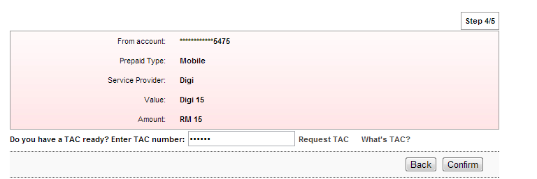

Figure 11: Pin Based Reload Confirmation screen

**Display Fields:**

| **No** | **Field** | **Format** | **Description** |
| --- | --- | --- | --- |
|  | From Account | Text | Account to debit payment. |
|  | Prepaid Type | Text | Selected prepaid type |
|  | Service Provider | Text | Selected service provider. |
|  | Value | Text | Selected product from user. |
|  | Amount | Numeric | Reload amount. |

Table 27: Pin Based Reload Confirmation Display Fields

**Input Specification:**

|  |  |  |  |  |  |
| --- | --- | --- | --- | --- | --- |
| **No** | **Field** | **Field Type** | **Validation Rule** | **Description** | **M/O** |
|  | TAC Number | Text Box, Masked | * Match Length: 6 * Numeric | A random, temporary generated number sent to mobile phone for transaction verification | M |

Table **28**: TAC Request Input Specification

**Action:**

| **No** | **Action** | **Type** | **Description** |
| --- | --- | --- | --- |
|  | Back | Button | Contains an action to go back to previous page |
|  | Confirm | Button | Contains an action to confirm the transaction. |
|  | Request a TAC number | Hyperlink | Contains an action to generate TAC Number and shows the TAC’s Pop-up window. |
|  | What’s TAC | Hyperlink | Contains an action to shows the What’s TAC Pop-up window. |

Table 29: Pinless Reload Confirmation List Action

**List of available messages for the screen:**

|  |  |  |
| --- | --- | --- |
| **No.** | **Event** | **Error Description** |
|  | Did not fill in TAC field. | TAC is required. |
|  | Fill in TAC with other than numeric. | TAC must be numeric. |
|  | Fill in TAC less than 6 digits. | TAC must consist of 6 digits. |
|  | Fill in invalid TAC | Invalid TAC. |
|  | Reach maximum length of attempt. | Your Account has been locked. Please call Agro Bank’s Contact Center. |
|  | Fill in an expired / no longer valid TAC. | TAC is expired. |

Table 30: TAC Request Error message list

***Step 5***

1. RIB System sent Pin Based Reload details to host and return result.
2. RIB System display Pin Based Reload result page. And user can make another transaction by clicking on the “Perform Another Reload” button

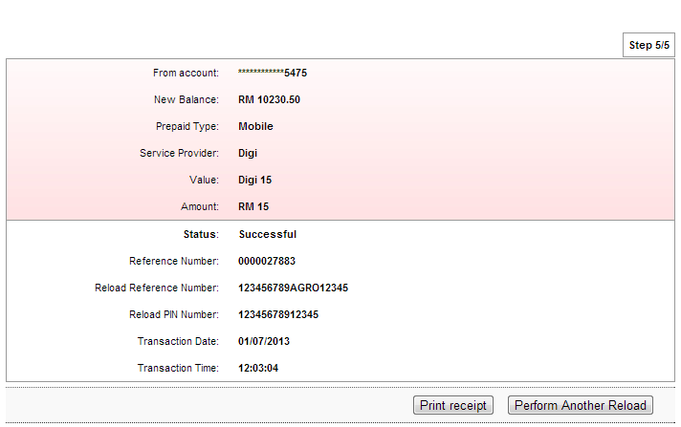

Figure 12: Pin Based Reload Result screen

**Display Fields:**

| **No** | **Field** | **Format** | **Description** |
| --- | --- | --- | --- |
|  | From Account | Text | Account to debit payment |
|  | New Balance | Numeric | Available balance after transaction. |
|  | Prepaid Type | Text | Selected prepaid type |
|  | Service Provider | Text | Selected service provider. |
|  | Value | Text | Selected product from user. |
|  | Amount | Numeric | Reload amount. |
|  | Status | Text | The status of the Transaction. |
|  | Reference Number | Numeric | Reference number of the transaction. |
|  | Reload Reference Number | Text | Reference number return from ePay. |
|  | Reload PIN Number | Numeric | Reload Pin number return from ePay. |
|  | Transaction Date | DD/MM/YYYY | The date of transaction. |
|  | Transaction Time | HH:MM:SS | The time of transaction. |

Table 31: Pin Based Reload Result Display Fields

**Action:**

| **No** | **Action** | **Type** | **Description** |
| --- | --- | --- | --- |
|  | Perform Another Reload | Button | Contain an action to go back to Pin Based Reload page |
|  | Print Receipt | Button | Contain an action To generate receipt’s pop-up display |

Table 32: Pin Based Reload Result List Action

1. IB user can print a receipt by clicking on the “Print Receipt” button. RIB System displays the print form of Pin Based Reload Receipt.

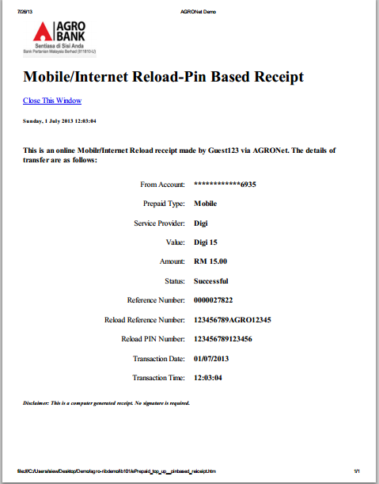

Figure 13: Pin Based Reload Receipt screen

**Display Fields:**

| **No** | **Field** | **Format** | **Description** |
| --- | --- | --- | --- |
|  | From Account | Text | Account to debit payment |
|  | Prepaid Type | Text | Selected prepaid type |
|  | Service Provider | Text | Selected service provider. |
|  | Value | Text | Selected product from user. |
|  | Amount | Numeric | Reload amount. |
|  | Status | Text | The status of the Transaction. |
|  | Reference Number | Numeric | Reference number of the transaction. |
|  | Reload Reference Number | Text | Reference number return from ePay. |
|  | Reload PIN Number | Numeric | Reload Pin number return from ePay. |
|  | Transaction Date | DD/MM/YYYY | The date of transaction. |
|  | Transaction Time | HH:MM:SS | The time of transaction. |

Table 33: Pin Based Reload Receipt Display Fields

Section 4: IBAM

ePay Payee and Product for both Prepaid Top Up and Bill Payment can be create and maintain through IBAM.

**Enhancement for the Prepaid Top Up**

We are proposing to create a new Payee category for the prepaid top up named “ePrepaid Top Up” that contain all the Prepaid Top Up payees and products.

**Enhancement for the Bill Payment**

We added a new Channel field with the channel values as below:-

1. HOST
2. EPAY

The channel ID shall be used as the channel preference set by Bank Admin.

We also added a new ePay Product Code that shall be used when the Channel ID is “EPAY due to ePay has its own product code for each Payee, which is not similar to Host Product Code.

# ePay Payee Maintenance

## Create Payee

### Progress Flow



Diagram 3: Create Payee Flow Diagram

### Screen Designs

***Step 1:***

1. IBAM user click on IBAM>Content>Payee>select Category> >Create Content.

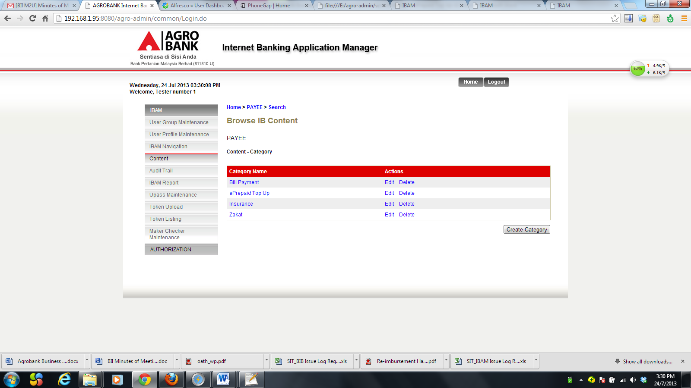

Figure 14: Category List Screen

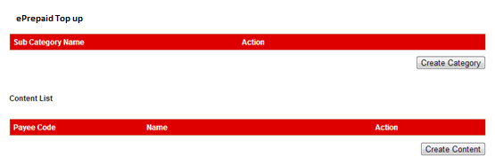

Figure 15: Subcategory List Screen

**Action:**

|  |  |  |  |
| --- | --- | --- | --- |
| No | Action | Type | Description |
|  | Create Content | Button | Contains an action to go to Create content page. |

Table 34: Payee Subcategory List Action

1. IBAM system shows Create content page as below.
2. IBAM user enters all the required information and click on “Done” button

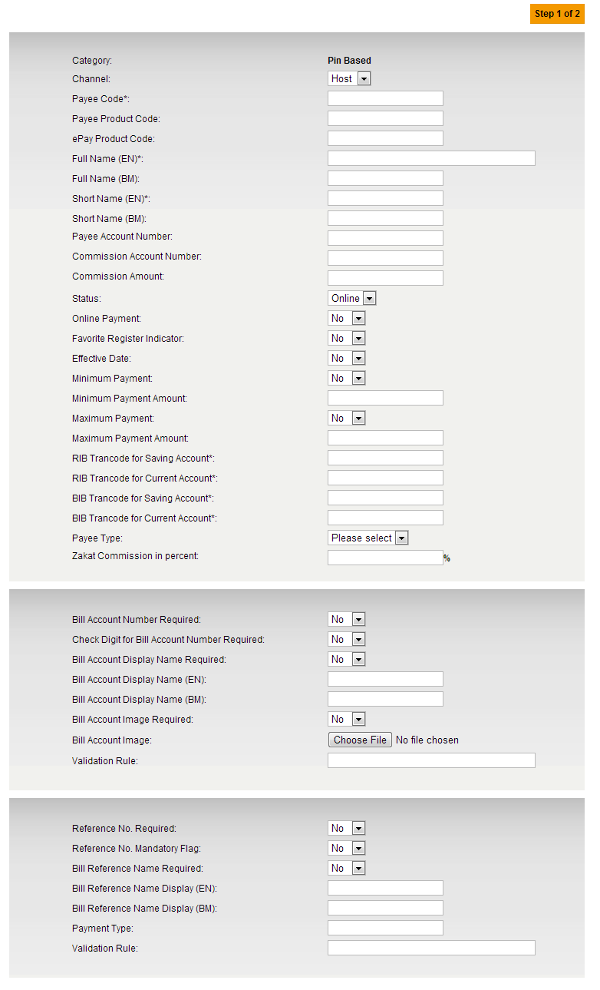

Figure 16: Create Content -Part 1

**Display Specification:**

|  |  |  |  |
| --- | --- | --- | --- |
| No | Field | Format | Description |
|  | Category | Text | Name of Category. |

Table 35: Create Content Details Display Field

**Input Specification:**

|  |  |  |  |  |  |
| --- | --- | --- | --- | --- | --- |
| No | Field | Field Type | Validation Rule | Description | M/O |
|  | Channel | Dropdown list | Default to Host | Payee Channel (Host, ePay) | M |
|  | Payee Code | Text | Max length: 16  Numeric | Unique company code | M |
|  | Payee Product Code | Text | Max length: 16  Alphanumeric | Unique service code by company | M |
|  | ePay Product Code | Text | Max length: 30 | Unique epay’s product code | O |
|  | Full Name (EN) | Text | Max length: 64 | Product value’s full name | M |
|  | Short Name (EN) | Text | Max length: 64 | Product value’s short name | M |
|  | Payee Account Number | Text | Max length: 16  Numeric | The payee account number | M |
|  | Commission Account Number | Text | Numeric | The payee commission account number | O |
|  | Commission Amount | Text | 15,2 Decimal  Numeric | The payee commission amount | O |
|  | Status | Dropdown list | Defaulted to Offline | Content Status (Online, Offline) | M |
|  | Online Payment | Dropdown list | Defaulted to No | Online payment status (Yes,No) | M |
|  | Favourite Register Indicator | Dropdown List | Defaulted to No | Indicator whether to include this payee for Favorite Payee registration. (Yes, No) | M |
|  | Effective Date | Dropdown List | Defaulted to No | Is effective date required? (Yes, No) | M |
|  | Minimum Payment | Dropdown List | Defaulted to No | Indicator whether this payee have a minimum payment requirement (Yes, No) | M |
|  | Minimum Payment Amount | Text | 15,2 decimal | Minimum payment amount, if Minimum Payment Flag is turned on | M  (if Maximum Payment select to Yes) |
|  | Maximum Payment | Dropdown List | Defaulted to No | Indicator whether this payee have a maximum payment requirement (Yes, No) | M |
|  | Maximum Payment Amount | Text | 15,2 decimal | Maximum payment amount, if Maximum Payment Flag is turned on | O |
|  | RIB Trancode for Saving Account | Text | Max length: 10  Numeric | Trancode for RIB Saving Account | M |
|  | RIB Trancode for Current Account | Text | Max length: 10  Numeric | Trancode for RIB Current Account | M |
|  | BIB Trancode for Saving Account | Text | Max length: 10  Numeric | Trancode for BIB Saving Account | M |
|  | BIB Trancode for Current Account | Text | Max length: 10  Numeric | Trancode for BIB Current Account | M |
|  | Payee Type | Dropdown list | Must be selected | Payee type | M |
|  | Zakat Commission in percent | Text | Numeric | Zakat commission percent | O |
|  | Bill Account Number Required | Dropdown list | Defaulted to No | Indicator whether Bill Account Number is required, (Yes, No) | M |
|  | Check Digit for Bill Account Number Required | Dropdown list | Defaulted to No | Indicate does check digit rule is required | M |
|  | Bill Account Display Name Required | Dropdown list | Defaulted to No | Indicator whether Bill Account Display Name is required, (Yes, No) | M |
|  | Bill Account Display Name (EN) | Text | Max length: 64 | Bill Account name in IB | M  (If Bill Account Display Name is required) |
|  | Bill Account Image Required | Dropdown list | Defaulted to No | Indicator whether Bill Account Image is required, (Yes, No) | M |
|  | Bill Account Image | File Browser | Required if Bill Account Image Required flag is YES | Image to display. | M  (If Bill Account Image is required) |
|  | Validation Rule | Text | Max length: 100 | Validation rule | O |
|  | Reference No. Required | Dropdown list | Defaulted to No | Indicator whether Reference number is required, (Yes, No) | M |
|  | Reference No. Mandatory Flag | Dropdown list | Defaulted to No | Reference mandatory requirement (Yes, No) | M |
|  | Bill Reference Name Required | Dropdown list | Defaulted to No | Indicator whether Bill Reference Name is required, (Yes, No) | M |
|  | Bill Reference Name Display (EN) | Text | Max length: 64 | Bill Reference name in IB | M  (If Bill Reference Name is required) |
|  | Payment Type | Text | Max length:2 | Payment Type | O |
|  | Validation Rule | Text | Max length: 100 | Validation rule | O |

Table 36: Create Content -Part 1 Input Specification

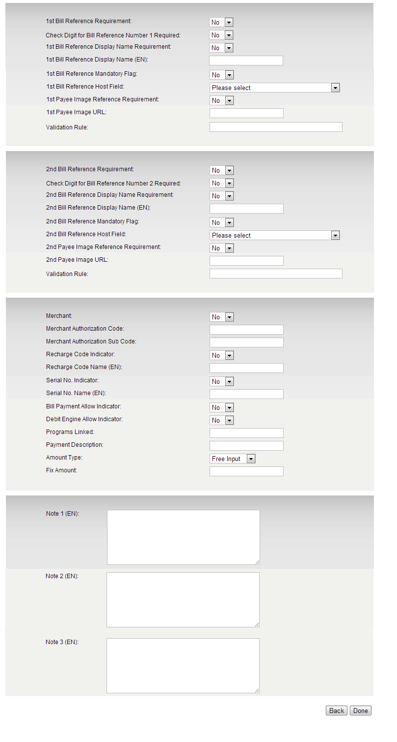

Figure 17: Create Content -Part 2

**Input Specification:**

|  |  |  |  |  |  |
| --- | --- | --- | --- | --- | --- |
| No | Field | Field Type | Validation Rule | Description | M/O |
|  | 1st Bill Reference Requirement | Dropdown list | Defaulted to No | Indicator whether 1st Reference number is required, (Yes, No) | M |
|  | Check Digit for Bill Reference Number 1 Required | Dropdown List | Defaulted to No | Indicate does check digit rule is required | M |
|  | 1st Bill Reference Display Name Requirement | Dropdown list | Defaulted to No | Indicator whether 1st Bill Reference Name is required, (Yes, No) | M |
|  | 1st Bill Reference Display Name(EN) | Text | Max length: 64 | 1st Bill Reference name in IB | M  (If 1st Bill Reference Name is required) |
|  | 1st Bill Reference Mandatory Flag | Dropdown list | Defaulted to No | 1st Bill Reference mandatory requirement (Yes, No) | M |
|  | 1st Bill Reference Host Field | Dropdown list | Must be selected if 1st Bill Reference is required | Host Field for 1st Bill Reference. | M  (if 1st Bill Reference is required) |
|  | 1st Payee Image Reference Requirement | Dropdown list | Defaulted to No | Indicator whether 1st Payee Image Reference is required, (Yes, No) | M |
|  | 1st Payee Image URL | Text | Required if 1st Payee Image Reference Requirement flag is YES | Image URL to display. | M  (If 1st Payee Image is required) |
|  | Validation Rule | Text | Max length: 100 | Validation rule | O |
|  | 2nd Bill Reference Requirement | Dropdown list | Defaulted to No | Indicator whether 2nd Reference number is required, (Yes, No) | M |
|  | Check Digit for Bill Reference Number 2 Required | Dropdown List | Defaulted to No | Indicate does check digit rule is required | M |
|  | 2nd Bill Reference Display Name Requirement | Dropdown list | Defaulted to No | Indicator whether 2nd Bill Reference Name is required, (Yes, No) | M |
|  | 2nd Bill Reference Display Name(EN) | Text | Max length: 64 | 2nd Bill Reference name in IB | M  (If 2nd Bill Reference Name is required) |
|  | 2nd Bill Reference Mandatory Flag | Dropdown list | Defaulted to No | 2nd Bill Reference mandatory requirement (Yes, No) | M |
|  | 2nd Bill Reference Host Field | Dropdown list | Must be selected if 2nd Bill Reference is required | Host Field for 2nd Bill Reference. | M  (If 2nd Bill Reference is required) |
|  | 2nd Payee Image Reference Requirement | Dropdown list | Defaulted to No | Indicator whether 2nd Payee Image Reference is required, (Yes, No) | M |
|  | 2nd Payee Image URL | Text | Required if 2nd Payee Image Reference Requirement flag is YES | Image URL to display. | M  (If 2nd Payee Image is required) |
|  | Validation Rule | Text | Max length: 100 | Validation rule | O |
|  | Merchant | Dropdown List | Defaulted to No | Indicator whether Merchant is required, (Yes, No) | M |
|  | Merchant Authorization Code | Text | Max length: 16  Alphanumeric | Merchant Authorization Code | M  (If Merchant is required) |
|  | Merchant Authorization Sub Code | Text | Max length: 16  Alphanumeric | Merchant Authorization Sub Code | M  (If Merchant is required) |
|  | Recharge Code Indicator | Dropdown List | Defaulted to No | Indicator whether Recharge Code is required, (Yes, No) | M |
|  | Recharge Code Name (EN) | Text | Max length: 64 | Name of recharge code name. | M  (if Recharge Code Indicator is required) |
|  | Serial No. Indicator | Dropdown List | Defaulted to No | Indicator whether Serial Number is required, (Yes, No) | M |
|  | Serial No. Name (EN) | Text | Max length: 64 | Name of serial number | M  (if Serial number Indicator is required) |
|  | Bill Payment Allow Indicator | Dropdown List | Defaulted to No | Indicator whether Bill Payment Allow is required, (Yes, No) | M |
|  | Debit Engine Allow Indicator | Dropdown List | Defaulted to No | Indicator whether Debit Engine Allow is required, (Yes, No) | M |
|  | Programs Linked | Text | Max length: 64  Alphanumeric | Programs Linked | O |
|  | Payment Description | Text | Max length: 64 | Payment Description | O |
|  | Amount Type | Dropdown List | Defaulted to Free Input | Free Input, Dropdown, Fix Amount | M |
|  | Fix Amount | Text | 11,2 decimal | Fix amount, if fix amount in Amount Type is chosen | M  (if Amount Type is Fix Amount) |
|  | Note 1-3 | Text area | Max length: 1000  Text | Custom payee note in at Payment Details page | O |

Table 37: Create Content – Part 2 Input Specifications

**Action:**

|  |  |  |  |
| --- | --- | --- | --- |
| No | Action | Type | Description |
|  | Done | Button | Contain an action to create Payee. |

Table 38: Create Content Action

**List of available messages for the screen:**

| **No** | **Event** | **Error Description in English** |
| --- | --- | --- |
|  | Did not fill in required fields:   * BIB Trancode for Saving Account * BIB Trancode for Current Account * RIB Trancode for Saving Account * RIB Trancode for Current Account * Payee Code * Full Name (EN) * Short Name (EN) | BIB Trancode for Saving Account is required. |
| BIB Trancode for Current Account is required. |
| RIB Trancode for Saving Account is required. |
| RIB Trancode for Current Account is required. |
| Payee Code is required. |
| Full Name (EN) is required. |
| Short Name (EN) is required. |
|  | Fill in Payee code with special character | Payee Code is not numeric. |
|  | Fill in Payee Code with the existing one. | Payee Code has been used. Please use another Payee Code. |
|  | Fill in Payee Product Code with special character | Payee Product Code cannot include special character and space. |
|  | Fill in Full Name with existing one. | Full Name has been used. Please use another Full Name. |
|  | Fill in Payee Account No others than numeric. | Payee Account No is not numeric. |
|  | Fill in Commission Account No with non-numeric. | Commission Account No is not numeric. |
|  | Fill in Commission Amount with alphabet and/or special character. | Commission Amount is not numeric. |
|  | Do not fill in the Minimum Payment Amount when Minimum Payment Flag is turned on. | Minimum Payment Amount is required. |
|  | Fill in Minimum Payment Amount with alphabet and/or special character | Minimum Payment Amount is not numeric. |
|  | Do not fill in the Maximum Payment Amount when Minimum Payment Flag is turned on. | Maximum Payment Amount is required. |
|  | Fill in Maximum Payment Amount with alphabet and/or special character | Maximum Payment Amount is not numeric. |
|  | Fill in Minimum Payment Amount with greater amounts than Maximum Payment Amount. | Maximum Payment Amount must be greater than Minimum Payment Amount. |
|  | Fill in Trancode for Saving Account with non-numeric. | Trancode of Saving Account with is not numeric. |
|  | Fill in Trancode for Current Account with non-numeric. | Trancode of Current Account with is not numeric. |
|  | Do not fill in the Bill Display Name when Bill Display Name Flag is turned on. | Bill Display Name is required. |
|  | Do not fill in the Bill Account Image when Bill Account Image Flag is turned on. | Bill Account Image is required. |
|  | Do not fill in the Bill Reference Display Name when Bill Reference Name Required Flag is turned on. | Bill Reference Name Display is required. |
|  | Fill in Bill Reference Display Name with special character | Bill Reference Display Name cannot include special character except space. |
|  | Do not fill in the 1st/2nd Bill Reference Display Name when 1st/2nd Bill Reference Display Name Flag is turned on. | 1st/2nd Bill Reference Display Name is required. |
|  | Do not fill in the 1st/2nd Payee Image when 1st/2nd Payee Image Flag is turned on. | 1st/2nd Payee Image is required. |
|  | Do not fill in Merchant Authorization Code when Merchant Flag is turned on. | Merchant Authorization Code is required. |
|  | Fill in Merchant Authorization Code with special character. | Merchant Authorization Code cannot include special character and space |
|  | Fill in Merchant Authorization Sub Code with special character. | Merchant Authorization Sub Code cannot include special character and space |
|  | Do not fill in the Recharge Code Name when Recharge Code Flag is turned on. | Recharge Code Name is required. |
|  | Do not fill in the Serial No Name when Serial No Flag is turned on. | Serial No Name is required. |
|  | Do not fill in the Fix Amount when Amount Type is selected as Fix Amount. | Fix Amount is required. |
|  | Fill in Fix amount with special character and/or alphabet. | Fix Amount is not numeric. |

Table 39: Create Content Error Message List

***Step 2:***

1. IBAM system display Payee creation result screen.

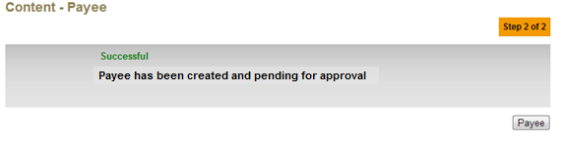  
Figure 18: Create Payee Result Screen

**Display Specification:**

|  |  |  |  |
| --- | --- | --- | --- |
| No | Field | Format | Description |
|  | Status | Text | Create payee status |
|  | Status Note | Text | Create payee status message |

Table 40: Create Payee Result Display Fields

**Action:**

|  |  |  |  |
| --- | --- | --- | --- |
| No | Action | Type | Description |
|  | Payee | Button | Back to Subcategory List page |

Table 41: Create Payee Result Action

## Create Product

### Progress Flow



Diagram 4: Create Product Flow Diagram

### Screen Designs

***Step 1:***

1. IBAM user clicks on Payee ‘Details’ hyperlink.

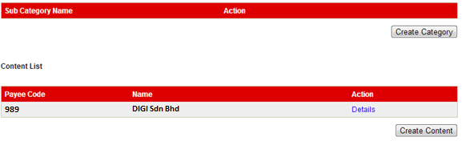

Figure 19: Payee List Screen

**Action:**

|  |  |  |  |
| --- | --- | --- | --- |
| No | Action | Type | Description |
|  | Details | Hyperlink | Contains an action to go to Payee details page. |

Table 42: Payee List List Action

1. IBAM display Payee Details page.
2. IBAM user clicks on “Add Prepaid Top up Product” button.

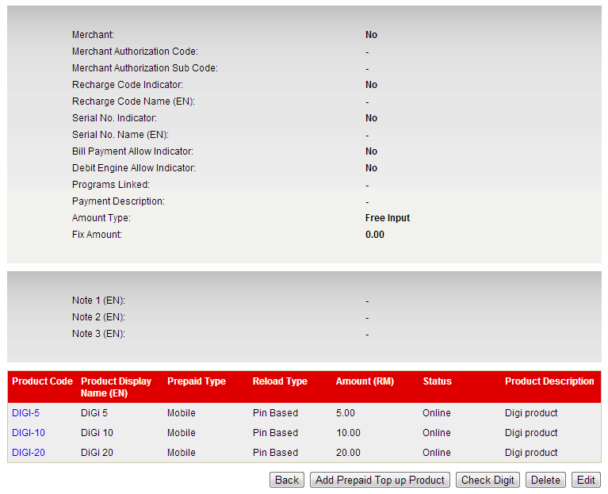

Figure 20: Payee Details Screen

**Display Specification:**

|  |  |  |  |
| --- | --- | --- | --- |
| No | Field | Format | Description |
|  | Product Code | Text | Unique code of the product |
|  | Product Display Name (EN) | Text | Create payee status message |
|  | Prepaid Type | Text | Prepaid type of the product |
|  | Reload type | Text | Reload type of the product |
|  | Amount (RM) | Numeric | Amount of the product |
|  | Status | Text | Status of the product |
|  | Product Description | Text | Description of the product |

Table 43: Create Payee Result Display Fields

**Action:**

|  |  |  |  |
| --- | --- | --- | --- |
| No | Action | Type | Description |
|  | Product Code | Hyperlink | Contains an action to view and update product. |
|  | Add Prepaid Top up Product | Button | Contains an action to create prepaid top up product. |

Table 44: Create Payee Result Action

***Step 2:***

1. IBAM System display Create Product page
2. IBAM user enters all the details and clicks on ‘Done’ button.

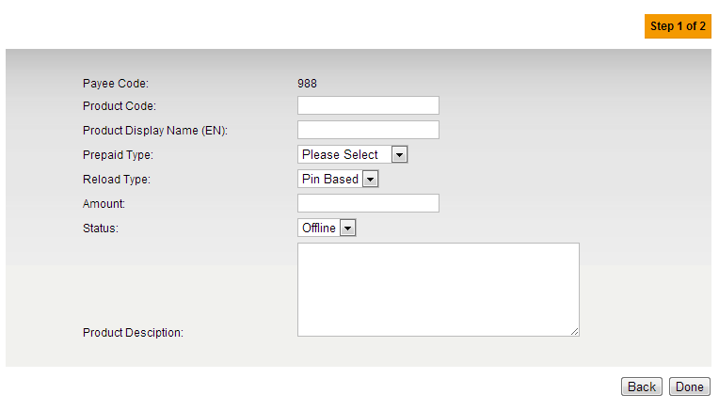

Figure 21: Create Product Screen

**Display Fields:**

| **No** | **Field** | **Format** | **Description** |
| --- | --- | --- | --- |
|  | Payee Code | Text | Unique payee code. |

Table 45: Create Product Display Fields

**Input Specification:**

| **No** | **Field** | **Field Type** | **Validation Rule** | **Description** | **M/O** |
| --- | --- | --- | --- | --- | --- |
|  | Product Code | Text | Max length: 16 | Unique product code | M |
|  | Product Display Name (EN) | Text | Max Length:64 | Product’s display name | M |
|  | Prepaid Type | Dropdown list |  | Prepaid type (Mobile, IDD/STD, Internet Access, Prepaid Wallet, Others.) | O |
|  | Reload Type | Dropdown list | Must be selected | Reload type (Pin Based, Pinless) | M |
|  | Amount | Text | 15,2 decimal  Numeric | Product ‘s amount | M |
|  | Status | Dropdown list | Defaulted to Offline | Product Status (Online, Offline) | M |
|  | Product Description | Text | Max length: 255  Text | Description of the product. | O |

Table 46: Create Product Input Specification

**Action:**

| **No** | **Action** | **Type** | **Description** |
| --- | --- | --- | --- |
|  | Back | Button | Contains an action to back to previous page |
|  | Done | Button | Contains an action to continue to next page |

Table 47: Create Product Action

**List of available messages for the screen:**

| **No.** | **Event** | **Error Description in English** |
| --- | --- | --- |
|  | Did not fill in mandatory fields:   * Product Code * Product Display Name (EN) * Reload Type * Amount | Product Code is required. |
| Product Display Name (EN) is required. |
| Reload Type is required. |
| Amount is required. |
|  | Fill in Amount others than numeric. | Amount must be numeric. |
|  | Fill in Product Description with more than 255 characters | Product Description cannot be greater than 255 characters. |

Table 48: Create Product Error Message List

***Step 3:***

1. IBAM System display Create Product Result page

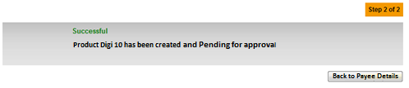

Figure 22: Create Product Result Screen

**Display Specification:**

|  |  |  |  |
| --- | --- | --- | --- |
| No | Field | Format | Description |
|  | Status | Text | Create product status |
|  | Status Note | Text | Create product status message |

Table 49: Create Product Result Display Fields

**Action:**

|  |  |  |  |
| --- | --- | --- | --- |
| No | Action | Type | Description |
|  | Back to Payee Details | Button | Back to Payee Details page |

Table 50: Create Product Result Action

## Edit Product

### Progress Flow



Diagram 5: Edit Product Flow Diagram

### Screen Designs

***Step 1:***

1. IBAM user clicks on ‘Product Code’ hyperlink.



Figure 23: Payee Details Screen

**Display Specification:**

|  |  |  |  |
| --- | --- | --- | --- |
| No | Field | Format | Description |
|  | Product Code | Text | Unique code of the product |
|  | Product Display Name (EN) | Text | Create payee status message |
|  | Prepaid Type | Text | Prepaid type of the product |
|  | Reload type | Text | Reload type of the product |
|  | Amount (RM) | Numeric | Amount of the product |
|  | Status | Text | Status of the product |
|  | Product Description | Text | Description of the product |

Table 51: Payee Details Display Fields

**Action:**

|  |  |  |  |
| --- | --- | --- | --- |
| No | Action | Type | Description |
|  | Product Code | Hyperlink | Contains an action to go view and update product. |

Table 52: Payee Details List Action

***Step 2:***

1. IBAM System display Product Details page
2. IBAM user clicks on ‘Edit’ button.

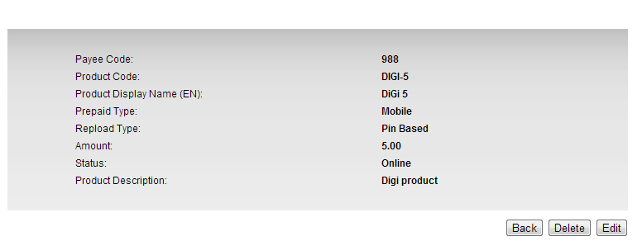

Figure 24: Product Details Screen

**Display Fields:**

| **No** | **Field** | **Format** | **Description** |
| --- | --- | --- | --- |
|  | Payee Code | Text | Unique payee code. |
|  | Product Display Name (EN) | Text | Create payee status message |
|  | Prepaid Type | Text | Prepaid type of the product |
|  | Reload type | Text | Reload type of the product |
|  | Amount (RM) | Numeric | Amount of the product |
|  | Status | Text | Status of the product |
|  | Product Description | Text | Description of the product |

Table 53: Product Details Display Fields

**Action:**

| **No** | **Action** | **Type** | **Description** |
| --- | --- | --- | --- |
|  | Back | Button | Contains an action to back to previous page |
|  | Delete | Button | Contains an action to delete the product |
|  | Edit | Button | Contains an action to edit the product |

Table 54: Product Details Action

***Step 2:***

1. IBAM System display Edit Product page.
2. IBAM user enters all the details and clicks on ‘Done’ button

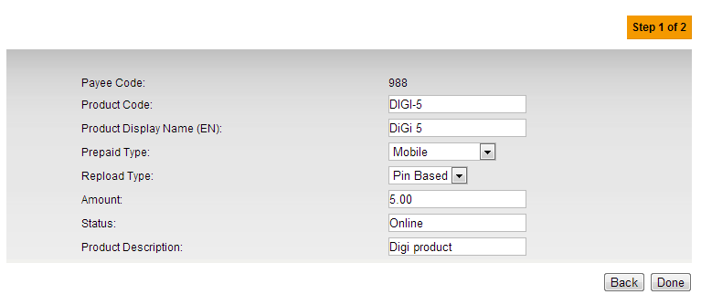

Figure 25: Edit Product Screen

**Input Specification:**

| **No** | **Field** | **Field Type** | **Validation Rule** | **Description** | **M/O** |
| --- | --- | --- | --- | --- | --- |
|  | Product Code | Text | Max length: 16 | Unique product code | M |
|  | Product Display Name (EN) | Text | Max Length:64 | Product’s display name | M |
|  | Prepaid Type | Dropdown list |  | Prepaid type (Mobile, IDD/STD, Internet Access, Prepaid Wallet, Others.) | O |
|  | Reload Type | Dropdown list | Must be selected | Reload type (Pin Based, Pinless) | M |
|  | Amount | Text | 15,2 decimal  Numeric | Product ‘s amount | M |
|  | Status | Dropdown list | Defaulted to Offline | Product Status (Online, Offline) | M |
|  | Product Description | Text | Max length: 255  Text | Description of the product. | O |

Table 55: Edit Product Input Specification

**Action:**

|  |  |  |  |
| --- | --- | --- | --- |
| No | Action | Type | Description |
|  | Back | Button | Contains an action to back to previous page |
|  | Done | Button | Contains an action to confirm to edit the product |

Table 56: Edit Product Result Action

**List of available messages for the screen:**

| **No.** | **Event** | **Error Description in English** |
| --- | --- | --- |
|  | Did not fill in mandatory fields:   * Product Code * Product Display Name (EN) * Reload Type * Amount | Product Code is required. |
| Product Display Name (EN) is required. |
| Reload Type is required. |
| Amount is required. |
|  | Fill in Amount others than numeric. | Amount must be numeric. |
|  | Fill in Product Description with more than 255 characters | Product Description cannot be greater than 255 characters. |

Table 57: Edit Product Error Message List

***Step 4:***

1. IBAM System display Edit Product Result page

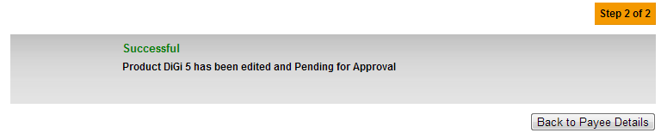

Figure 26: Edit Product Result Screen

**Display Specification:**

|  |  |  |  |
| --- | --- | --- | --- |
| No | Field | Format | Description |
|  | Status | Text | Edit product status |
|  | Status Note | Text | Edit product status message |

Table 58: Edit Product Result Display Fields

**Action:**

|  |  |  |  |
| --- | --- | --- | --- |
| No | Action | Type | Description |
|  | Back to Payee Details | Button | Back to Payee Details page |

Table 59: Edit Product Result Action

## Delete Product

### Progress Flow



Diagram 6: Delete Product Flow Diagram

### Screen Designs

***Step 1:***

1. IBAM user clicks on ‘Product Code’ hyperlink.



Figure 27: Payee Details Screen

**Display Specification:**

|  |  |  |  |
| --- | --- | --- | --- |
| No | Field | Format | Description |
|  | Product Code | Text | Unique code of the product |
|  | Product Display Name (EN) | Text | Create payee status message |
|  | Prepaid Type | Text | Prepaid type of the product |
|  | Reload type | Text | Reload type of the product |
|  | Amount (RM) | Numeric | Amount of the product |
|  | Status | Text | Status of the product |
|  | Product Description | Text | Description of the product |

Table 60: Payee Details Display Fields

**Action:**

|  |  |  |  |
| --- | --- | --- | --- |
| No | Action | Type | Description |
|  | Product Code | Hyperlink | Contains an action to go view and update product. |

Table 61: Payee Details List Action

***Step 2:***

1. IBAM System display Product Details page
2. IBAM user clicks on ‘Delete’ button.



Figure 28: Product Details Screen

**Display Fields:**

| **No** | **Field** | **Format** | **Description** |
| --- | --- | --- | --- |
|  | Product Code | Text | Unique code of the product |
|  | Product Display Name (EN) | Text | Create payee status message |
|  | Prepaid Type | Text | Prepaid type of the product |
|  | Reload type | Text | Reload type of the product |
|  | Amount (RM) | Numeric | Amount of the product |
|  | Status | Text | Status of the product |
|  | Product Description | Text | Description of the product |

Table 62: Product Details Display Fields

**Action:**

| **No** | **Action** | **Type** | **Description** |
| --- | --- | --- | --- |
|  | Back | Button | Contains an action to back to previous page |
|  | Delete | Button | Contains an action to delete the product |
|  | Edit | Button | Contains an action to edit the product |

Table 63: Product Details Action

***Step 3:***

1. IBAM System display Edit Product page.
2. IBAM user clicks on ‘Confirm’ button to confirm to delete the product or clicks on ‘Back’ button to go back to product details page.

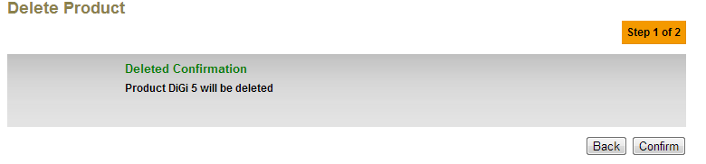

Figure 29: Delete Product Screen

**Display Specification:**

|  |  |  |  |
| --- | --- | --- | --- |
| No | Field | Format | Description |
|  | Status | Text | Delete product confirmation status |
|  | Status Note | Text | Delete product status confirmation message |

Table 64: Delete Product Display Fields

**Action:**

|  |  |  |  |
| --- | --- | --- | --- |
| No | Action | Type | Description |
|  | Back | Button | Contains an action to back to the product details page |
|  | Confirm | Button | Contains an action to confirm to delete the product |

Table 65: Delete Product Result Action

***Step 4:***

1. IBAM System display Edit Product Result page

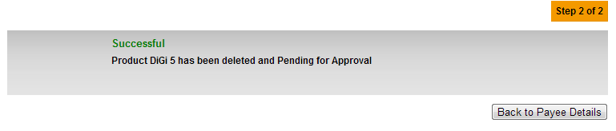

Figure 30: Delete Product Result Screen

**Display Specification:**

|  |  |  |  |
| --- | --- | --- | --- |
| No | Field | Format | Description |
|  | Status | Text | Delete product status |
|  | Status Note | Text | Delete product status message |

Table 66: Delete Product Result Display Fields

**Action:**

|  |  |  |  |
| --- | --- | --- | --- |
| No | Action | Type | Description |
|  | Back to Payee Details | Button | Back to Payee Details page |

Table 67: Delete Product Result Action

Section 5: ePrepaid Top Up Reload Limit

There are 2 ways to maintain the ePrepaid To Up reload limit maintenance:-

1. System max limit – to set the maximum allowable daily limit
2. User configurable limit – allow user to configure own reload limit

# Reload Limit Maintenance

## System Reload Limit Maintenance

System maximum limit maintenance is maintained at system configuration file as the current system design.

In the app.config file:-

|  |
| --- |
| app.reload.limit=600 |

## User Reload Limit Maintenance

### Process Flows



Diagram 7: Reload Limit Flow Diagram

There are 2 participants involved in this process which is IB User and RIB System.

### Screen Designs

***Step 1:***

1. User clicks on Reload limit on Mobile/ Internet Reload page and user views list of current limit.
2. User can select new limit.
3. User clicks the “NEXT” button to go the next page or user can click “CLEAR” button to clear the entire text box.

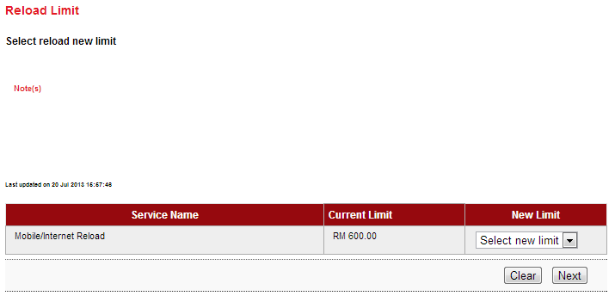

Figure 31: Reload Limit Details screen

**Display Specification:**

|  |  |  |  |
| --- | --- | --- | --- |
| **No** | **Field** | **Format** | **Description** |
|  | Service Name | Text | Shows the available Service name |
|  | Current Limit | Numeric | Shows the current reload limit |

Table 68: Reload Limit Display fields

**Input Specification:**

|  |  |  |  |  |  |
| --- | --- | --- | --- | --- | --- |
| **No** | **Field** | **Field Type** | **Validation Rule** | **Description** | **M/O** |
|  | New Limit | Dropdown list | Must be selected | New reload Limit | M |

Table **69**: Reload Limit Input Specification

**Action:**

|  |  |  |  |
| --- | --- | --- | --- |
| **No** | **Action** | **Type** | **Description** |
|  | Clear | Button | To clear the selected new limit |
|  | Next | Button | To continue to reload Limit confirmation page |

Table **70**: Reload Limit List Action

**List of available messages for the screen:**

| **No** | **Event** | **Error Description in English** |
| --- | --- | --- |
|  | Did not select New Limit | New Limit is required. |

Table **71**: Reload Limit Error message list

***Step 2:***

1. IBS displays reload limit Confirmation Page.
2. IB User input the TAC number.
3. IB User clicks on the ‘Confirm’ button to confirm the New Reload Limit and go to the next page or clicks on the ‘Back’ button back to the previous page.

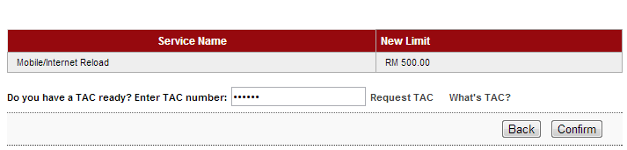

Figure 32: Reload Limit Confirmation screen

**Display Fields:**

| **No** | **Field** | **Format** | **Description** |
| --- | --- | --- | --- |
|  | Service Name | Text | Shows the Service name. |
|  | New Limit | Numeric | Shows the New Reload limit |

Table 72: Reload Limit Confirmation Display Fields

**Input Specification:**

|  |  |  |  |  |  |
| --- | --- | --- | --- | --- | --- |
| **No** | **Field** | **Field Type** | **Validation Rule** | **Description** | **M/O** |
|  | TAC Number | Text Box, Masked | * Match Length: 6 * Numeric | A random, temporary generated number sent to mobile phone for transaction verification | M |

Table **73**: TAC Request Input Specification

**Action:**

| **No** | **Action** | **Type** | **Description** |
| --- | --- | --- | --- |
|  | Back | Button | Contains an action to go back to previous page |
|  | Confirm | Button | Contains an action to confirm the Reload Limit. |
|  | Request a TAC number | Hyperlink | Contains an action to generate TAC Number and shows the TAC’s Pop-up window. |
|  | What’s TAC | Hyperlink | Contains an action to shows the What’s TAC Pop-up window. |

Table 74: Reload Limit Confirmation List Action

**List of available messages for the screen:**

|  |  |  |
| --- | --- | --- |
| **No.** | **Event** | **Error Description** |
|  | Did not fill in TAC field. | TAC is required. |
|  | Fill in TAC with other than numeric. | TAC must be numeric. |
|  | Fill in TAC less than 6 digits. | TAC must consist of 6 digits. |
|  | Fill in invalid TAC | Invalid TAC. |
|  | Reach maximum length of attempt. | Your Account has been locked. Please call Agro Bank’s Contact Center. |
|  | Fill in an expired / no longer valid TAC. | TAC is expired. |

Table **75**: TAC Request Error message list

**Step 3:**

1. IBS display Reload Result page.

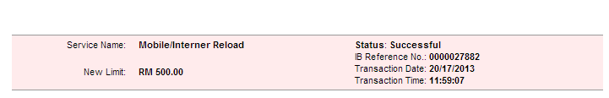

Figure 33: Reload Limit Result Page

**Display Specification:**

|  |  |  |  |
| --- | --- | --- | --- |
| **No** | **Field** | **Format** | **Description** |
|  | Service Name | Text | Shows the Service name |
|  | New Limit | Text | Shows the New reload limit |
|  | Status | Text | The status of the Transaction. |
|  | IB Reference No. | Numeric | Reference number of the transaction. |
|  | Transaction Date | DD/MM/YYYY | The date of transaction. |
|  | Transaction Time | HH:MM:SS | The time of transaction. |

Table 76: Reload Limit Result Display fields

Section 6: Report

A daily and monthly report will be produce as below:

**Bill Payment Report**

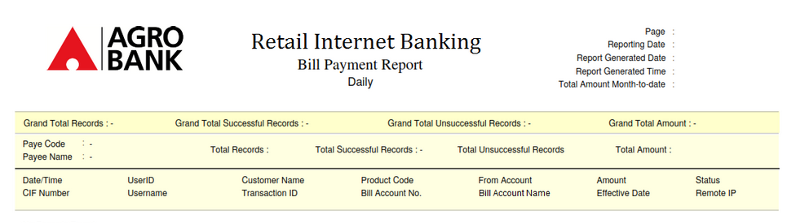

**ePrepaid Top-up Report**

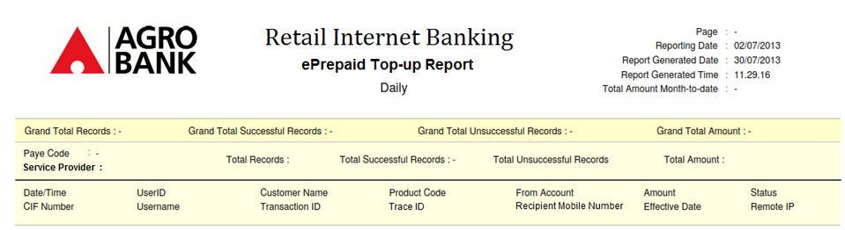

Section 5: Setting

New App.config setting

These new values will be used for ePay’s Prepaid Top Up and Bill Payments

|  |
| --- |
| //ePay configuration  epay.payeecode=  epay.productcode=  epay.gl= |

Filtering rules and use of the ePay configuration in the App.config file

|  |
| --- |
| If category is “ePrepaid Top Up” then Host Payee Code and Host Product Code shall get from App.config’s epay.payeecode and epay.productcode |
| If category is “Bill Payment” and Channel is “EPAY” then Host Payee Code and Host Product Code shall get from App.config’s epay.payeecode and epay.productcode, and ePay Product Code shall get from IBAM; otherwise the Host Payee Code and Host Product Code shall get from IBAM, and ePay Product Code is not applicable. |

# Appendix 1: List of Prepaid Top Up Product

|  |  |  |  |  |
| --- | --- | --- | --- | --- |
| **\* PIN = pin based** | | | | |
| **\* ETU = etopup/ pinless** | | | | |
| **Prepaid Type** | **Payee** | **Title** | **Denomination** | **ProductCode** | | **Amount in Cents** | **Product Type** | |
|  |  |  |  |  | |  |  |  |
| Mobile | Celcom | Celcom Airtime 5 | 5.00 | CELCOMAIRTIME | | 500 | PIN |  |
|  |  | Celcom Airtime 10 | 10.00 | CELCOMAIRTIME | | 1000 | PIN | ETU |
|  |  | Celcom Airtime 30 | 30.00 | CELCOMAIRTIME | | 3000 | PIN | ETU |
|  |  | Celcom Airtime 50 | 50.00 | CELCOMAIRTIME | | 5000 | PIN | ETU |
|  |  | Celcom Airtime 100 | 100.00 | CELCOMAIRTIME | | 10000 | PIN | ETU |
|  |  | Celcom Airtime 200 | 200.00 | CELCOMAIRTIME | | 20000 | PIN | ETU |
|  |  | Celcom Network Access 50 | 50.00 | CELCOMACCESS | | 5000 | PIN |  |
|  |  | Celcom Kaw Kaw (Data 10) | 10.00 | KAWKAWD | | 1000 | PIN |  |
|  |  | Celcom Kaw Kaw (i10) | 10.00 | KAWKAWI | | 1000 | PIN |  |
|  |  | Celcom Kaw Kaw (Talk & Data 10) | 10.00 | KAWKAWTD | | 1000 | PIN |  |
|  | Digi | Digi 5 | 5.00 | DIGI | | 500 | PIN | ETU |
|  |  | Digi 10 | 10.00 | DIGI | | 1000 | PIN | ETU |
|  |  | Digi 30 | 30.00 | DIGI | | 3000 | PIN | ETU |
|  |  | Digi 50 | 50.00 | DIGI | | 5000 | PIN | ETU |
|  |  | Digi 100 | 100.00 | DIGI | | 10000 | PIN | ETU |
|  |  | Digi 15 (SR-SOCIAL) | 15.00 | DIGISRSOCIAL | | 1500 | PIN |  |
|  | Maxis | Maxis Hotlink 5 | 5.00 | MAXISHOTLINK | | 500 |  | ETU |
|  |  | Maxis Hotlink 10 | 10.00 | MAXISHOTLINK | | 1000 |  | ETU |
|  |  | Maxis Hotlink 20 | 20.00 | MAXISHOTLINK | | 2000 |  | ETU |
|  |  | Maxis Hotlink 30 | 30.00 | MAXISHOTLINK | | 3000 |  | ETU |
|  |  | Maxis Hotlink 60 | 60.00 | MAXISHOTLINK | | 6000 |  | ETU |
|  |  | Maxis Hotlink 100 | 100.00 | MAXISHOTLINK | | 10000 |  | ETU |
|  | Happy | Happy 10 | 10.00 | HAPPY | | 1000 | PIN |  |
|  |  | Happy 20 | 20.00 | HAPPY | | 2000 | PIN |  |
|  |  | Happy 30 | 30.00 | HAPPY | | 3000 | PIN |  |
|  |  | Happy 50 | 50.00 | HAPPY | | 5000 | PIN |  |
|  |  | Happy 100 | 100.00 | HAPPY | | 10000 | PIN |  |
|  | Merchantrade | MerchantradePM 5 | 5.00 | MERCHANTRADEPM | | 500 | PIN |  |
|  |  | MerchantradePM 10 | 10.00 | MERCHANTRADEPM | | 1000 | PIN |  |
|  |  | MerchantradePM 30 | 30.00 | MERCHANTRADEPM | | 3000 | PIN |  |
|  |  | MerchantradePM 50 | 50.00 | MERCHANTRADEPM | | 5000 | PIN |  |
|  | ITel | ITel 5 | 5.00 | OKTEL | | 500 | PIN |  |
|  |  | ITel 10 | 10.00 | OKTEL | | 1000 | PIN |  |
|  |  | ITel 30 | 30.00 | OKTEL | | 3000 | PIN |  |
|  |  | ITel 50 | 50.00 | OKTEL | | 5000 | PIN |  |
|  | Salamfone | Salamfone 5 | 5.00 | SALAMFONE | | 500 | PIN |  |
|  |  | Salamfone 10 | 10.00 | SALAMFONE | | 1000 | PIN |  |
|  |  | Salamfone 30 | 30.00 | SALAMFONE | | 3000 | PIN |  |
|  |  | Salamfone 50 | 50.00 | SALAMFONE | | 5000 | PIN |  |
|  | Tune Talk | Tune Talk 5 | 5.00 | TUNETALK | | 500 | PIN |  |
|  |  | Tune Talk 10 | 10.00 | TUNETALK | | 1000 | PIN |  |
|  |  | Tune Talk 15 | 15.00 | TUNETALK | | 1500 | PIN |  |
|  |  | Tune Talk 30 | 30.00 | TUNETALK | | 3000 | PIN |  |
|  |  | Tune Talk 50 | 50.00 | TUNETALK | | 5000 | PIN |  |
|  | U Mobile | U Mobile 5 | 5.00 | UMOBILE | | 500 | PIN |  |
|  |  | U Mobile 10 | 10.00 | UMOBILE | | 1000 | PIN |  |
|  |  | U Mobile 30 | 30.00 | UMOBILE | | 3000 | PIN |  |
|  |  | U Mobile 50 | 50.00 | UMOBILE | | 5000 | PIN |  |
|  |  | U Mobile 100 | 100.00 | UMOBILE | | 10000 | PIN |  |
|  | XOX | XOX 5 | 5.00 | XOX | | 500 | PIN |  |
|  |  | XOX 10 | 10.00 | XOX | | 1000 | PIN |  |
|  |  | XOX 30 | 30.00 | XOX | | 3000 | PIN |  |
|  |  | XOX 50 | 50.00 | XOX | | 5000 | PIN |  |
|  | Tron | Tron Talktime 10 | 10.00 | TRONTALKTIME | | 1000 | PIN |  |
|  |  | Tron Talktime 30 | 30.00 | TRONTALKTIME | | 3000 | PIN |  |
|  |  | Tron Talktime 50 | 50.00 | TRONTALKTIME | | 5000 | PIN |  |
|  |  | Tron Talktime 100 | 100.00 | TRONTALKTIME | | 10000 | PIN |  |
|  |  | Tron Cash 10 | 10.00 | TRONCASH | | 1000 | PIN |  |
|  |  | Tron Cash 30 | 30.00 | TRONCASH | | 3000 | PIN |  |
|  |  | Tron Cash 50 | 50.00 | TRONCASH | | 5000 | PIN |  |
|  |  | Tron Cash 100 | 100.00 | TRONCASH | | 10000 | PIN |  |
|  | Speak Out | Speak Out 3 | 3.00 | SPEAKOUT | | 300 | PIN |  |
|  |  | Speak Out 10 | 10.00 | SPEAKOUT | | 1000 | PIN |  |
|  |  | Speak Out 30 | 30.00 | SPEAKOUT | | 3000 | PIN |  |
|  |  | Speak Out 50 | 50.00 | SPEAKOUT | | 5000 | PIN |  |
|  | m8 | @m8 5 | 5.00 | M8 | | 500 | PIN |  |
|  |  | @m8 10 | 10.00 | M8 | | 1000 | PIN |  |
|  |  | @m8 30 | 30.00 | M8 | | 3000 | PIN |  |
|  |  | @m8 50 | 50.00 | M8 | | 5000 | PIN |  |
|  |  | @m8 100 | 100.00 | M8 | | 10000 | PIN |  |
|  | Clixster | Clixster 5 | 5.00 | CLIXSTER | | 500 | PIN |  |
|  |  | Clixster 10 | 10.00 | CLIXSTER | | 1000 | PIN |  |
|  |  | Clixster 30 | 30.00 | CLIXSTER | | 3000 | PIN |  |
|  |  | Clixster 50 | 50.00 | CLIXSTER | | 5000 | PIN |  |
|  |  |  |  |  | |  |  |  |
| IDD & STD | GloReload | GloReload 7 | 7.00 | GLORELOAD | | 700 | PIN |  |
|  |  | GloReload 13 | 13.00 | GLORELOAD | | 1300 | PIN |  |
|  |  | GloReload 25 | 25.00 | GLORELOAD | | 2500 | PIN |  |
|  | Digi | Digi Chatz 10 | 10.00 | DIGICHATZ | | 1000 | PIN |  |
|  |  | Digi Chatz 30 | 30.00 | DIGICHATZ | | 3000 | PIN |  |
|  |  | Digi Chatz 50 | 50.00 | DIGICHATZ | | 5000 | PIN |  |
|  |  | Digi Chatz 100 | 100.00 | DIGICHATZ | | 10000 | PIN |  |
|  | Celcom | iTalk Mobile 10 | 10.00 | ITALKMOBILE | | 1000 | PIN |  |
|  |  | iTalk Mobile 30 | 30.00 | ITALKMOBILE | | 3000 | PIN |  |
|  |  | iTalk Mobile 50 | 50.00 | ITALKMOBILE | | 5000 | PIN |  |
|  | Centennial | Centennial 10 | 10.00 | CENTENNIAL | | 1000 | PIN |  |
|  |  | Centennial 20 | 20.00 | CENTENNIAL | | 2000 | PIN |  |
|  |  | Centennial 50 | 50.00 | CENTENNIAL | | 5000 | PIN |  |
|  |  | Centennial 100 | 100.00 | CENTENNIAL | | 10000 | PIN |  |
|  | Mushi Mushi | Mushi Mushi 20 | 20.00 | MUSHIMUSHI | | 2000 | PIN |  |
|  |  | Mushi Mushi 50 | 50.00 | MUSHIMUSHI | | 5000 | PIN |  |
|  | Redtone | Redtone IDD 5 | 5.00 | REDTONEIDD | | 500 | PIN |  |
|  |  | Redtone IDD 10 | 10.00 | REDTONEIDD | | 1000 | PIN |  |
|  |  | Redtone IDD 30 | 30.00 | REDTONEIDD | | 3000 | PIN |  |
|  | Ultratone | Ultratone 5 | 5.00 | ULTRATONE | | 500 | PIN |  |
|  |  | Ultratone 10 | 10.00 | ULTRATONE | | 1000 | PIN |  |
|  |  | Ultratone 20 | 20.00 | ULTRATONE | | 2000 | PIN |  |
|  |  | Ultratone 30 | 30.00 | ULTRATONE | | 3000 | PIN |  |
|  |  | Ultratone 50 | 50.00 | ULTRATONE | | 5000 | PIN |  |
|  |  | Ultratone 100 | 100.00 | ULTRATONE | | 10000 | PIN |  |
|  |  |  |  |  | |  |  |  |
| Internet Access | JET | JET Coupon 50 | 50.00 | JETCOUPON | | 5000 | PIN |  |
|  | P1 | P1 10 | 10.00 | PACKETONE | | 1000 | PIN |  |
|  |  | P1 20 | 20.00 | PACKETONE | | 2000 | PIN |  |
|  |  | P1 50 | 50.00 | PACKETONE | | 5000 | PIN |  |
|  | YES | YES 3 | 3.00 | YES | | 300 | PIN |  |
|  |  | YES 5 | 5.00 | YES | | 500 | PIN |  |
|  |  | YES 10 | 10.00 | YES | | 1000 | PIN |  |
|  |  | YES 30 | 30.00 | YES | | 3000 | PIN |  |
|  |  | YES 50 | 50.00 | YES | | 5000 | PIN |  |
|  |  | YES 100 | 100.00 | YES | | 10000 | PIN |  |
|  |  |  |  |  | |  |  |  |
| Online Games | Cash | @Cash 5000 | 12.50 | ACASH | | 1250 | PIN |  |
|  |  | @Cash 10000 | 25.00 | ACASH | | 2500 | PIN |  |
|  |  | @Cash 20000 | 50.00 | ACASH | | 5000 | PIN |  |
|  |  | @Cash 30000 | 75.00 | ACASH | | 7500 | PIN |  |
|  |  | @Cash 50000 | 125.00 | ACASH | | 12500 | PIN |  |
|  | Cubicard | Cubicard 10 | 10.00 | CUBICARD | | 1000 | PIN |  |
|  |  | Cubicard 40 | 40.00 | CUBICARD | | 4000 | PIN |  |
|  |  | Cubicard 100 | 100.00 | CUBICARD | | 10000 | PIN |  |
|  |  | Cubicard 200 | 200.00 | CUBICARD | | 20000 | PIN |  |
|  | MOL Points | MOLPoints 10 | 10.00 | MOLEPOINT | | 1000 | PIN |  |
|  |  | MOLPoints 20 | 20.00 | MOLEPOINT | | 2000 | PIN |  |
|  |  | MOLPoints 30 | 30.00 | MOLEPOINT | | 3000 | PIN |  |
|  |  | MOLPoints 40 | 40.00 | MOLEPOINT | | 4000 | PIN |  |
|  |  | MOLPoints 50 | 50.00 | MOLEPOINT | | 5000 | PIN |  |
|  |  | MOLPoints 100 | 100.00 | MOLEPOINT | | 10000 | PIN |  |
|  | MyCard | MyCard 5.70 | 5.70 | MYCARD | | 570 | PIN |  |
|  |  | MyCard 17 | 17.00 | MYCARD | | 1700 | PIN |  |
|  |  | MyCard 38 | 38.00 | MYCARD | | 3800 | PIN |  |
|  |  | MyCard 49 | 49.00 | MYCARD | | 4900 | PIN |  |
|  |  | MyCard 108 | 108.00 | MYCARD | | 10800 | PIN |  |
|  |  | MyCard 216 | 216.00 | MYCARD | | 21600 | PIN |  |
|  | Cherry | Cherry Credits 10 | 10.00 | CHERRY | | 1000 | PIN |  |
|  |  | Cherry Credits 20 | 20.00 | CHERRY | | 2000 | PIN |  |
|  |  | Cherry Credits 50 | 50.00 | CHERRY | | 5000 | PIN |  |
|  |  | Cherry Credits 100 | 100.00 | CHERRY | | 10000 | PIN |  |
|  | Gash | Gash Point 50 | 6.00 | GAMANIA | | 600 | PIN |  |
|  |  | Gash Point 150 | 18.00 | GAMANIA | | 1800 | PIN |  |
|  |  | Gash Point 300 | 35.00 | GAMANIA | | 3500 | PIN |  |
|  |  | Gash Point 500 | 58.00 | GAMANIA | | 5800 | PIN |  |
|  |  | Gash Point 1000 | 115.00 | GAMANIA | | 11500 | PIN |  |
|  | UPoint | UPoint 10 | 10.00 | GAMEPRO | | 1000 | PIN |  |
|  |  | UPoint 50 | 50.00 | GAMEPRO | | 5000 | PIN |  |
|  |  | UPoint 100 | 100.00 | GAMEPRO | | 10000 | PIN |  |
|  |  | UPoint 200 | 200.00 | GAMEPRO | | 20000 | PIN |  |
|  | Garena Shells | Garena Shells 100 | 7.00 | GARENA | | 700 | PIN |  |
|  |  | Garena Shells 200 | 14.00 | GARENA | | 1400 | PIN |  |
|  |  | Garena Shells 500 | 35.00 | GARENA | | 3500 | PIN |  |
|  |  | Garena Shells 1000 | 70.00 | GARENA | | 7000 | PIN |  |
|  |  | Garena Shells 3000 | 210.00 | GARENA | | 21000 | PIN |  |
|  | JoinCard | JoinCard 5 | 5.00 | JOINCARD | | 500 | PIN |  |
|  |  | JoinCard 10 | 10.00 | JOINCARD | | 1000 | PIN |  |
|  |  | JoinCard 20 | 20.00 | JOINCARD | | 2000 | PIN |  |
|  |  | JoinCard 50 | 50.00 | JOINCARD | | 5000 | PIN |  |
|  |  | JoinCard 100 | 100.00 | JOINCARD | | 10000 | PIN |  |
|  | OffGamers | OffGamers 10 | 10.000 | OFFGAMERS | | 1000 | PIN |  |
|  |  | OffGamers 20 | 20.000 | OFFGAMERS | | 2000 | PIN |  |
|  |  | OffGamers 30 | 30.000 | OFFGAMERS | | 3000 | PIN |  |
|  |  | OffGamers 50 | 50.000 | OFFGAMERS | | 5000 | PIN |  |
|  |  | OffGamers 100 | 100.000 | OFFGAMERS | | 10000 | PIN |  |
|  | CiB | CiB 5 | 5.00 | CIB | | 500 | PIN |  |
|  |  | CiB 10 | 10.00 | CIB | | 1000 | PIN |  |
|  |  | CiB 30 | 30.00 | CIB | | 3000 | PIN |  |
|  |  | CiB 50 | 50.00 | CIB | | 5000 | PIN |  |
|  |  | CiB 100 | 100.00 | CIB | | 10000 | PIN |  |
|  | RMS | 50 RMS_Pts (RM5) | 5.00 | RMS | | 500 | PIN |  |
|  |  | 200 RMS_Pts (RM20) | 20.00 | RMS | | 2000 | PIN |  |
|  |  | 1000 RMS_Pts (RM100) | 100.00 | RMS | | 10000 | PIN |  |
|  |  | 2500 RMS_Pts (RM250) | 250.00 | RMS | | 25000 | PIN |  |
|  | WinCash | 10 WinCash | 10.00 | WINNER | | 1000 | PIN |  |
|  |  | 30 WinCash | 30.00 | WINNER | | 3000 | PIN |  |
|  |  | 50 WinCash | 50.00 | WINNER | | 5000 | PIN |  |
|  |  | 100 WinCash | 100.00 | WINNER | | 10000 | PIN |  |
|  |  | 200 WinCash | 200.00 | WINNER | | 20000 | PIN |  |
|  | MF Point | MF Point 100 (RM10) | 10.00 | MFACE | | 1000 | PIN |  |
|  |  | MF Point 300 (RM30) | 30.00 | MFACE | | 3000 | PIN |  |
|  |  | MF Point 500 (RM50) | 50.00 | MFACE | | 5000 | PIN |  |
|  |  | MF Point 1000 (RM100) | 100.00 | MFACE | | 10000 | PIN |  |
|  |  | MF Point 2000 (RM200) | 200.00 | MFACE | | 20000 | PIN |  |
|  | Mcash | MCash 10 | 10.00 | MCASH | | 1000 | PIN |  |
|  |  | MCash 30 | 30.00 | MCASH | | 3000 | PIN |  |
|  |  | MCash 50 | 50.00 | MCASH | | 5000 | PIN |  |
|  |  | MCash 100 | 100.00 | MCASH | | 10000 | PIN |  |
|  |  | MCash 150 | 150.00 | MCASH | | 15000 | PIN |  |
|  |  | MCash 200 | 200.00 | MCASH | | 20000 | PIN |  |
|  | myRosso | myRosso Points 10 | 10.00 | MYROSSO | | 1000 | PIN |  |
|  |  | myRosso Points 50 | 50.00 | MYROSSO | | 5000 | PIN |  |
|  |  | myRosso Points 100 | 100.00 | MYROSSO | | 10000 | PIN |  |
|  |  |  |  |  | |  |  |  |

# Appendix 2: List Bill Payment Payee

|  |  |  |  |  |  |  |
| --- | --- | --- | --- | --- | --- | --- |
| **Payee** | **Title** | **Denomination** | **ProductCode** | **Amount in Cents** | **Product Type** | **Remarks** |
| Astro | Astro Bill Payment | 0.00 – 500.00 | ASTRO | 0 - 50000 | ETU | Enter Account No |
| Celcom | Celcom Bill Payment | 0.00 – 500.00 | CELCOMBILL | 0 - 50000 | ETU | Enter Account No |
| Umobile | UMobile Bill Payment | 30.00 – 500.00 | UMOBILEBIL | 3000 - 50000 | ETU | Enter Account No or Phone No |
| Maxis | Maxis Bill Payment | 1.00 – 500.00 | MAXISBILL | 100 - 50000 | ETU | Enter Account No or Phone No |
| TM Telephone | TM Telephone Bill | 10.00 - 500.00 | TMPHONE | 1000 - 50000 | ETU | Enter Account No |
| TM Streamyx | TM Streamyx Bill | 10.00 - 500.00 | STREAMYX | 1000 - 50000 | ETU | Enter Account No |
| TM Unifi | TM Unifi Bill | 10.00 - 500.00 | UNIFI | 1000 - 50000 | ETU | Enter Account No |
| Makna | Makna 10 | 10.00 | MAKNA | 1000 | ETU | Enter IC |
|  | Makna 30 | 30.00 | MAKNA | 3000 | ETU | Enter IC |
|  | Makna 50 | 50.00 | MAKNA | 5000 | ETU | Enter IC |
| YES | YES Bill Payment | 10.00-500.00 | YESBILL | 1000 - 50000 | ETU | Enter Account No or Phone No |

--- End ---