# Setup JMS on Weblogic 10.0

## Create JMS Server

JMS servers act as management containers for the queues and topics in JMS modules that are targeted to them.

1. Login to Weblogic

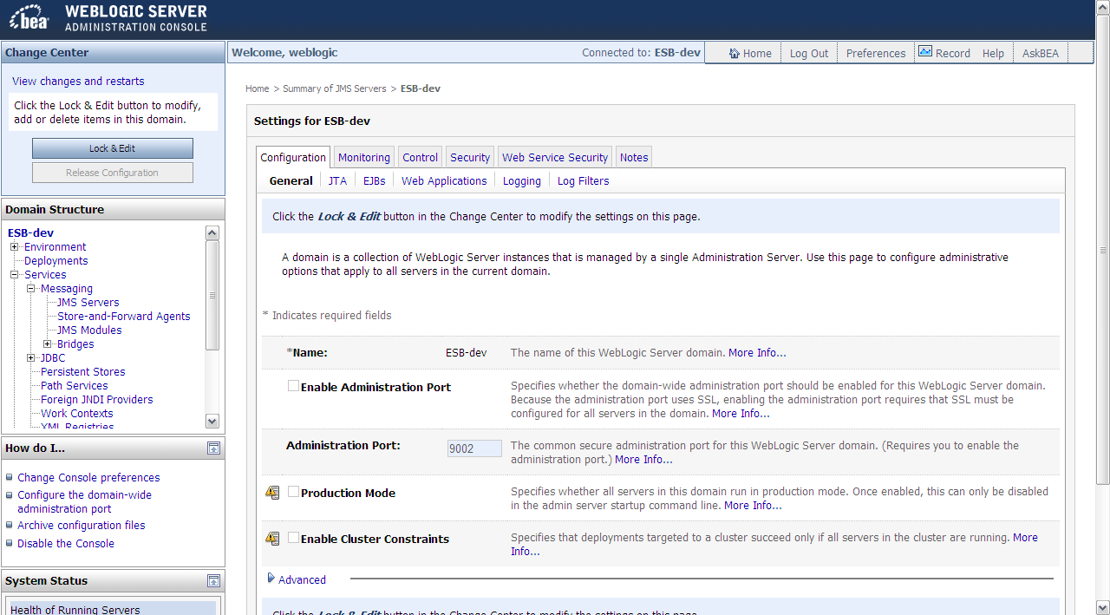

1. Services -> Messaging -> JMS Servers  
   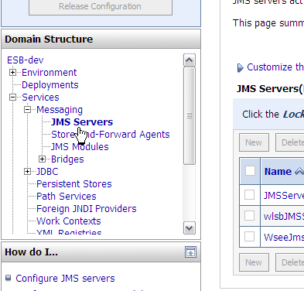
2. Click on “Lock & Edit”.

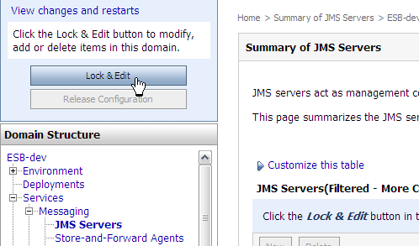

It would turn green and changed to “Activate Changes”.

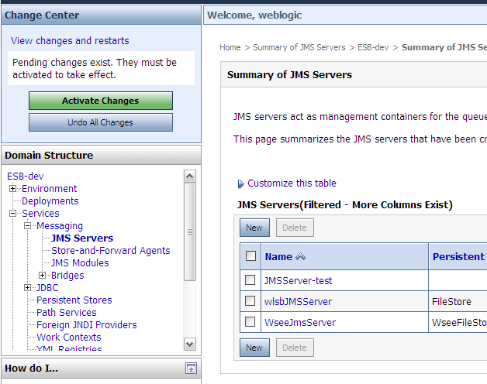

1. Click on “New” button to create new JMS Server.

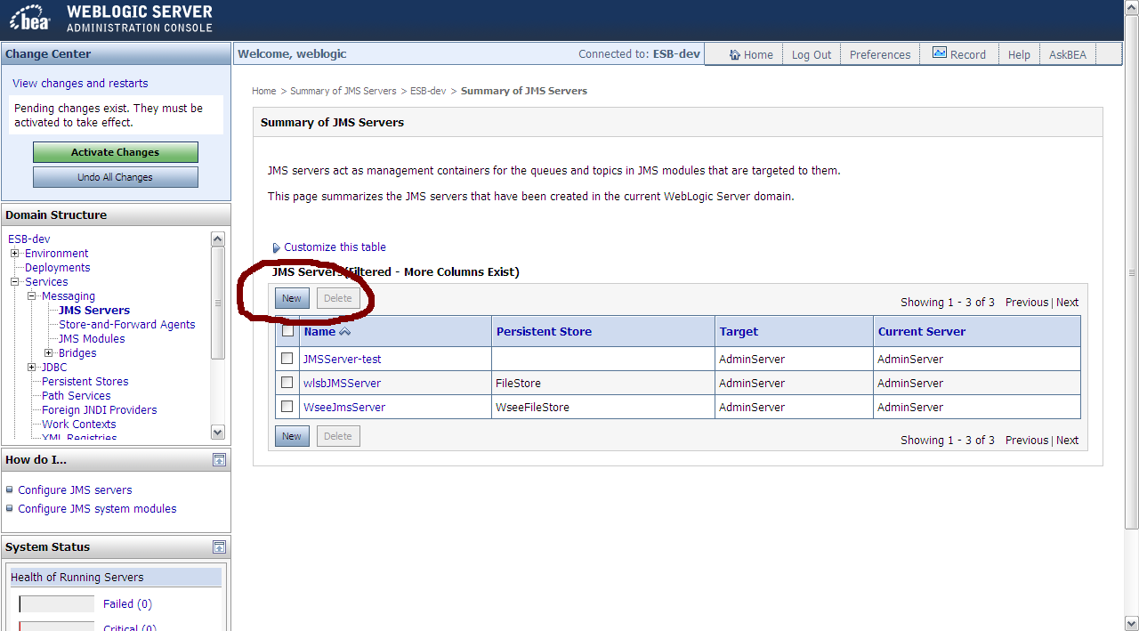

1. Fill in “Name” for the new JMS Server. Persistent Store can be set to (null) to use the server’s default option.

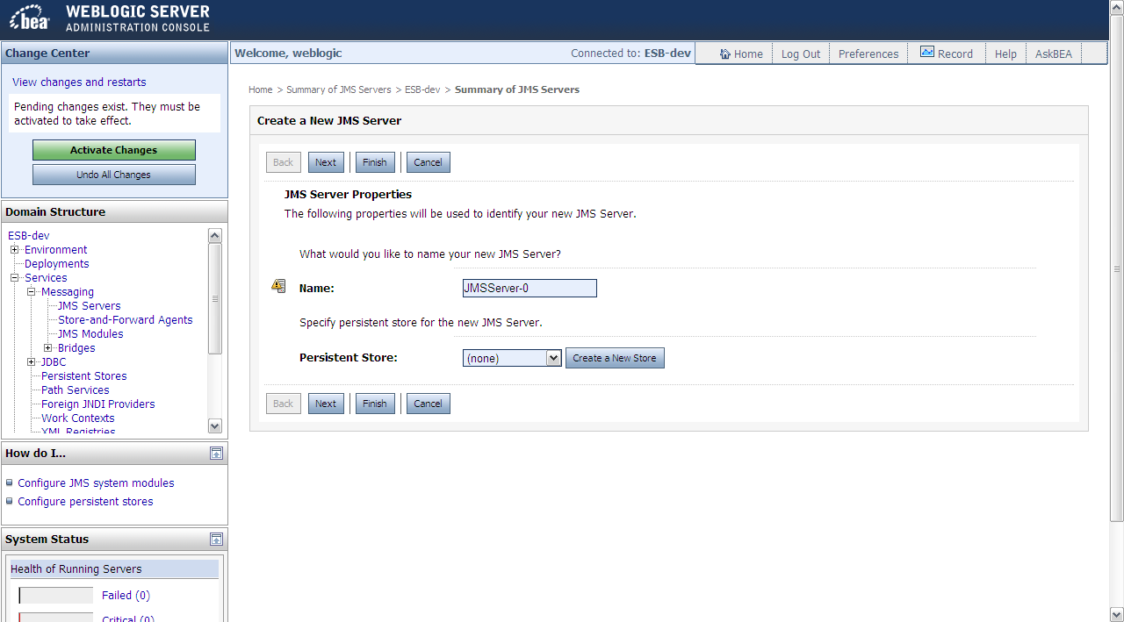

1. Click on “Next” button. Select the “Target” server instance to deploy the JMS Server.

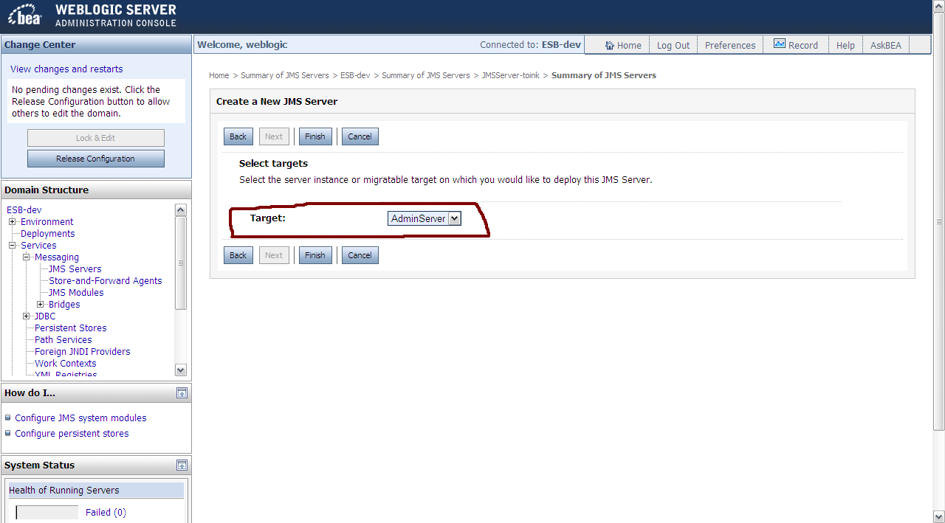

1. Click on “Finish”. A new JMS Server is created.

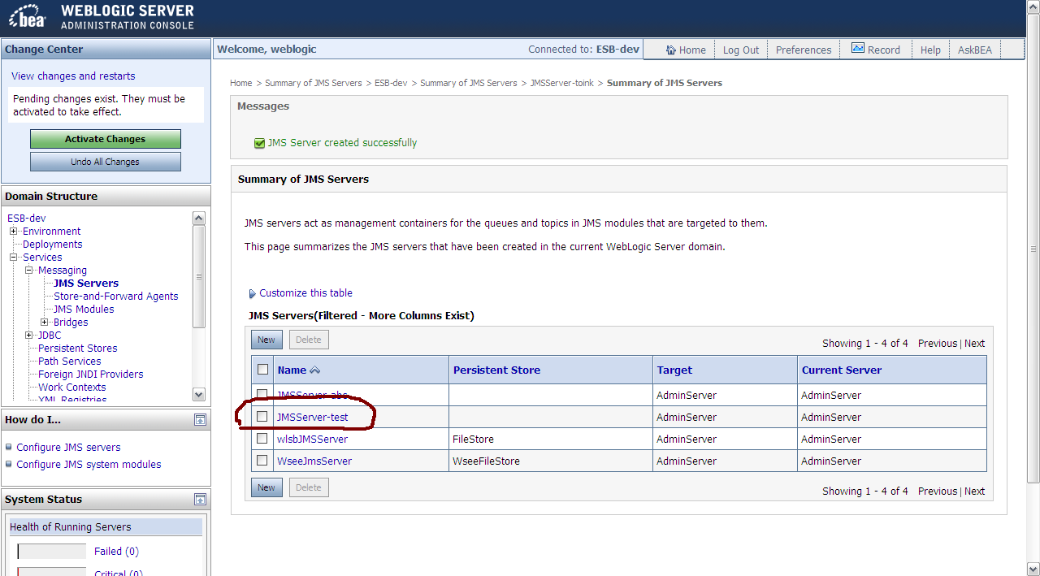

1. Click on “Activate Changes” button to apply the changes made.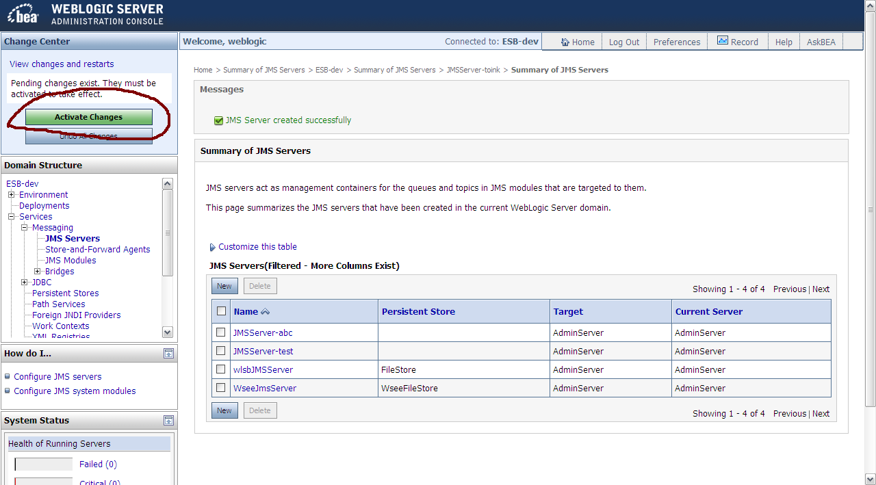
2. A message will be shown to indicate the changes have been made successfully. No restart is required. The JMS Server is created.

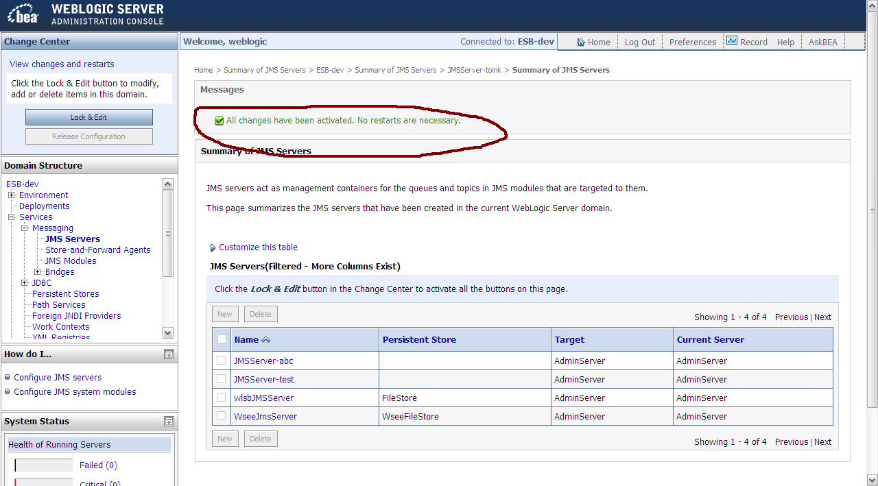

## Create JMS Module

Queues, topics, connection factories, etc. are grouped into JMS Module(s) in WebLogic server.

1. Click on “Lock & Edit”.



It would turn green and changed to “Activate Changes”.



1. Services -> Messaging -> JMS Modules

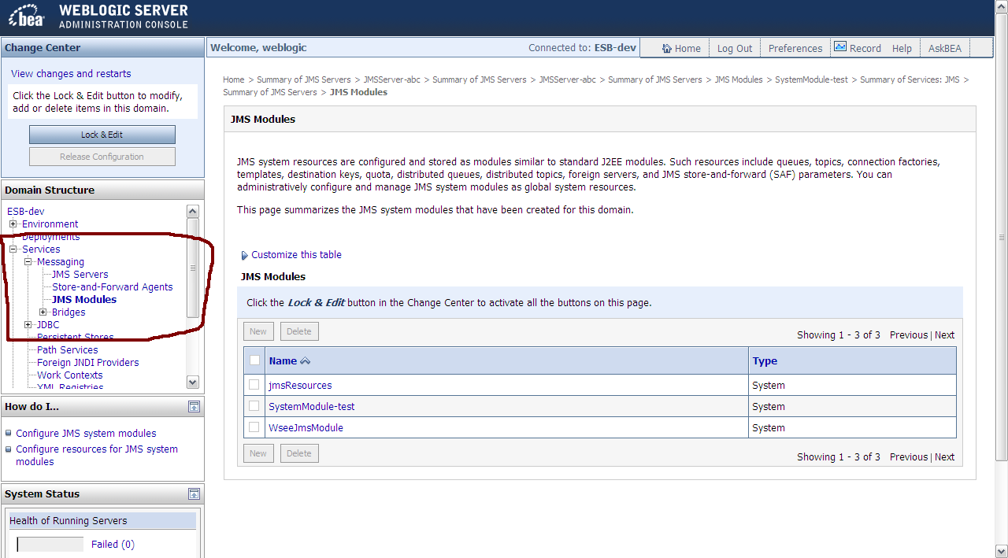

1. Click “New” button to create new JMS Module.

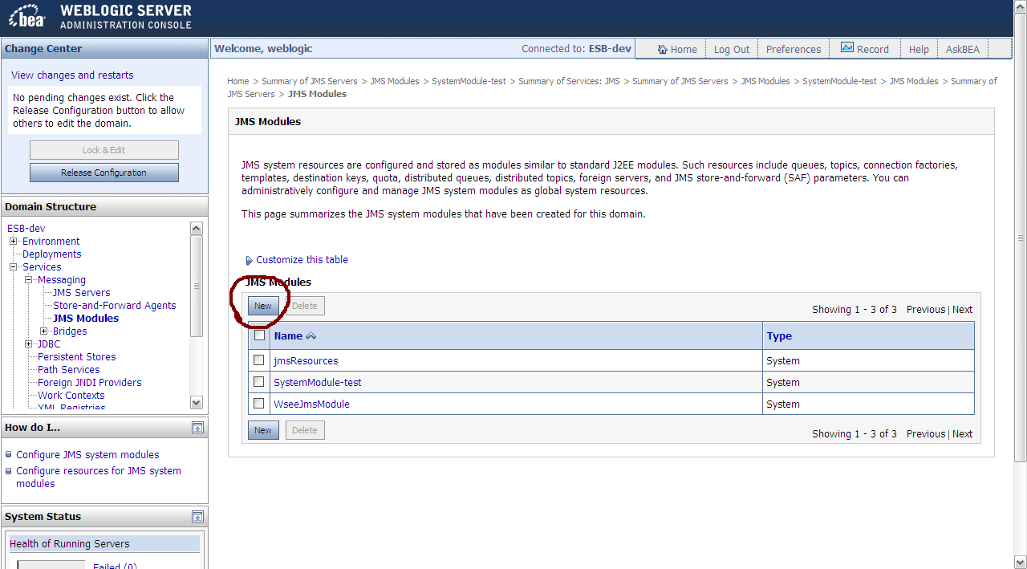

1. Enter “Name” for the new JMS Module. 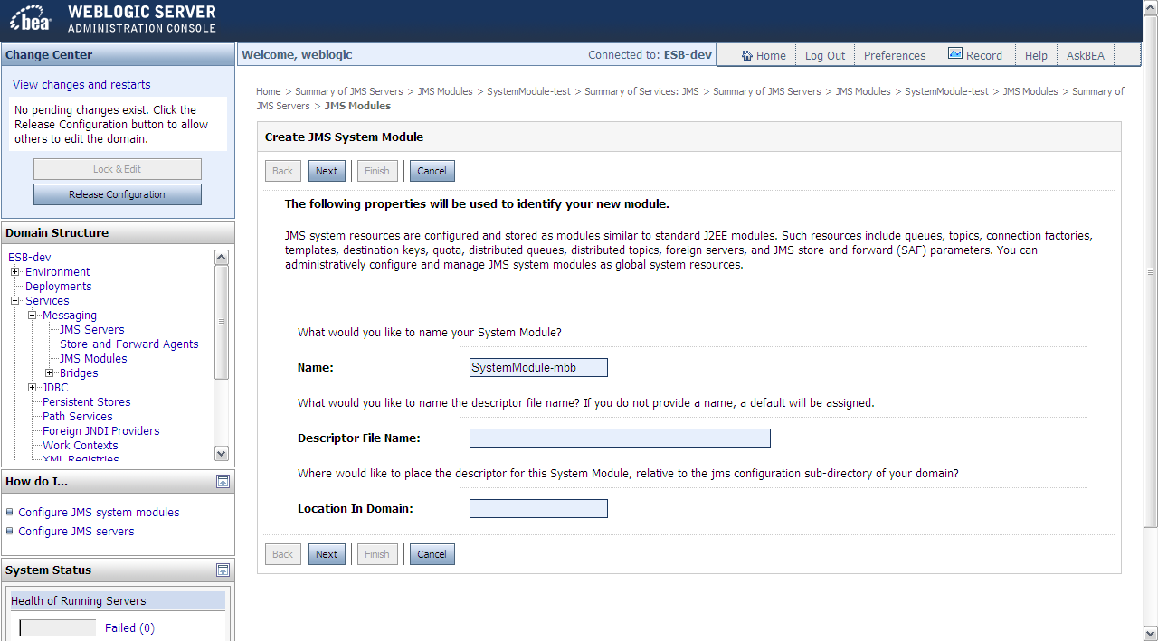
2. Click “Next” button. Tick on the checkbox to select the server instance for the JMS Module.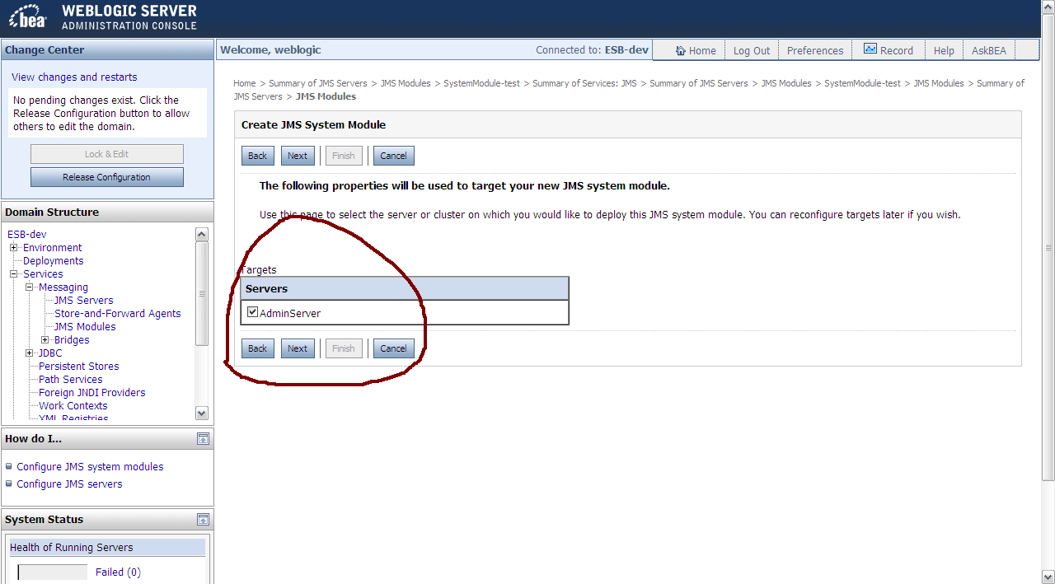
3. Click on “Next” button. Tick on the checkbox to create JMS Resources for the JMS Module.

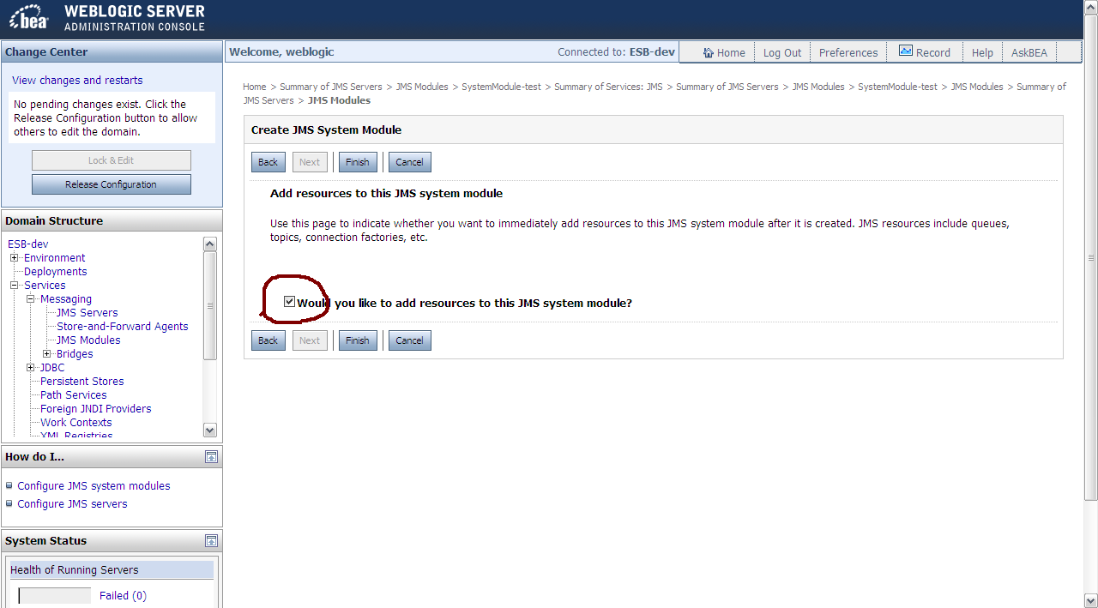

1. Click on “Finish” button.

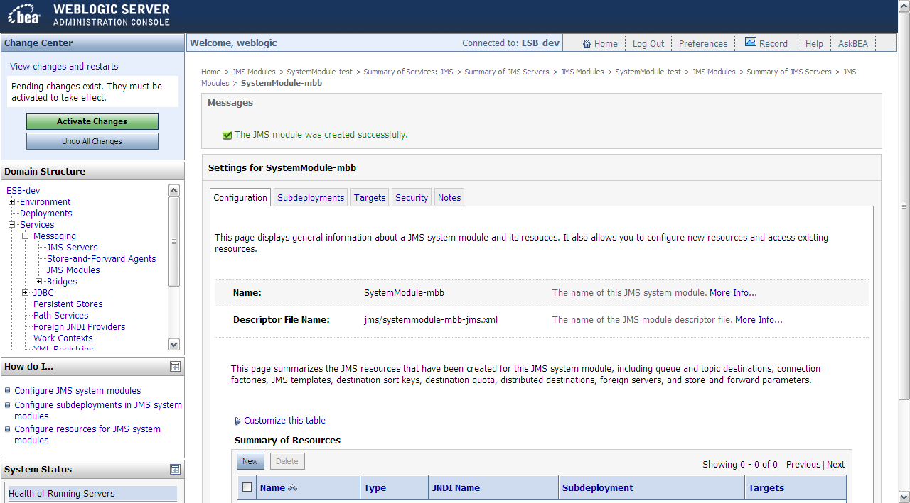

## Create JMS Resource(s)

### Create Connection Factory

1. Click on “Lock & Edit”.



It would turn green and changed to “Activate Changes”.



1. Services -> Messaging -> JMS Modules. Click on the JMS Module that you want to add JMS Resource (Queue, Connection Factory, etc.) into.

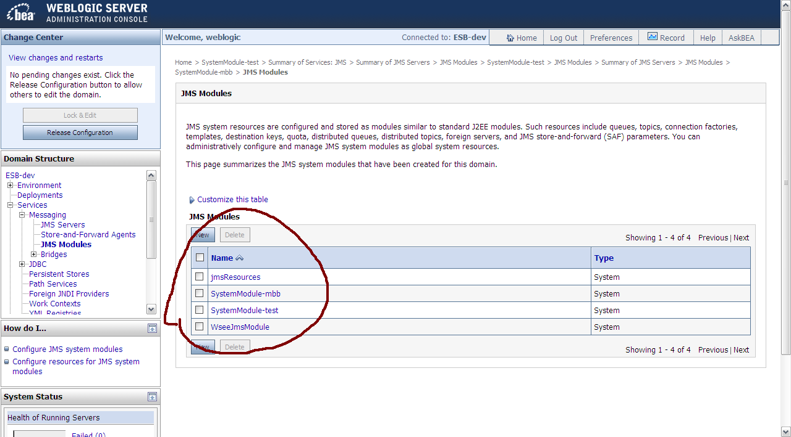

1. Make sure you are in the detail page for the **desired JMS Module**. Click on “New” button.

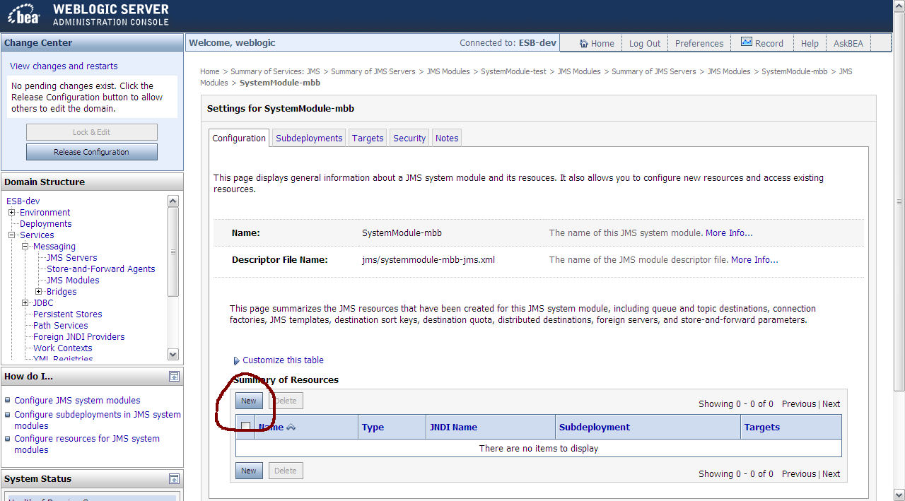

1. Click on the radio button for “Connection Factory” to create a new Connection Factory.

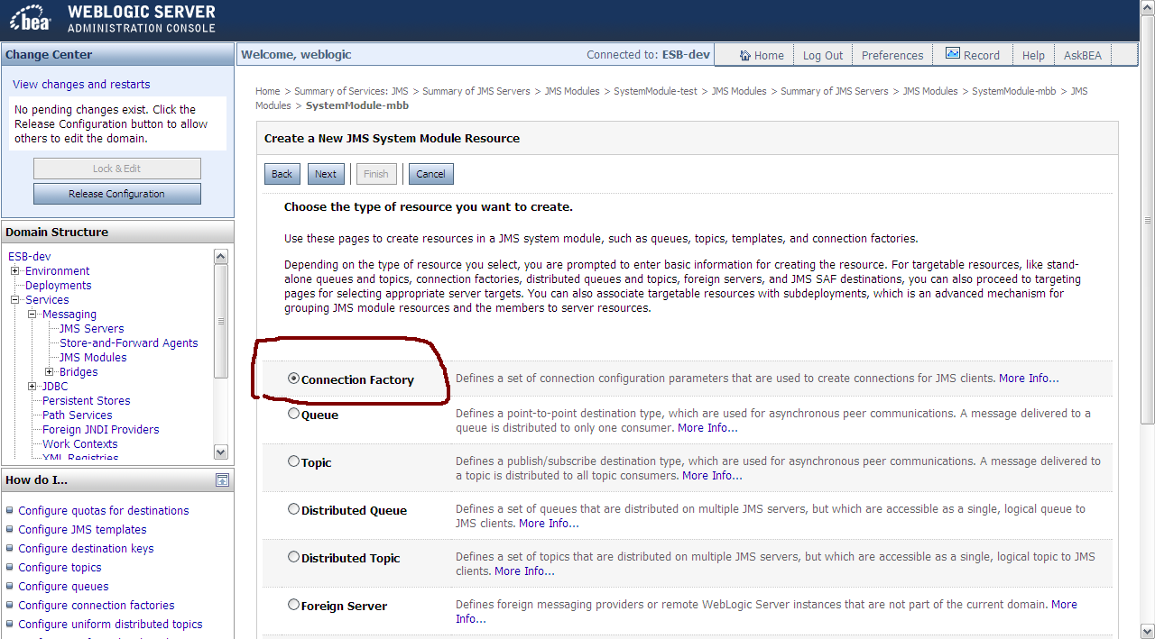

1. Click on “Next” button. Enter “Name” for the Connection Factory. Enter “JNDI Name” for the Connection Factory. Java code would use the JNDI Name to connect to this connection factory. JNDI naming convention for JMS resource is that it must starts with jms/<resource name>.

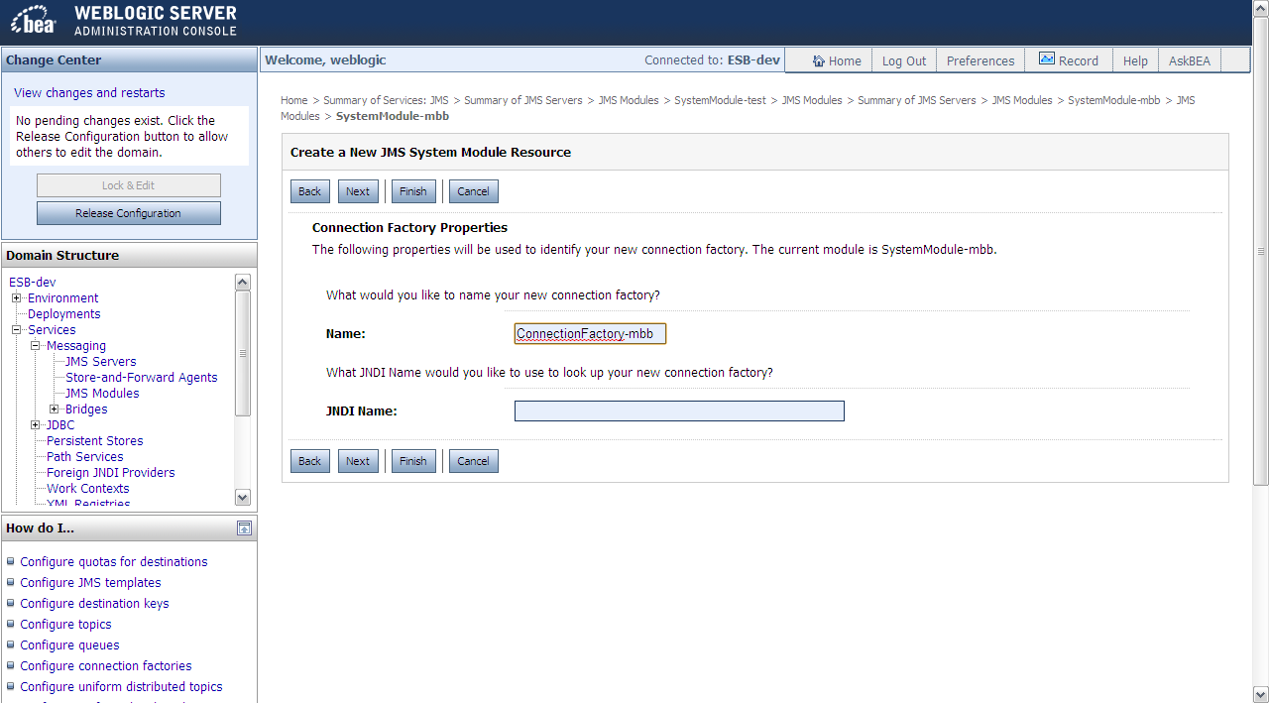

1. Click on “Finish” button. Remember to click on “Activate Changes” to apply the changes.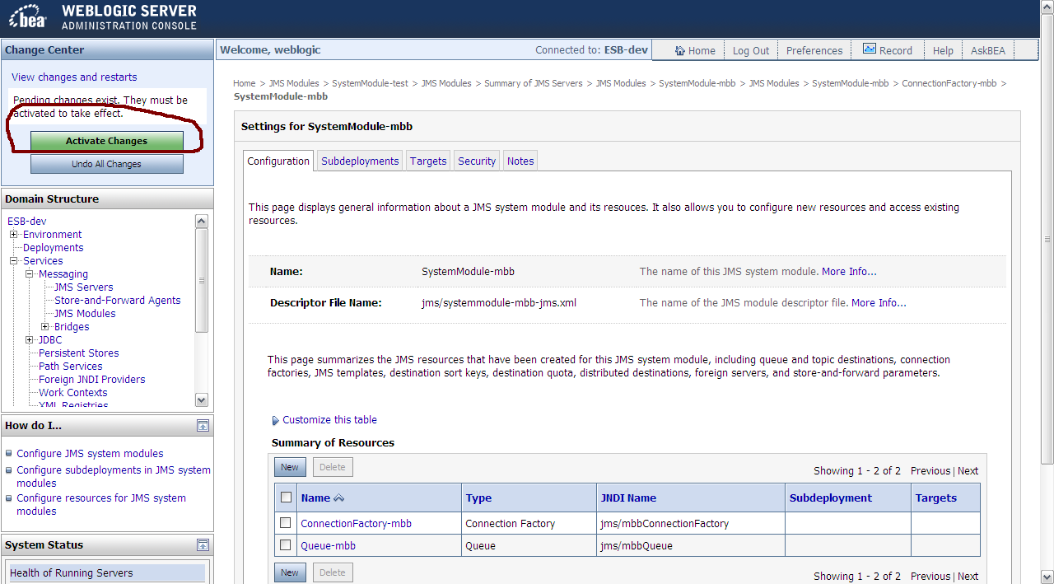

### Create Queue

1. Click on “Lock & Edit”.



It would turn green and changed to “Activate Changes”.



1. Services -> Messaging -> JMS Modules. Click on the JMS Module that you want to add JMS Resource (Queue, Connection Factory, etc.) into.



1. Make sure you are in the detail page for the **desired JMS Module**. Click on “New” button.



1. Click on the radio button for “Queue” to create a new Queue.

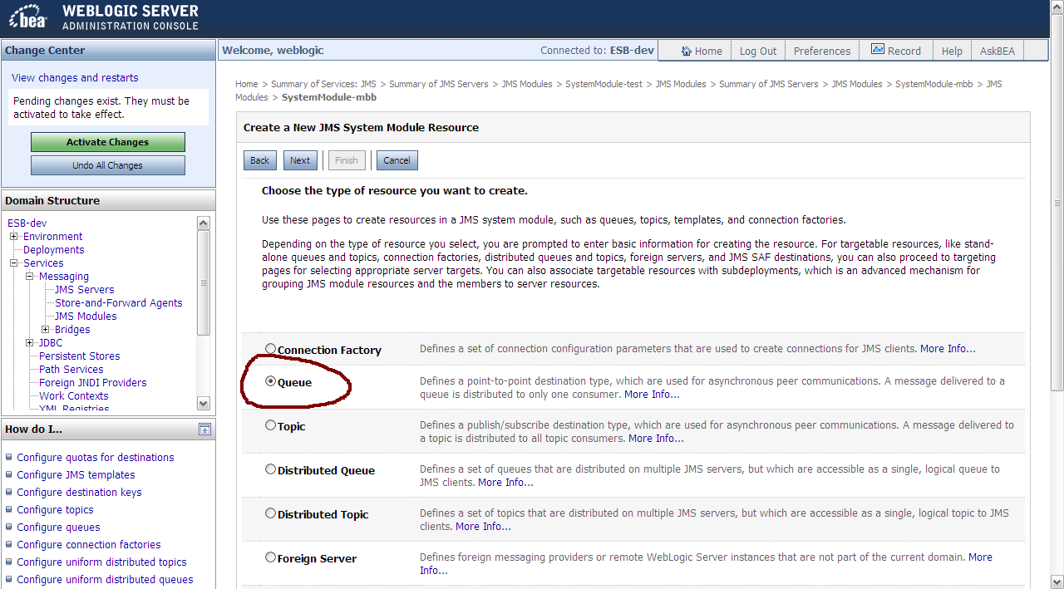

1. Click on “Next” button. Enter “Name” and “JNDI Name” for the Queue. Java code would use the “JNDI Name” to connect to this Queue. JNDI Naming convention for JMS resource is that it must start with jms/<resource name>.

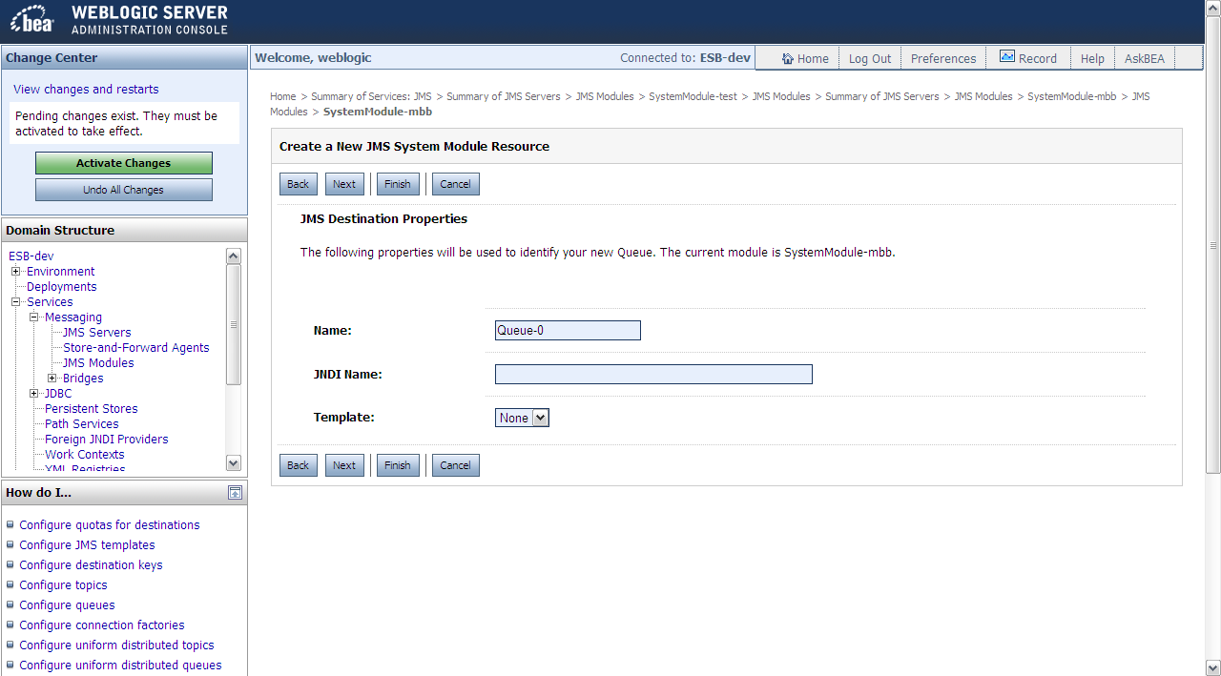

1. Click on “Finish” button. Remember to click on “Activate Changes” to apply the changes.

## Configure JMS Module

### Create new Subdeployment

1. Click on “Lock & Edit”.



It would turn green and changed to “Activate Changes”.



1. Services -> Messaging -> JMS Modules. Click on the desired JMS Module.



1. In the JMS Module detail page, click on the “Subdeployments” tab.

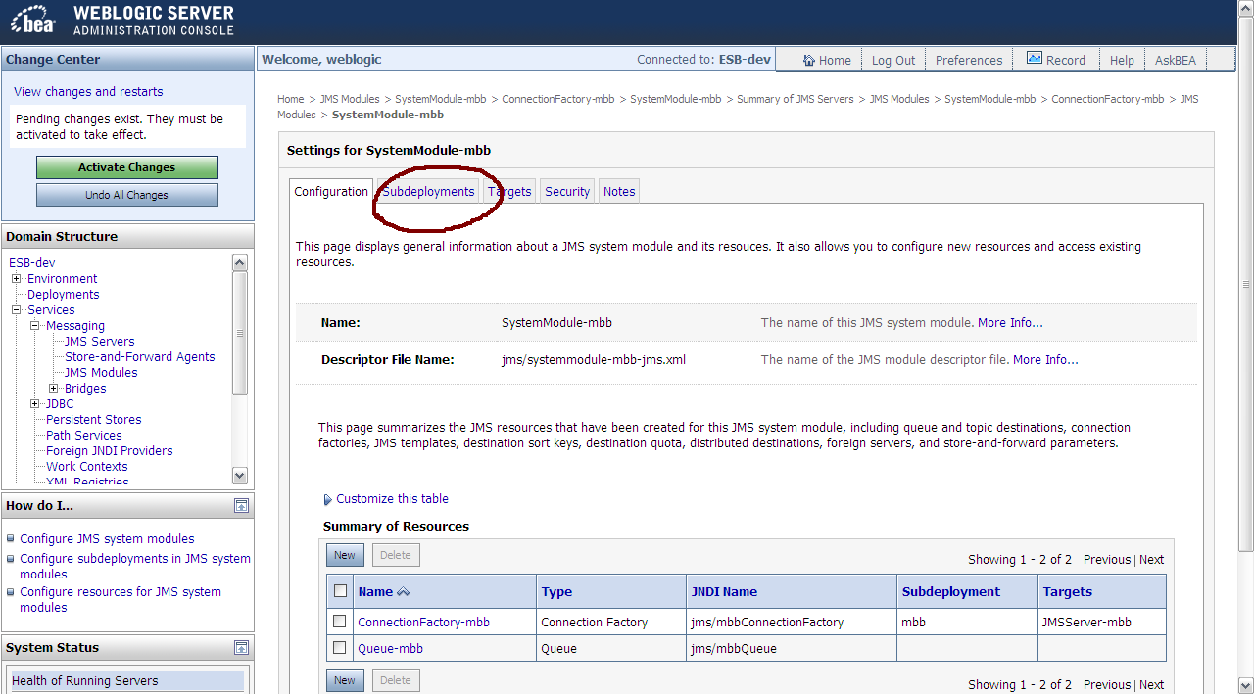

1. Click on “New” button to configure new Subdeployment.

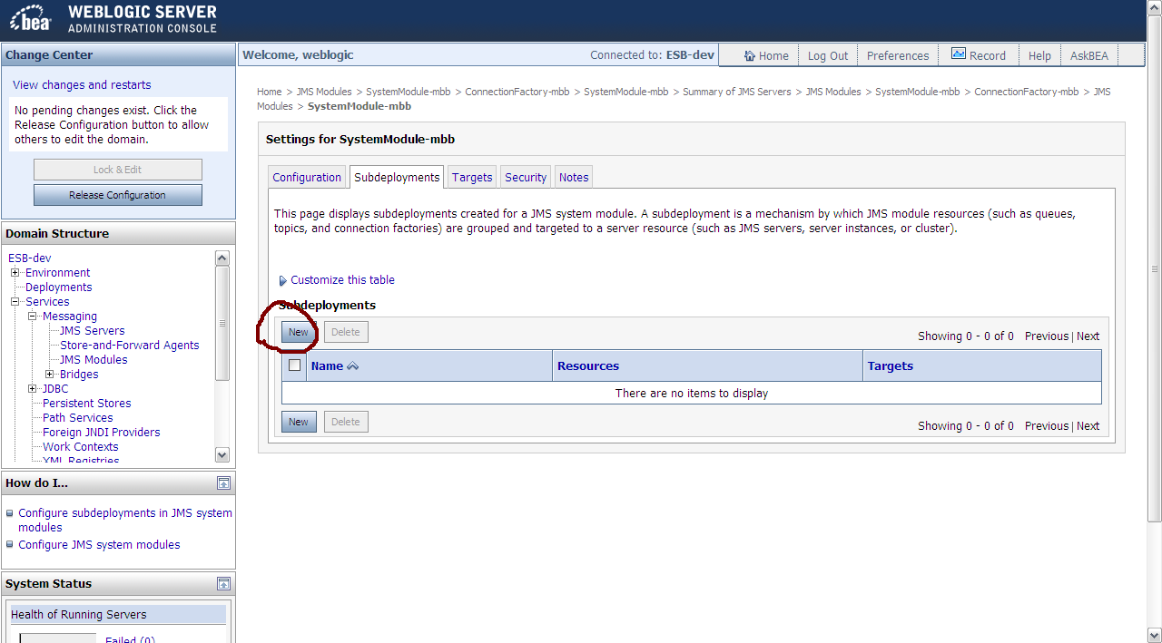

1. Enter a name for the subdeployment and click “Next”.

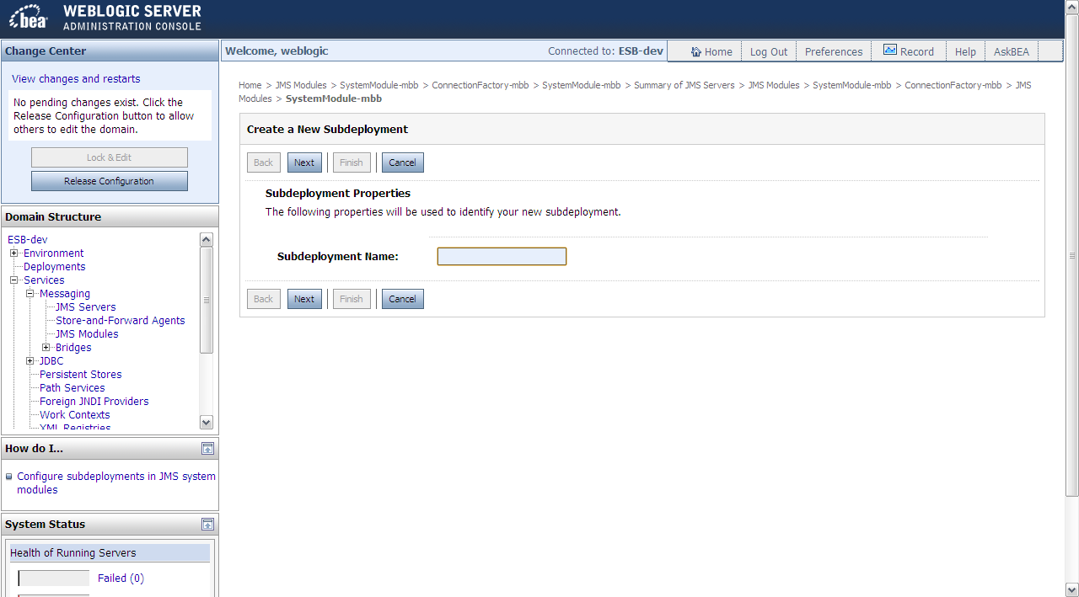

1. Tick on the checkbox for the **JMS Server** that you created just now.

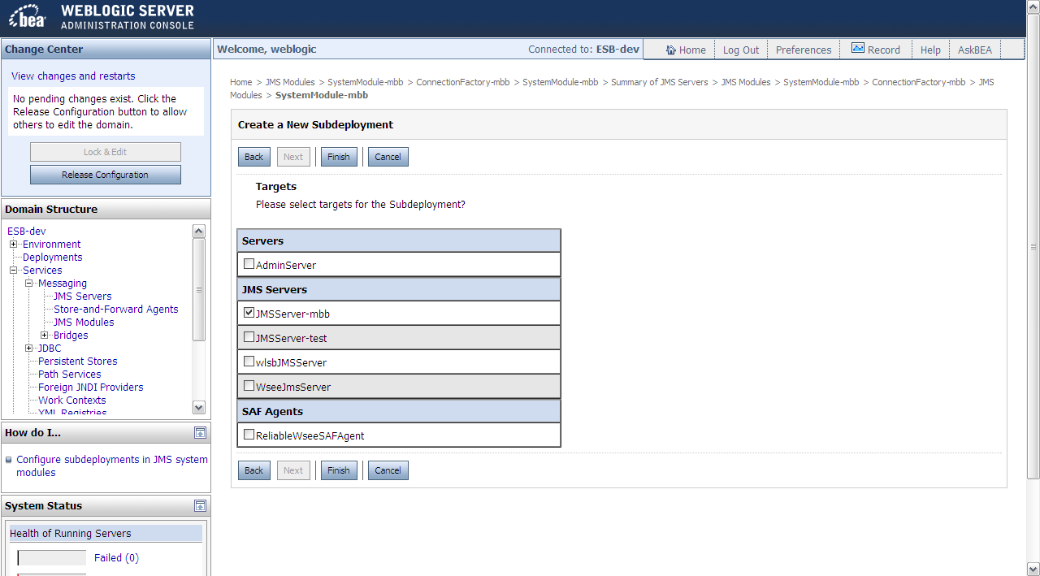

1. Click on “Finish” button.

### Configure Subdeployment target for JMS resource(s)

1. Click on “Lock & Edit”.



It would turn green and changed to “Activate Changes”.



1. Services -> Messaging -> JMS Modules. Click on the JMS Module that you want to add JMS Resource (Queue, Connection Factory, etc.) into.



1. Select the module to assign the subdeployment target that you created just now. Note that you need to assign the subdeployment target for each of the resources (in this case, queue and connection factory).

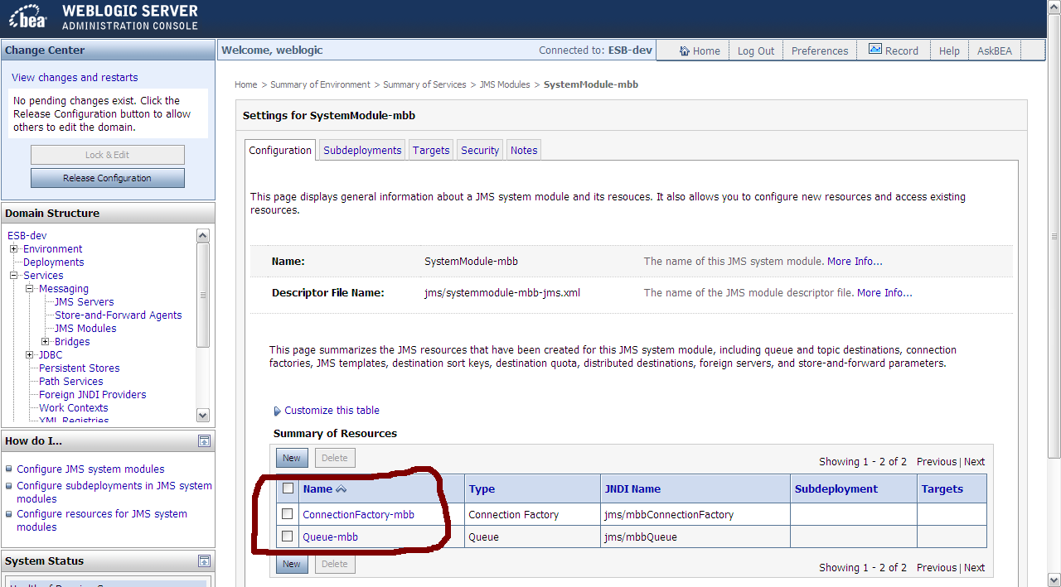

1. In the details of the JMS module, click on the Subdeployment tab.

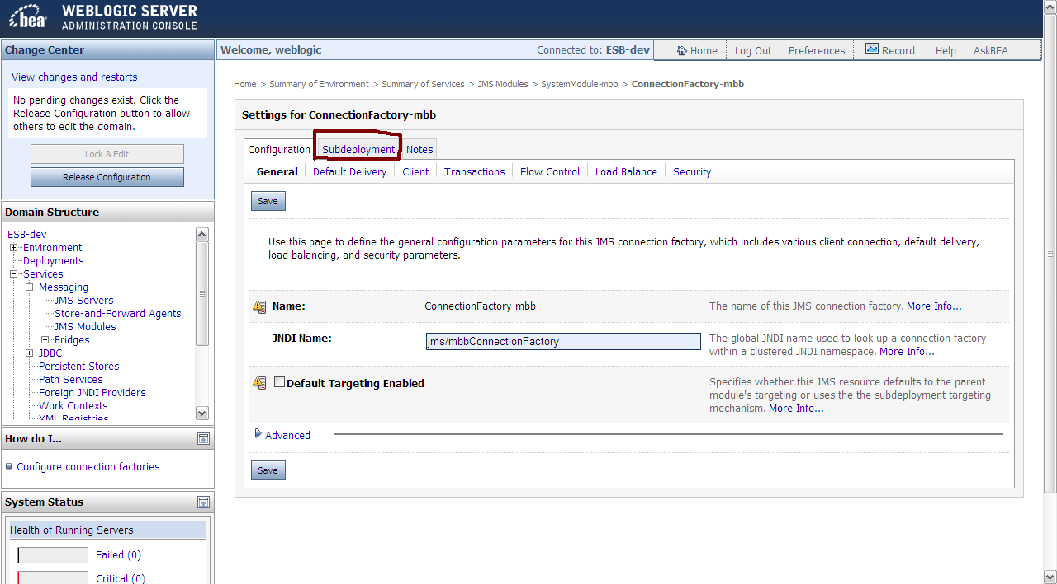

1. Choose the subdeployment target that you created just now.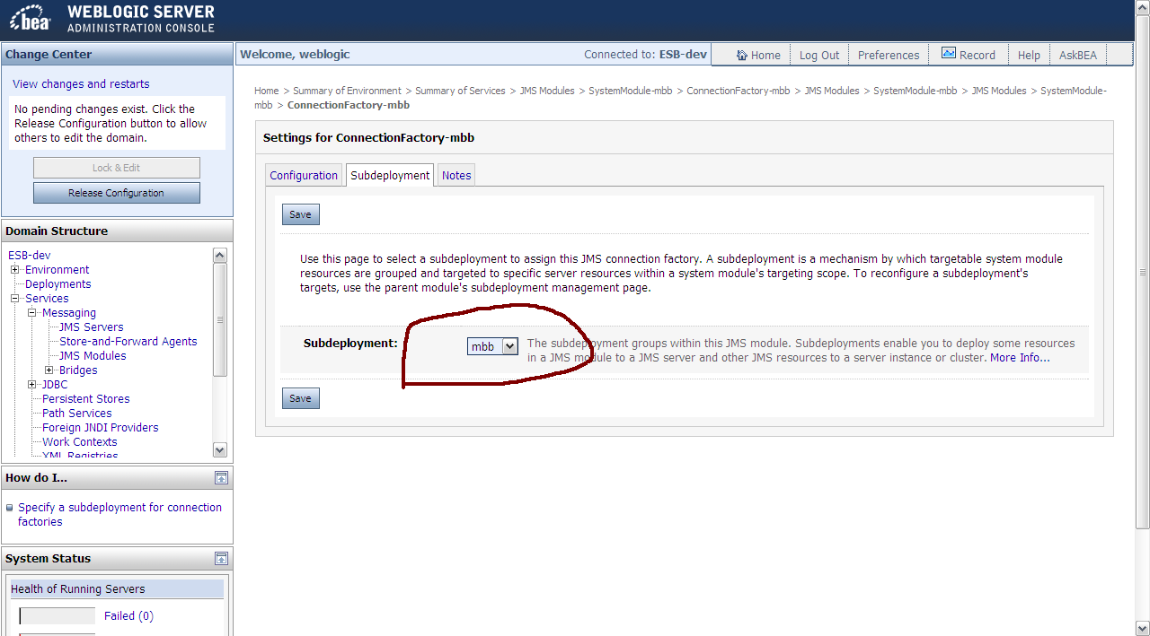
2. Click on “Save” button. After that click on “Activate Changes”.



1. Double check that the “Subdeployments” and “Targets” column for the selected module have already been changed. Do the same thing for each of the appropriate modules.

