CR Resolution (EB130070 - Super Group)

### Host

1. 1 new host message – to get account list based on Primary CIF Number
2. New / Update CIF Inquiry (1607) – To return Primary CIF Number
3. Bulk Payment Inquiry Update (2660, 2661 & 2662) - To include primary company code

### Database Update

1. Add 1 column to table, BIB_COMPANY, for PRIMARY_CIF. Leave empty if is Primary Company

| **Name** | **Type** | **Required?** | **Default** | **Description** |
| --- | --- | --- | --- | --- |
| PRIMARY_CIF | nvarchar | No |  | Primary CIF for company |

### IBAM

1. Change in the Register Company screen, where Parent Company Information will be display when creating Child Company.
   1. Parent Company must be created first before Child Company is created. IBAM will prompt error if Parent CIF not found in record.
2. All Child Company Profile must be created individually. If not created, Bulk Payment for Child Company cannot be performed.

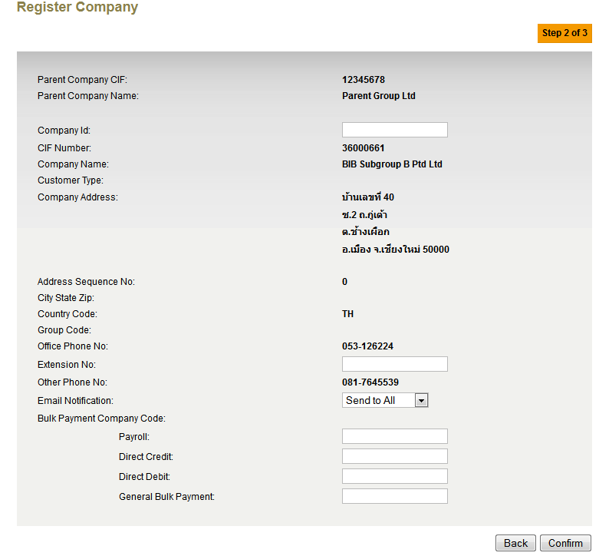

Figure : Register Child Company Details

1. For Account Management, Parent Company has access to all accounts within the group. In the listing table, add new column for Account Name. Child Company only have access to own accounts

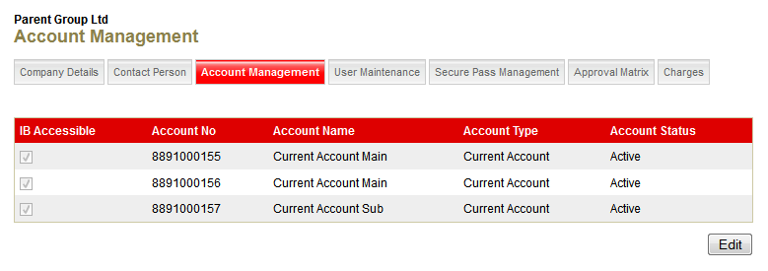

Figure : Account Management - Parent Company

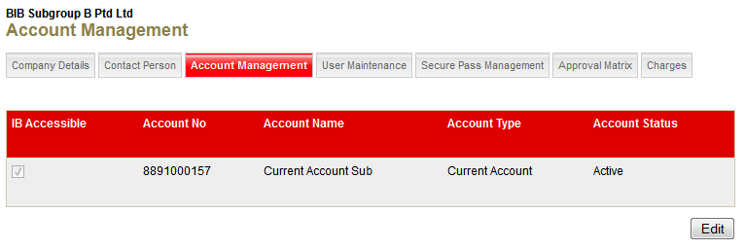

Figure : Account Management - Child Company

## BIB

#### User Management

1. For User Maintenance screen, add new column for Account Name. Accounts accessibility will be based on the company setup in IBAM. Each company within the same group will be maintained separately within own Corporate Administrator each.

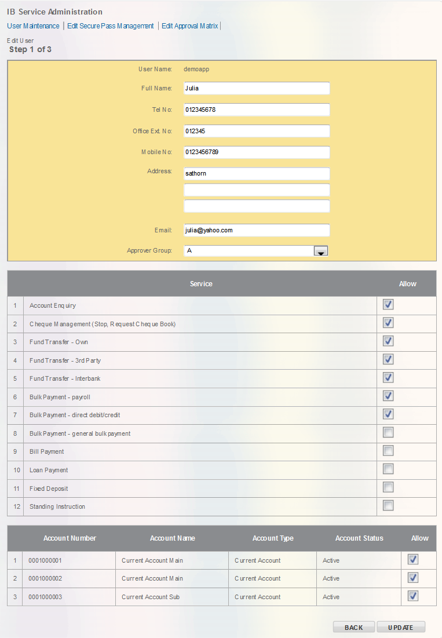

#### Bulk Payment

The below applies for all Bulk Payment Modules – Direct Debit, Direct Credit, Payroll & General Bulk Payment

1. In File Upload, add additional field for Initiator to select Company (if have child company) for this bulk payment transaction.

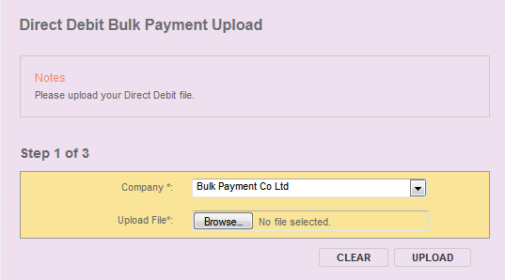

Figure Bulk Payment Upload with Child Company

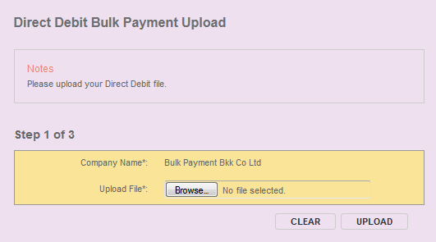

Figure Bulk Payment Upload without Child Company

1. Based on the selected Company, BIB will send the corresponding Company Code to Host.

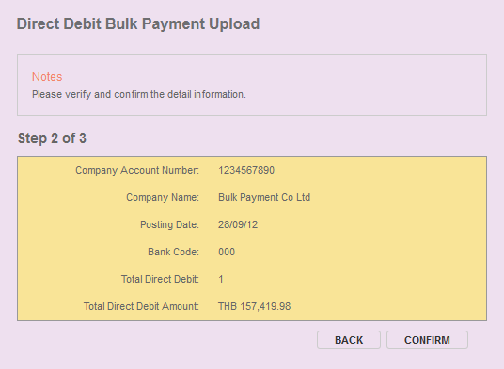

Figure : Bulk Payment Confirm Screen

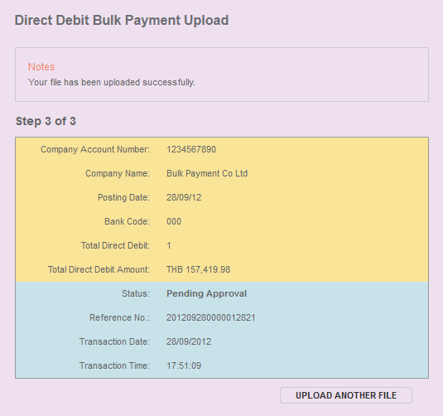

Figure : Bulk Payment Result Screen

1. For Enquiry Screen, Initiator needs to select the Company to view Bulk Payment Transaction History

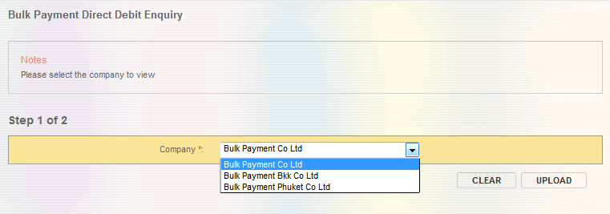

Figure : Enquiry with Company Selection

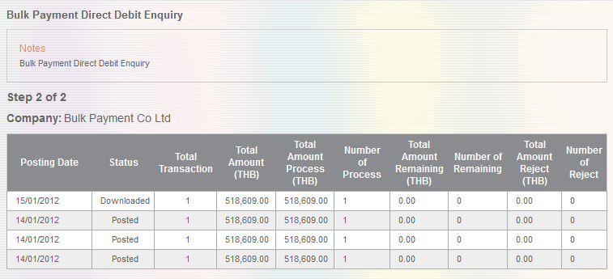

Figure : Enquiry Result Screen

## Assumptions:

1. In terms of user management, each company is independent from each other. Each company will have own Corporate Administrator to manage other user(s) within own company
2. Child Company / Subsidiary are not allowed to access accounts belonging to other child company /subsidiary or Parent Company. Only Parent Company has access to all accounts within the entire group.

|  |  |
| --- | --- |
| Effort(man-days) | 15 |
| Affected Area | IBAM  BIB  User Manual – IBAM  User Manual – BIB |