CR#EB120051_1 – To separate Interbank list from ORFT bank list

**Database**

Add 2 columns to table, IB_INTERBANK_LIST for the Interbank/ORFT & Bahtnet indicator.

| **Name** | **Type** | **Required?** | **Default** | **Description** |
| --- | --- | --- | --- | --- |
| **ORFT_ON** | **int** | **No** | **1** | **Indicator to display in ORFT list** |
| **BAHTNET_ON** | **int** | **No** | **1** | **Indicator to display in BAHTNET list** |

**IBAM**

Update Interbank List forms (Create and Update) and display (View Details) to include two (2) new fields for Interbank /ORFT List & Bahtnet List

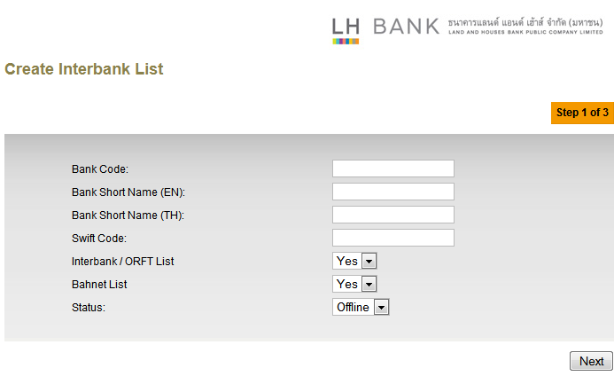

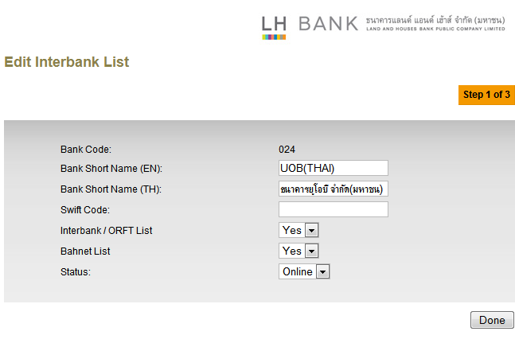

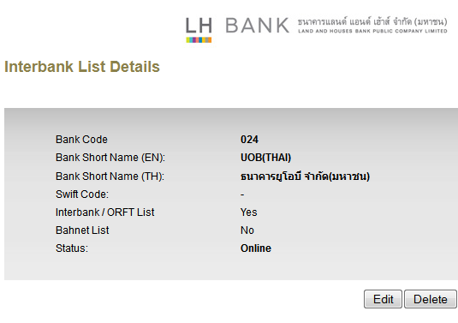

## RIB

Add filter the bank listing in modules, Open Interbank Transfer and Add Favourite Interbank Account. The filter will only display bank with indicator, Interbank /ORFT List = Yes

## BIB

1. Add filter to the bank listing in Open Interbank Transfer and Add Favourite Interbank Account modules. The filter will only display bank with indicator, Interbank /ORFT List = Yes.
2. Add filter to the bank listing in Bahtnet module. The filter will only display bank with indicator, Bahtnet List = Yes.

|  |  |
| --- | --- |
| Effort(man-days) | 4 |
| Affected Area | IBAM  RIB  BIB  User Manual –IBAM |