CR Resolution (EB130092 – To Provide Fax Extension No at Company Information)

### Database Update

1. Add 1 column to table, BIB_COMPANY, for Fax Number Extension

| **Name** | **Type** | **Required?** | **Default** | **Description** |
| --- | --- | --- | --- | --- |
| OTHER_PHONE_EXT_NO | nvarchar(6) | No |  | Company’s Fax Extension number |

### IBAM

1. Add new field, Fax Extension No to form. Affected area:
   1. Register Company
   2. View Company Detail
   3. Edit Company Detail

|  |  |
| --- | --- |
| Effort(man-days) | 0.5 |
| Affected Area | IBAM  User Manual – IBAM |

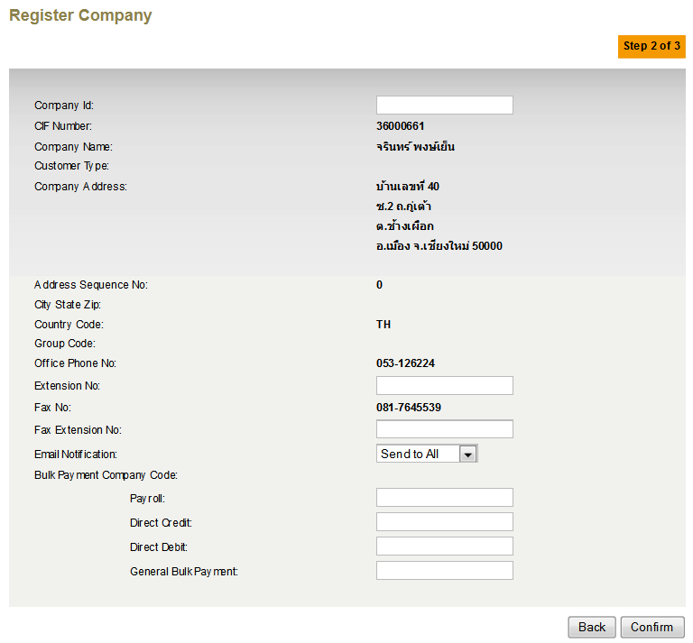

Figure 1: Register Company

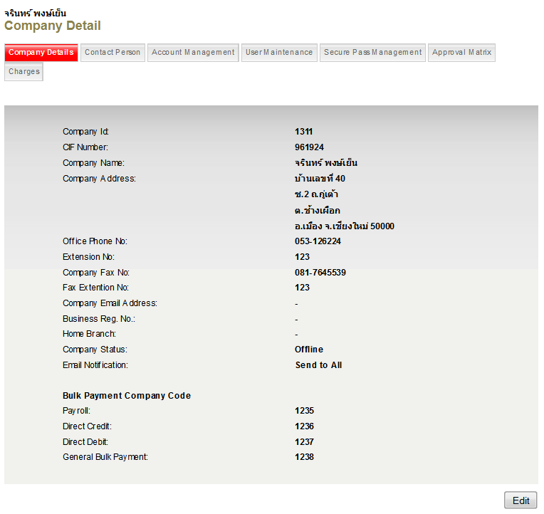

Figure 2: View Company Detail

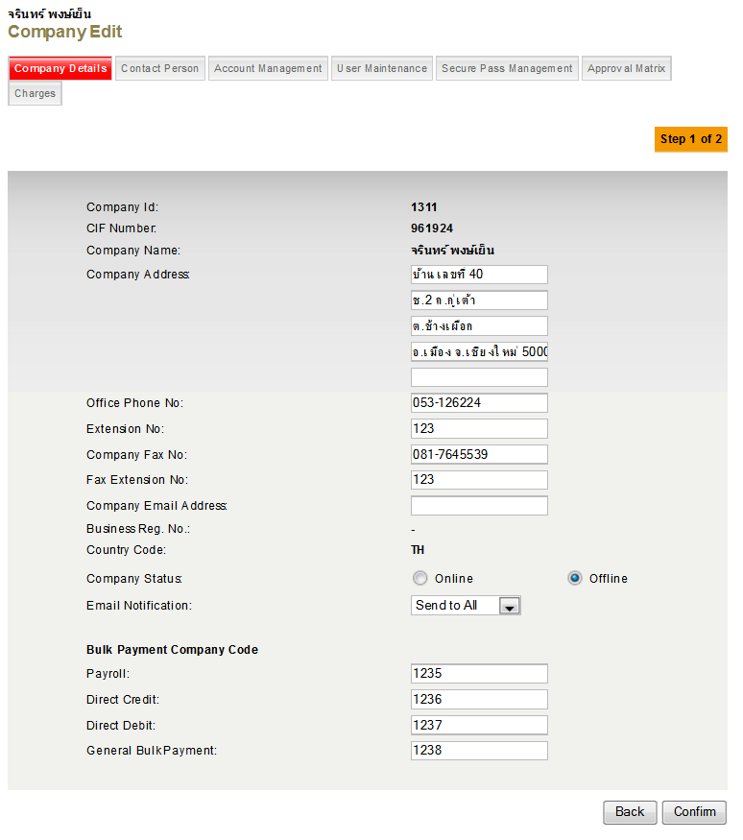

Figure 3: Edit Company Detail