EB130065 – To change the date selection method of Transaction History and Online Transaction History in RIB and BIB

### RIB & BIB

1. To convert existing Transaction History filter selection from Month Based to Date Based
2. From Date & To Date can be on the same day
3. From Date must be within the last 6 months from current date.
4. Affected Modules:
   1. Account Transaction History
   2. LH Bank Online Transaction History
5. Print & Download Function – To retrieve all transactions within selected duration for print or download[1]

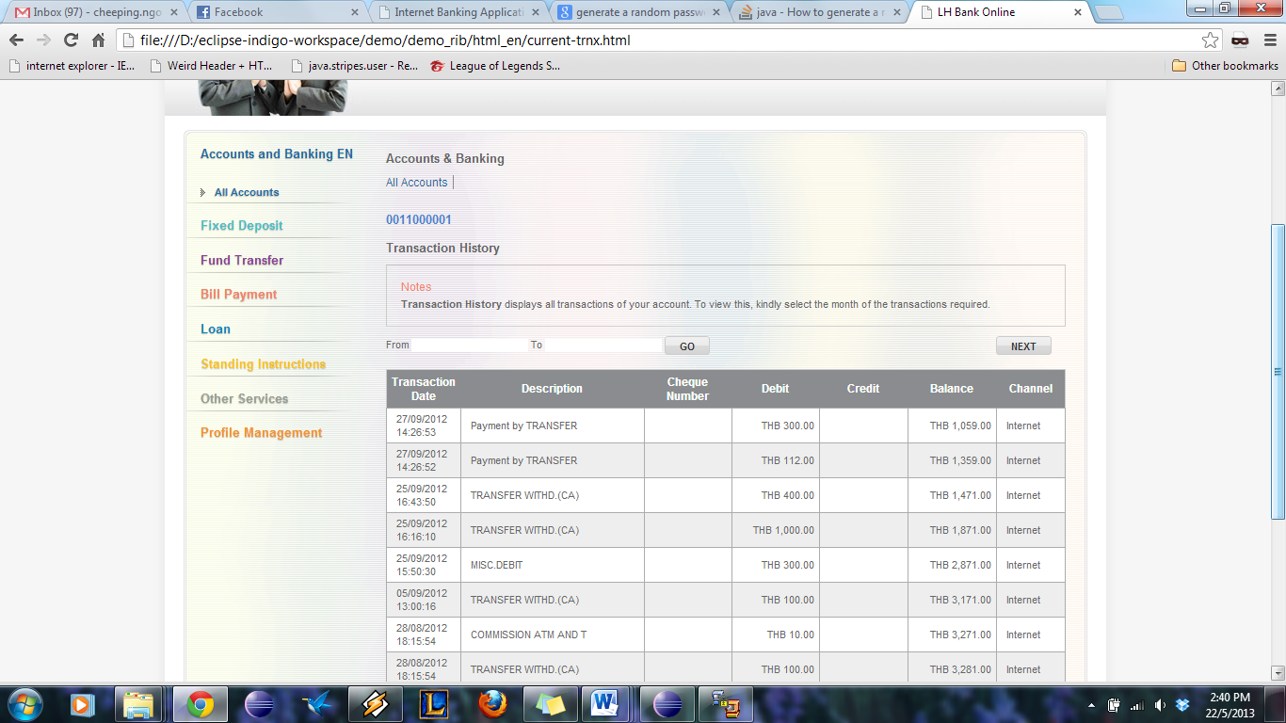

Display record from specific date, after check “GO” button.

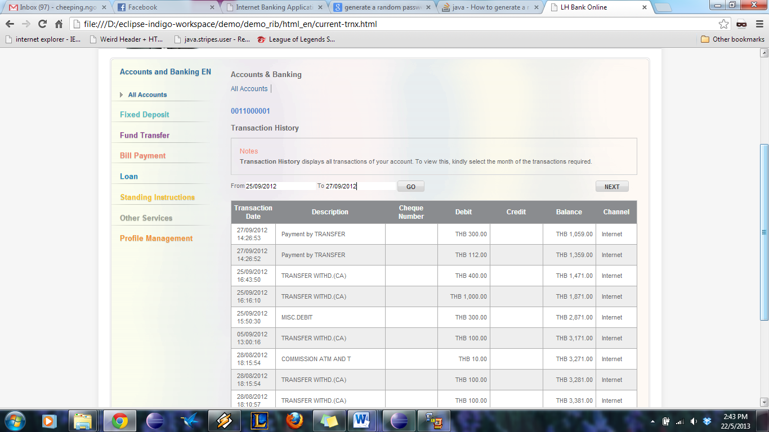

|  |  |
| --- | --- |
| Effort(man-days) | 9 |
| Affected Area | BIB  RIB  User Manual –BIB  User Manual –RIB |

1. Loading time for print or download function may take longer, depending on the total transactions records to be retrieved. On extreme cases, it may cause session time out.