EB130062 - Add new function for Tax Free account

### RIB

1. Create a new navigation module Tax Free, with 2 sub-modules

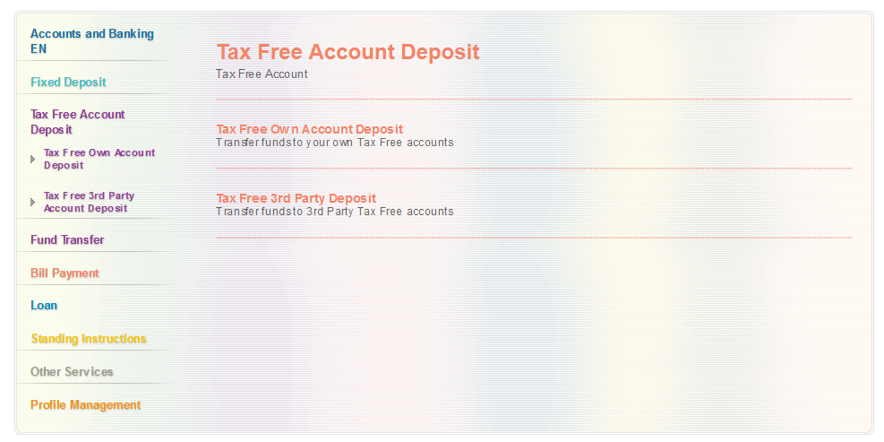

Figure 1 Tax Free Account Deposit Channel Page

* 1. **Tax Free Own Account Deposit** – to allow funds transfer from Savings/Current account to own Tax Free account (same CIF)

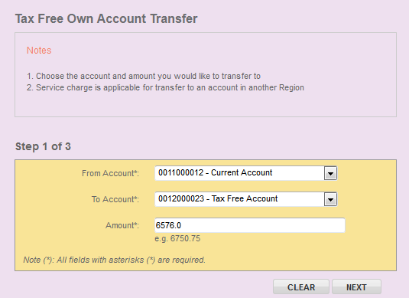

Figure 3 Own Tax Free Account Deposit – Details Page

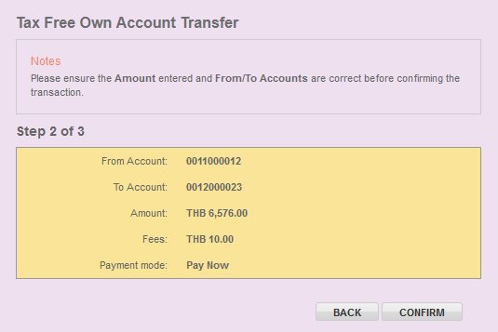

Figure 4 Own Tax Free Account Deposit – Confirm Page

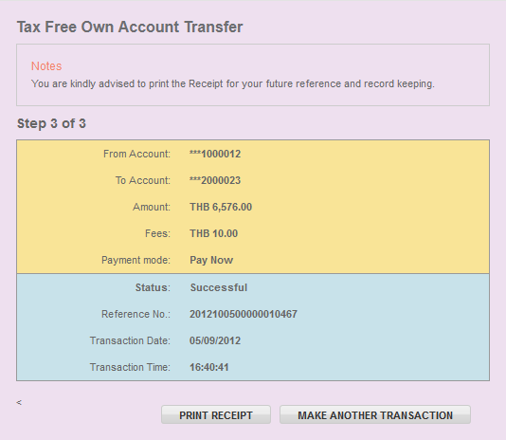

Figure 5 Own Tax Free Account Deposit – Result Page

* 1. **Tax Free Third Party Account Deposit** – to allow funds transfer from Savings/Current account to a Third Party Tax Free account (different CIF)

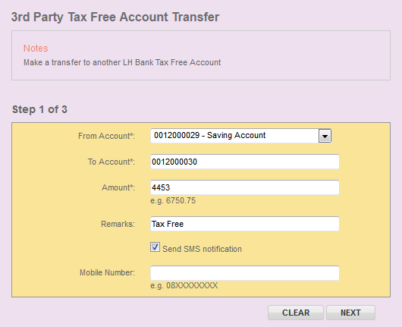

Figure 6 3rd Party Tax Free Account Deposit – Details Page

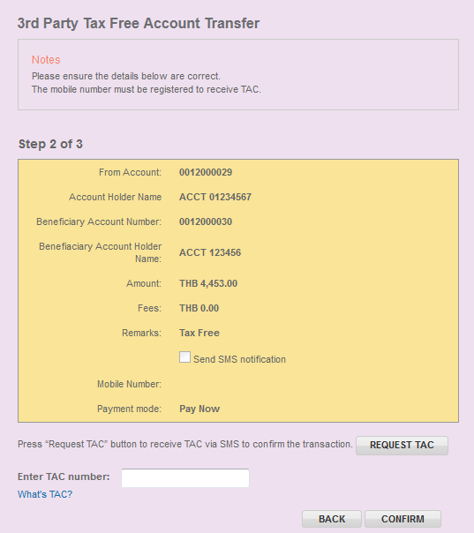

Figure 7 3rd Party Tax Free Account Deposit – Confirm Page

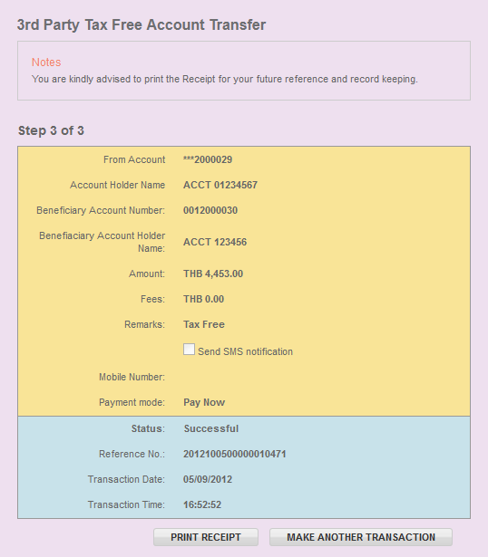

Figure 8 3rd Party Tax Free Account Deposit – Result Page

### IBAM

1. Add “Own Tax Free Account Deposit” and “3rd party Tax Free Account Deposit” transaction type in RIB Transaction Enquiry.

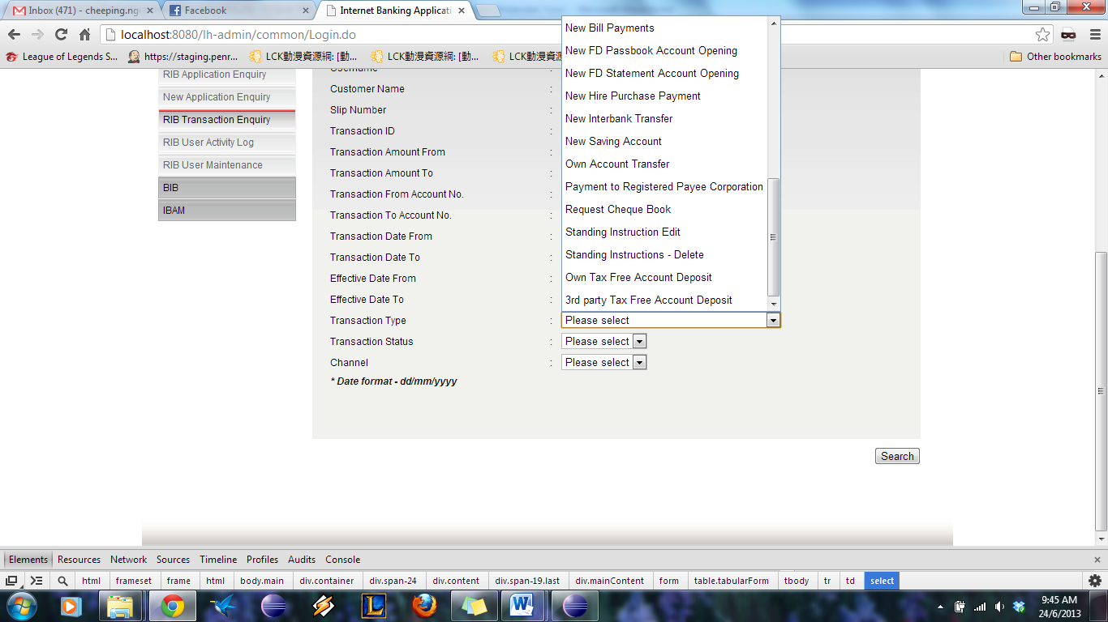

Figure 9 RIB Transaction Enquiry

1. Display Tax Free Account Deposit Enquiry Result

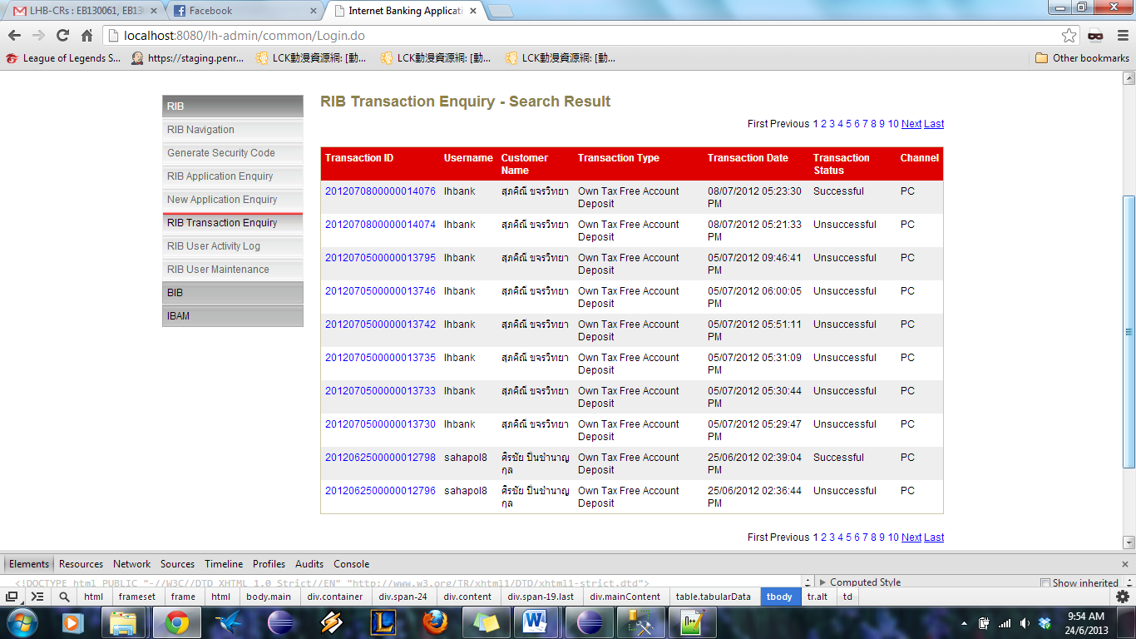

Figure 10 RIB Transaction Enquiry – Own Tax Free Account Deposit

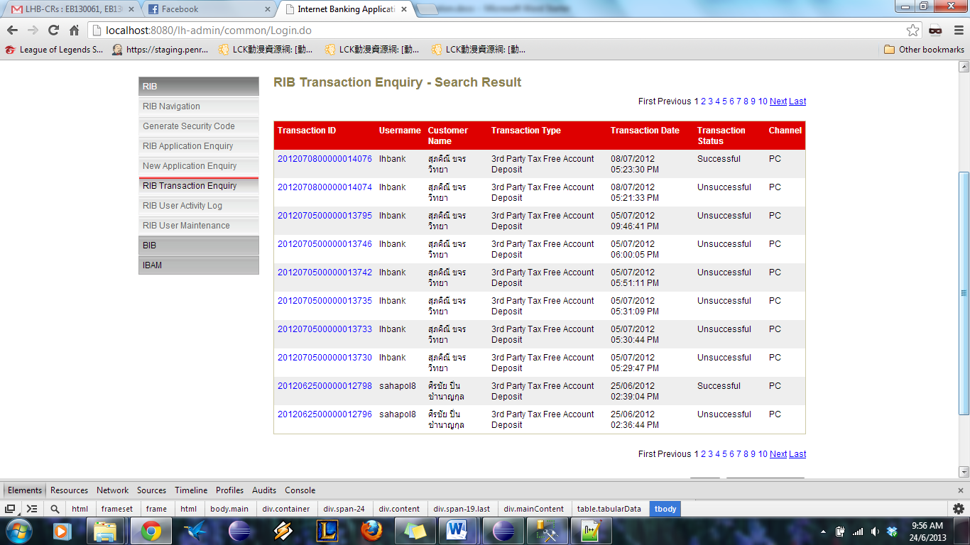

Figure 11 RIB Transaction Enquiry – 3rd Party Tax Free Account Deposit

1. Create Transaction Details Page

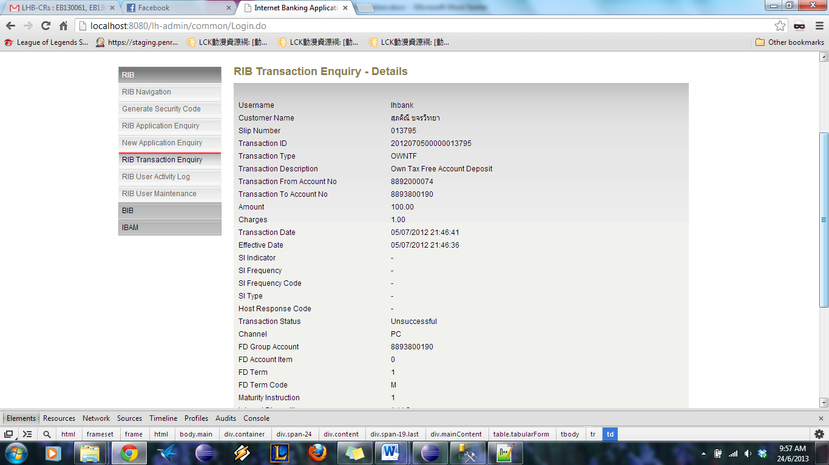

Figure 12 RIB Transaction Enquiry – Transaction Details

|  |  |
| --- | --- |
| Effort(man-days) | 9 |
| Affected Area | IBAM  RIB  User Manual –IBAM  User Manual –RIB |