

USER REQUIREMENT SPECIFICATION (URS) DOCUMENT

INTERNET BANKING

CM201300058/IE0000030C - AGRONet > BILL PAYMENT > Syarikat Air Terengganu [SATU]
VERSION: V1.0 | REVISION DATE: 03.06.2013

Authors
Name | Designation & contact email | Remark
Halimah Mohammad Shukor | Executive  halimahms@agrobank.com.my  ext : 2312

Amendment Record
Version | Date | Status | Description of Revision
1.0 | 03.06.2013 | New Requirement

TABLE OF CONTENTS

1.0 INTRODUCTION/SYSTEM OVERVIEW 4
2.0 PROBLEM STATEMENT 6
3.0 OBJECTIVE 6
4.0 SCOPE OF WORK 6
5.0 BUSINESS PROCESS FLOW 6
6.0 REQUIREMENT DEFINITION 7
7.0 ACCESS MATRIX & AUTHORIZATION 7
8.0 INTERFACES 7
9.0 LIST OF TRANSACTION CODE 10
10.0 FILE/DATA 10
11.0 GENERAL LEDGER ACCOUNT 10
12.0 INTEGRATION WITH OTHER CHANNELS 10
13.0 REPORT 10
14.0 FORMS AND VOUCHERS 10
15.0 FUTURE REQUIREMENTS 10

- INTRODUCTION/SYSTEM OVERVIEW

Internet Banking or e-banking is defined as the automated delivery of new and traditional banking products and services directly to customers through electronic, interactive communication channels. E-banking includes the systems that enable financial institution customers, individuals or businesses, to access accounts, transact business, or obtain information on financial products and services through a public or private network, including the Internet.
The Retail Internet Banking solution targets the individual or joint group of customers. The solution provides a browser-based interface for the Agrobank Online customer to do some of the basic services such as but not limited to account enquiries, transfers and service applications. Customer can make any payment and transaction from their home or office as long as there is an internet connection.
In the IBAM system two major functionalities will be introduced, first is the RIB Management, where it is intended to ease a IBAM Admin, from ‘managing the content that would appeared in RIB Site according to user role in a particular company’, or ‘review a specific transaction history that has been done by a particular RIB User’. IBAM consist the module to allow the admin to manage the IBAM itself.

- Group Maintenance
- User Profile Maintenance
- IBAM Navigation
- IB User Group
- Audit Log
- Change Own Password
- Message Box
- Pending Task
- RIB Report
- RIB Navigation
- Content
- RIB User Enquiry
- RIB Transaction Enquiry

This overview diagram shows the Internet Banking System is not a standalone application. It’s tightly coupled with other components and systems to make it work. The diagram shows IBS shall use the Authentication Services for identity authentication, send an SMS through SMS gateway, retrieve and store information to the database, send request to Host and other 3rd Parties servers through middleware, and also able to send email to a specified back office official and request service to the appointed billing aggregator through Host.

- PROBLEM STATEMENT

The payment of the service fee RM0.40 for each transaction done via Internet Banking shall be paid by the customer. This will apply to New Bill Payment and Favourite Bill Payment as well.

- OBJECTIVE

To ensure that payment of the service fee RM0.40 for each transaction done via Internet Banking will be charge to the customer. This will apply to New Bill Payment and Favourite Bill Payment as well.

- SCOPE OF WORK

To ensure that payment of the service fee RM0.40 for each transaction done via Internet Banking will be charge to the customer. This will apply to New Bill Payment and Favourite Bill Payment as well.

- BUSINESS PROCESS FLOW

Enter AGRONet login page and successfully displayed the announcement and promotion.

Start

End
BROWSE AGRONet URL
www.agronet.com.my
AGRONet Login Page
Select SATU
Select Bill Payment
Performed SATU Transaction
Transaction Successful
Received notification via SMS

- REQUIREMENT DEFINITION

6.1
Requirement No | Requirement | Description
CM201300058/IE0000030C _URS_V1 _001 | To ensure that payment of the service fee RM0.40 for each transaction done via Internet Banking will be charge to the customer.  This will apply to New Bill Payment and Favourite Bill Payment as well. | Able to view all data required.

    - To ensure amount debited from customer’s account is:

TOTAL amount to be deducted = Bill Payment Amount + Commission

Eg:

New Process Flow |  | Existing Process Flow
Bill Amount | 45.00 | Bill Amount | 45.00
Commission | 0.40 | Commission | 0.40
Total Amount to be deducted from Customer's Account | 45.40 | Total Amount to be deducted from Customer's Account | 45.00

    - To display two lines of transaction activity in Account Inquiry (Host)

- To follow the existing GIRO transaction Inquiry

6.2 Proposed Changes at IBAM

6.2.1 To add a function to calculate TOTAL amount to be deducted from customer’s account.

Field | Option
Total Amount to be deducted from Customer's Account | Bill Amount
Total Amount to be deducted from Customer's Account | Bill Amount + Commission

6.2.2 To pass Bill Amount and Commission to Host bucket accordingly.

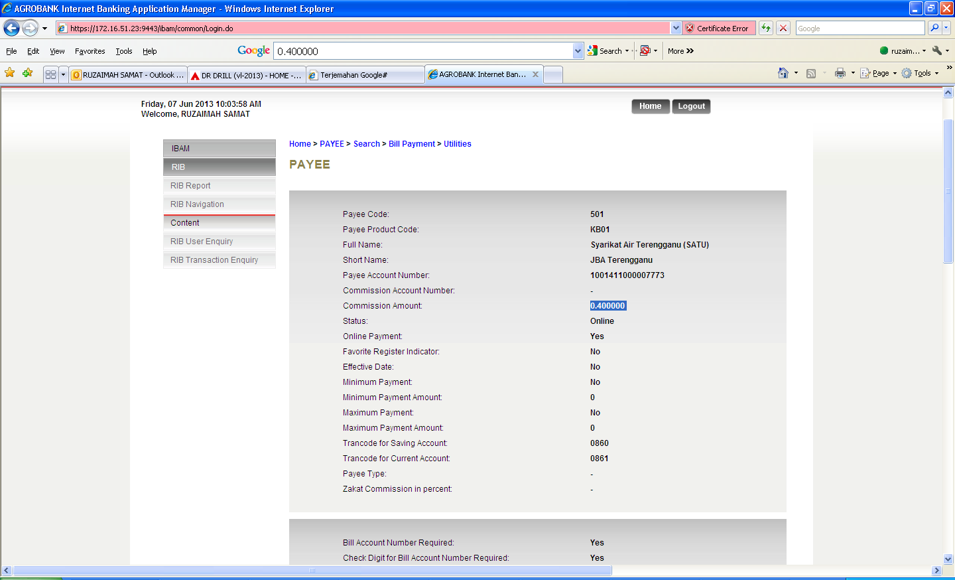
New
-Amount
-Amount + Commission
Total Amount to be deducted from Customers;’s Account

- ACCESS MATRIX AND AUTHORIZATION

User  Role | Customer | IB Contact Centre User | Virtual Banking User | IB Core Banking Technical User | Admin (Information Security Unit)

View
Edit | - | - | -

- INTERFACES

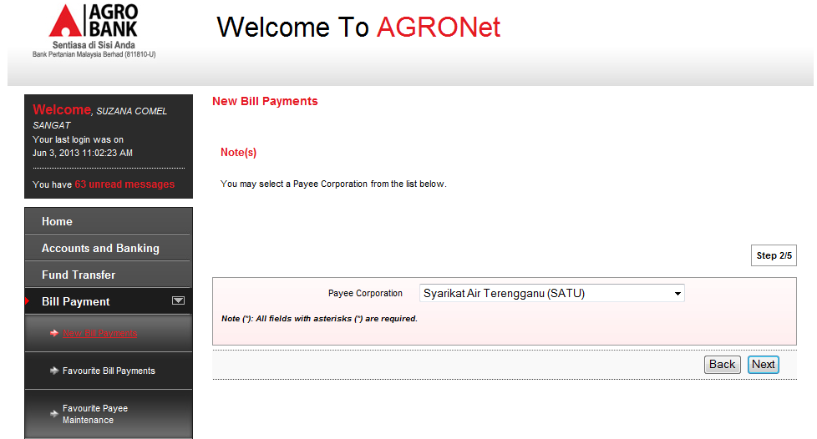

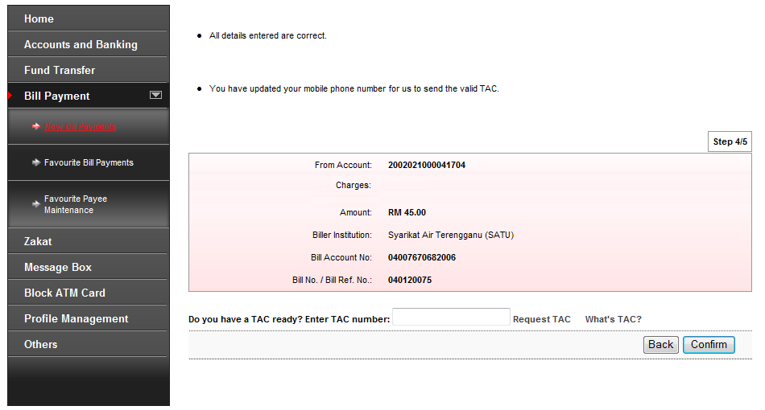
RM0.40

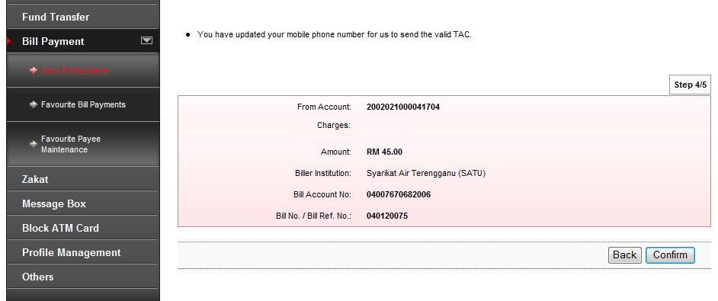
RM0.40

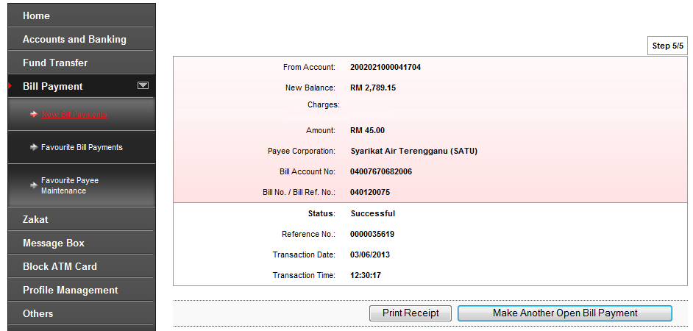
RM0.40

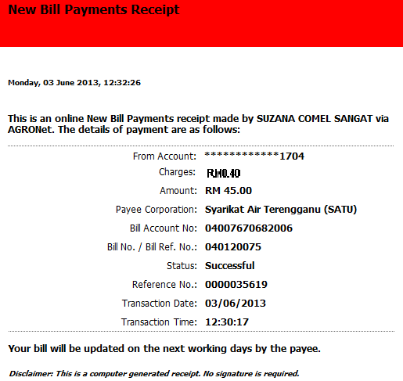
- LIST OF TRANSACTION CODE

N/A

- FILE/DATA

N/A

- GENERAL LEDGER ACCOUNT

11.1 Required to charge customers on the service fee at the accounting entry.

11.2 Charges will be received by the accounting branch as per the existing flow.

- INTEGRATION WITH OTHER CHANNEL

N/A

- REPORT

13.1 As per the existing. Report DDI300P required to display the charges imposed which is RM0.40 for each transaction.

- FORMS AND VOUCHERS

N/A

- FUTURE REQUIREMENT

N/A

