Title : ISSUE RESOLUTION  Mandatory Change  Nice to have/Preferences |  |  | Project : Internet Banking  Application : Internet Banking
Issue Number : EB130118 |  | Issue Title : Unlink Account Error
Issue Description :
Perform Unlink Account as following steps
- Login to RIB
- Click Account Opening and Other Services
- Click Unlink
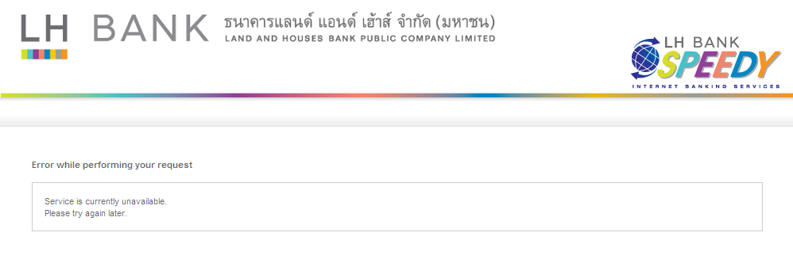

** Cannot unlink (total linked 19 accounts)

Recommendation & Rationale:

Resolution : |  |  |  |  | Man-days:
Raised By: Pongpan  Date : 29/08/2556 | Review by :  Date: |  |  | Cross Reference :

