# EJB EAR compilation for WebLogic 10

WebLogic 10 requires the source code to be compiled with its own EJBGen Ant script if we are going to use the WebService feature of the EJB.

Below are the steps taken:-

1. Install WebLogic 10. Make sure the samples code option is selected.
2. Go into WebLogic samples domain directory from command line.

For example:-

<WebLogic folder>\wlserver_10.0\samples\domains\wl_server

*C:\bea\wlserver_10\ samples\domains\wl_server*

1. Enter “setExamplesEnv.cmd” and press Enter. The environment path required to build the EAR project shall be set for the session.

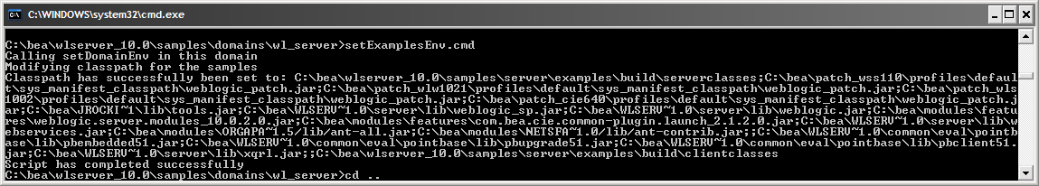

1. Clone EJB project from the mercurial repository into the samples source code folder.

For example:-

<WebLogic folder>\wlserver_10.0\samples\server\examples\src\examples\...

*C:\bea\wlserver_10.0\samples\server\examples\src\examples\webservices\jws_basic*

1. Go into the EJB project from the same command prompt.
2. Enter “ant build” to start the build process.

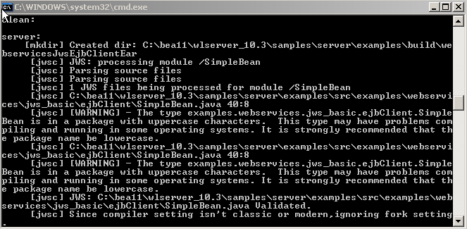

1. Browse to the samples build folder.

For example:-

<WebLogic folder> \wlserver_10.3\samples\server\examples\build\...

*C:\bea11\wlserver_10.3\samples\server\examples\build\webservicesJwsSimpleReceiverEar*

1. Package the generated files in zip format. Rename file extension of the zip archive from “.zip” into “.ear”.
2. Upload the EAR file through the WebLogic console.

# Message Driven Bean JAR Compilation for WebLogic

1. Clone the Message Driven Bean project from mercurial repository from Eclipse IDE.
2. Right click on the project and choose to “Export..” as Jar file.

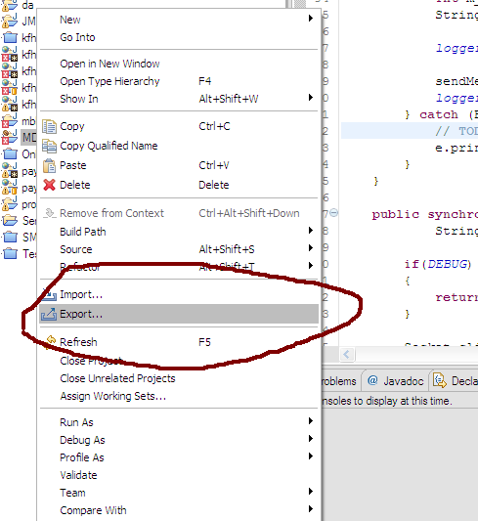

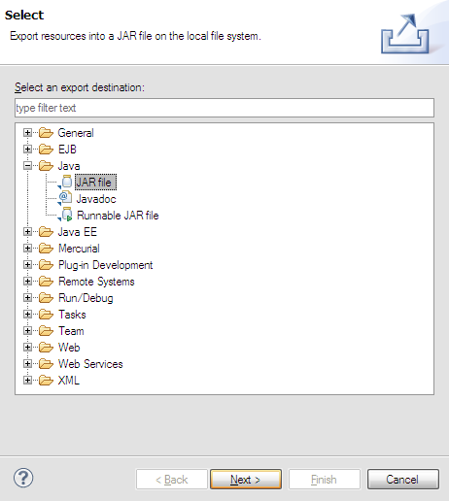

1. Upload the Jar file through the WebLogic Console.