**Transaksi IBG – Testing 2nd Validation**

Filler 04

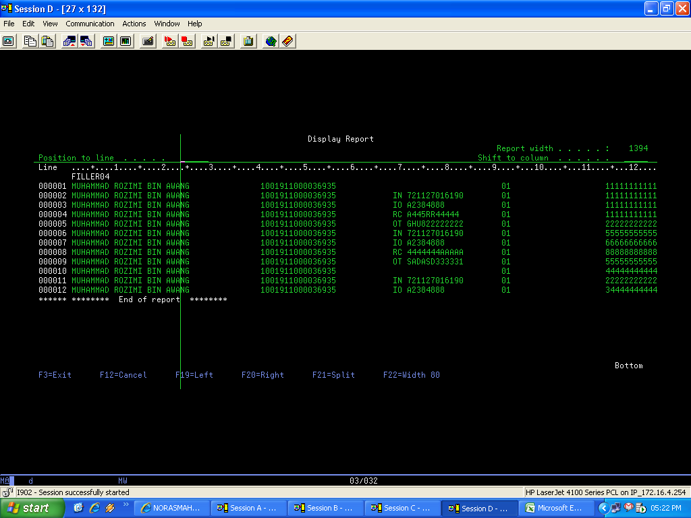

Should be Applicant’s data not beneficiary’s data

Next

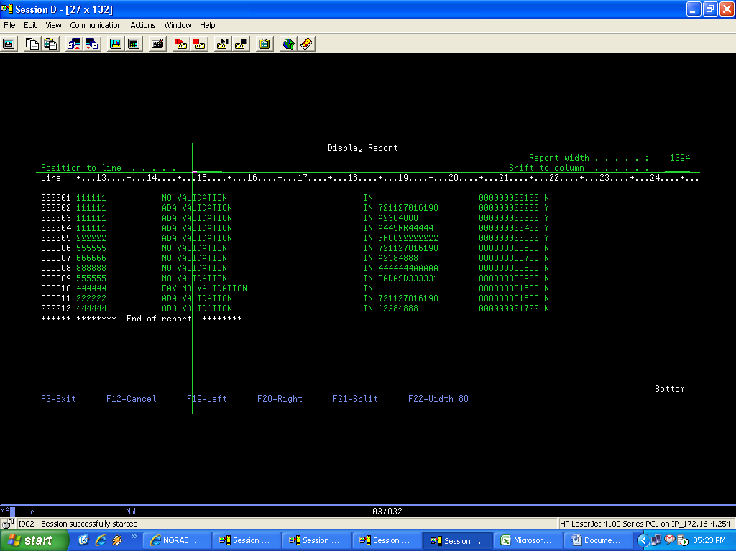

Should be beneficiary’s id type

Should be ‘Y’