NEW INTERBANK GIRO TRANSFER (CHROME)
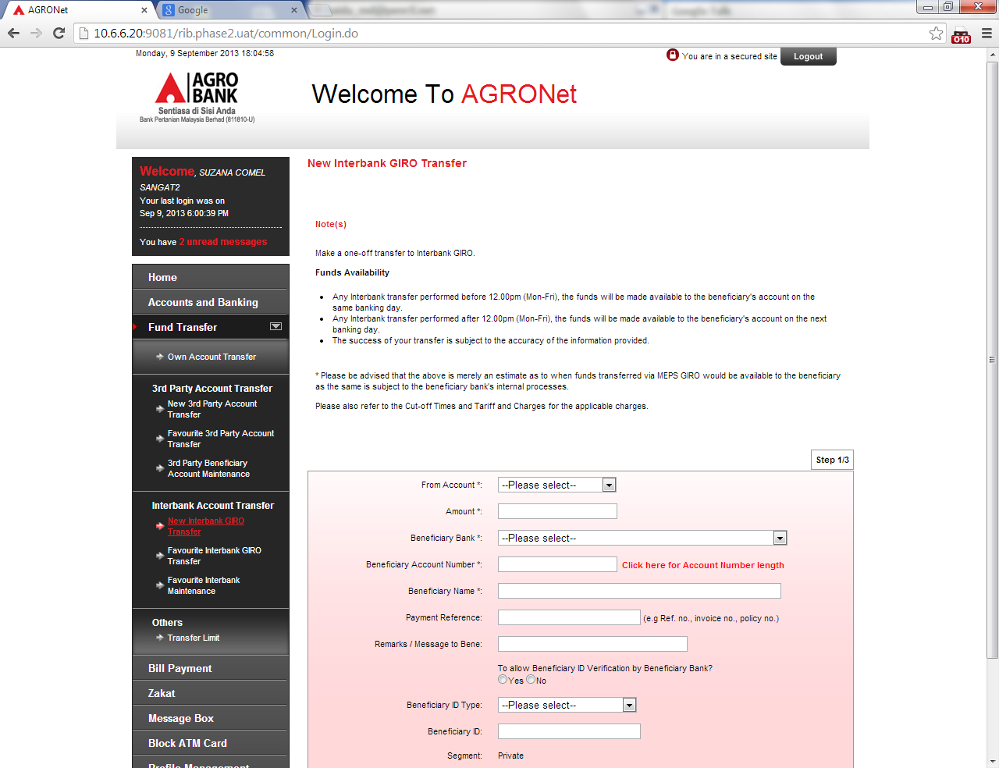

NEW INTERBANK GIRO TRANSFER (IE)
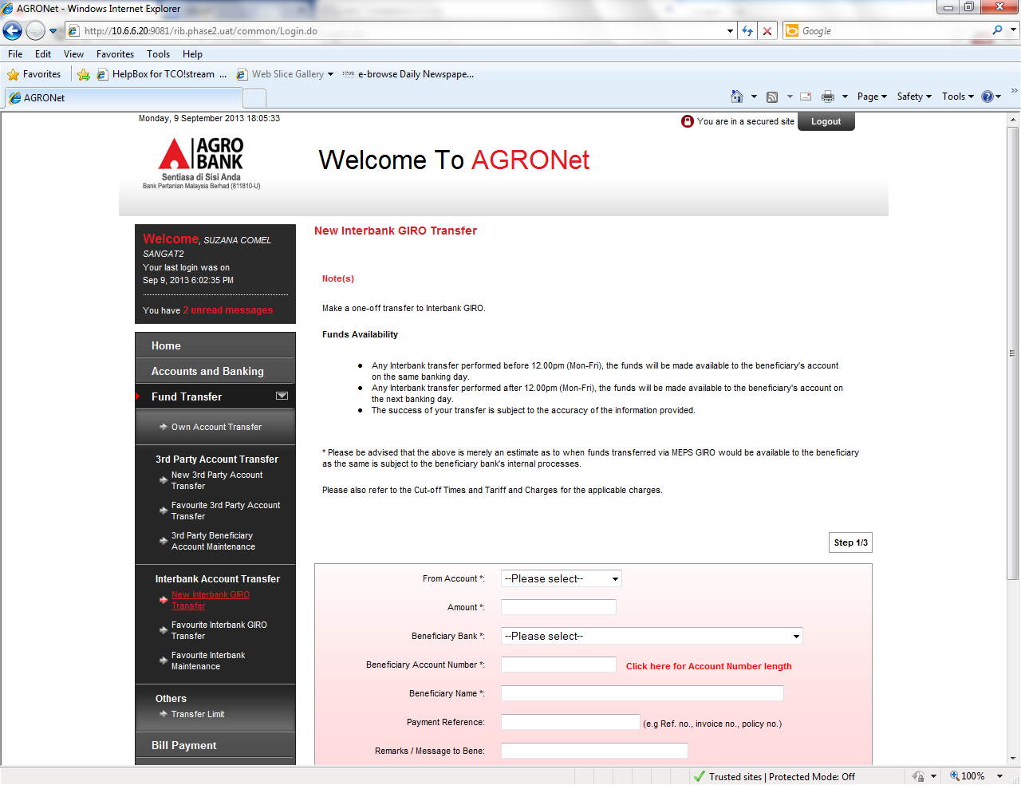

FAVOURITE INTERBANK GIRO TRANSFER (CHROME)
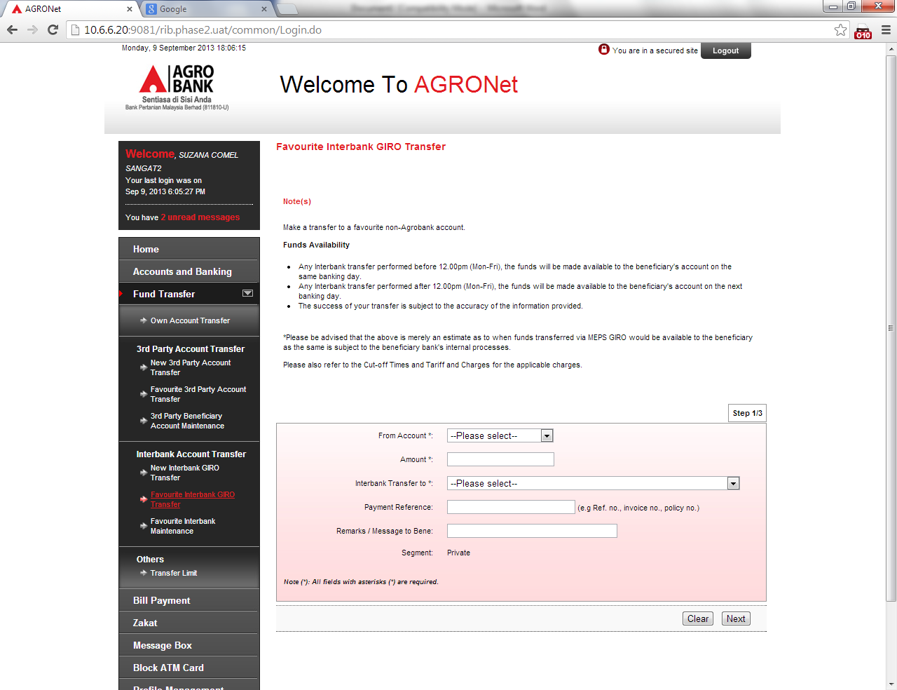

FAVOURITE INTERBANK GIRO TRANSFER (IE)
