Issue on SKN transaction Error : Value of SourceDescription is too long

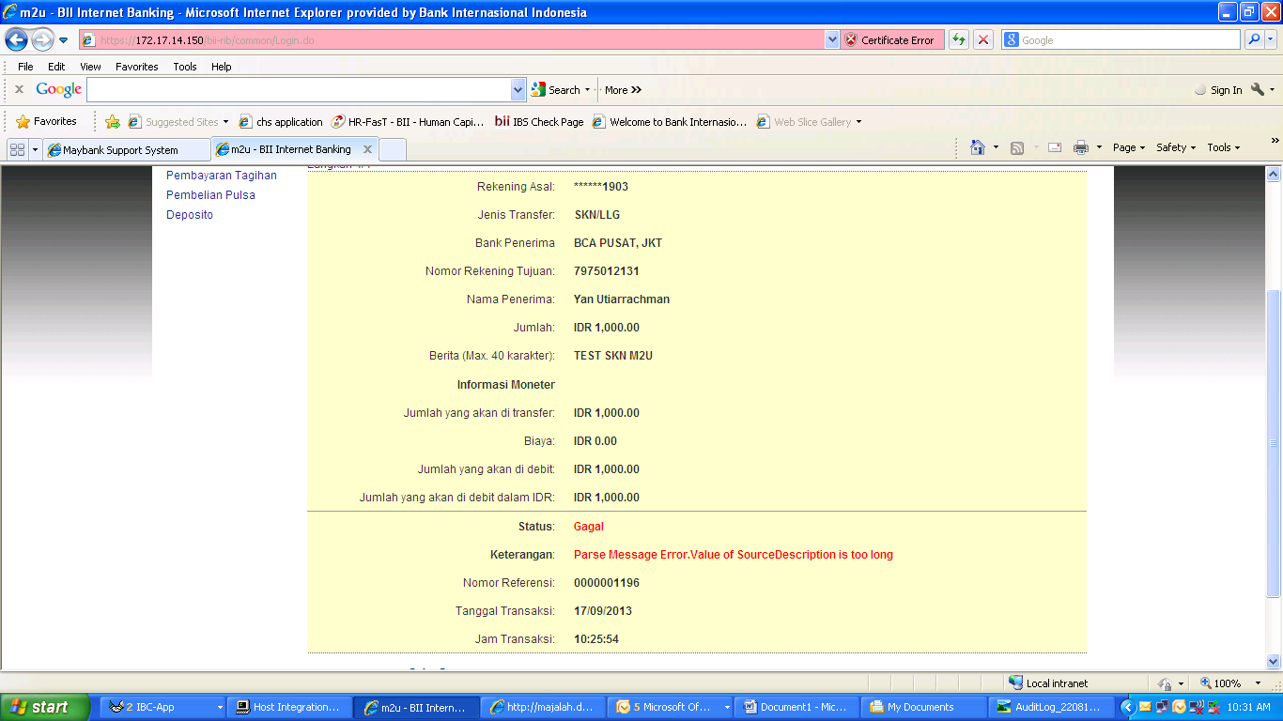

TBR 2969 on field SourceDescription length is 13 character.