**Locked Account**

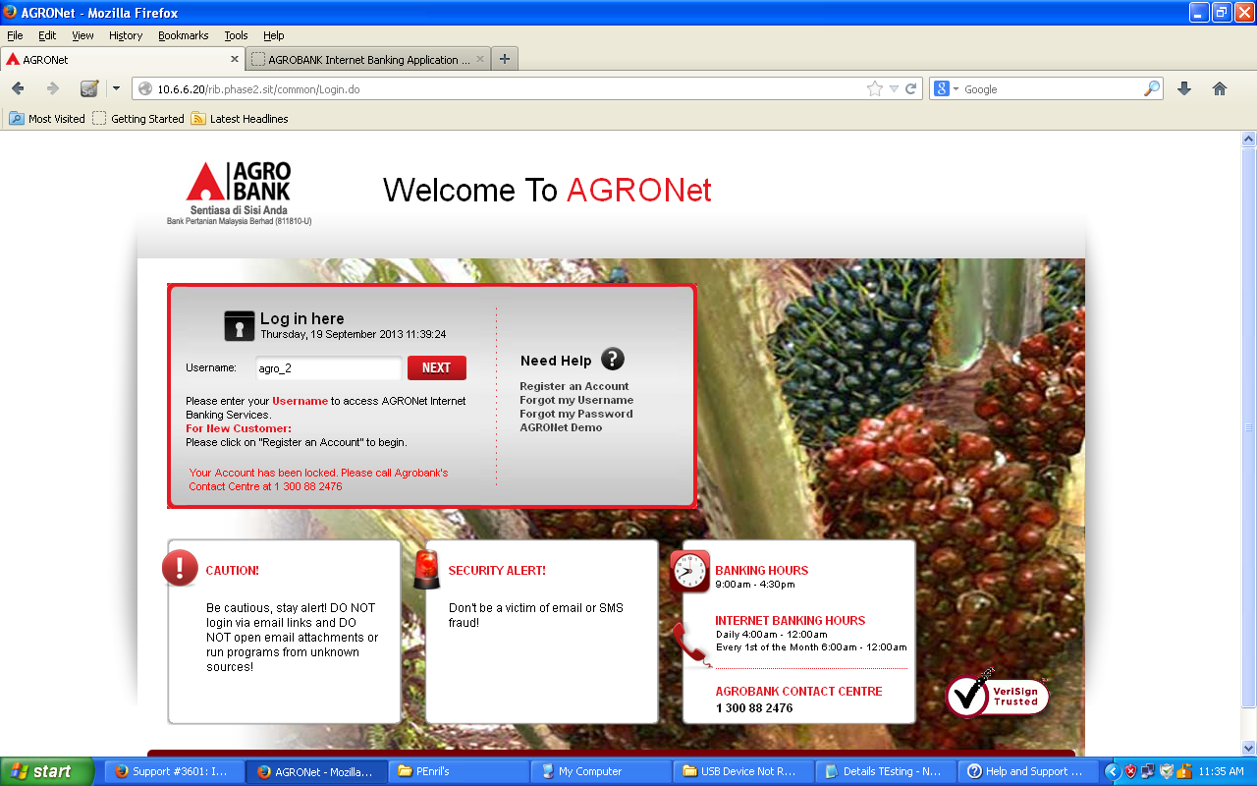

1. **To test on Unlocked account for Force Change Password**

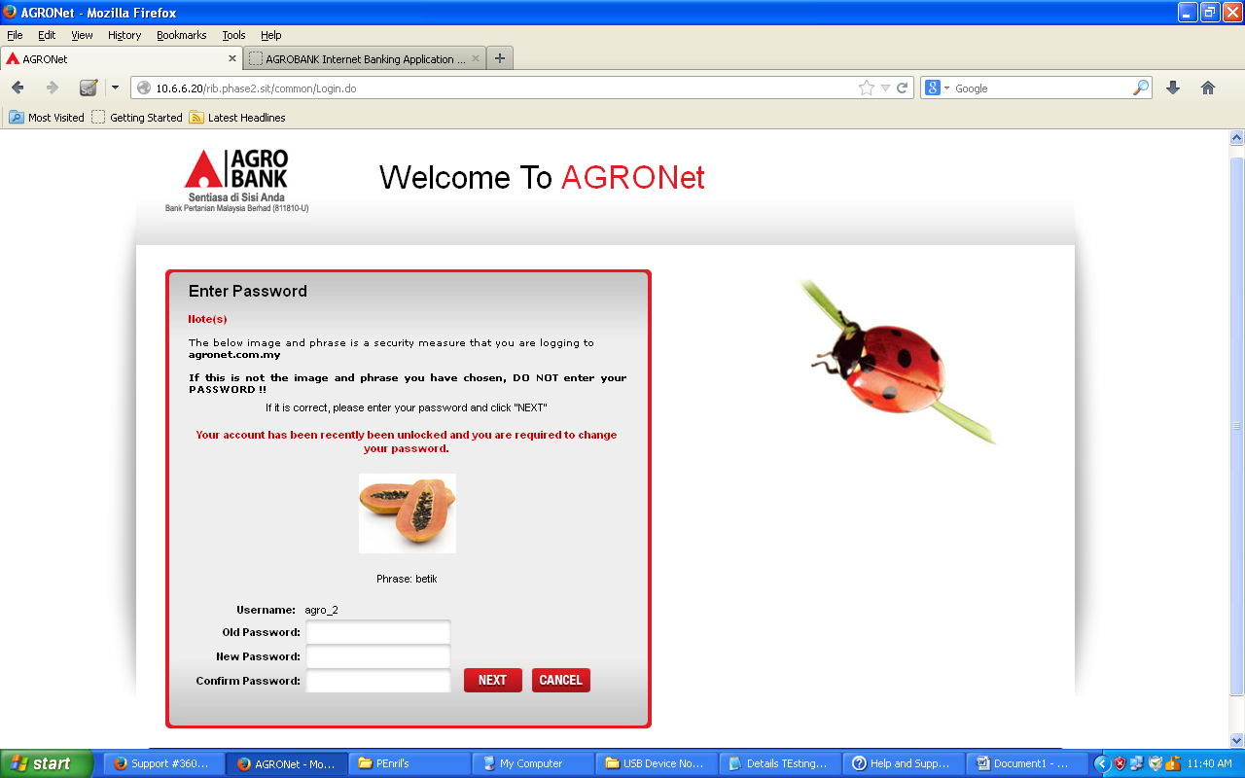

* 1. **Negative Testing**
     1. **To test on invalid Old Password**

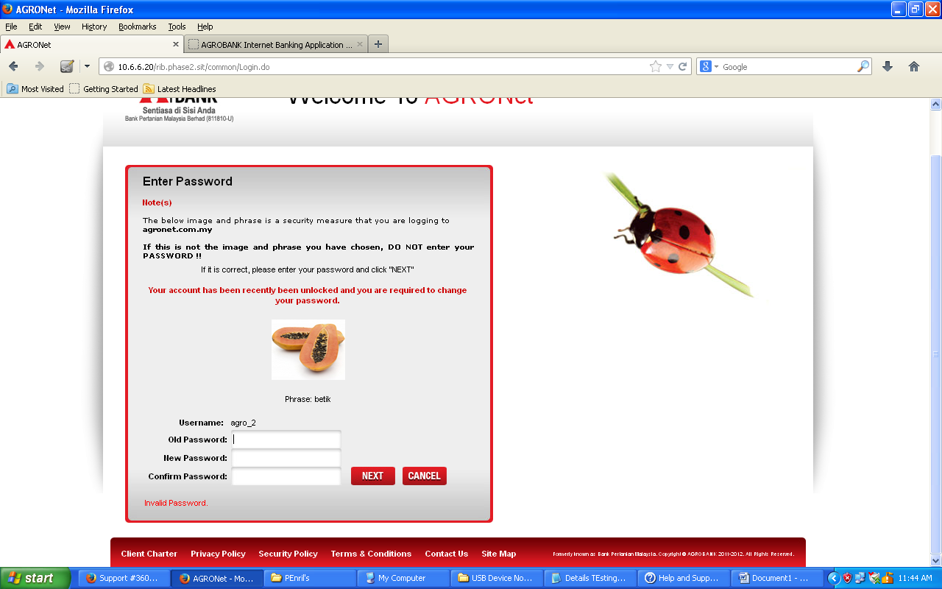

* + 1. **To test on using Previous Password to New Password and Confirm New Password**

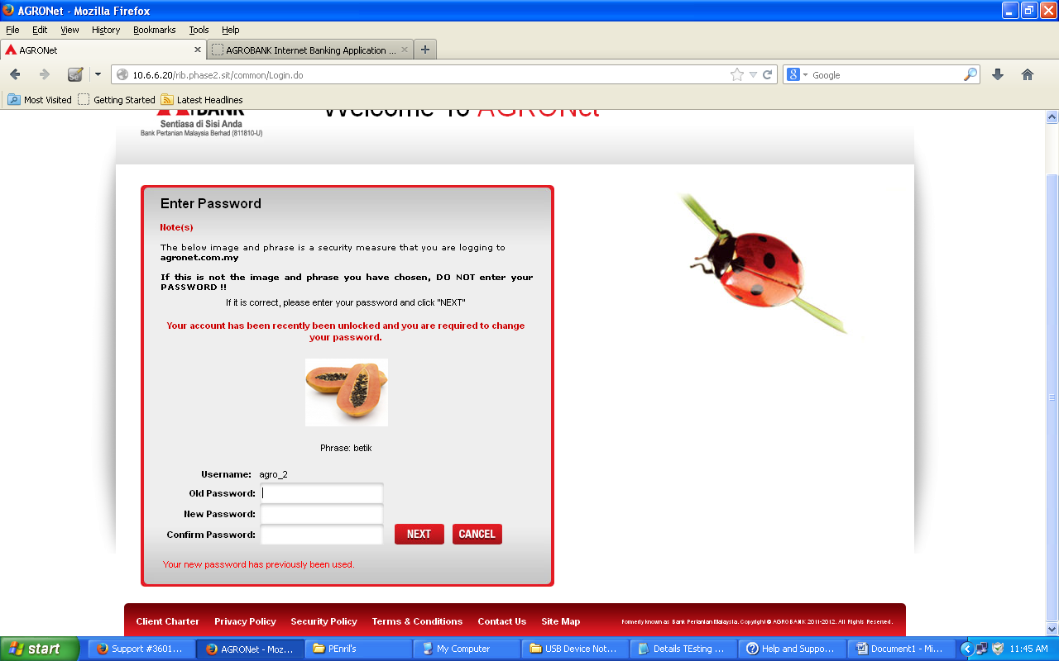

* 1. **Positive Testing**

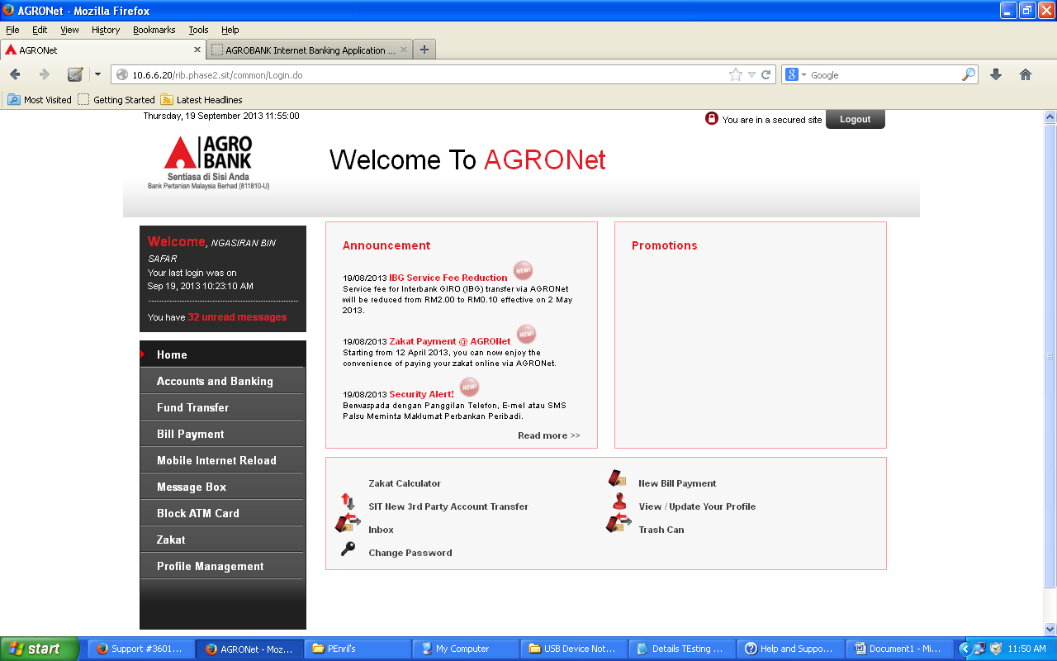

1. **To test on Reset Password – Using messi123 ID**
   1. **Negative Testing**
      1. **To test on using Previous Password to Password and Confirm Password**

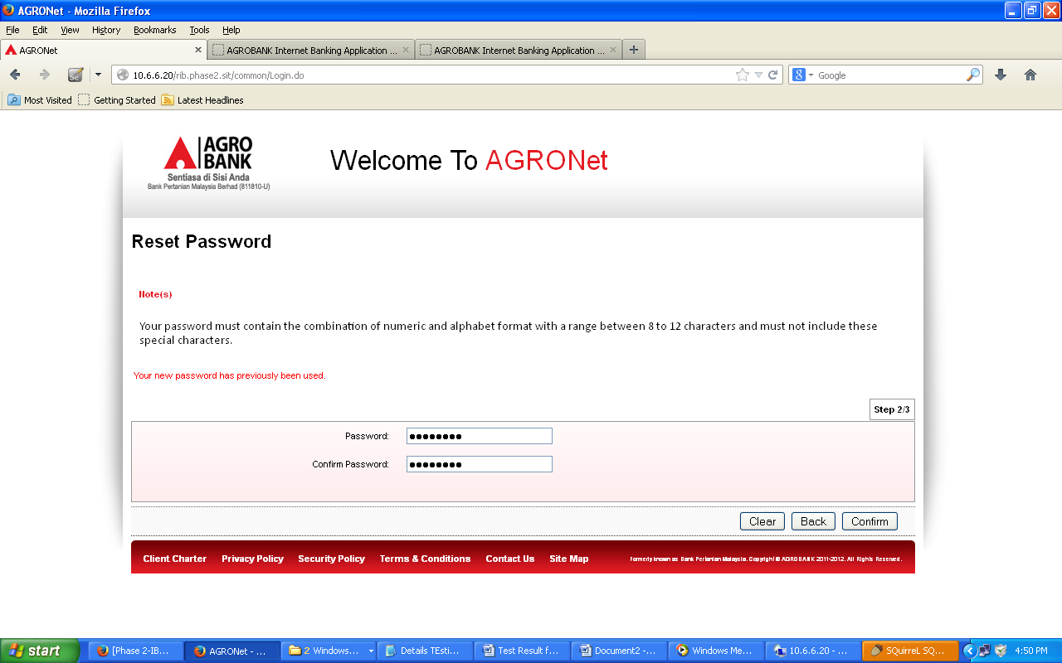

* 1. **Positive Testing**

