CR Resolution (EB130074 – e-Statement)

# Host Message

1. To create new host message integration for
   1. e-Statement Subscription Listing
   2. Change / Update e-Statement Subscription
2. To update existing host message
   1. Request eStatement (1770)
   2. Cancel eStatement (1970)

# RIB

Add new module, e-Statement under Other Services for customer to subscribe / enroll to e-Statement for selected Savings or Current accounts and also to update or cancel existing e-Statement subscription.

## e-Statement Enrolment

### Steps

**Step 0**: e-Statement Listing (No Subscription)

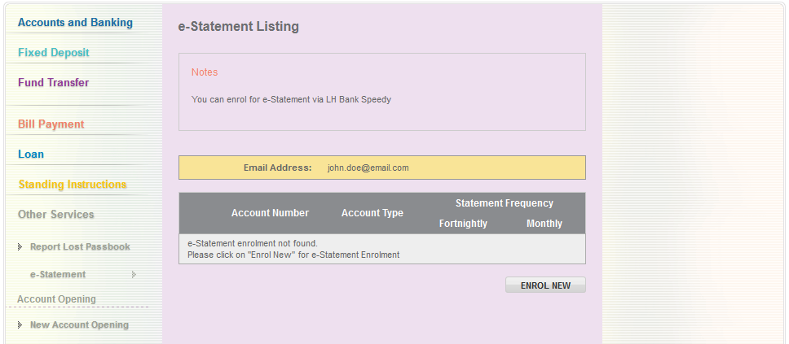

1. Click on “Enrol New” to start enrolment.

**Step 1:** Terms & Condition

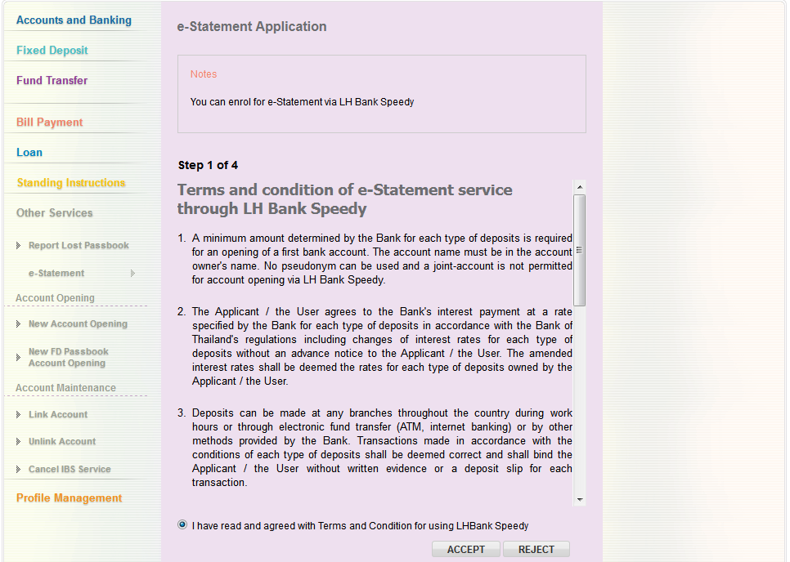

**Step 2:** Details

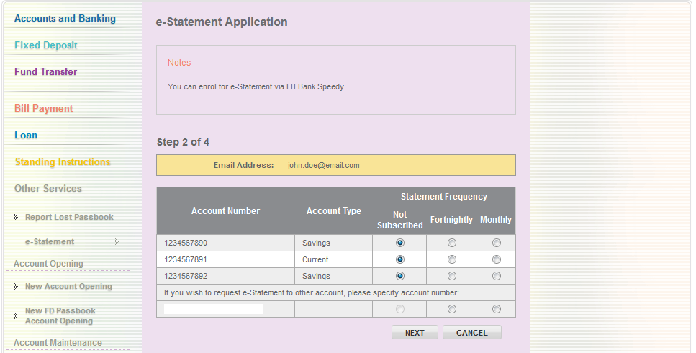

1. Customer is allowed to enroll account (not link to IB) for e-Statement.

**Step 3:** Confirmation

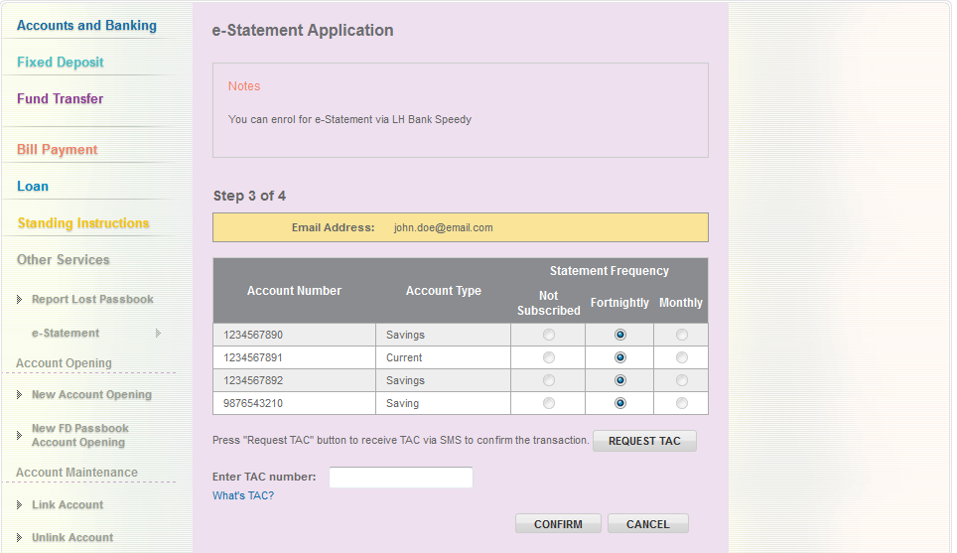

**Step 4:** Result

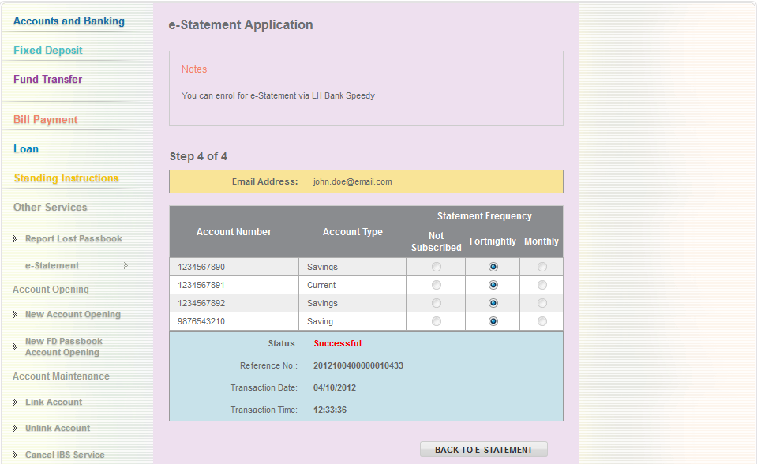

## Update e-Statement Enrolment

### Steps

**Step 1**: Select Account to modify

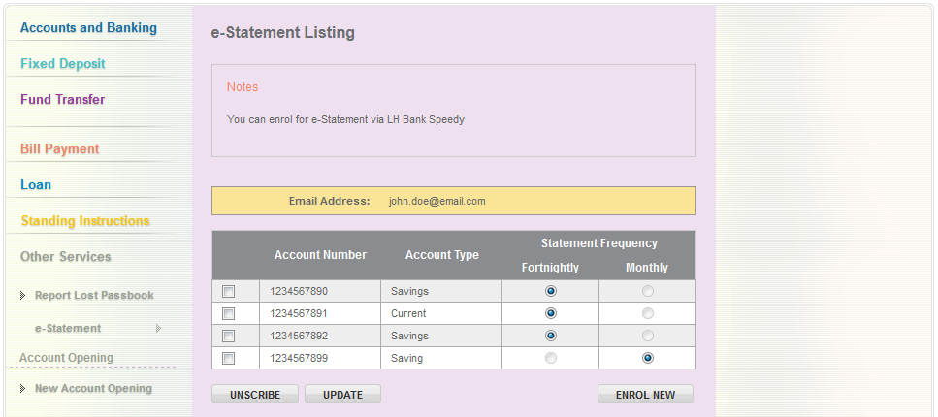

1. Customer select account(s) to modify e-Statement subscription and click “Update”

**Step 1:** Modify e-Statement Frequency

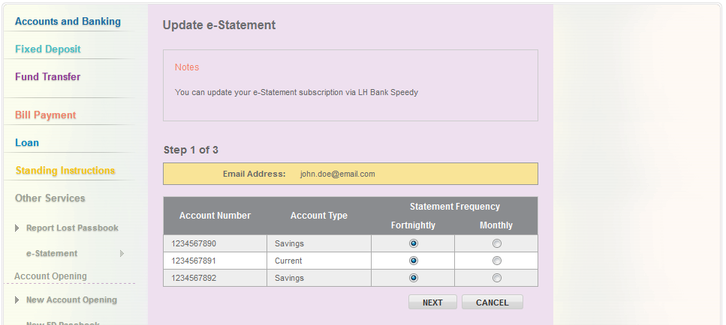

1. Based on the selection from Step 1, list the accounts and available options to modify.

**Step 2:** Confirm

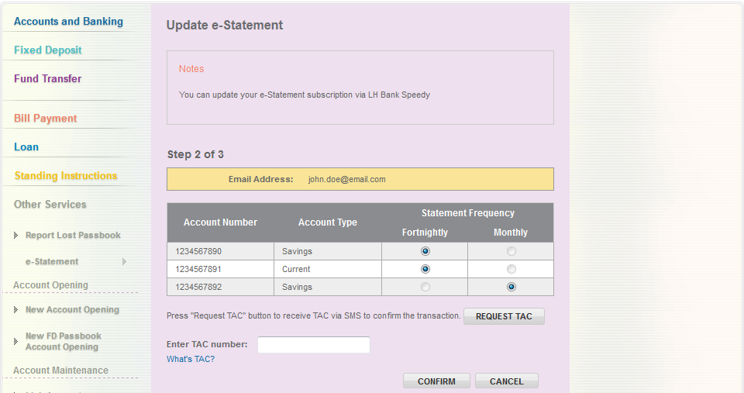

**Step 3:** Result

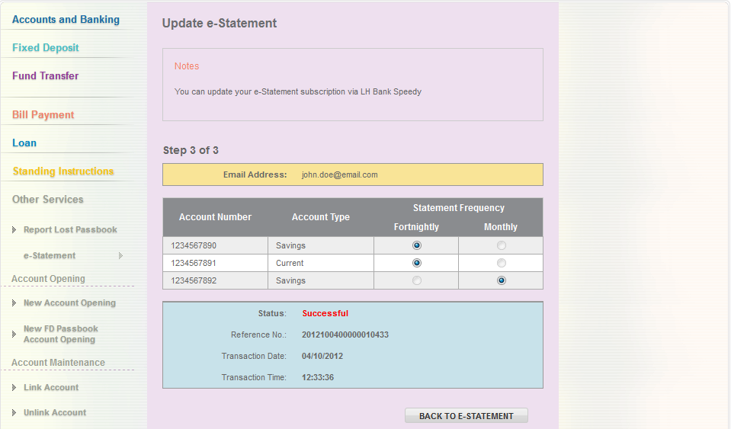

## Cancel e-Statement Subscription

### Steps

**Step 1:** Select account to cancel e-Statement Subscription



1. Customer select account(s) to modify e-Statement subscription and click “Un-scribe”

**Step 2:** Confirm

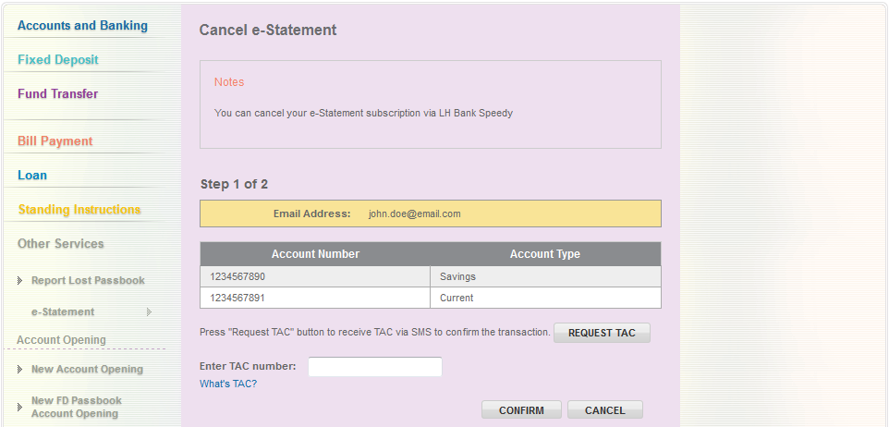

1. Based on the selection from Step 1, list the accounts to cancel the e-Statement subscription

**Step 3:** Result

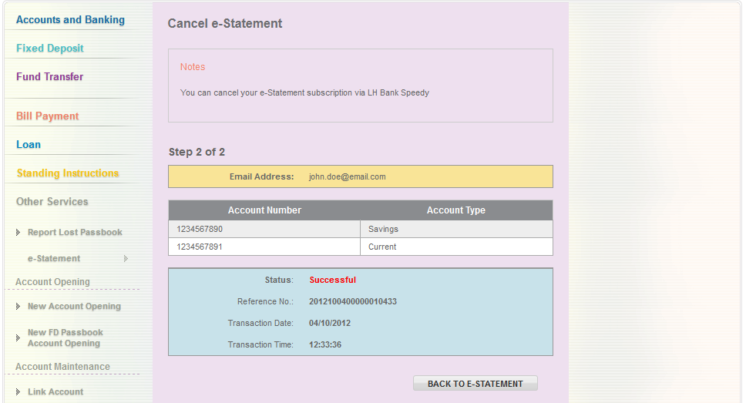

# IBAM

1. Update RIB Navigation & RIB Group Navigation Access
2. Create new Service Info for e-Statement – Listing, Enrolment, Update & Cancellation
3. Update User Activity Log to include e-Statement activities

|  |  |
| --- | --- |
| Effort(man-days) | 20 |
| Affected Area | RIB  IBAM  RIB Manual  IBAM Manual |