OMS (JPJ) Problem

1: VIEW STATEMENT – We unable to click on the “Number of Transaction” value if we search using a same start and end date.

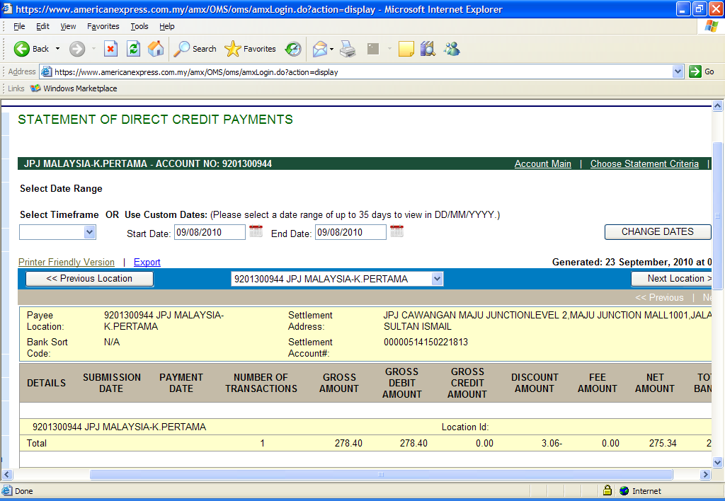

But if we widen the start date and end date, the system allowed us to click the Number of transaction.

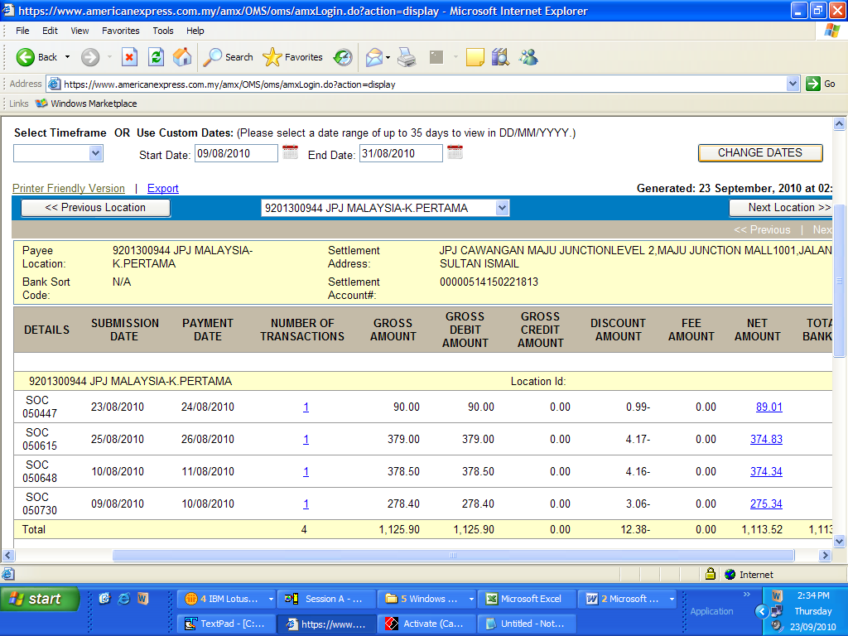

2: The data that display at the “VIEW STATEMENT “Screen is inconsistence with Host data.

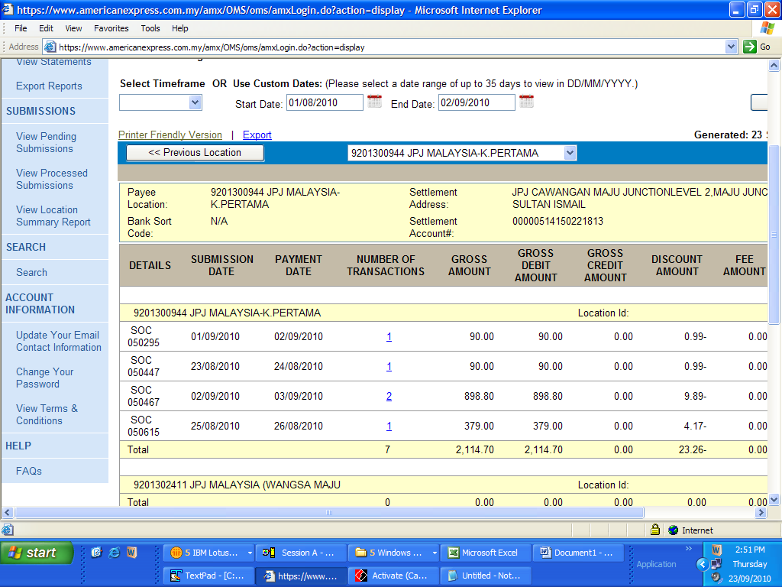

At host the total payment between 01/08/2010 to 02/09/2010 is
