Hi Moon/Naza,

Can you check why the below user unable to login?

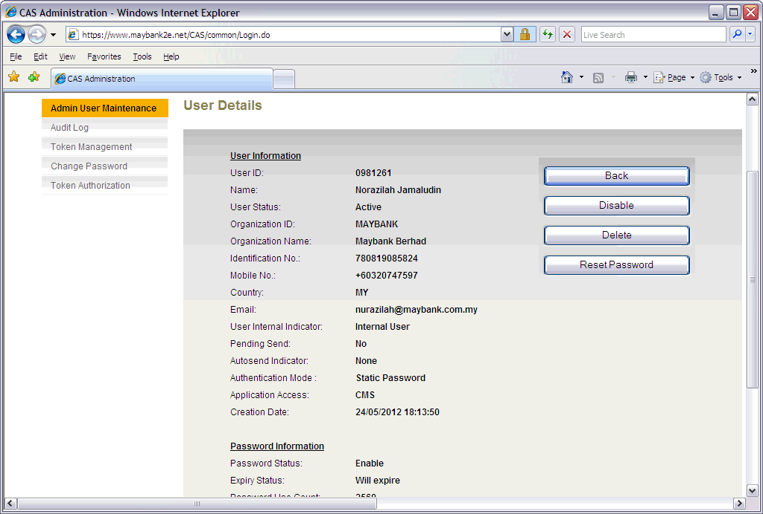

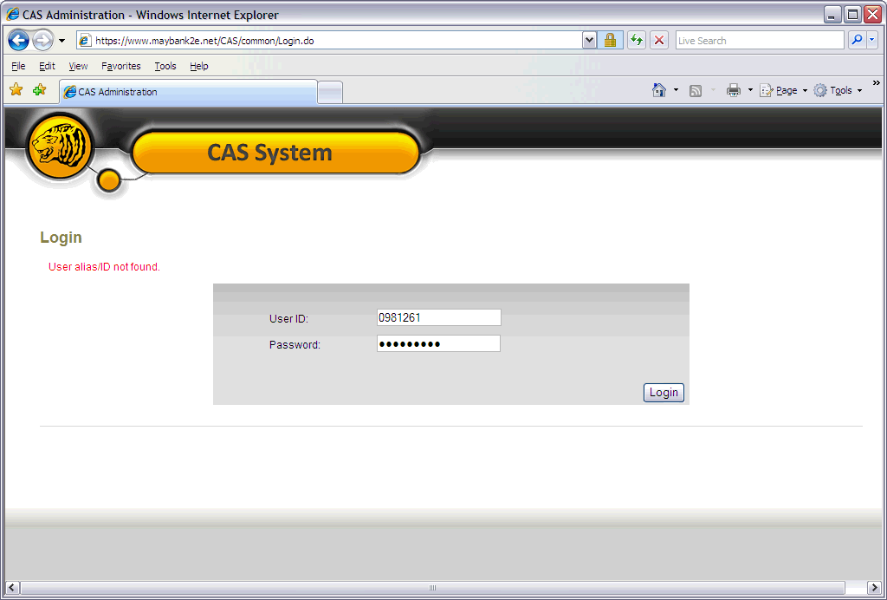  
  
 Best Regards,  
 **Joey Liew Foong Yee**  
 Associate, Product Development & Marketing Strategies  
 Cash Management, Transaction Banking, Global Banking  
 23rd Floor, Menara Maybank, 100 Jalan Tun Perak, 50050 Kuala Lumpur  
 DID: +603-2074 7182 | Fax: +603-2034 2119