Error session time out when click detail on Sent Box Menu

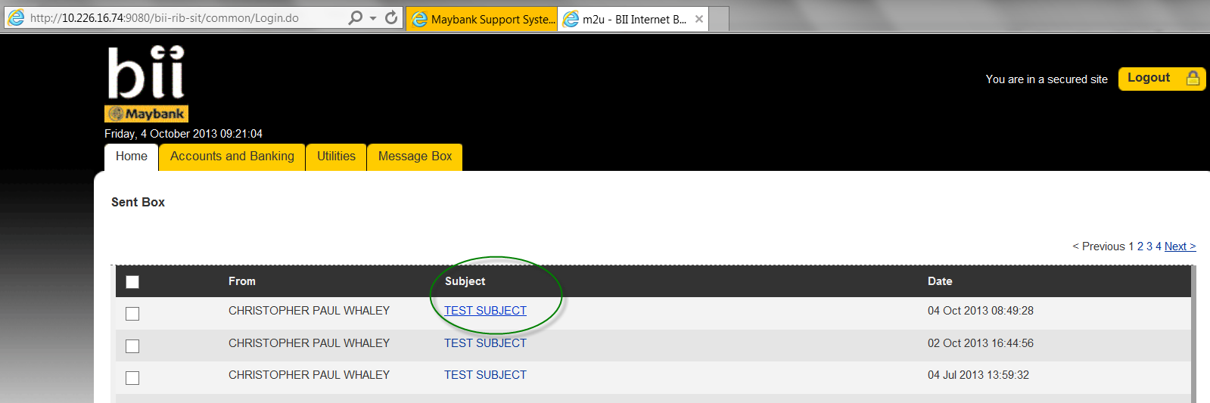

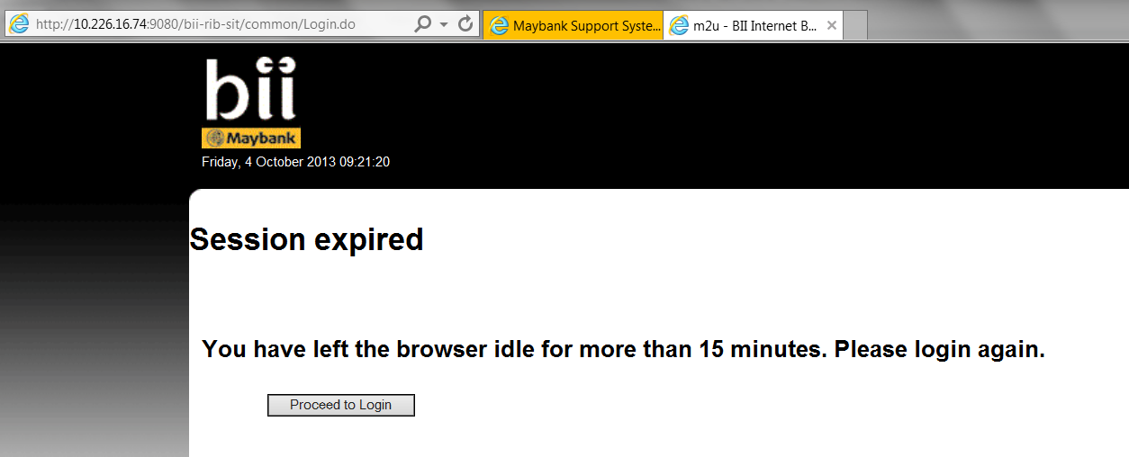

There’s warning : when acces via menu Message Box

