Filter Decimal point for YEN is done, 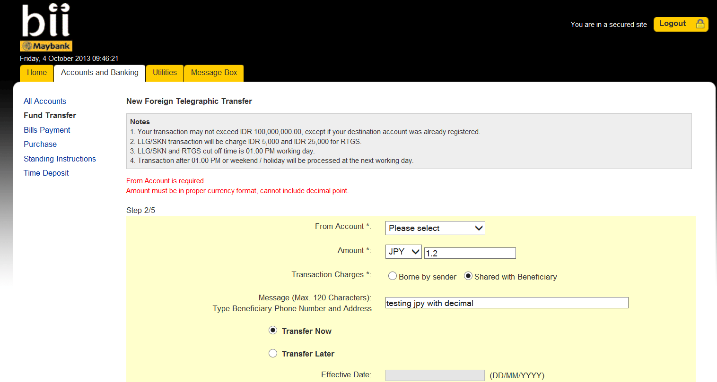

But throw a session timeout when try to submit (allready fix input the amount without decimal point)

