Theres no coloumn Balance on Today Transaction Menu

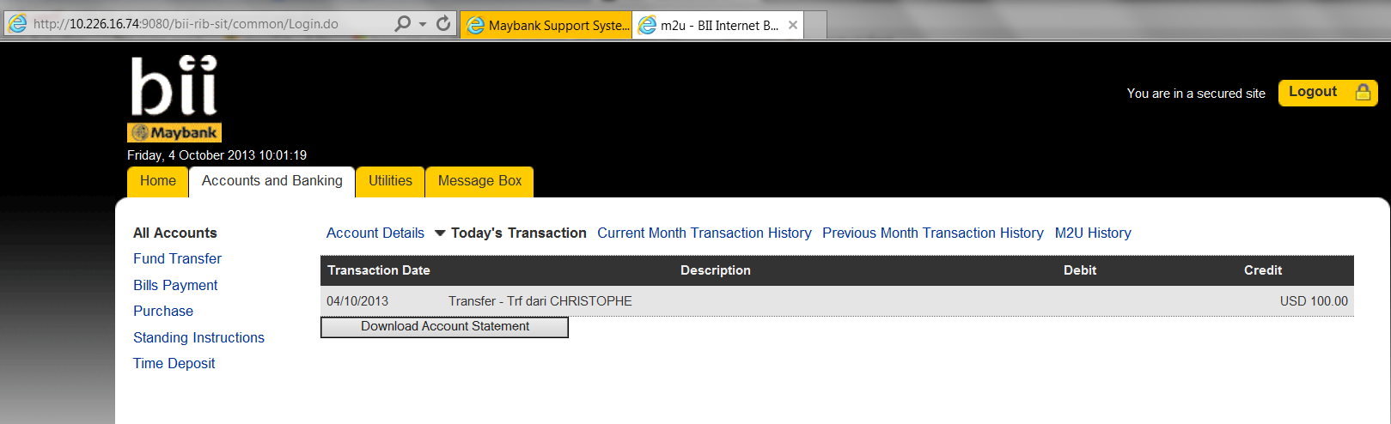

Done Fix by gabby via email : Fri 10/4/2013 1:18 PM

