
Issue Form (PROD)
Originator's Name: Sharon Lai  Project: Internet Banking  Project Manager: Malarvili / Chris Gunn  Module : BVMC  Date Raised: 9.6.10  Phase :  Functional Area : | Issue ID Number: SL025  Related Issue ID Number:  Classification:  Priority: Critical/High/Medium/Low  Assigned to: Vendor / IT / PMO SA / UPA  Actual Closed Date:
Status: Open/Assigned/Investigated/Resolved/Approved/Deferred/No Action (Circle one)
Description :  Intrabank/FTT/Bill Beneficiary Maintenance (edit/delete) found in both Internet Tranx & User Act Rpt  Pls remove maintenance activities from Internet Tranx rpt |  | Impact:
Findings/Root Caused (Description): |  | Resolution:
Estimated Impact :

Recommendation:

Accepted :  (Vendor / IT / PMO SA / UPA)  Date: | Accepted (KFHMB Tester):  Date:

Maint act found in Internet Tranx > pls remove
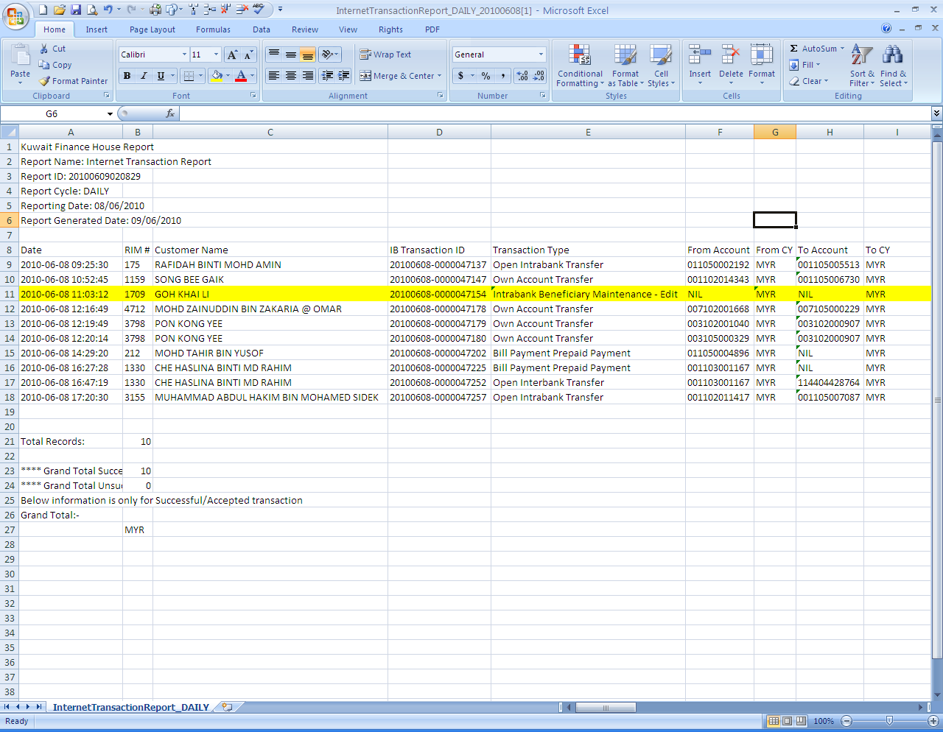
Same found in User Act
