NO | BEFORE | AFTER
R1 |  | 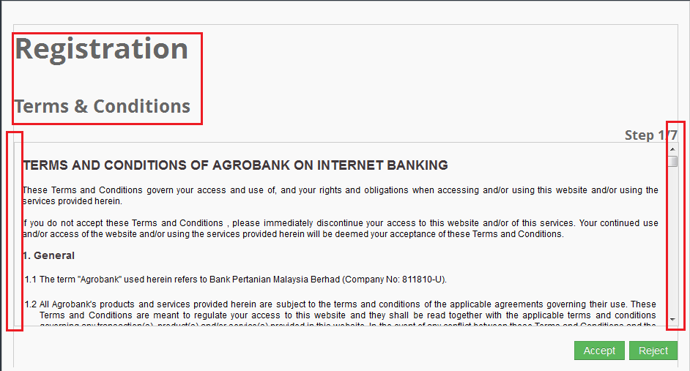
R2

R3
R4

