CR#EB130067_Rev 2 –One-stop service

## IBAM

### Create RIB Application

**Step 1**: Enter CIF

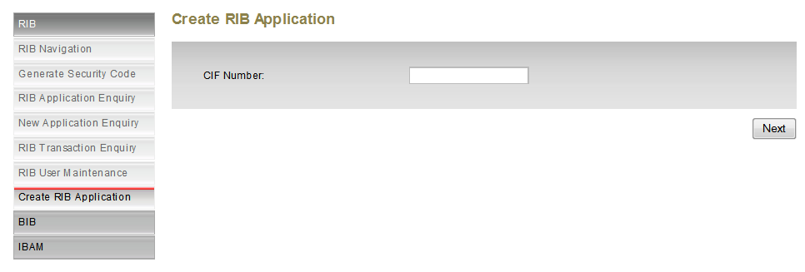

1. Update Page Title

**Step 2**: Enter Customer Information

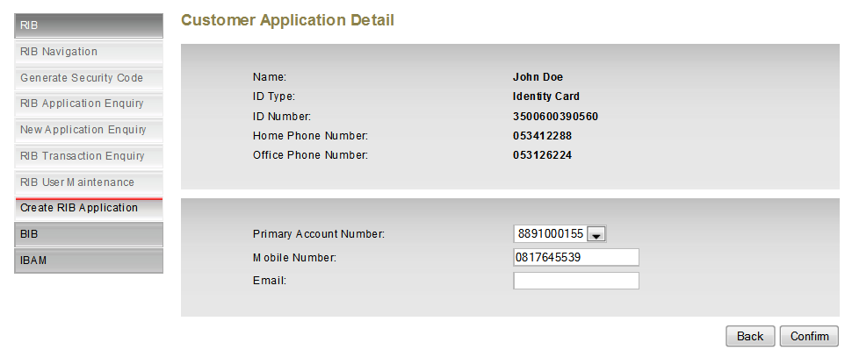

1. For Primary Account Number, instead of text input box, IBAM will have a dropdown list of accounts. The accounts will be retrieved from Host based on customer’s CIF.
2. Change button to “Back”

**Step 3: View & Print Application**

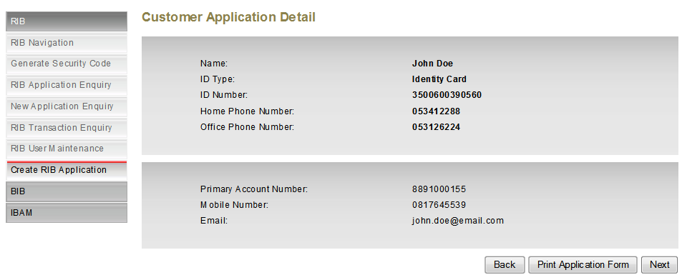

1. Separate view for Print Application. The print template will have watermark and converted to PDF. Fields to be included in the printed form:
2. Name
3. ID Type
4. ID Number
5. Home Phone Number
6. Office Phone Number
7. Primary Account Number
8. Mobile Number (To received Security Code and TAC)
9. Email
10. Print Date & Time

**Step 4**: Generate & Confirm Security Code

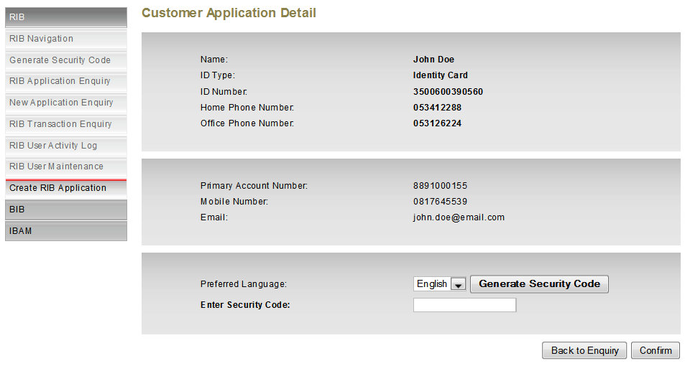

1. Teller to generate and enter Security Code to confirm the application.
2. If 3 times invalid security code entered, the application will be voided. Teller needs to perform the application from start.

**Step 5**: RIB Application Result (No Change)

Upon successful Security Code validation, IBAM will send another Security Code to Customer for FTL usage.

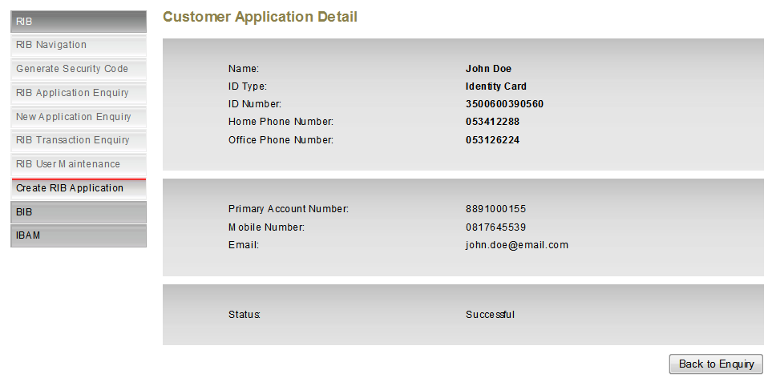

|  |  |
| --- | --- |
| Effort(man-days) | 2 |
| Affected Area | IBAM  User Manual –IBAM |