MPI Business Requirement

Module 6: Cheque Services



By M2U Product Management
Virtual Banking
Sept 2010

Version 1.0

Document Control

Author

Revision History

Rev# | Date | Description | Author
1.0 | 1/09/10 | First Draft | Faizul Hamdan

Copyright

MBB, VB – M2U Product Management

Business Requirement Background

Background
This module will elaborate the business requirement on Cheque Services for MPI Internet Banking.

High level description
- In this release customer will be able to :
      - Check Status – Allow customer to check the status of the cheque
      - Stop Cheque – Allow customer to stop payment of the cheque via IB
      - Cheque book re order – Allow customer to place order for new cheque book

Objective/Justification
- To specify the Cheque Services process flow via MPI Internet Banking

Requirement for M2U

Check Status
- Customer need to login the username and password
- Select account – Current/ Checking account
- Select cheque services
- Click at cheque Status
- Select no of cheque
- Enter the cheque no
- System will show the status of the cheque
- Refer to Appendix 1- Sample Screen

Stop Cheque
- Customer Login username and password
- Select account – Current/ Checking account
- Select cheque services
- Click at Stop Cheque
- Select no of cheque
- Enter the cheque no
- Click Confirm
- System will stop the cheque payment
- Refer to Appendix 2 – Sample Screen

Cheque book re-order
- Customer Login username and password
- Select account – Current/ Checking account
- Select cheque services
- Click at Request Cheque Book
- Select – request the cheque book to be collect at branch or mail to address
- Customer need to click Continue
- Then customer need to click confirm to confirm the transaction
- Refer to Appendix 3 – Sample Screen

Appendix 1 – Sample screen – Cheque Status

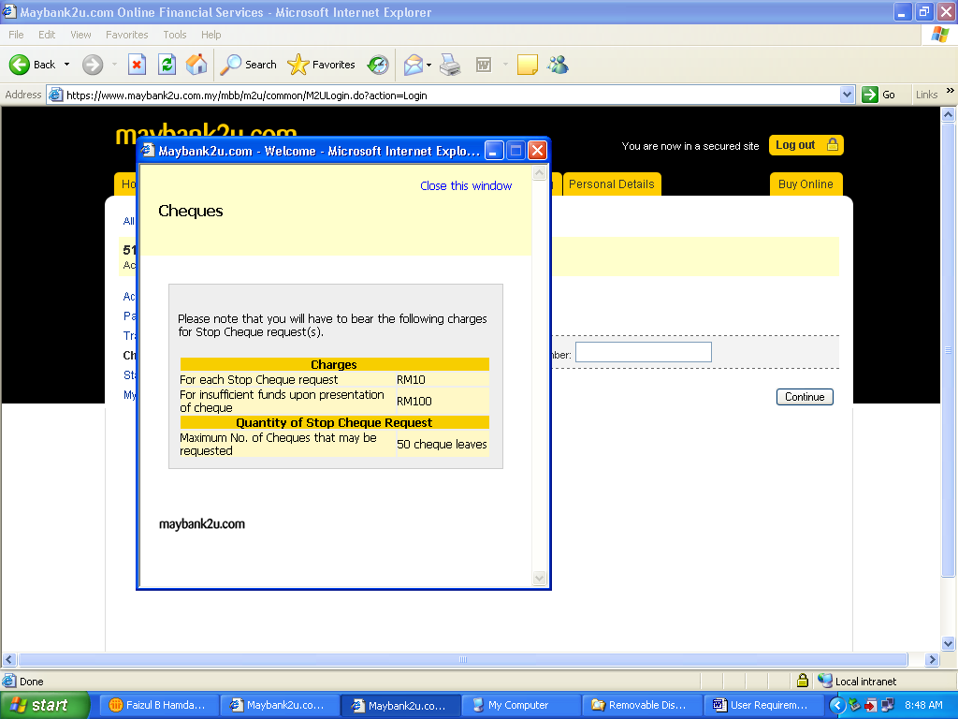

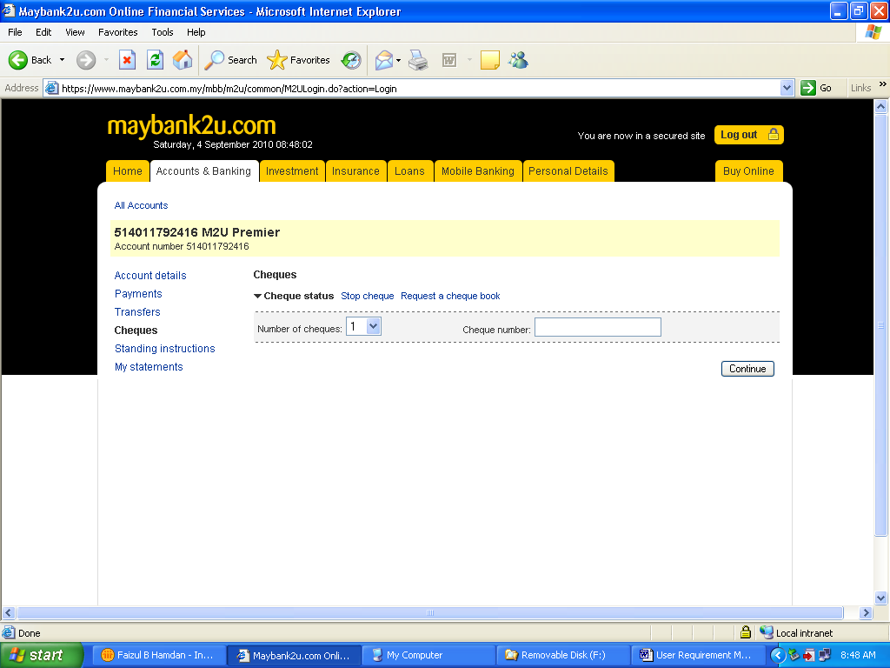

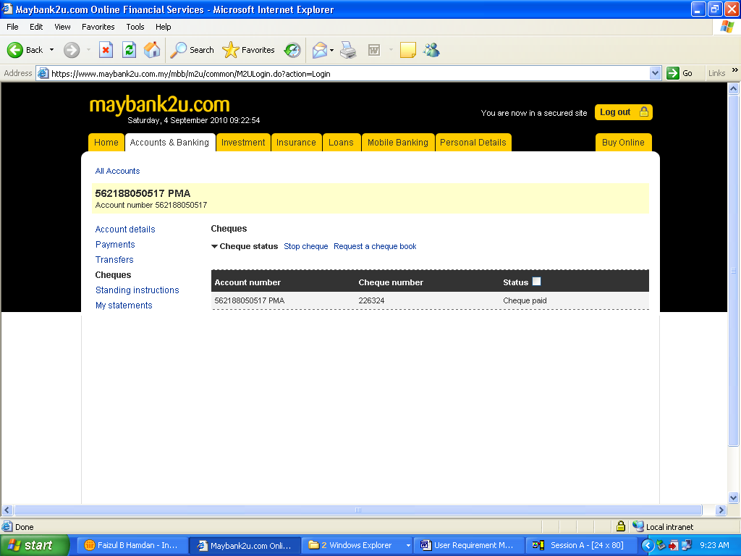

Appendix 2 – Sample Screen - Stop Cheque
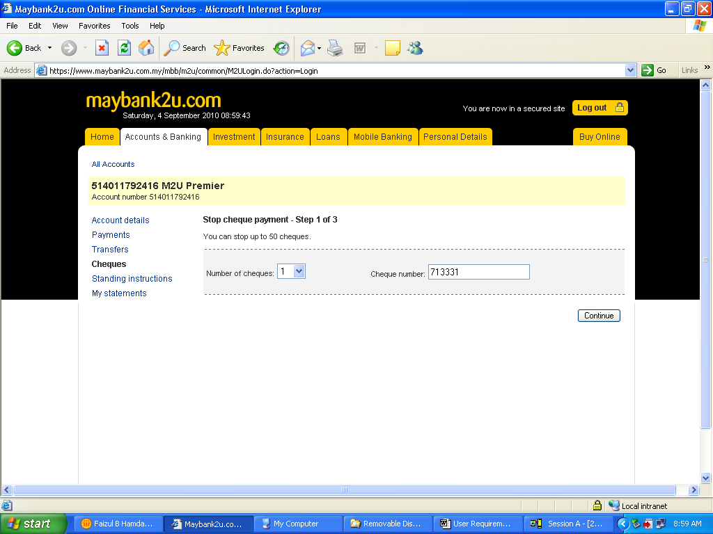

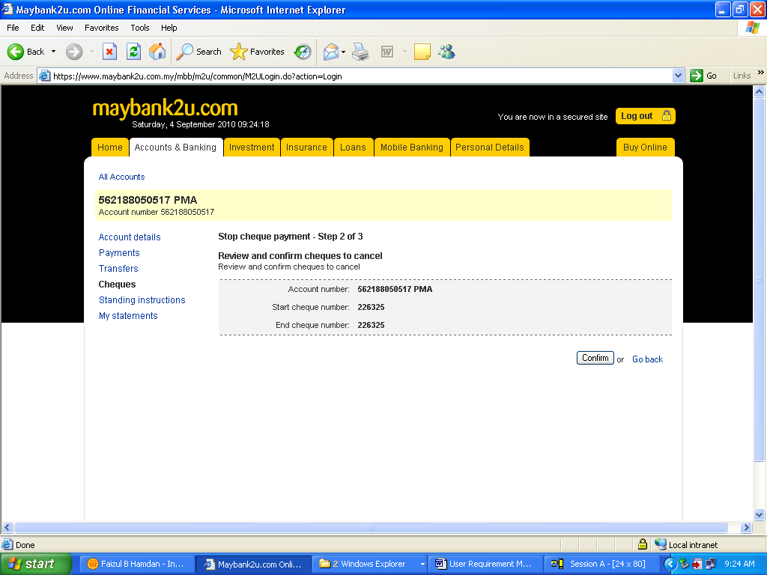

Appendix 3 – Sample Screen - Re Order Cheque Book

