**Agrobank**

|  |
| --- |
| **IBAM - RIB User Enquiry**  **(IE0000034C)** |
| Business Requirement and System Specification |

**(PENRIL/AGRO/BRS/CR/20130502/01)**

**Version: 1.0**

**8 November 2013**

Prepared By:



**Penril Datability (SEA) Sdn Bhd (384556-U)**

Suite A-07-07 Plaza Mon’t Kiara

No. 2, Jalan Kiara, Mon’t Kiara

50480 Kuala Lumpur, Malaysia

Tel: (603) 6201 2622Fax: (603) 6201 7622

Document Amendment Log

|  |  |  |  |  |  |
| --- | --- | --- | --- | --- | --- |
| Rev. No | Date Update | Description of Change | Update By  <Name, Dept> | Review By  <Name, dept> | Approved By  <Name, Dept> |
| 1.0 | 08/11/2013 | Initial Release | Lizahwati Basirun,  Penril Datability | Haida Dasuki, Penril Datability | Tan Lee Yong, Penril Datability |
|  |  |  |  |  |  |
|  |  |  |  |  |  |
|  |  |  |  |  |  |
|  |  |  |  |  |  |

Table of Contents

Document Amendment Log 2

Table of Contents 3

Business Requirement Acceptance 4

Section 1: Introduction 5

Section 2: IBAM 6

2.1 RIB User Enquiry 6

2.1.1 Search and View RIB User Details 6

2.1.1.1 Process Flow 6

2.1.1.2 Screen Designs 7

Section 3: Change Impact Analysis 13

Business Requirement Acceptance

I/We hereby verify that this Business Requirement consist of all the requirements requested by AGROBANK. The implemented system will fulfill ONLY this requirement.

I/We also hereby AGREE that this satisfies our entire requirement for CR IE0000034C – Add Customer ID Filed for IBAM “RIB User Enquiry”

Any future changes to this agreed scope will be treated as an enhancement to the system. Any future changes to the project timeline will be subjected to the final approval of the project steering committee.

**AGROBANK:**

|  |  |  |  |
| --- | --- | --- | --- |
| **Approved by** | **Role** | **Signature** | **Date** |
|  |  |  |  |
|  |  |  |  |
|  |  |  |  |
|  |  |  |  |
|  |  |  |  |
|  |  |  |  |
|  |  |  |  |

**Penril Datability (SEA) Sdn. Bhd.:**

|  |  |  |  |
| --- | --- | --- | --- |
| **Approved by** | **Role** | **Signature** | **Date** |
| Norhaidah Bt Md Dasuki | Project Manager |  |  |
| Alwil Husada | Team Lead |  |  |

Section 1: Introduction

This document served as the business requirement and system specification for the below:-

1. Internet Banking Administration
   1. RIB Transaction Enquiry details

This document shall explain all the features and functionalities, which is elaborating with screen captures, process flow, descriptions, input fields specifications and error messages. **All screen designs provided in this document are samples and only illustration purpose for easy understanding. The screen designs are not final.**

Section 2: IBAM

**Enhancement for the IBAM - RIB User Enquiry module**

We are proposing to add additional filed of Customer ID at IBAM RIB User Enquiry module that allows IBAM user to search and view user details of Retail Internet Banking customers based on Customer ID.

**Purpose:**

1. RIB User Enquiry allows IBAM user to view details of Retail Internet Banking customers.
2. Change request have been raised by users to add another search option by customer ID number to ensure the search result more accurate.

## RIB User Enquiry

## Search and View RIB User Details

### Process Flow



Diagram 1: RIB User Enquiry

### Screen Designs

***Step 1:***

1. IBAM user selects RIB User Enqury side navigation link.
2. IBAM display RIB User Enquiry Search menu.
3. IBAM user input search criteria and click on “**Search**”.

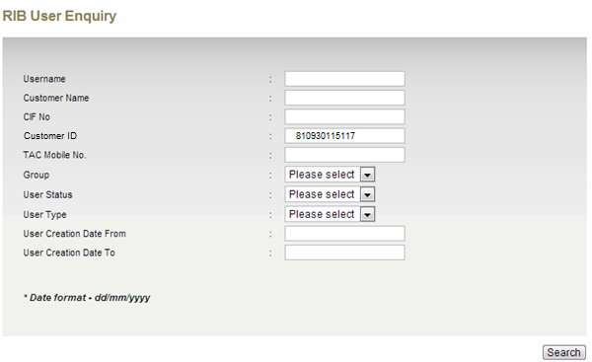

Figure 1: RIB User Enquiry Search page

**Input Specification:**

|  |  |  |  |  |  |
| --- | --- | --- | --- | --- | --- |
| No | Field | Field Type | Validation Rule | Description | Compulsory |
|  | User Name | Text Box | 64 digits of alpha, alpha, or alphanumeric | Search based on RIB User alias which normally will be shown at the RIB page as a nickname. | No |
|  | Customer Name | Text Box | 255 digits of alpha, alpha, alphanumeric, and/or symbol | Search based on RIB User Name | No |
|  | CIF No. | Text Box | 64 digits numeric | Search based on the RIB User CIF No. | No |
|  | ***Customer ID*** | ***Text Box*** | ***15 digits of alphanumeric*** | ***Search based on the RIB User ID No. (New IC, Old IC, Army ID, Police ID)*** | ***No*** |
|  | TAC Mobile No. | Text Box | 64 digits of numeric | Search based on TAC No. | No |
|  | Group | Drop Down List | Drop Down List | Search based on the RIB User Group | No |
|  | User Status | Drop Down List | Drop Down List | Search based on RIB User Status (Normal, Locked, TAC Unlocked). | No |
|  | User Type | Drop Down List | Drop Down List | Search based on the user type. | No |
|  | User Creation Date From | Text Box | Calendar  Format DD/MM/YYYY | Search based on the time when a particular RIB User was created starts from the date specified. | No |
|  | User Creation Date To | Text Box | Calendar  Format DD/MM/YYYY | Search based on the time when a particular RIB User was created ends to the date specified. | No |

Table 1: RIB User Enquiry Search Input Specification

**Action:**

|  |  |  |  |
| --- | --- | --- | --- |
| No | Action | Type | Description |
|  | Search | Button | Contains an action to display the search page according to the parameter had been entered. |

Table 2: RIB User Enquiry Search Input Specification

**List of available messages for the screen:**

|  |  |  |
| --- | --- | --- |
| **No.** | **Event** | **Error Description in English** |
|  | Fill in invalid User Name | No User(s) Found. |
|  | Fill in User Name with special character | User Name cannot include special character except underscore. |
|  | Fill in Customer Name with un allowed special characters. | Customer Name cannot include numeric and special characters except space @. / |
|  | Fill in CIF No with special characters. | CIF No is not numeric. |
|  | ***Fill in Customer ID No with special characters.*** | ***Customer ID cannot include special character*** |
|  | Fill in TAC Mobile No with alphabet and/or special character | TAC Mobile No. is not numeric |

Table 3: RIB User Enquiry Search Error Message List

***Step 2:***

1. IBAM displays a list of users based on search criteria.
2. IBAM user select on one of the RIB user.

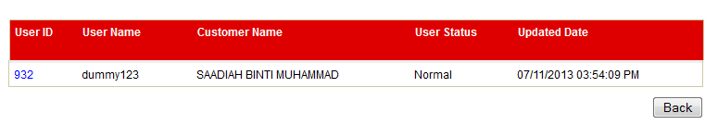

Figure 2: RIB User Enquiry Search Result Page

**Display Specification:**

|  |  |  |  |
| --- | --- | --- | --- |
| No | Field | Format | Description |
| 1. | User ID | Numeric | Shows the selected User ID |
| 2. | User Name | Alpha, numeric, and/or alphanumeric | Shows the user alias, normally this field is shown in RIB home page (E.g.: Welcome back, John) |
| 3. | Customer Name | Alpha, numeric, and/or alphanumeric | Contains the full name of selected RIB User |
| 4. | User Status | Alpha | Shows the user status (Active, Locked, Unlocked, Dormant) |
| 5. | Updated Date | DD/MM/YYYY HH:MM:SS AM/PM | Shows when is the time of that particular RIB User was updated. |

Table 4: RIB User Enquiry Search Result Display Field

**Action:**

|  |  |  |  |
| --- | --- | --- | --- |
| No | Action | Type | Description |
| 1 | User ID | Hyperlink | Goes to selected RIB User Details page |

Table 5: RIB User Enquiry Search Result Action

***Step 3:***

1. IBAM displays the details of selected RIB user.

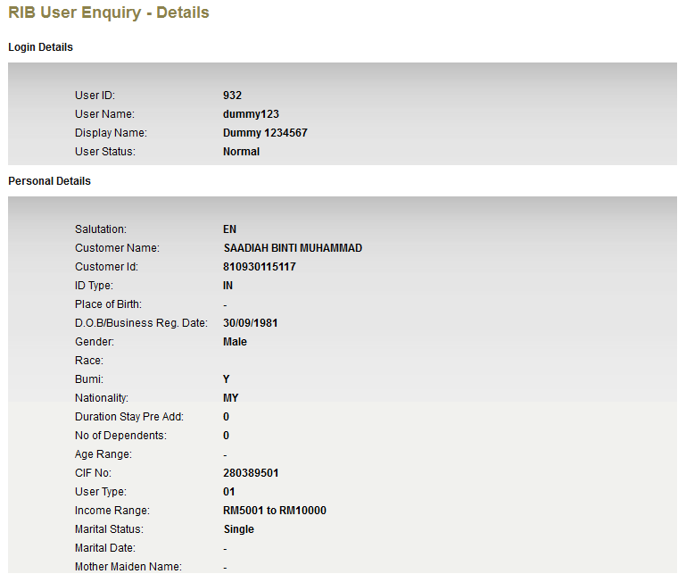

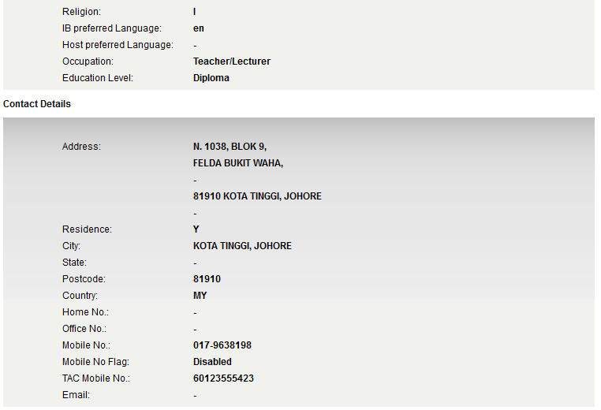

Figure 3: RIB User Details Screen

**Display Specification:**

|  |  |  |  |
| --- | --- | --- | --- |
| No | Field | Field Type | Description |
|  | User ID | Numeric | Shows the selected User ID |
|  | User Name | Alpha, numeric, and/or alphanumeric | Shows the user name |
|  | Display Name | Alpha, numeric, and/or alphanumeric | Shows the user display name, normally this field is shown in RIB home page (E.g.: Welcome back, John) |
|  | User Status | Alpha | Shows the user status (Normal, Locked, Unlocked, TAC Locked, Dormant) |
|  | Salutation | Alpha | Shows the salutation of the user |
|  | Customer Name | Alpha, numeric, and/or alphanumeric | Contains the full name of selected RIB User |
|  | ***Customer ID*** | ***Alphanumeric*** | ***Show the user ID No. (New IC, Old IC, Army ID, Police ID)*** |
|  | ID Type | Alpha, numeric, and/or alphanumeric | Shows the ID Type of the user |
|  | Place of Birth | Alpha, numeric, and/or alphanumeric | Shows the user place of birth |
|  | D.O.B. / Business Reg. Date | Alpha, Special Character | Date of Birth of the user |
|  | Gender | Alpha | Shows the gender of the user |
|  | Race | Alpha | Shows the race of the user |
|  | Bumi | Alpha | Shows the user bumiputra status |
|  | Nationality | Alpha | Shows the user nationality |
|  | Duration Stay Pre Add | Numeric | Shows the duration of Stay Pre Add |
|  | No of Dependents | Numeric | Shows the user no of dependents |
|  | Age Range | Alpha, Numeric, and or special character | Shows the user age range |
|  | CIF No | Numeric | Shows the CIF No |
|  | User Type | Numeric | Shows the user type |
|  | Income Range | Alpha, numeric, and/or alphanumeric | Shows the user income range |
|  | Marital Status | Alpha | Shows the user marital status |
|  | Marital Date | Date | Shows the user marital date |
|  | Mother Maiden Name | Alpha, numeric, and/or alphanumeric | Shows the user mother maiden name |
|  | Religion | Alpha | Shows the user religion |
|  | IB preferred Language | Alpha | Shows the IB preferred language |
|  | Host preferred Language | Alpha | Shows the Host preferred language |
|  | Occupation | Alpha, numeric, and/or alphanumeric, special character | Shows the user occupation |
|  | Education Level | Alpha, numeric, and/or alphanumeric | Shows the user education level |
|  | Address | Alpha, Numeric, and or special character | Shows the address of the user |
|  | Residence | Alpha | Shows user residency |
|  | City | Alpha, numeric, and/or alphanumeric, special character | Shows user city |
|  | State | Alpha, numeric, and/or alphanumeric, special character | Shows user state |
|  | Postcode | Numeric | Shows user postcode |
|  | Country | Alpha | Shows user country |
|  | Home No. | Numeric, special character | Shows the home contact no. |
|  | Office No. | Numeric, special character | Shows the office contact no. |
|  | Mobile No. | Numeric, special character | Shows the user’s mobile contact no. |
|  | Mobile No Flag | Alpha | Shows the mobile no flag |
|  | TAC Mobile No. | Numeric, special character | Shows the user’s mobile no. that is registered with the TAC for transaction security purposes. |
|  | Email | <field>@<field>.com | Shows the user’s email contact. |
|  | Created By | Alpha, numeric | Shows the creator of this RIB User |
|  | Updated By | Alpha, numeric | Shows the name of last IBAM User who had updated that RIB User details. |
|  | Creation Date | DD/MM/YYYY HH:MM:SS AM/PM | Shows when is the time of that particular RIB User was created. |
|  | Updated Date | DD/MM/YYYY HH:MM:SS AM/PM | Shows when is the time of that particular RIB User was updated. |

Table 6: RIB User Details Display Field

**Action:**

|  |  |  |  |
| --- | --- | --- | --- |
| No | Action | Type | Description |
| 1. | Back | Button | Goes back to previous page(**RIB User Enquiry Search Result page)** |

Table 7: RIB User Details Action

Section 3: Change Impact Analysis

Impacted Modules:-

|  |  |  |
| --- | --- | --- |
| No | Modules | Changes |
|  | IBAM->RIB User Enquiry | Added new field, “Customer ID”, allowing bank admin to search and view RIB Customer details based on Customer ID Number. |

---END-- -