**Agrobank**

|  |
| --- |
| **Internet Banking Giro Status**  **(IE0000039C)** |
| Business Requirement and System Specification |

**(PENRIL/AGRO/BRS/20130502/03)**

**Version:1.0**

**23 October 2013**

Prepared By:



**Penril Datability (SEA) Sdn Bhd (384556-U)**

Suite A-07-07 Plaza Mon’t Kiara

No. 2, Jalan Kiara, Mon’t Kiara

50480 Kuala Lumpur, Malaysia

Tel: (603) 6201 2622Fax: (603) 6201 7622

Document Amendment Log

|  |  |  |  |  |  |
| --- | --- | --- | --- | --- | --- |
| Rev. No | Date Update | Description of Change | Update By  <Name, Dept> | Review By  <Name, dept> | Approved By  <Name, Dept> |
| 1.0 | 23/10/2013 | Initial Release | Lizahwati Basirun,  Penril Datability | Haida Dasuki, Penril Datability | Tan Lee Yong, Penril Datability |
|  |  |  |  |  |  |
|  |  |  |  |  |  |
|  |  |  |  |  |  |
|  |  |  |  |  |  |

Table of Contents

Document Amendment Log 2

Table of Contents 3

Business Requirement Acceptance 4

Section 1: Introduction 5

Section 2: RIB and BIB 6

2.1 Interbank Account Transfer 7

2.1.1 New Interbank and Favourite Interbank 7

2.1.1.1 Process Flow 7

2.1.1.2 Screen Designs 7

2.1.2 SMS Notification 10

2.1.3 AGRONet Transaction History 11

Section 3: IBAM 12

3.1 RIB Transaction Enquiry 12

3.1.1 New Interbank Transfer and Favourite Interbank Transfer 12

3.1.1.1 Process Flow 12

3.1.1.2 Screen Designs 12

Section 4: Change Impact Analysis 17

Business Requirement Acceptance

I/We hereby verify that this Business Requirement consist of all the requirements requested by AGROBANK. The implemented system will fulfill ONLY this requirement.

I/We also hereby AGREE that this satisfies our entire requirement for CR IE0000034C – Add Customer ID Filed for IBAM “RIB User Enquiry”

Any future changes to this agreed scope will be treated as an enhancement to the system. Any future changes to the project timeline will be subjected to the final approval of the project steering committee.

**AGROBANK:**

|  |  |  |  |
| --- | --- | --- | --- |
| **Approved by** | **Role** | **Signature** | **Date** |
|  |  |  |  |
|  |  |  |  |
|  |  |  |  |
|  |  |  |  |
|  |  |  |  |
|  |  |  |  |
|  |  |  |  |

**Penril Datability (SEA) Sdn. Bhd.:**

|  |  |  |  |
| --- | --- | --- | --- |
| **Approved by** | **Role** | **Signature** | **Date** |
| Norhaidah Bt Md Dasuki | Project Manager |  |  |
| Alwil Husada | Team Lead |  |  |

Section 1: Introduction

This document served as the business requirement and system specification for the below:-

1. Retail Internet Banking (RIB)
   1. New IBG and Favourite Interbank result page, receipt page, AGRONet Transaction History details and SMS Notification details
2. Business Internet Banking (BIB)
   1. New IBG and Favourite Interbank result page, receipt page, AGRONet Transaction History details and SMS Notification details
3. Internet Banking Administration
   1. RIB Transaction Enquiry details

This document shall explain all the features and functionalities, which is elaborating with screen captures, process flow, descriptions, input fields specifications and error messages. All screen designs provided in this document are samples and only illustration purpose for easy understanding. The screen designs are not final.

Section 2: RIB and BIB

**Enhancement for the RIB/BIB> Fund Transfer – Interbank Account Transfer (IBG)**

These changes will cater for:

1. Retails Internet Banking (RIB)
2. Business Internet Banking(BIB)

**Purpose:**

Change status “Successful to “Accepted” and “[The success of your transfer is conditional to the accuracy of information provided]”

* IBG Screen (New and Favourite Interbank transaction)
* IBG Receipt (New and Favourite Interbank transaction)
* IBG Online Transaction History
* SMS Notification

The general steps of IBG transfer for BIB and RIB are similar to each other. However, this manual demonstrates Interbank Transfer for RIB only.

*Notes:*

The new status will be reflected after deployed the fix to production. All the passed status before the deployment date and time will remain **unchanged**.

## Interbank Account Transfer

## New Interbank and Favourite Interbank

### Process Flow



Diagram 1: Fund Transfer – Interbank Transfer Flow Diagram

### Screen Designs

***Step 1:***

1. RIB User accesses the Interbank Account Transfer screen and IBS displays Interbank Transfer screen.
2. IBS display Interbank Transfer input screen
3. RIB User input all the required details

***Step 2:***

1. IBS display Interbank Transfer confirmation screen
2. RIB User confirms Interbank Transfer

***Step 3:***

1. RIB User view Interbank Transfer Result screen.

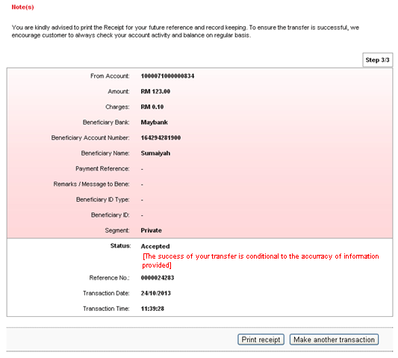

**Figure 1: Interbank Transfer Result Page**

**Display Fields:**

| **No** | **Field** | **Format** | **Description** |
| --- | --- | --- | --- |
|  | From Account | Numeric | Shows the account number of sender |
|  | Amount | Text | Shows the inserted amount of transaction |
|  | Charges | Text | Shows the inserted charges of transaction |
|  | Beneficiary Bank | Text | Shows the beneficiary bank of the Interbank Beneficiary |
|  | Beneficiary Account Number | Numeric | Shows the account number of Interbank Beneficiary |
|  | Beneficiary Name | Text | Shows the beneficiary name |
|  | Payment Reference | Text | Shows the reference of the payment |
|  | Remarks / Message to Bene | Text | Shows the remarks of user |
|  | Beneficiary ID Type | Text | Show the Beneficiary ID Type |
|  | Beneficiary ID | Text | Show the Beneficiary ID |
|  | Segment | Text | Shows segment for Interbank transfer |
|  | Status | Text | Shows the status of transaction |
|  | References No | Numeric | Shows the references number of particular transaction |
|  | Transaction Date | DD/MM/YYYY | Shows the date of transaction |
|  | Transaction Time | HH:MM:SS | Show the time of transaction |

Table 1: Interbank Transfer via IBG Result Display Fields

**Action:**

| **No** | **Action** | **Type** | **Description** |
| --- | --- | --- | --- |
|  | Make another transaction | Button | Contains an action to go back to fund transfer page |
|  | Print Receipt | Button | Contains an action to generate receipt’s pop-up display |

Table 2: Interbank Transfer via IBG Result List Action

***Step 4:***

1. User is able to print out the receipt by clicking on the “Print Receipt” button. RIB system displays the print form of New Interbank Transfer Receipt.
2. 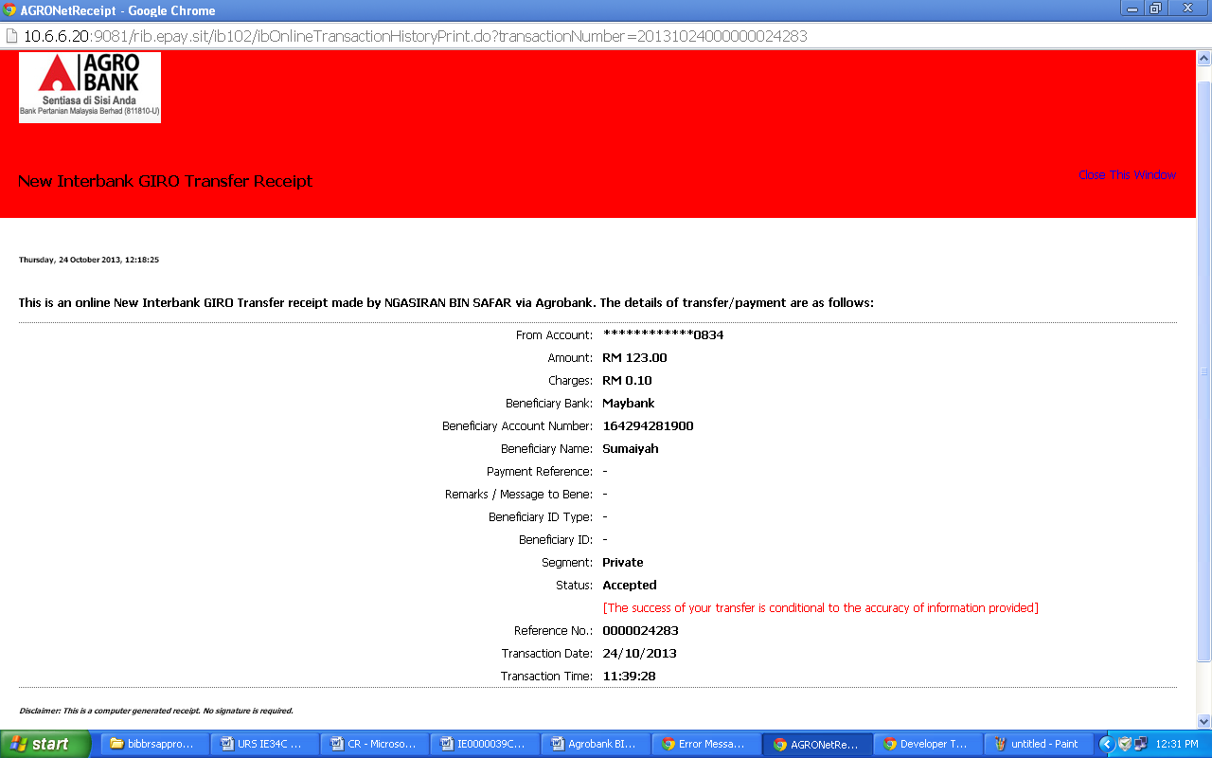

**Display Fields:**

| **No** | **Field** | **Format** | **Description** |
| --- | --- | --- | --- |
|  | From Account | Numeric,  Partial Masked | Shows the account number of sender |
|  | Amount | Text | Shows the inserted amount of transaction |
|  | Charges | Text | Shows service Charges for Interbank transfer |
|  | Beneficiary Bank | Text | Shows the beneficiary bank of the Interbank Beneficiary |
|  | Beneficiary Account Number | Numeric | Shows the account number of Interbank Beneficiary |
|  | Beneficiary Name | Text | Shows the name of beneficiary |
|  | Payment Reference | Text | Shows the reference of the payment |
|  | Remarks/ Message to Bene | Text | Shows the remarks or comment for the transaction |
|  | Beneficiary ID Type | Text | Show the Beneficiary ID Type |
|  | Beneficiary ID | Text | Show the Beneficiary ID |
|  | Segment | Text | Shows segment for Interbank transfer |
|  | Status | Text | Shows the status of transaction |
|  | References No | Numeric | Shows the references number of particular transaction |
|  | Transaction Date | DD/MM/YYYY | Shows the date of transaction |
|  | Transaction Time | HH:MM:SS | Show the time of transaction |

Table 3: Interbank Fund Transfer via IBG Print Receipt Display Fields

**Action:**

| **No** | **Action** | **Type** | **Description** |
| --- | --- | --- | --- |
|  | Close the Window | Hyperlink | Contains an action to close the print receipt window. |

Table 4: Interbank Fund Transfer via IBG Print Receipt Action

## SMS Notification

RIB user will receive the SMS Notification to inform the user about the successful transaction.

|  |
| --- |
| RM0.00 AGRONet: Interbank Trf – RM123.00 Accepted on 24 Oct 2013 11:39:28. Call 1 300 88 2476 for inquiries. TQ |

## AGRONet Transaction History

RIB user is able to check their history on AGRONet Transaction History details.

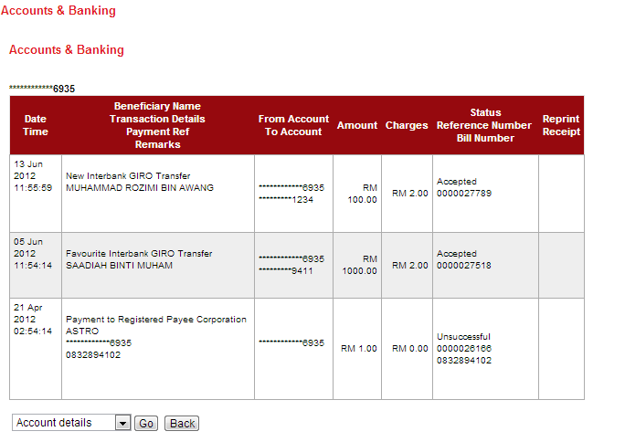

Display Fields:

|  |  |  |  |
| --- | --- | --- | --- |
| No | Field | Format | Description |
|  | Date Time | DD/MM/YYYY HH:MM:SS | Shows the date and time of the occurring transaction |
|  | Beneficiary Name, Transaction Details, Payment Ref, Remarks | Text | Shows the Transaction Details |
|  | From Account To Account | Numeric | Shows From account and to account number in particular transaction. |
|  | Amount | Numeric | Shows Amount of funds in particular transaction |
|  | Chargers | Numeric | Shows Chargers of funds in particular transaction |
|  | ***Status***  ***Reference Number*** | ***Text*** | ***Show status and reference number of the Transaction.*** |

Table 5: AGRONet Transaction History details

Section 3: IBAM

## RIB Transaction Enquiry

This feature allows an authorized IBAM user to view Retail Internet Banking monetary transaction activities.

## New Interbank Transfer and Favourite Interbank Transfer

### Process Flow



Diagram 2: RIB Transaction Enquiry Flow Diagram

### Screen Designs

***Step 1:***

1. Admin can access to RIB Transaction Enquiry Screen by clicking on the “RIB Transaction Enquiry” link on the left navigation menu
2. Admin may input search criteria and click the “Search” button. The search/filter mechanism working as OR case, which means all items are optional
3. ***Admin can select “Accepted” status from Transaction Status drop down list***

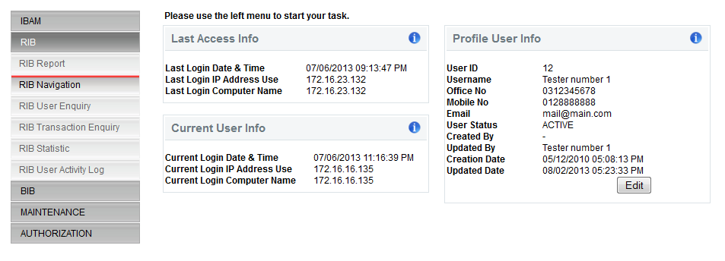

Figure 2: RIB Transaction Enquiry Side Navigation

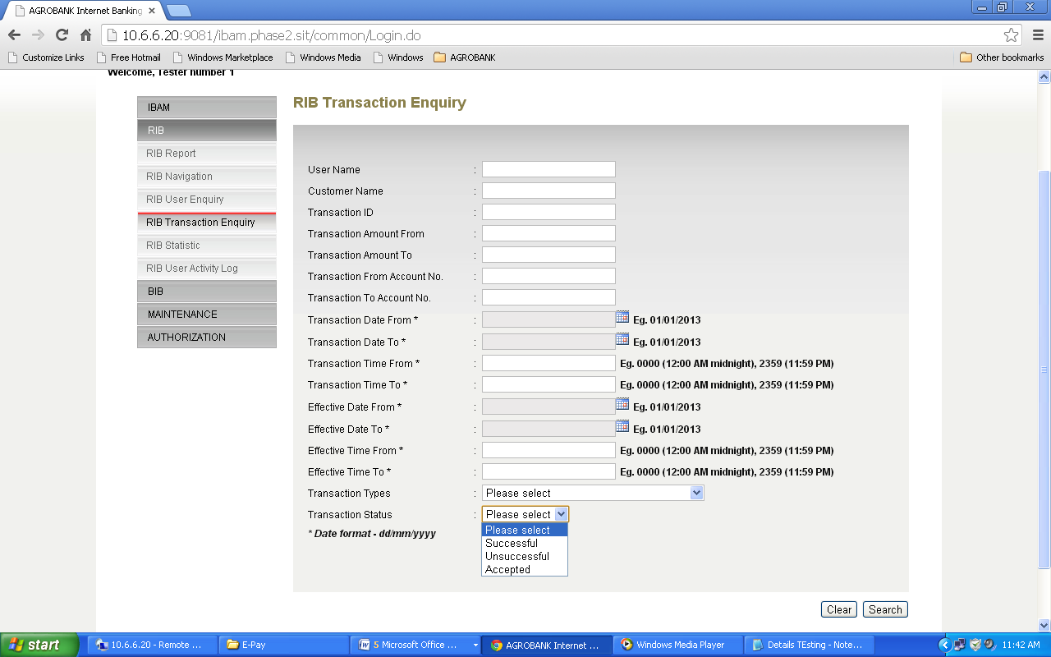

Figure 3: RIB Transaction Enquiry Screen

**Input Specification:**

|  |  |  |  |  |  |
| --- | --- | --- | --- | --- | --- |
| No | Field | Field Type | Validation Rule | Description | Compulsory |
|  | User Name | Text Box | 64 digits of alphanumeric. | Search based on the user alias, normally it is displayed in RIB homepage (E.g.: Welcome back, *John*). Used as a nickname. | No |
|  | Customer Name | Text Box | 255 digits of alpha and symbol | Search any transaction according to the User Name. | No |
|  | Transaction ID | Text Box | Numeric | Search based on the transaction ID. | No |
|  | Transaction Amount From | Text Box | Numeric | Search any transaction based on the transaction amount starts from the field defined (from minimum amount). | No |
|  | Transaction Amount To | Text Box | Numeric | Search any transaction based on the transaction amount ends to the field defined (to maximum amount). | No |
|  | Transaction From Account No. | Text Box | Numeric | Search according to the account no. which had initiated the transaction. | No |
|  | Transaction To Account No. | Text Box | Numeric | Search according to the account no. which had received the transaction. | No |
|  | Transaction Date From | Calendar, Date Picker | DD/MM/YYYY | Search any transaction that occurred from the date defined. | No |
|  | Transaction Date to | Calendar, Date Picker | DD/MM/YYYY | Search any transaction that occurred until to the date defined. | No |
|  | Transaction Time From | Text Box | hh:mm | Search any transaction that occurred from the time defined. | No |
|  | Transaction Time to | Text Box | hh:mm | Search any transaction that occurred until to the time defined. | No |
|  | Effective Date From | Calendar, Date Picker | DD/MM/YYYY | Search any transaction that occurred from the effective date defined. | No |
|  | Effective Date To | Calendar, Date Picker | DD/MM/YYYY | Search any transaction that occurred to the effective date defined. | No |
|  | Transaction Type | Drop Down List |  | Search according to the transaction type. | No |
|  | ***Transaction Status*** | ***Drop Down List*** |  | ***Search any transaction based on the status whether ‘successful or unsuccessful’ or accepted.*** | ***No*** |

Table 5: RIB Transaction Enquiry Specification

**Action:**

|  |  |  |  |
| --- | --- | --- | --- |
| No | Action | Type | Description |
| 1. | Search | Button | To retrieve list of transaction, based on the search criteria or list of all transactions, if no criteria specified. |

Table 6: RIB Transaction Enquiry Action

**List of available messages for the screen**

|  |  |  |
| --- | --- | --- |
| **No.** | **Event** | **Error Description in English** |
| 1. | Fill in User Name with special character | |  | | --- | | User Name is not an alphanumeric. | |
| 2. | Fill in Transaction ID field with alpha and/or special character | |  | | --- | | Transaction ID is not numeric. | |
| 3. | Fill in Transaction Amount from and/or to field with alphabet. | Transaction Amount From/To is not in proper currency format. |
| 4. | Fill in Transaction from and/or to account number with alphabet or special character. | Transaction From/To Account No is not numeric. |
| 5. | Fill in Transaction Date from and/or to field with invalid date format. | Transaction Date From/To is an invalid date/time format |
| 6. | Fill in Effective Date from and/or to field with invalid date format. | Effective Date From/To is an invalid date/time format |

Table 7: RIB Transaction Enquiry Action

***Step 2:***

1. IBAM display RIB Transaction Listing which based on Interbank Transaction.
2. Admin can view an RIB Transaction Details by clicking on a Transaction ID.
3. Admin can check the transaction in RIB Transaction Enquiry with the “**Accepted**” status for IBG transfer.

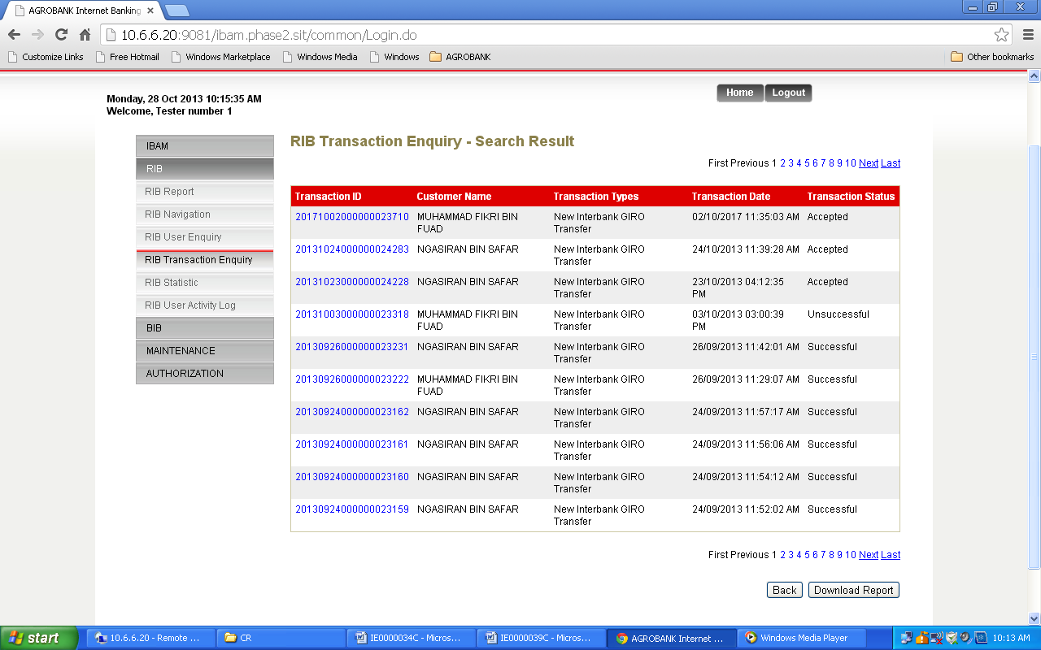

Figure 4: RIB Transaction Enquiry List Screen

**Display Specification:**

|  |  |  |  |
| --- | --- | --- | --- |
| No | Field | Format | Description |
| 1. | Transaction ID | Numeric | Transaction Unique ID |
| 2. | Customer Name | Alpha, Numeric, and or special character | Customer Name |
| 3. | Transaction Type | Textbox | Type of transactions performed by customer. |
| 4. | Transaction Date | Date and Time Format | Date of Transaction performed |
| ***5.*** | ***Transaction Status*** | ***Textbox*** | ***Status of transaction*** |

Table 8: RIB Transaction Enquiry List Display Field

**Action:**

|  |  |  |  |
| --- | --- | --- | --- |
| No | Action | Type | Description |
|  | Transaction ID | Hyperlink | Contains an action to display the details of transaction according to particular transaction ID selected. |
|  | Back | Button | Goes back to the RIB Transaction Search page. |
|  | Page No. | Hyperlink | Contains an action to display the list of any transaction that listed on the other page. |

Table 9: RIB Transaction Enquiry List Action

***Step 3:***

1. IBAM display IB Transaction Details.

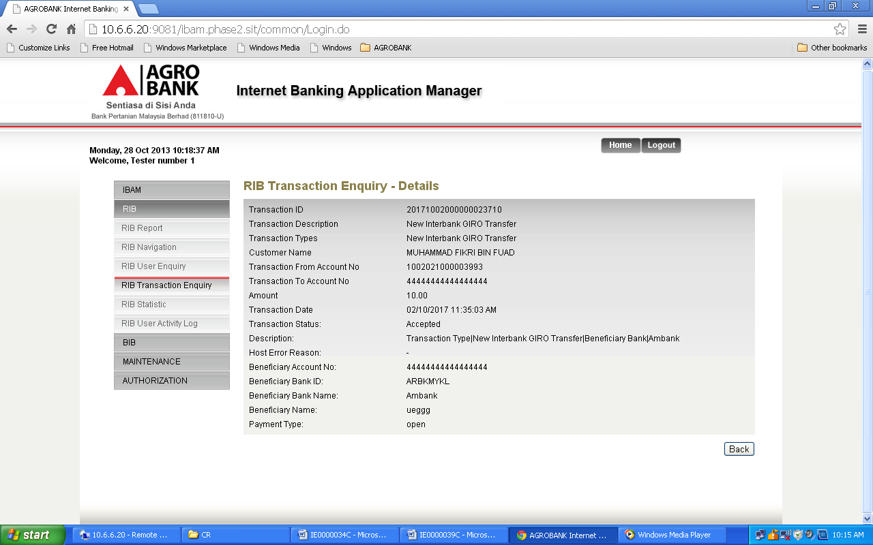

Figure 5: Sample of RIB Transaction Enquiry Details Screen

**Action:**

|  |  |  |  |
| --- | --- | --- | --- |
| No | Action | Type | Description |
| 1. | Back | Button | Goes back to the RIB Transaction Enquiry – Search Result page. |

Table 10: RIB Transaction Enquiry Details Action

Section 4: Change Impact Analysis

Impacted Modules:-

|  |  |  |
| --- | --- | --- |
| No | Modules | Changes |
|  | IBAM->RIB Transaction Enquiry  IBAM->BIB Transaction Enquiry | Status changes from “Successful” to “Accepted” for module New Interbank Transfer and Favourite Interbank Transfer |
|  | * RIB   + New Interbank Transfer   + Favourite Interbank Transfer * BIB   + For Single User     - New Interbank Transfer     - Favourite Interbank Transfer   + Approver     - Authorization Module | Status changes from “**Successful**” to “**Accepted**” for modules New Interbank Transfer and Favourite Interbank Transfer at result and receipt pages, AGRONet Transaction History, SMS Notification and Logout Summary |

---END-- -