Request ID# 1327
Test Title: |  | RIB/BIB: PaySwitch – Label name for field Bill No. / Bill Ref. No. * not appeared in Favourite Bill Payment screen for SYABAS.
Test Description: |  | To ensure Bill No./ Bill Ref. No appear in Favourite Bill Payment screen for SYABAS
Test Functionality: |  | IBAM>Content>Payee>Bill Payment  RIB>Bill Payment>Favourite Payee Maintenance  RIB>Bill Payment>Favourite Bill Payment  BIB>Bill Payment>Favourite Payee Maintenance  BIB>Bill Payment>Favourite Bill Payment
Test Procedure: |  | - Add SYABAS as Favourite  - Make a bill payment for SYABAS favourite
Response Message:
- RIB
  - Go to result page with message successful or unsuccessful
- BIB
  - Go to result page with message Pending for Initiator and Successful or Unsuccessful for Single User.
Test Result: | Pass: Fail: |  | Tested by: | Lizahwati Basirun (QA Engineer)
Reason for Failure:
Remarks: |  | Test Item 1: To test on navigation flag for Bill No./ Bill Ref. No in IBAM. Set flag as NO  Result:  In RIB/BIB will not showing the field for Bill No./ Bill Ref. No  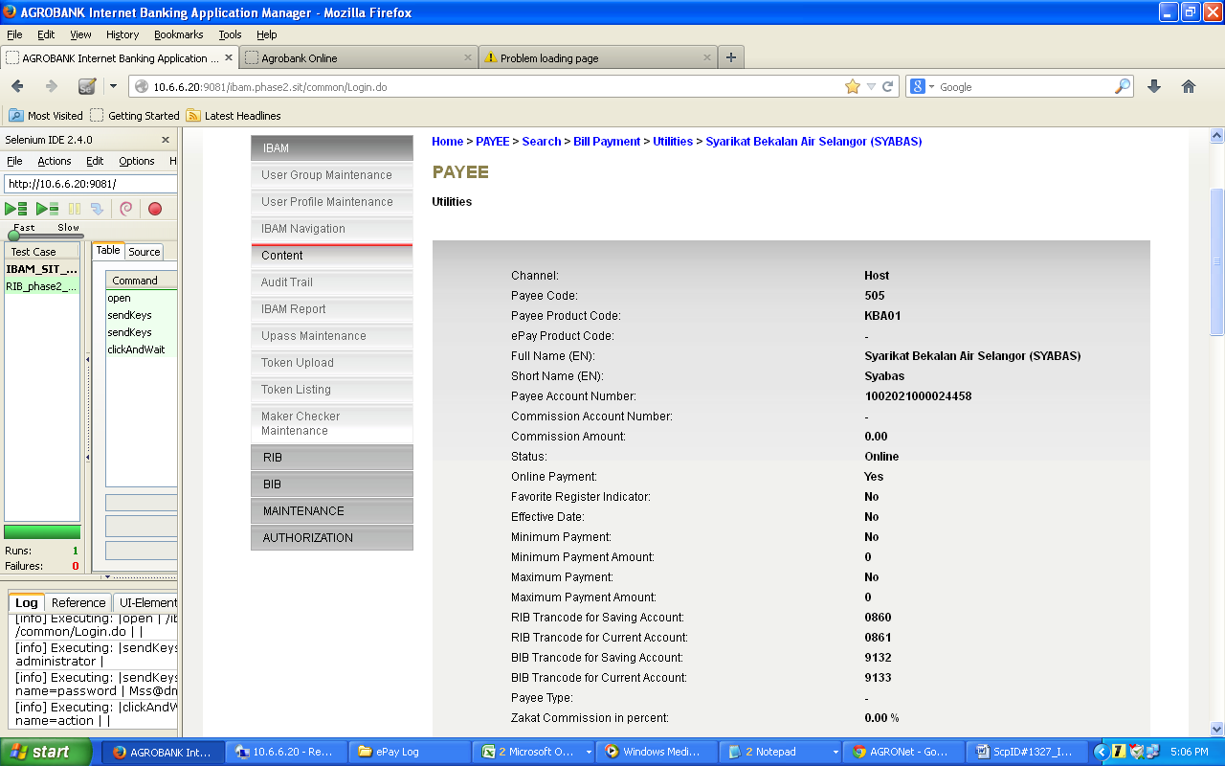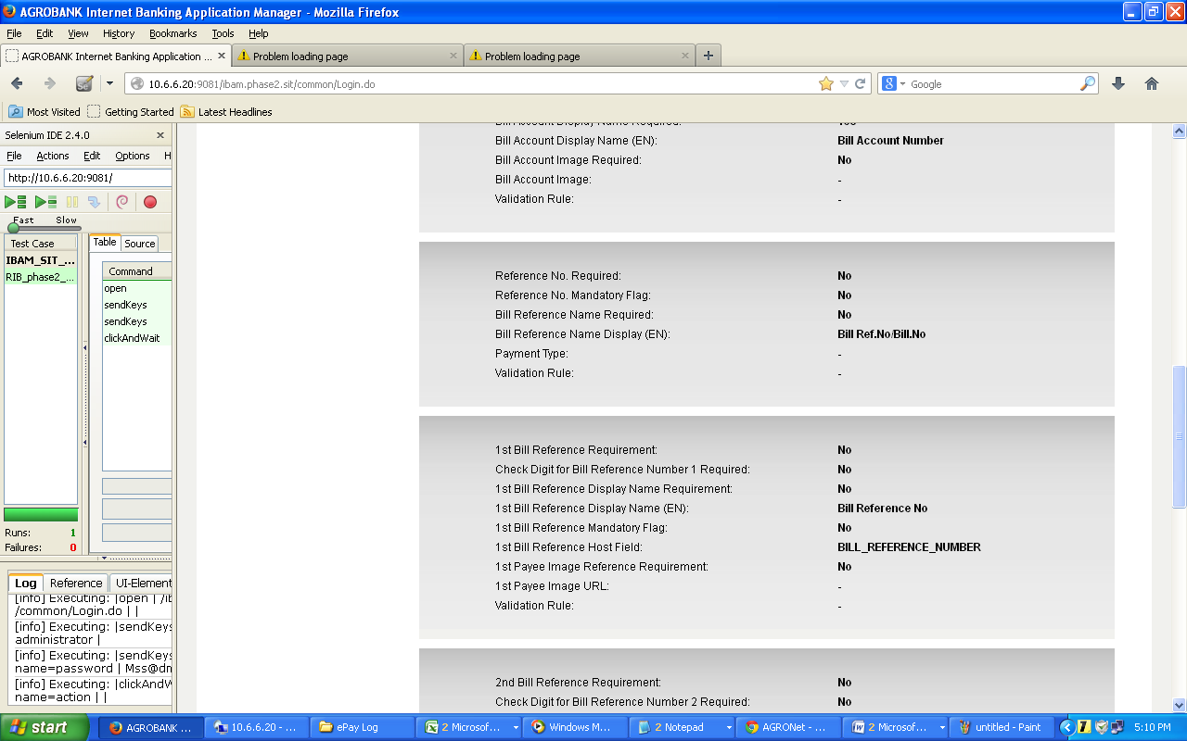  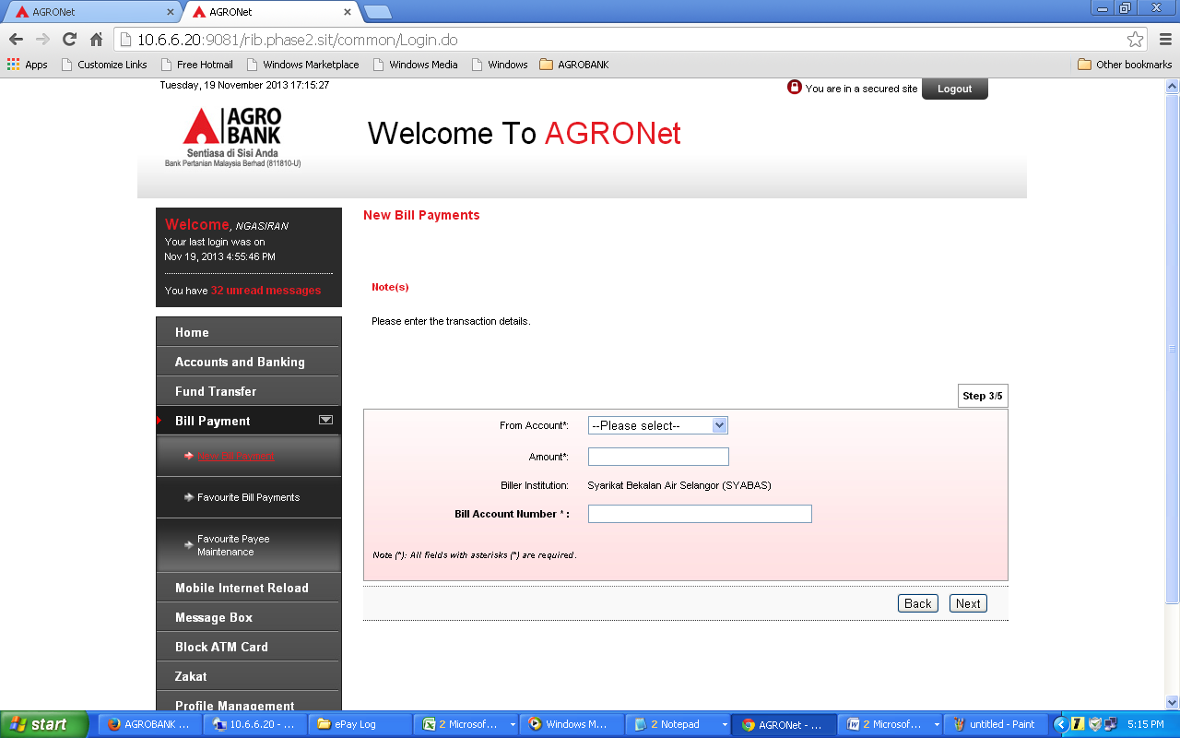  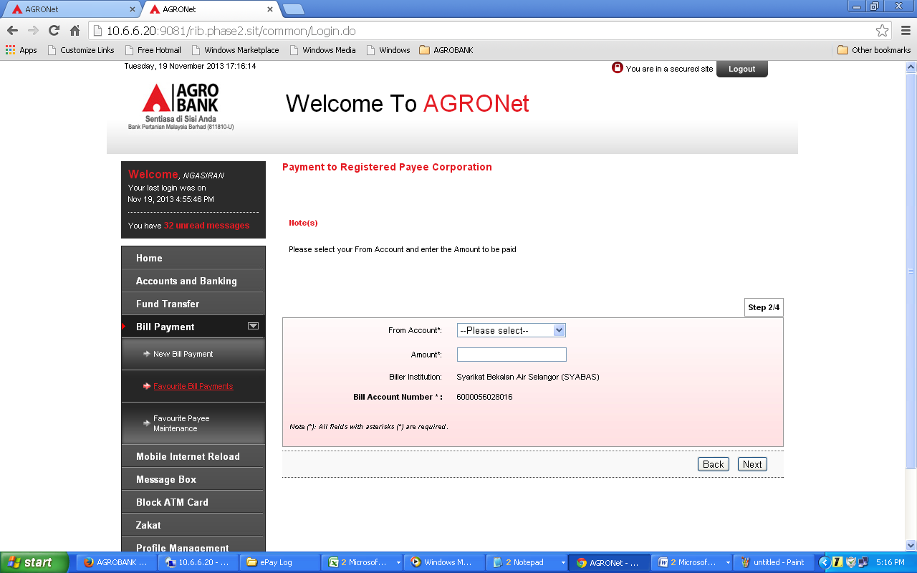  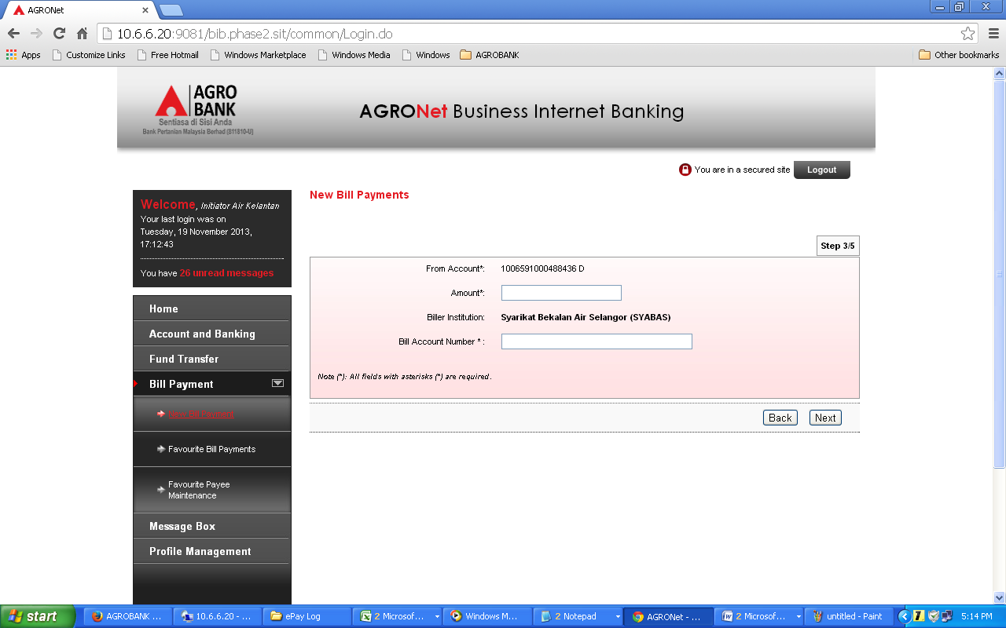  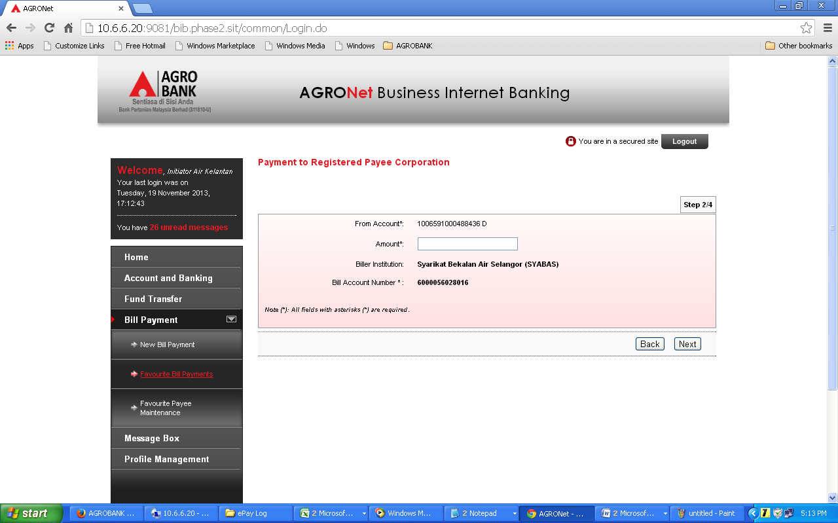  Test Item 2: To test on navigation flag for Bill No./ Bill Ref. No in IBAM. Set flag as YES  Result:  In RIB/BIB will showing the field for Bill No./ Bill Ref. No  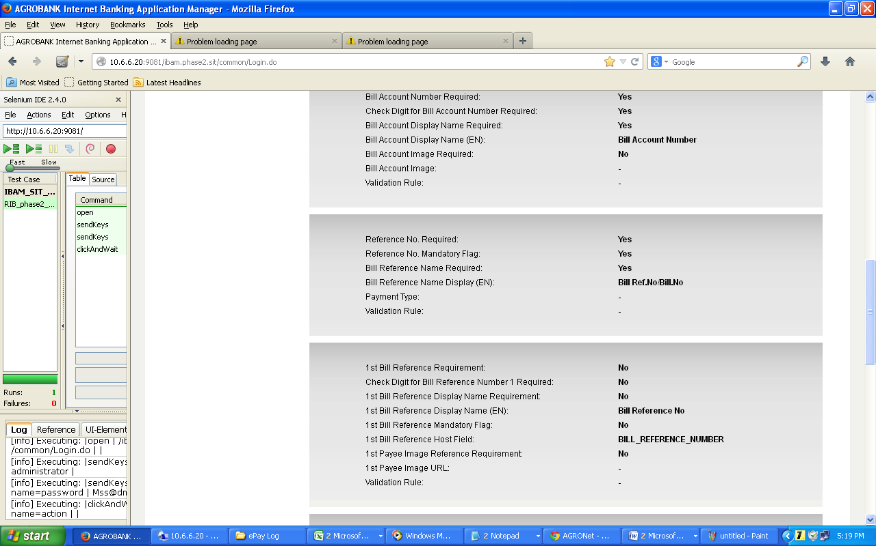  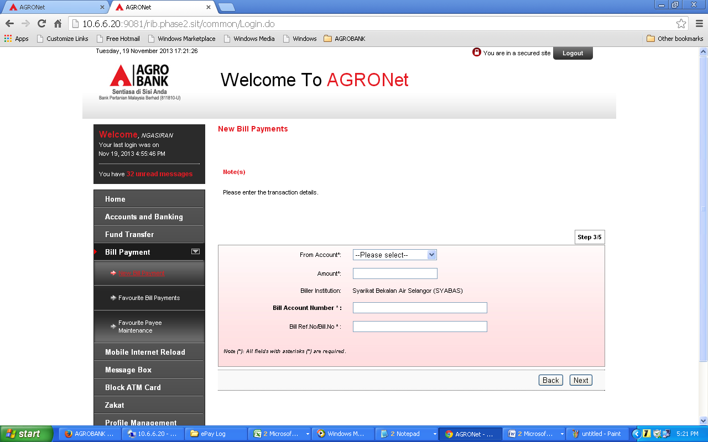  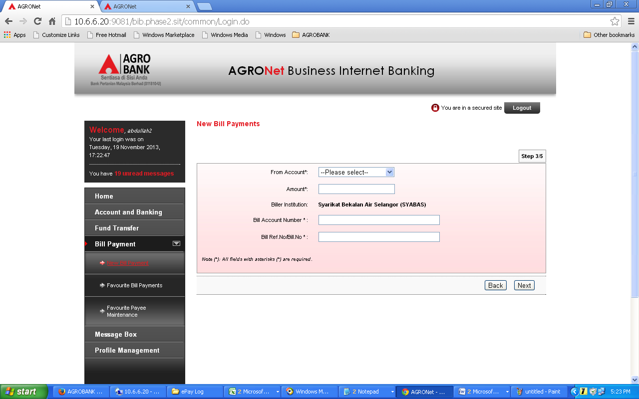  Test Item 3: To test on Add SYABAS as Favourite Payee  Result:  In Bill Payment Favourite Payee Add, IB will store the Bill Account Number only.  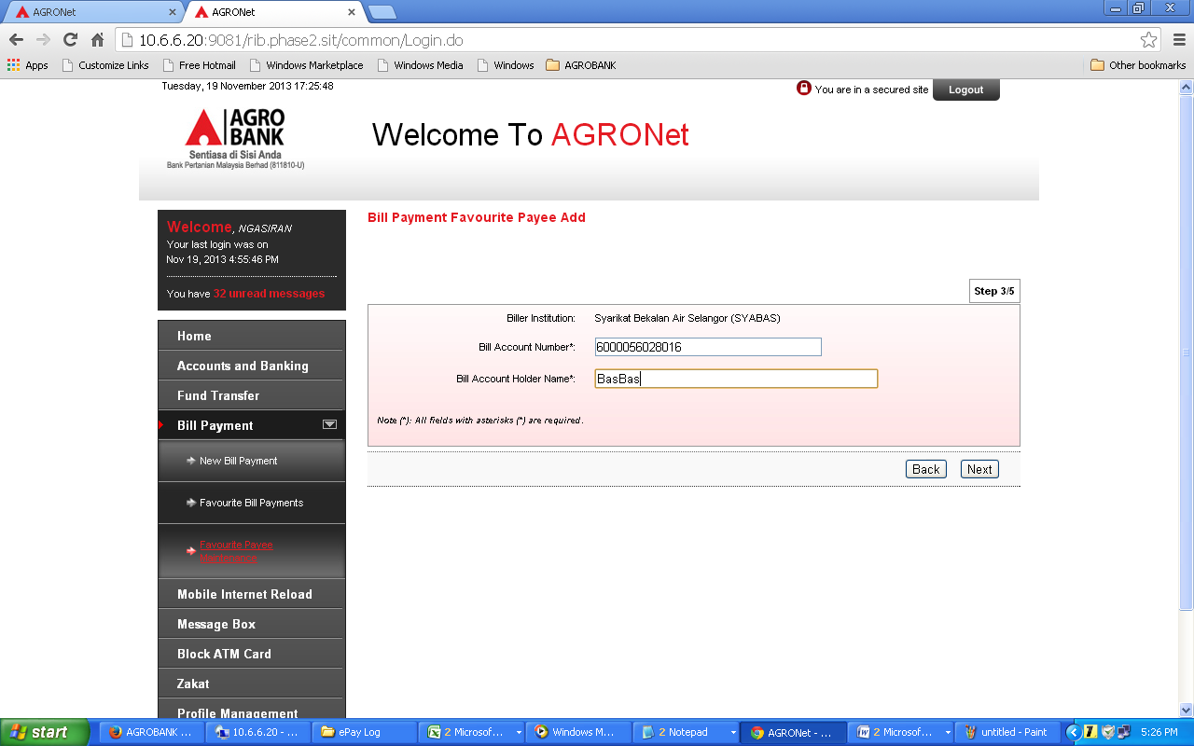  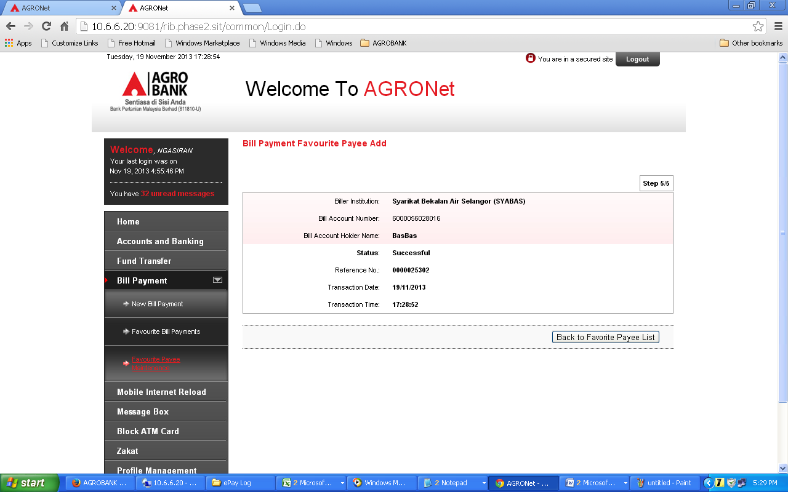  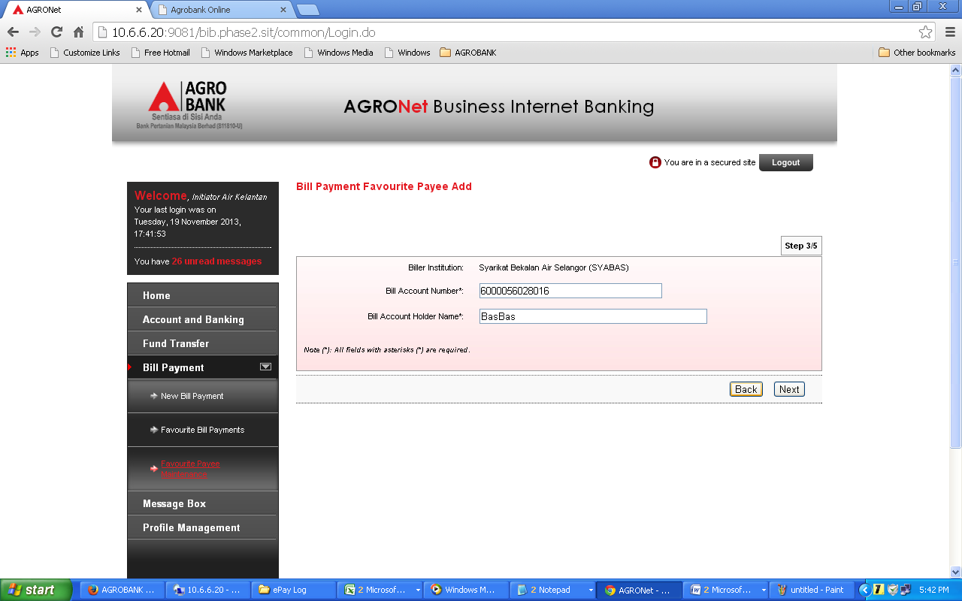  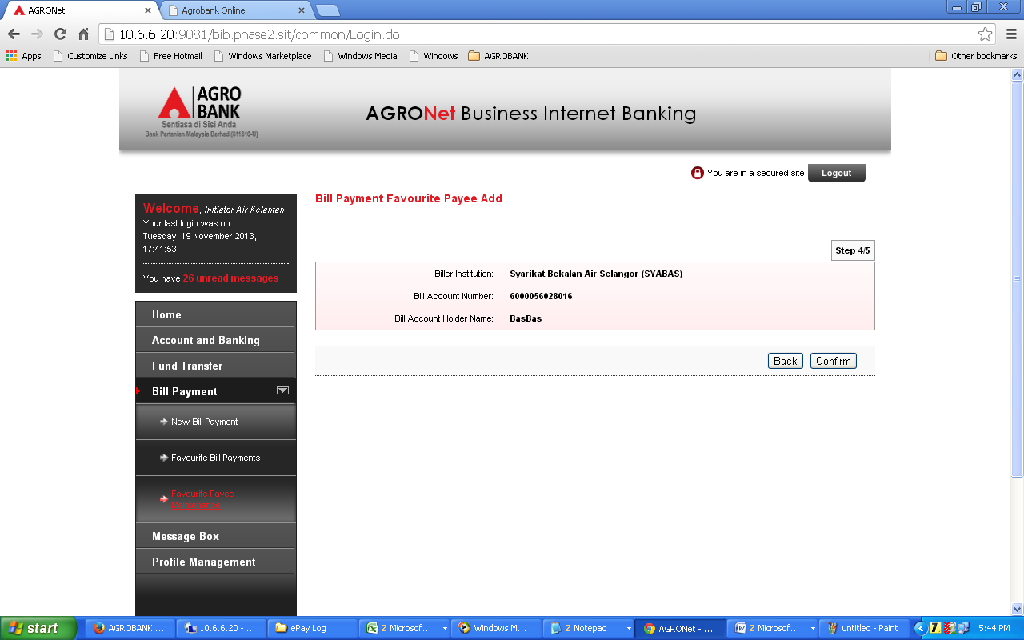  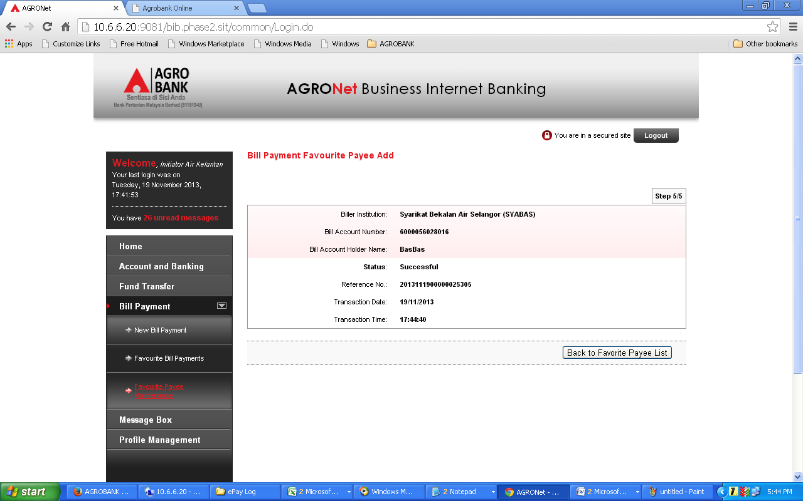  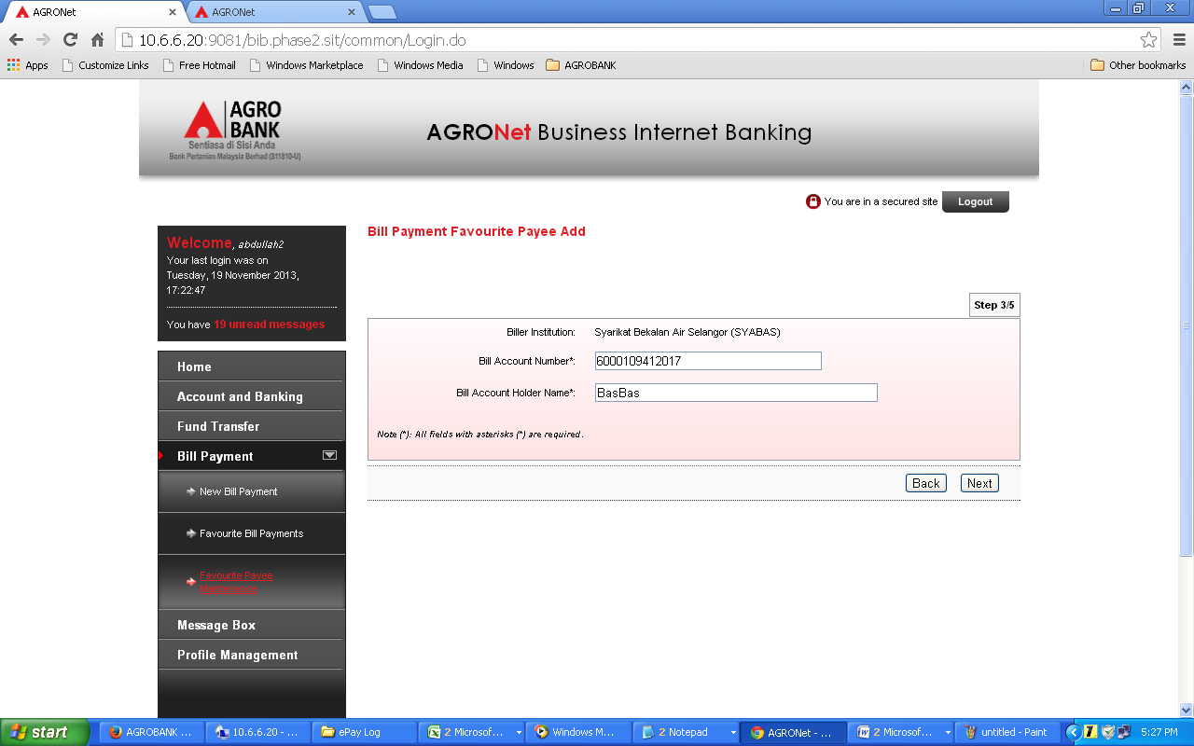  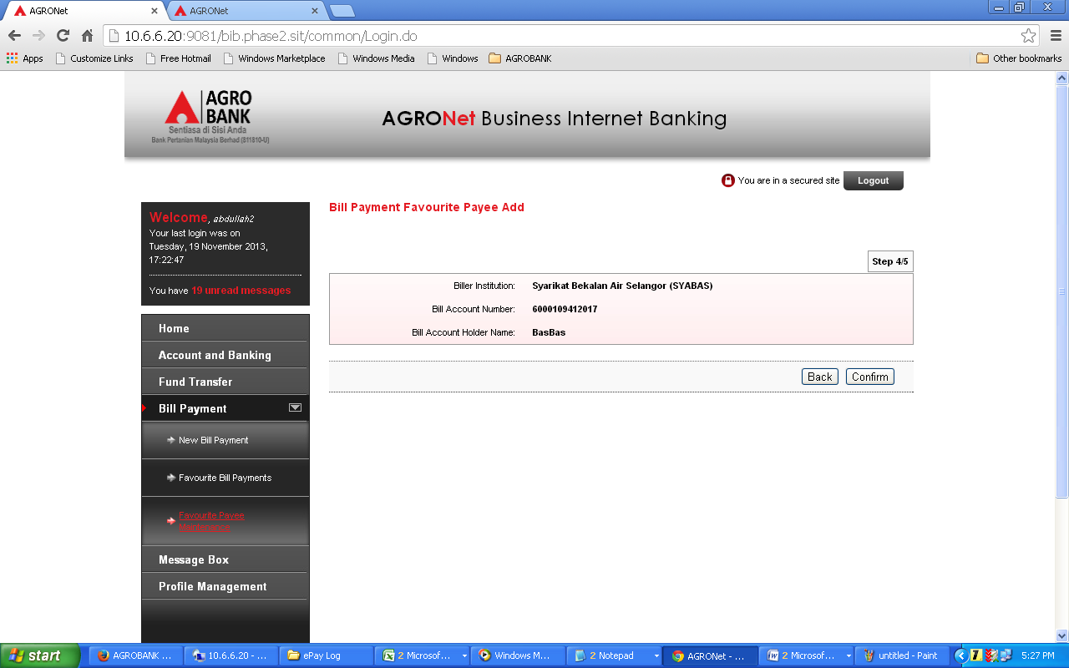  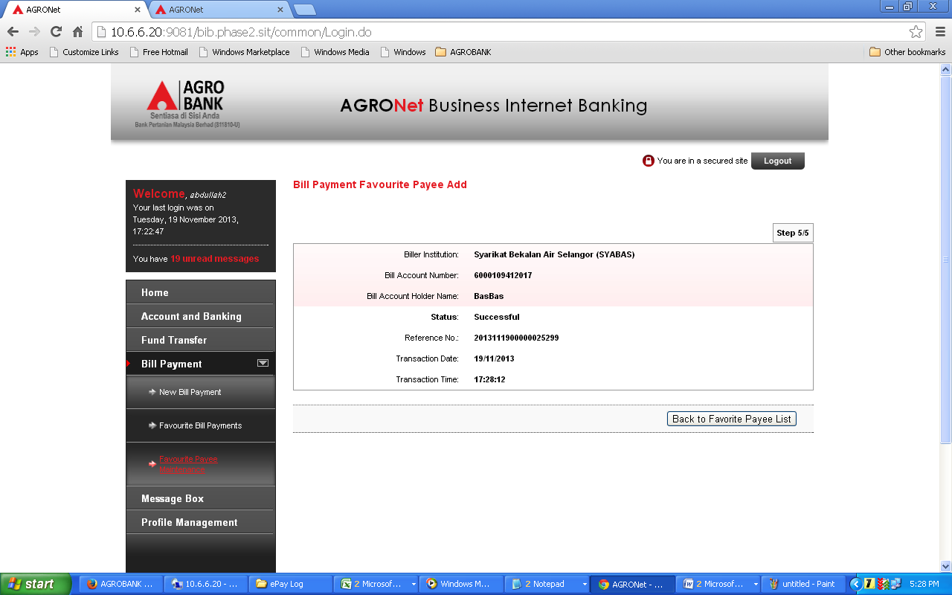  Test Item 4: To test on Favourite Payment to SYABAS  Result:  IB will show the Bill No./Bill Ref. No on the details screen  