Request ID# 307
Test Title: |  | RIB: Added Customer ID field at IBAM RIB User Enquiry module
Test Description: |  | To allow admin user to search and view RIB Customer details based on Customer ID
Test Functionality: |  | IBAM>RIB>RIB User Enquiry
Test Procedure: |  | - Search RIB User using Customer ID  - Display Customer ID at search result table  - Display Customer ID at RIB User Enquiry Details page
Response Message:
IB will search Customer ID on DB and fetch the data to display on RIB User details page.

Test Result: | Pass: Fail: |  | Tested by: | Siti Norahayu Binti Mohd Desa (QA Engineer)
Reason for Failure:
Remarks: |  | RIB USER ENQUIRY  Test Item 1: Search RIB User using Customer ID  Result:  Successfully search using New IC, Old IC, Army ID, Police ID  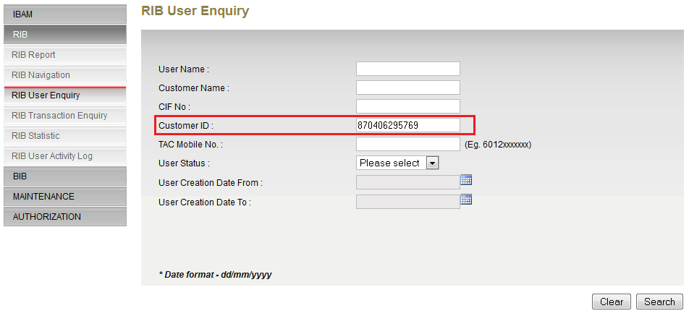  Figure 1: RIB User Enquiry Screen  RIB USER ENQUIRY SEARCH RESULT  Test Item 2: Display Customer ID at search result table  Result:  Successfully display RIB User based on Customer ID  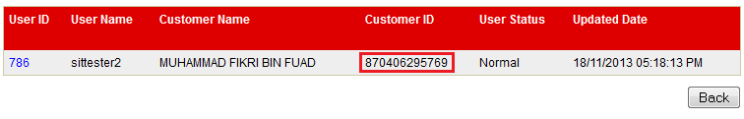  Figure 2: RIB User Search Result Screen  RIB USER ENQUIRY DETAILS  Test Item 3: Display Customer ID at RIB User Enquiry Details page  Result:  Successfully view RIB User details  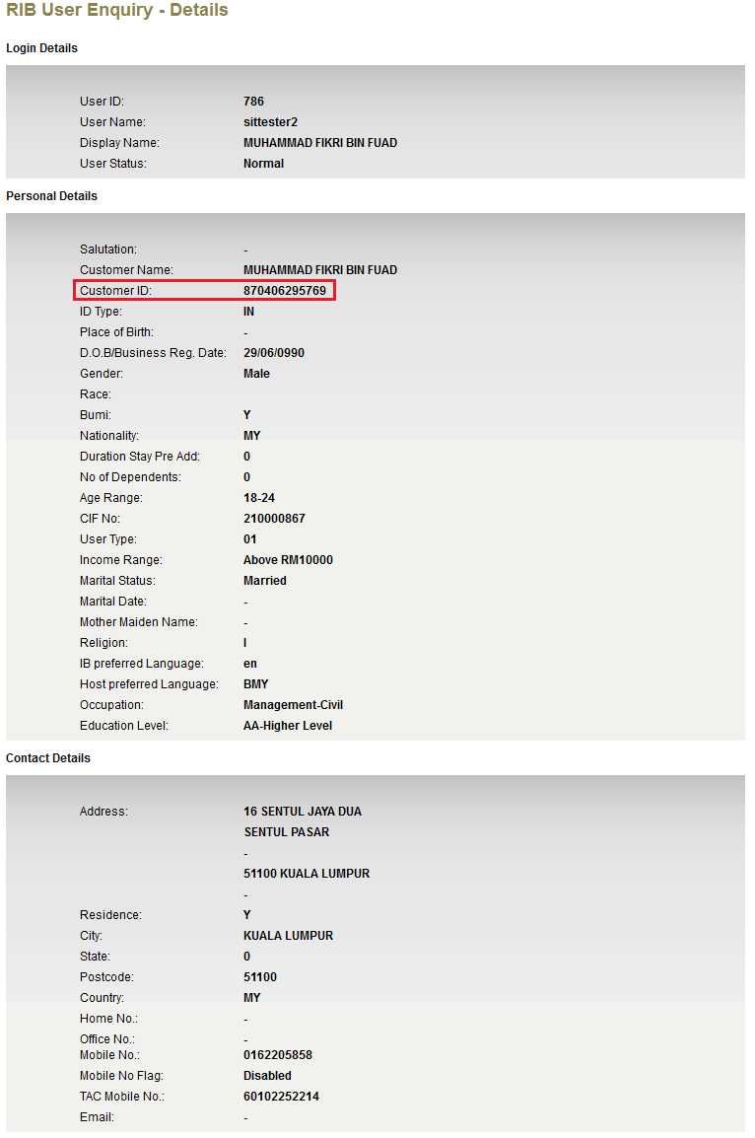  Figure 3: RIB User Details Screen

