MPI Business Requirement

Module 10 : Time Deposit



By M2U Product Management
Virtual Banking
Sept 2010

Version 1.0

Document Control

Author

Revision History

Rev# | Date | Description | Author
1.0 | 1/09/10 | First Draft | Faizul Hamdan

Copyright

MBB, VB – M2U Product Management

Business Requirement Background

Background
This module will elaborate the business requirement on Time Deposit/ Fixed Depost transaction services for MPI Internet Banking.

High level description
      - In this release we are proposing that customer will be able to do :
        - View and Inquiry – Had been specify in Module 1
        - Time Deposit Placement
        - Time Deposit Upliftment
      - System will capture the transaction and request will be routed to branch (via back office) to process.
      - To know the process – via branch / operation team – to be discuss

Objective/Justification
- To specify the Time Deposit process flow via MPI

Requirement for M2U

Time Deposit Placement
- Customer need to login MPI wedsite - enter Username and Password.
- Once customer in secure site, they need to select Time Deposit/ Fixed Deposit.
- Under this facility, customer can :
  - View and Inquiry their Time Deposit
  - Make an Time Deposit Placement
  - Make an Time Deposit Upliftment
- Customer need to select Time Deposit Placement.
- TAC is not required for this transaction.
- Once customer select Time Deposit placement, customer required to select:
  - Time Deposit type -TBC
  - Select Tenure - TBC
  - Enter Principal amount
  - Select Interest Payment Frequency
  - Select Interest Payment Mode
  - Select Instruction of Maturity
- Once transaction complete – system will display message “Accepted”
- Branch need to create/ open the Time Deposit placement
- Refer to Appendix 1- Sample Screen

Time Deposit Upliftment
- This option allowed customer to do upliftment via MPI IB.
- Customer need to login to secure site
- Select Fixed Deposit
- Then select Time Deposit Upliftment
- System will display list of Time Deposit account
- Customer need to select which account that they want to do uplliftment
- Once customer select the account, system will display the list of certificate of Time Deposit. TBC
- Then customer need to select “uplift”.
- TAC is required for this transaction
- Page will display “Accepted” once customer successful do the upliftment.
- The request will routed to Branch – back office to do the upliftment.
- To give a new a/c or new cert. TBC
- Refer to Appendix 2 – Sample Screen

Appendix 1 – Sample Screen 1st Placement

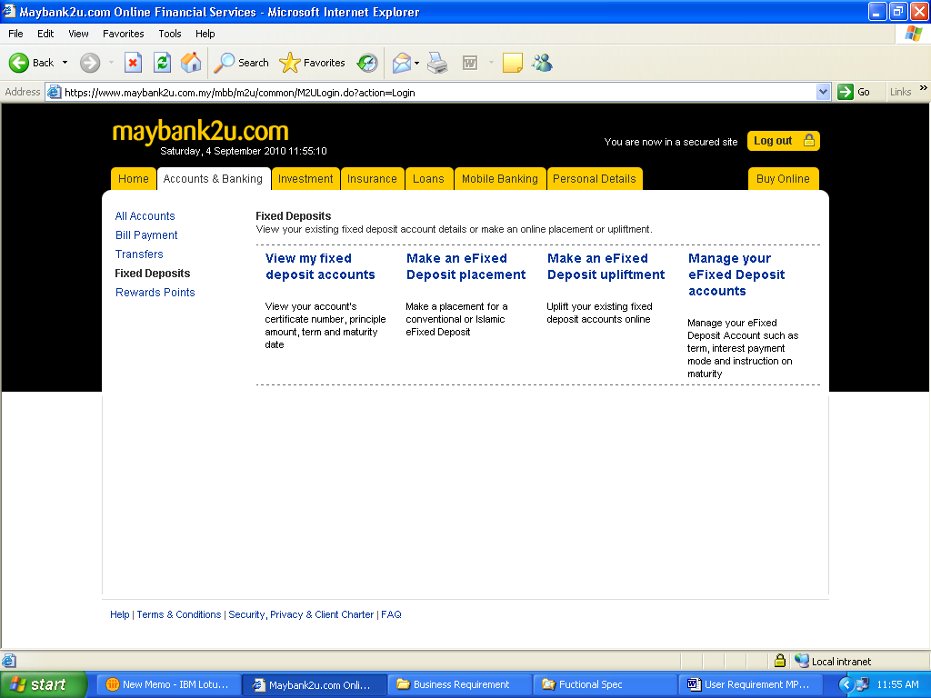

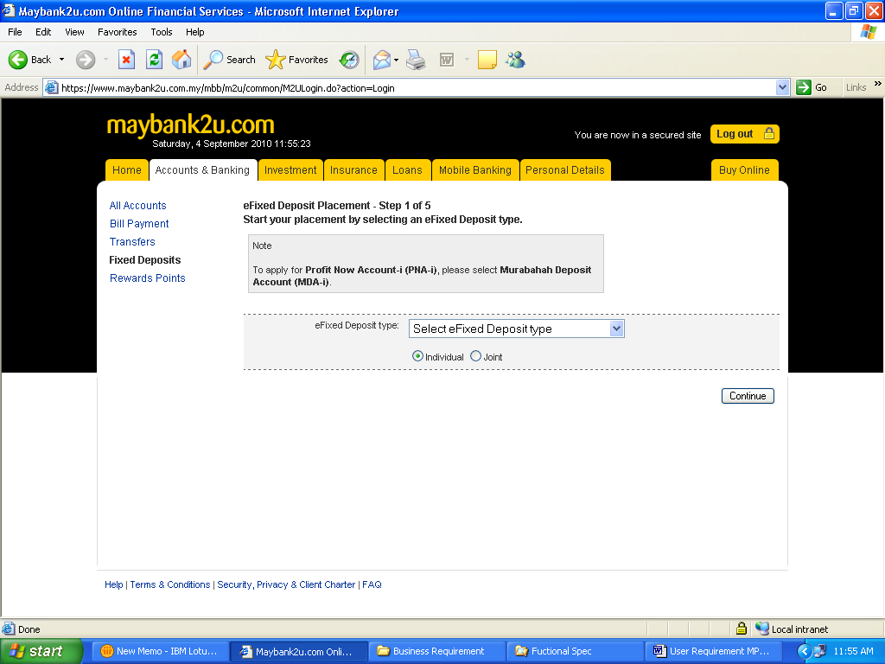

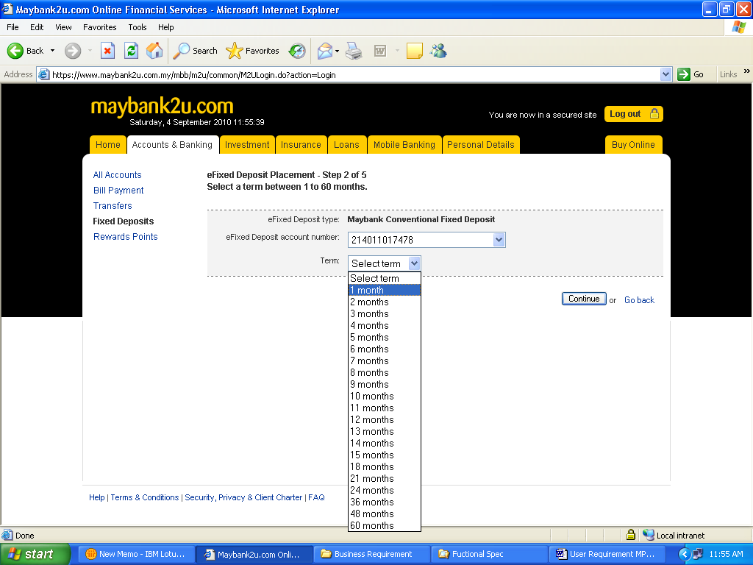

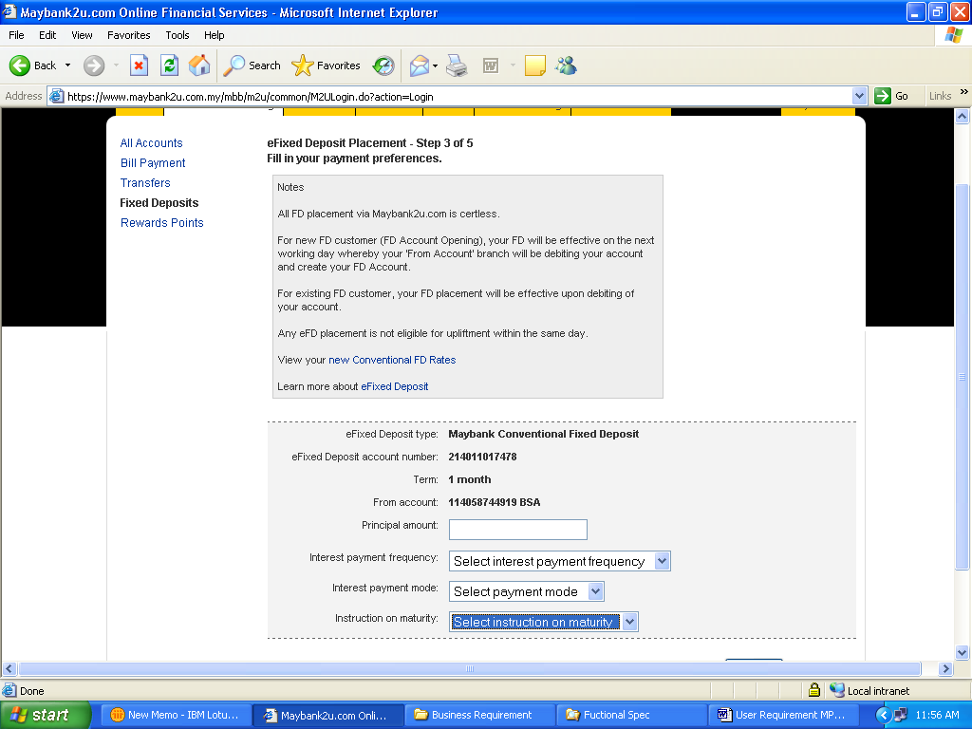

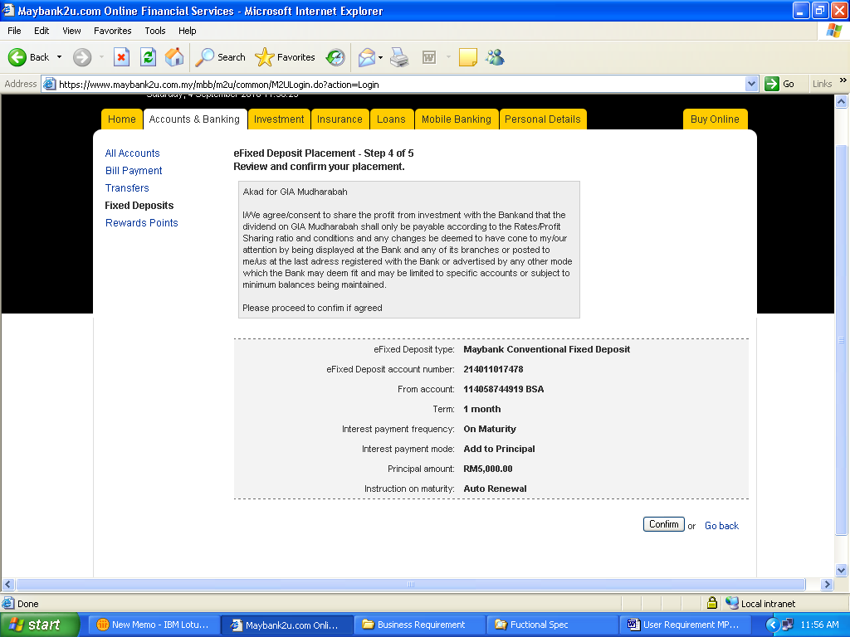

Appendix 2 – Sample Screen Upliftment

