Reset Credentials

**Scenario A:**

IB User forgot password & security question.

**Resolution:**

IB User calls Customer Support to request for TAC. This TAC will be used to reset IB User’s password and security question.

**MSS**

1. Customer Support views the requested Customer Profile. Customer status must be locked. Customer Support unlocks the Customer.

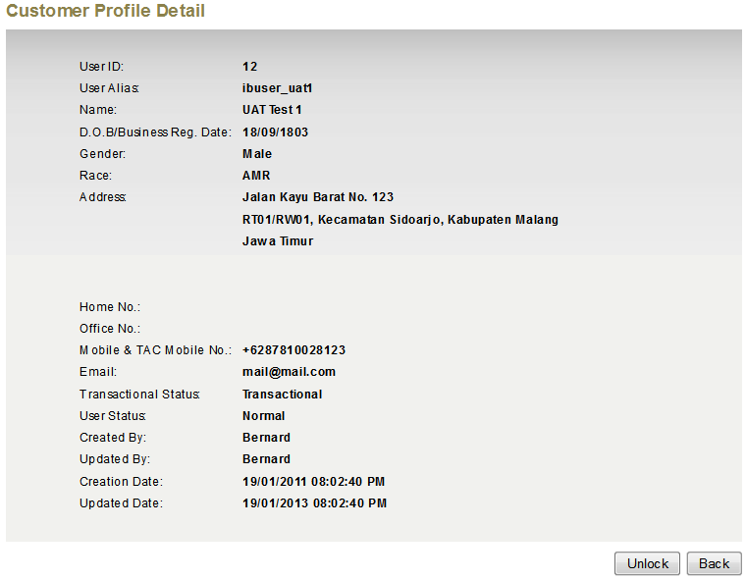

**Locked**

1. After unlocks, Customer Support can send TAC to Customer for Reset Password & Security Questions using button “Generate TAC”. TAC will be sent to the registered mobile number. "Generate TAC” will only be accessible when Customer’s Status is “Unlocked”.

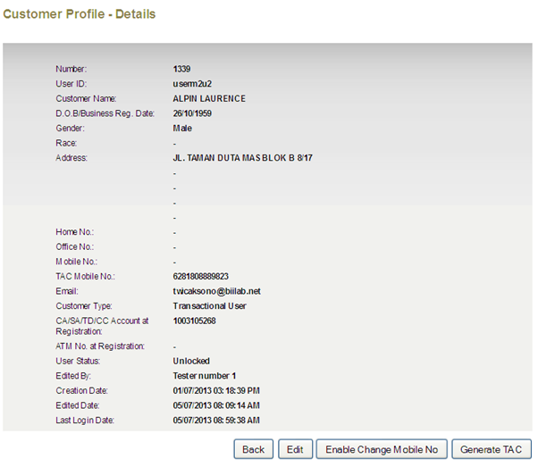

**RIB**

1. User access to RIB, and select “Forget Password & Security Questions”
2. User required to enter Username and Captcha Code

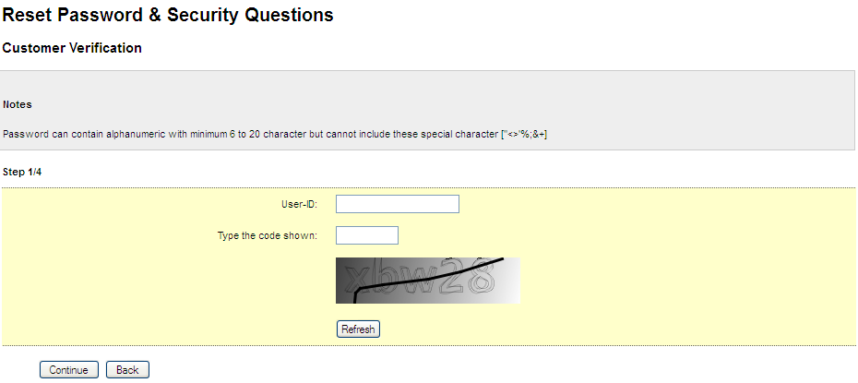

1. Upon successful verification, system prompt user to enter Account Number (linked to M2U account) and TAC

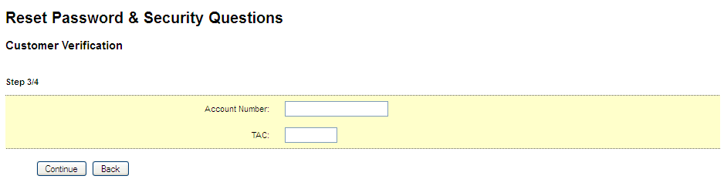

1. If not valid TAC, system will prompt to re-enter TAC again.
2. After 3 times failed attempts, username will be locked. User is required to call Customer Support to unlock and request for a new TAC again.
3. If valid TAC, user can proceed to create new password & select new security question. Email notification to user on the successful rest password and security question.

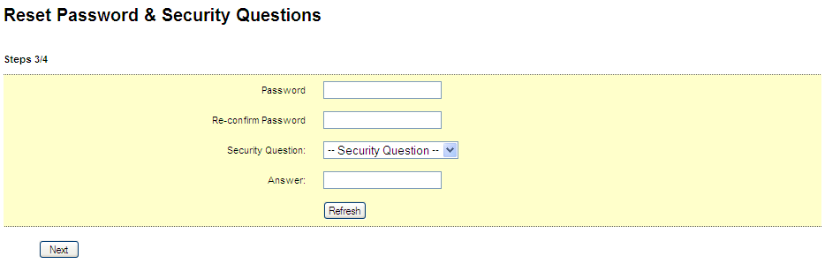

1. After completion of the reset process, user can login to RIB again.

**Scenario B:**

IB User forgot password & security question and have changed his/her mobile number

**Resolution**

Firstly, IB User is required to visit Bank Branch and submit request to Change Mobile Number. Bank Officer performs the necessary validation and forwards the request to IBS Back Office.

Once received the request, Back Office will update IB User’s mobile number via MSS.

**MSS**

1. Admin views the requested Customer Profile. Customer status must be either “Locked” or “Unlocked” for “Change Mobile Number” button to be available. Also, Admin with rights to update user’s profile will have access to this function.



Change Mobile Number

1. Admin update the mobile number for IB Customer. The change will need to go thru “Maker/Checker” process. Once the change has been approved, MSS will send SMS to Customer’s Old Mobile Number and New Mobile Number and notification email to inform the Customer on the mobile number changes.

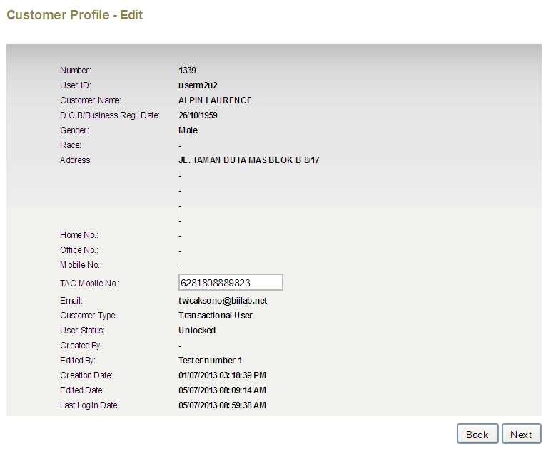

1. Customer calls Customer Support to get new TAC. Steps in Scenario A will take place.