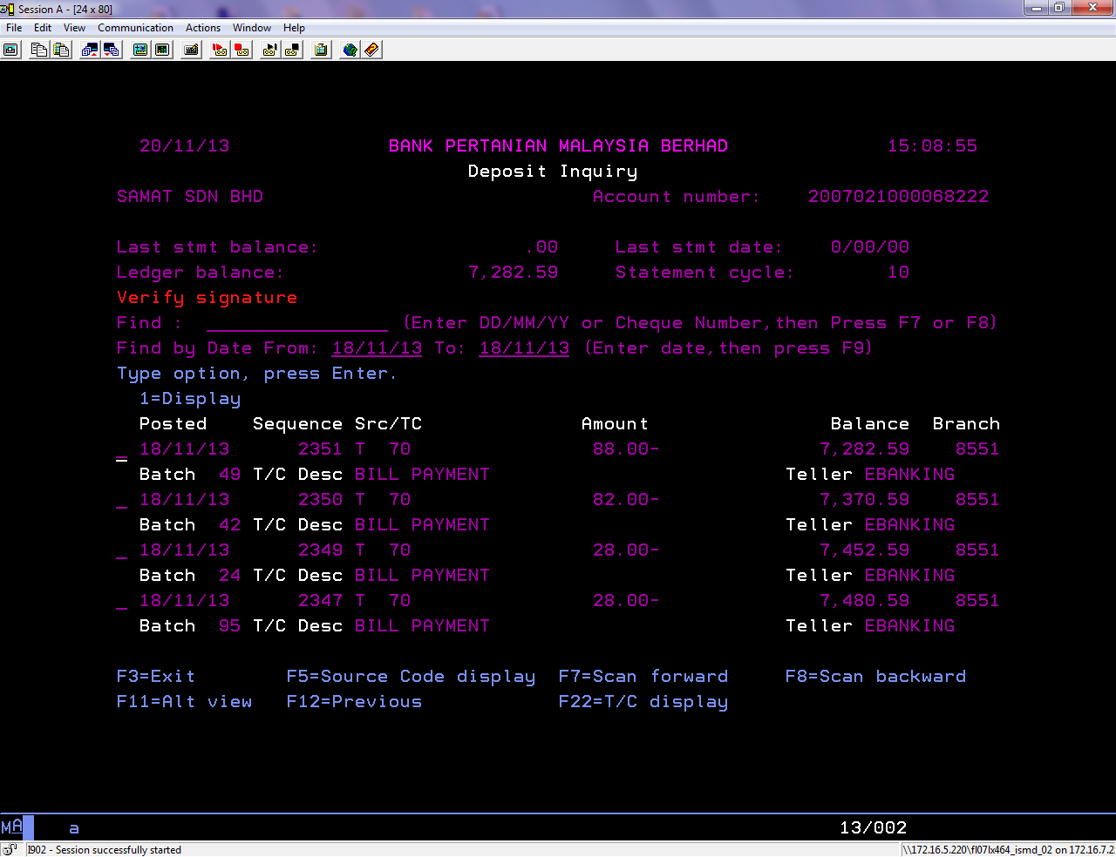

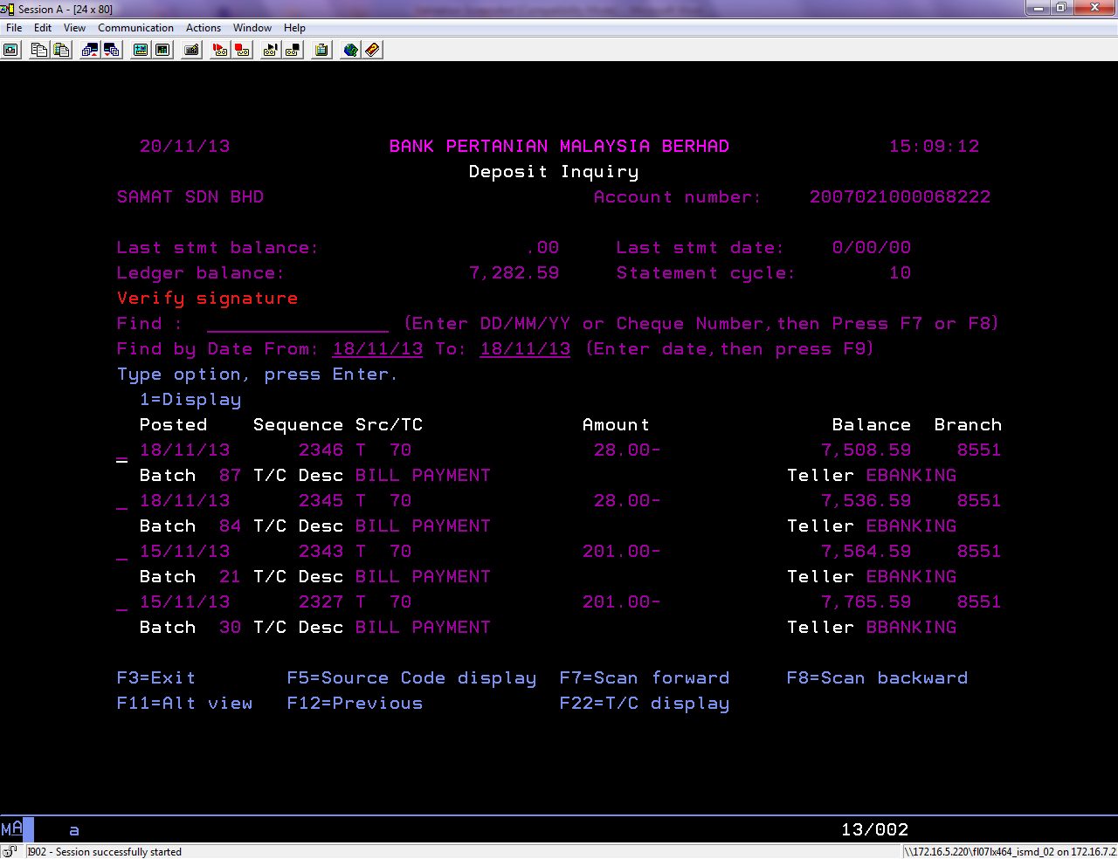
Trnx Date | Trnx ID | Amount | Teller ID | Status | Channel
18/11/2013 | 2351 | 88 | EBANKING | Successful | ePay
18/11/2013 | 2350 | 82 | EBANKING | Successful | ePay
18/11/2013 | 2349 | 28 | EBANKING | Successful | ePay
18/11/2013 | 2347 | 28 | EBANKING | Successful | ePay
18/11/2013 | 2346 | 28 | EBANKING | Successful | ePay
18/11/2013 | 2345 | 28 | EBANKING | Successful | ePay
15/11/2013 | 2343 | 201 | EBANKING | Unsuccessful | ePay
15/11/2013 | 2327 | 201 | BBANKING | Successful | Host

