Task ID# 3938
Test Title: |  | To disallowed special character to be key-in. Only allow alphabet and numeric or alphanumeric with/out space.
Test Description: |  | To add validation to:  - Profile Management – Display Name  - New Interbank GIRO Transfer – Recipient’s Reference and Other Payment Details (changed label name from Payment Reference and Remarks/Message to Bene on CR-SCP ID# 280)  - Favourite Interbank GIRO Transfer – Recipient’s Reference and Other Payment Details (changed label name from Payment Reference and Remarks/Message to Bene on CR-SCP ID# 280)  - Favourite Interbank Maintenance – Notes for Own Reference  Expected Result: Error Message <Display Name cannot include special character except space.>
Test Functionality: |  | - Profile Management RIB/BIB  - New Interbank GIRO Transfer RIB/BIB  - Favourite GIRO Transfer RIB/BIB  - Favourite Interbank Maintenance RIB/BIB
Test Procedure: |  | - Key in disallowed Special Character to the fields
Response Message:
IB will send error message <….. cannot include special character except space.>
Test Result: | Pass: Fail: |  | Tested by: | Lizahwati Basirun (QA Engineer)
Reason for Failure:
Remarks: |  | Test Item 1: To test on invalid special character to Profile Management – Display Name  Result:  Display Name cannot include special character except space.  RIB  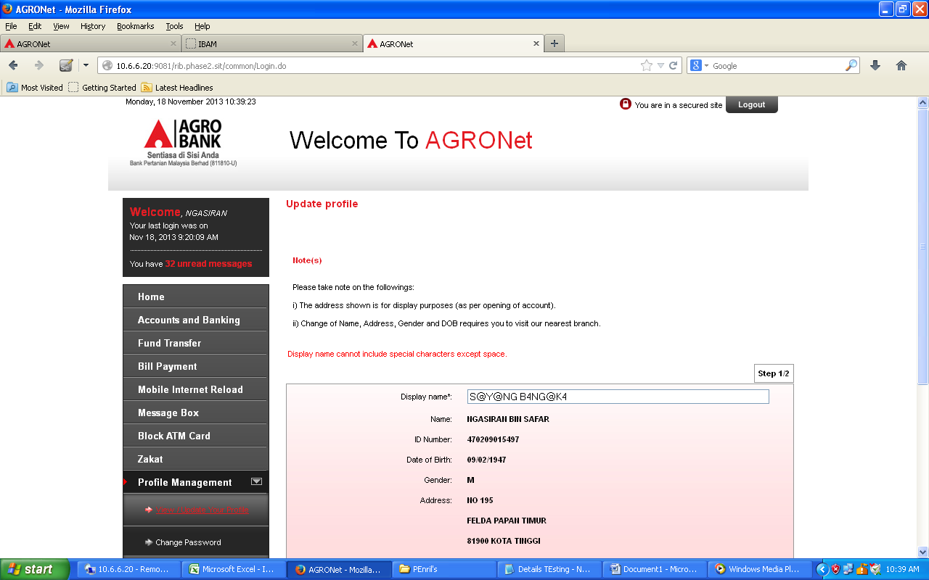  BIB – CORPORATE ADMIN  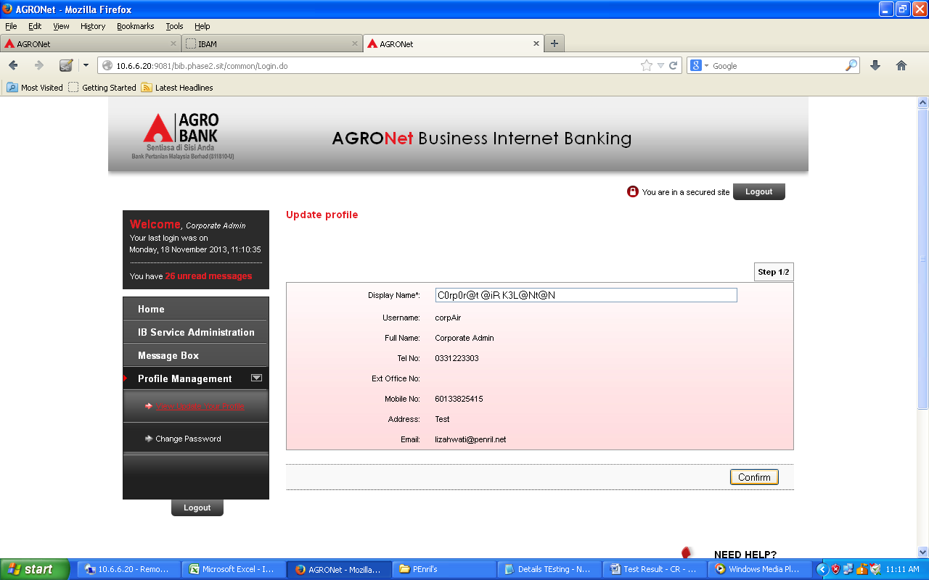  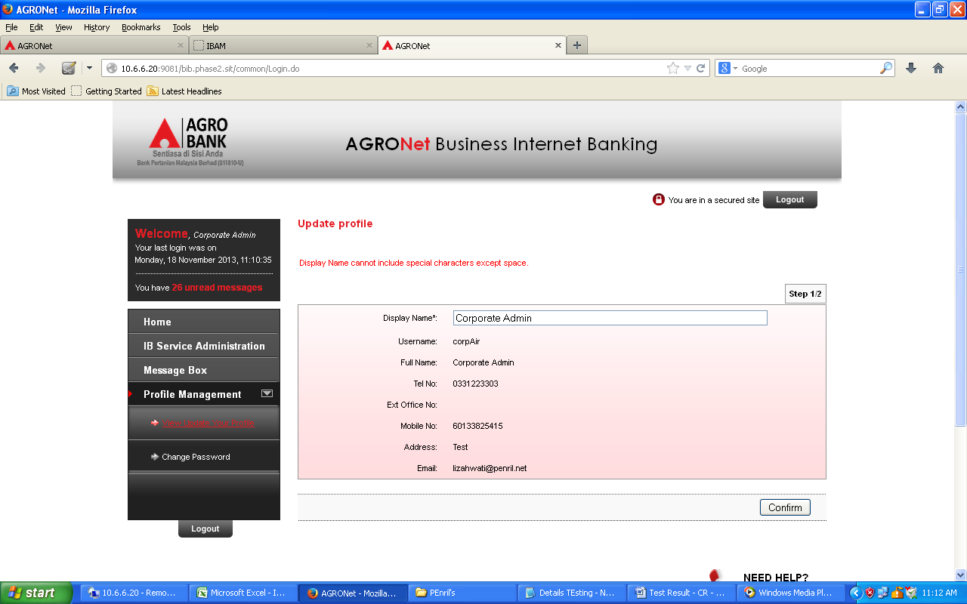  BIB – INITIATOR  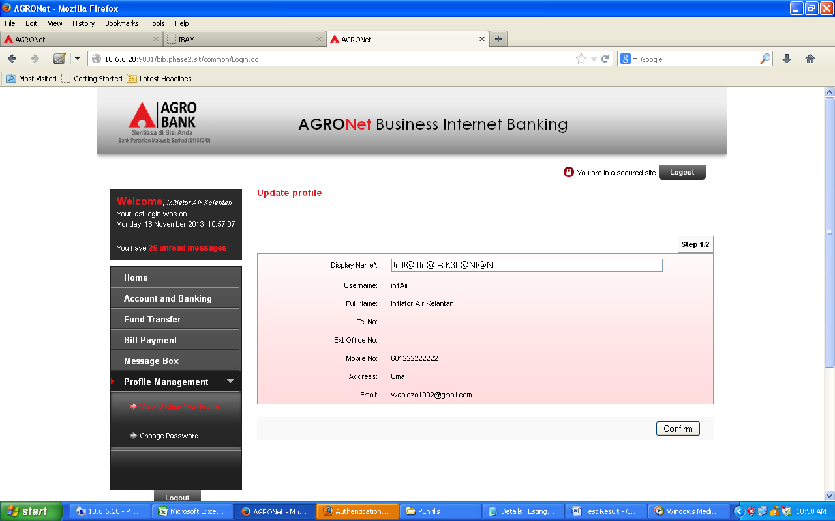  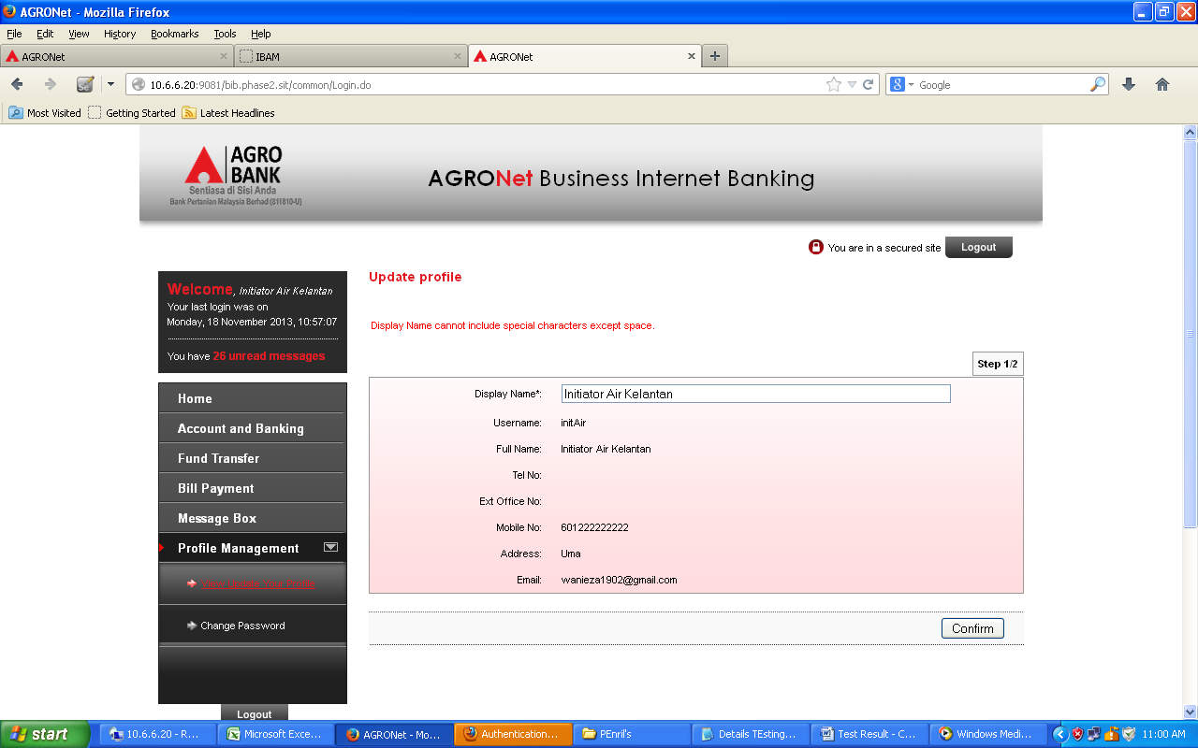  BIB – APPROVER  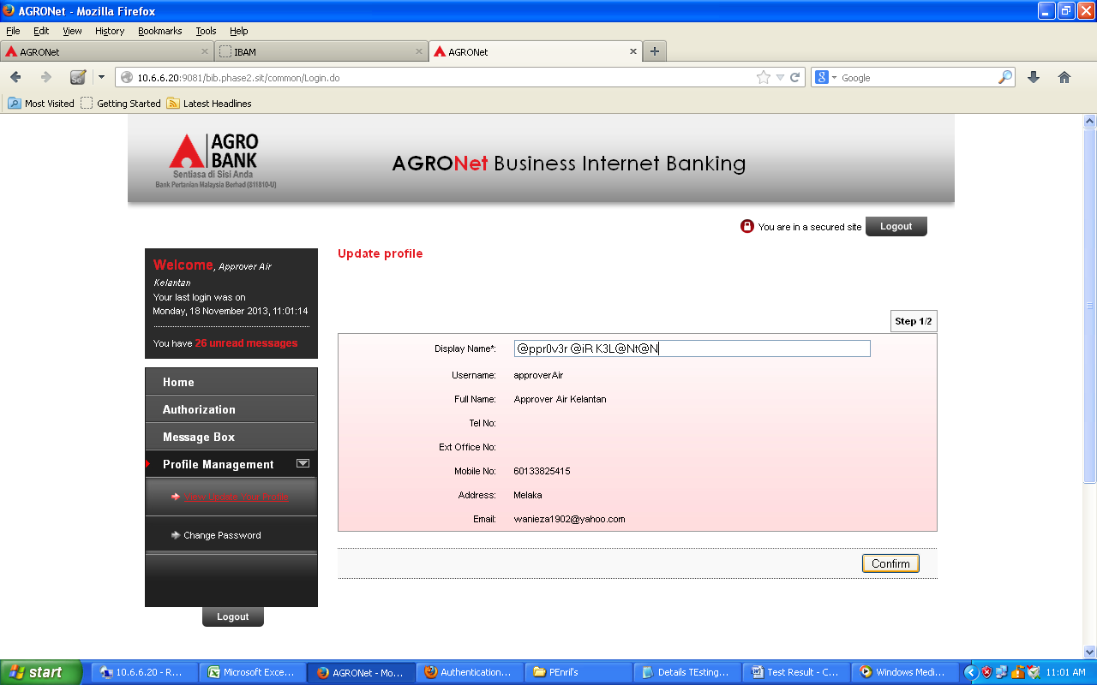  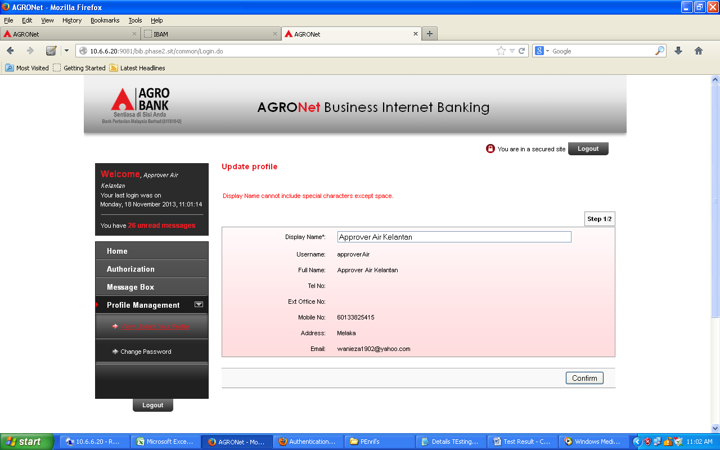  BIB – SINGLE USER  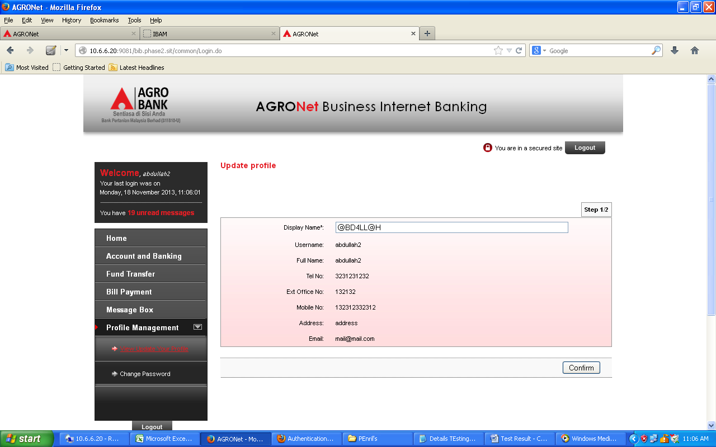  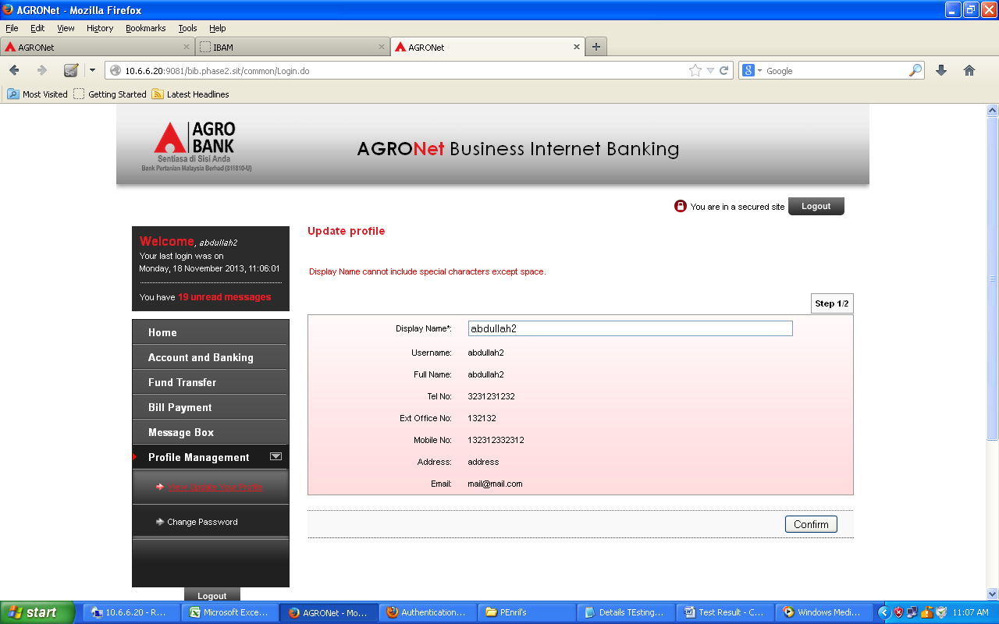  Test Item 2: To test on invalid special character to IBG fields.  Test Results:  - Recipient’s Reference cannot include special character except space.  - Other Payment Details cannot include special character except space.  - Notes for Own Reference cannot include special character except space.  RIB – New Interbank Transfer  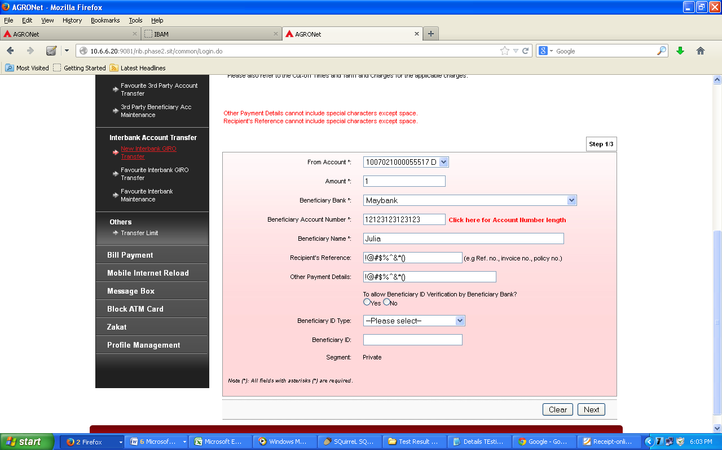  RIB – Favourite Interbank Transfer  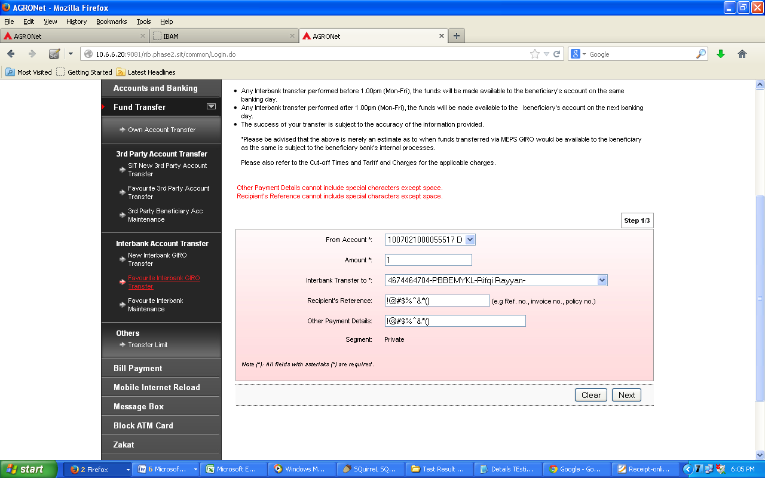  RIB – Favourite Interbank Maintenance  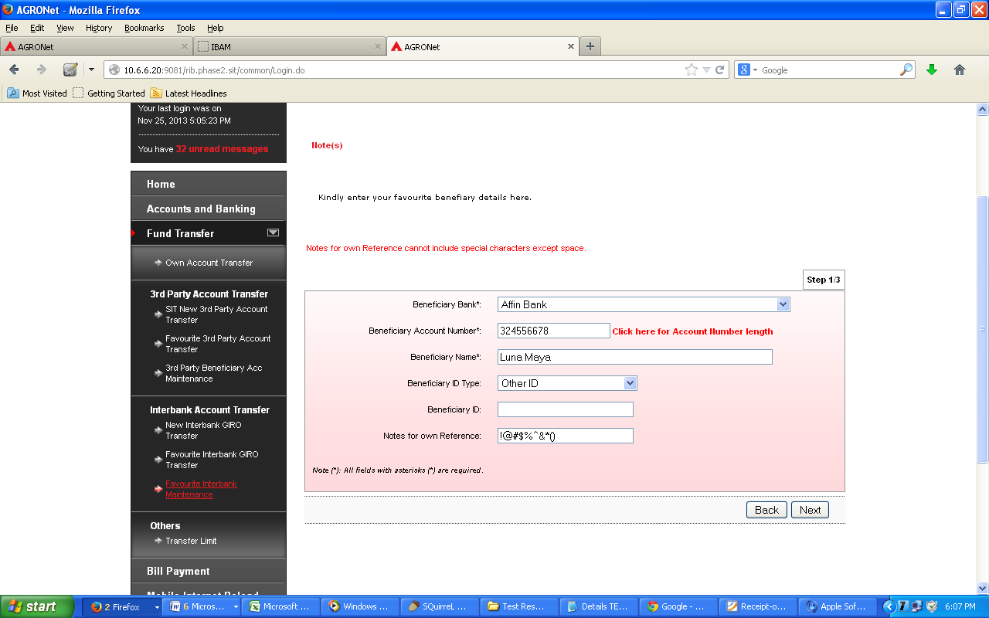  BIB – New Interbank Transfer (Initiator)  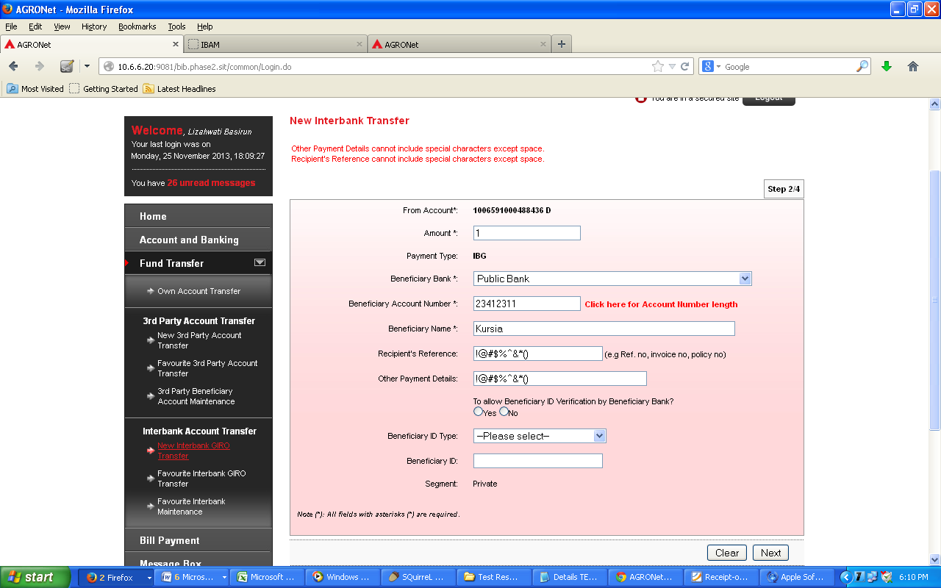  BIB – Favourite Interbank Transfer (Initiator)  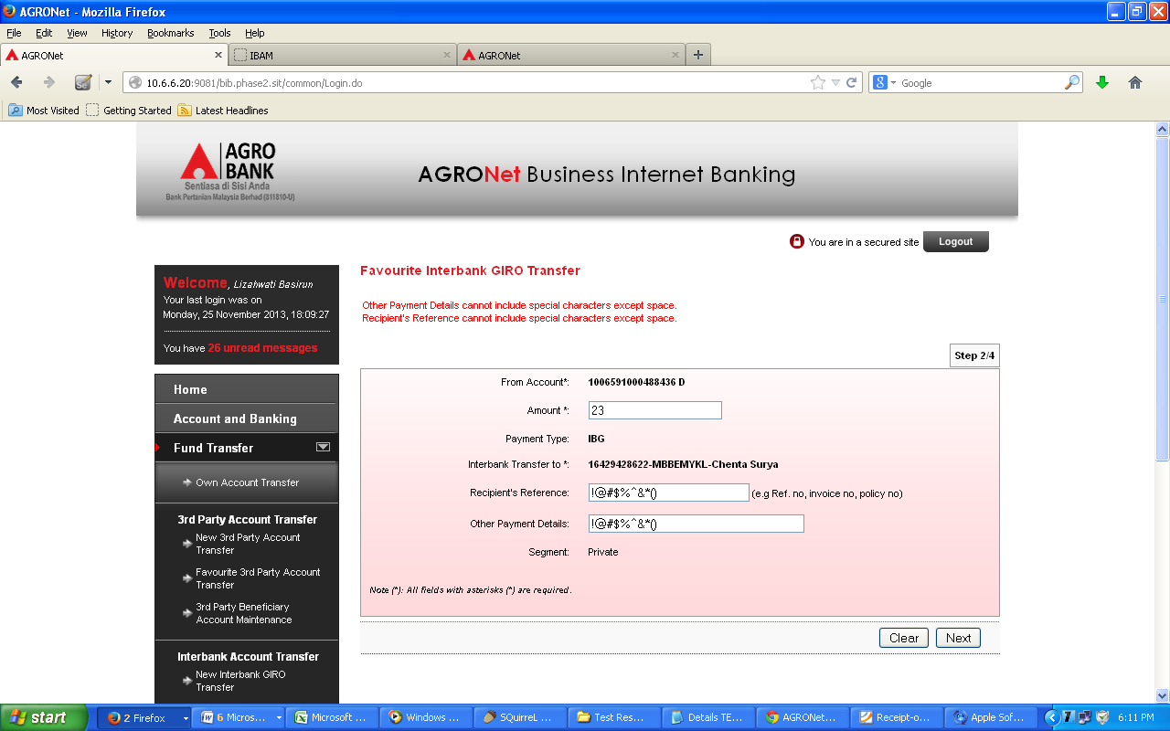  BIB – Favourite Interbank Maintenance (Initiator)  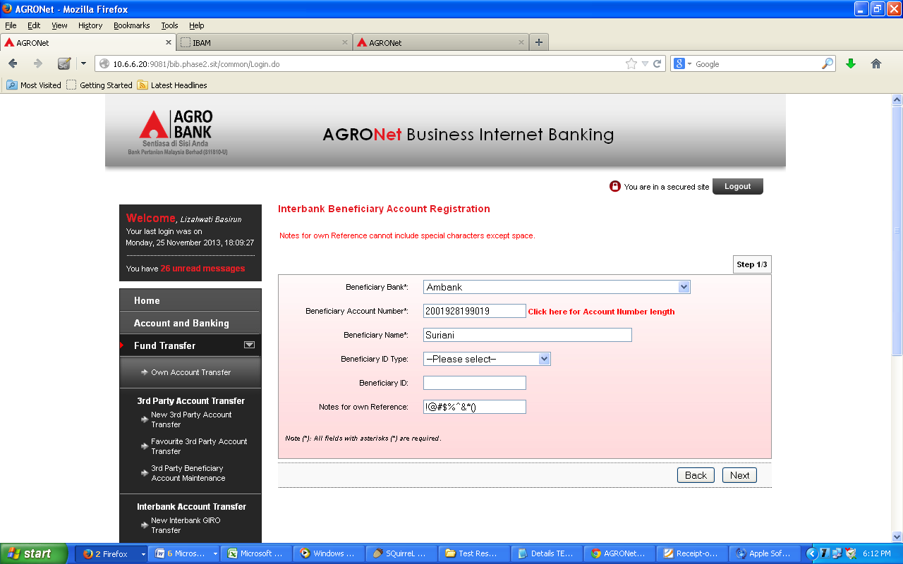  BIB – New Interbank Transfer (Single User)  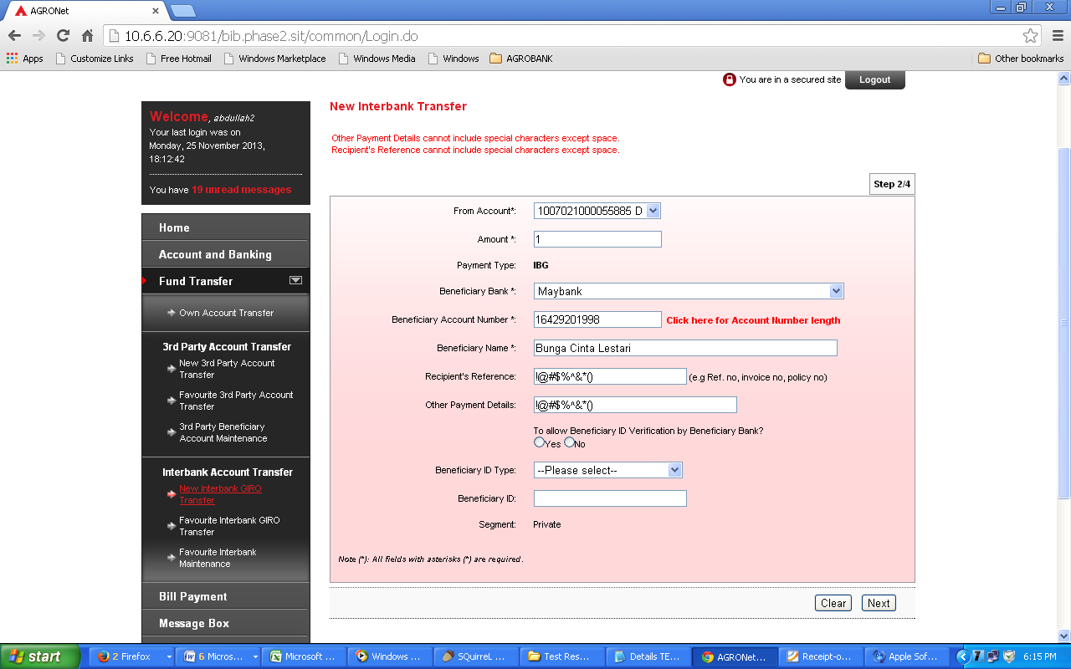  BIB – Favourite Interbank Transfer (Single User)  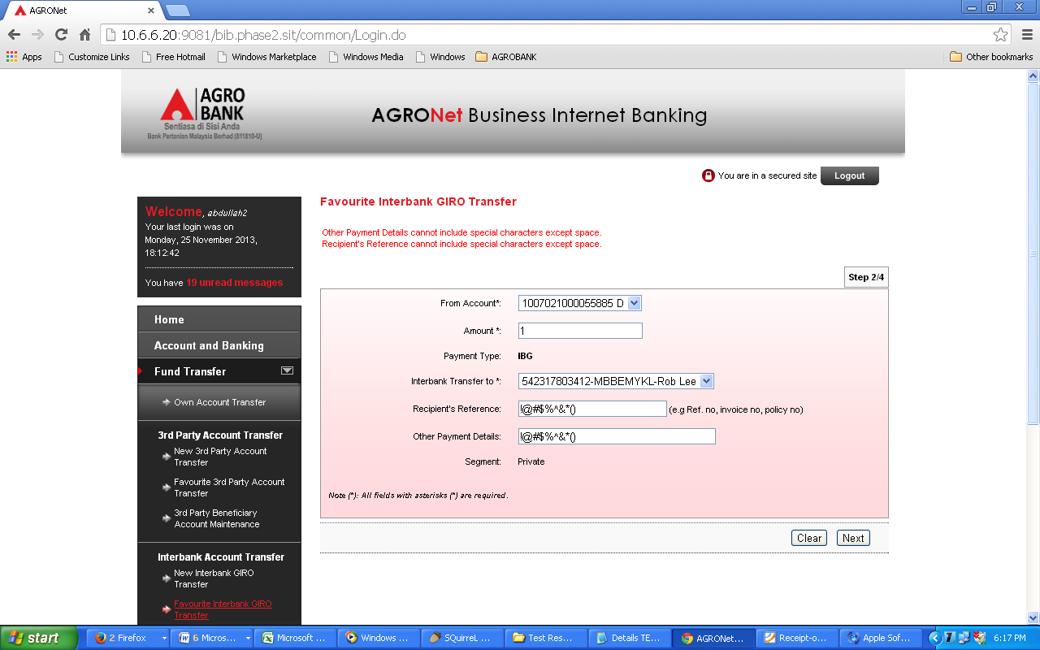  BIB – Favourite Interbank Maintenance (Single User)  