MPI Business Requirement

Module 1: Registration Process & Logins



By M2U Product Management
Virtual Banking
Sept 2010

Version 1.0

Document Control

Author

Revision History

Rev# | Date | Description | Author
1.0 | 1/09/10 | First Draft | Faizul Hamdan

Copyright

MBB,VB – M2U Product Management

Business Requirement Background

Background
This module will elaborate the business requirement on Registration Process, 1st time login and Login services for MPI Internet Banking.

High level description
- In this release proposing the Internet Banking Application will be via Over the Counter at ant MPI branch.
- It is an Online registration where customer can immediately activate and use the facility upon getting First Time Activation Code.
- The proposed flow is designed on the assumption that each of MPI has a :
        - Unique “Customer Number”
        - All the product held under the customer tied to this number
- New CICS host system (CRF, CAF) will be introduced in this phase.
- It will create a customer and transaction record upon the registration of Internet Banking Application is successful.
- This New HOST system will integrate with MPI CORE to grab and pass the selected info which required.

Objective/Justification
- To specify the Internet Banking Application process flow.

Requirement for M2U

Proses Step for IB Registration
- Customer need to fill up the Internet Banking Application Form (Registration)
- Teller to create the facility for customer via the new proposed Host function by entering :
  - Customer Number (To be Finalize in system design phase)
  - ID No (To be finalize in system design phase)
  - Mobile Number (For transaction Authentication usage)
- Once teller key in the info, system will create a record at the new Host and generate a temporary 6 digit First Time Activation Code for customer.
- This number will send out via SMS to the customer’s registered mobile number.
- Upon the IB registration proses is successful, customer record will be updated :
  - Generate 16 digit access number
  - Create CRF Record (Customer Info)
  - Create CAF Record (List of Account link)
- This registration process is apply for Customer Type:
  - Individual
  - Corporate
- Refer to Appendix 1- Process Flow

1st Time Login
- Once customer received the Access no and 6 digit first time activation code, they are required to perform 1st time login at MPI website.
- Customer need to click 1st time login link.
- Customer need to accept the “Term and Condition” .
- Customer required to enter the Access No and 6 digit first time activation code.
- Customer only have 3 attempt to key in the correct Access no and 6 digit 1st time activation code.
- If customer key in incorrect access no or 6 digit activation code, customer need to reapply again at MPI branches.
- Once successful, system/ screen will prompt customer to create Username and Password.
- Username – must be alphanumeric 6 to 16 character
- Password – must be alphanumeric 8 to 12 character
- Once successful customer will direct to the secure site of M2U – proceed to do transaction.
- Refer to Appendix 2 – Process Flow and Sample Screen

Login
- Login is for customer that already successfully created their Username and Password.
- Customer need to enter their Username and Password
- Username and Password is case sensitive
- Customer only can retry 3 times if they key in wrong Username and Password.
- In the event if customer key in wrong username and password more that 3 times, system will block and customer need to perform Reset Password via Online.
- Once successful, customer will be landed to Secure MPI website to do transaction.
- Refer to Appendix 3 – Sample Screen

Appendix 1 – Registration IB Facility
- Process Flow

Start
Customer to fill up form
HOST to create :
1 Cust Profile (CRF)
2 A/C Profile (CAF)
3 Generate 1st time activation code – via SMS gateway to customer

Error Message displayed
Registration Successful
Print Slip
Access no

END
Teller to key in ID & CIF no & Mobile No

Appendix 2 – 1st Time Login
- Process Flow
Accept Term and condition
END
Secure site MPI Website
Create Username & Password
Successfull
Enter Access no and 6 digit activation code
Click 1st time login – MPI Web Website
Start
Reapply at MPI Branch
System Block
Retry more 3 time
- Sample of 1st time Login Screen

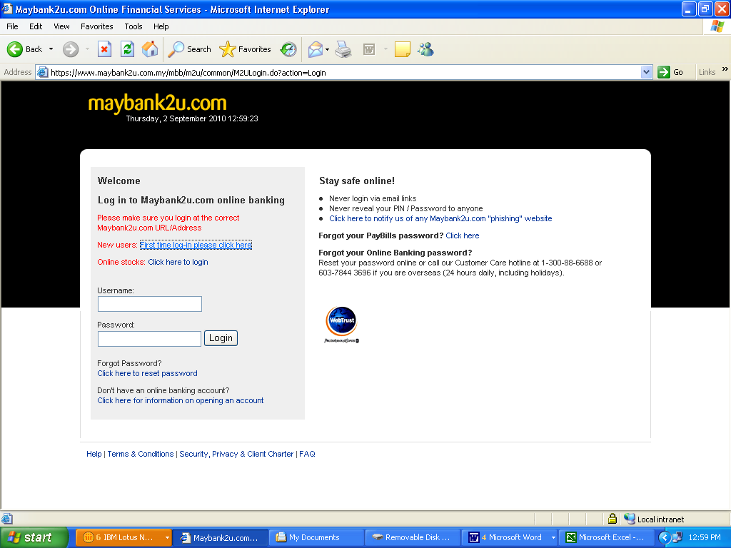

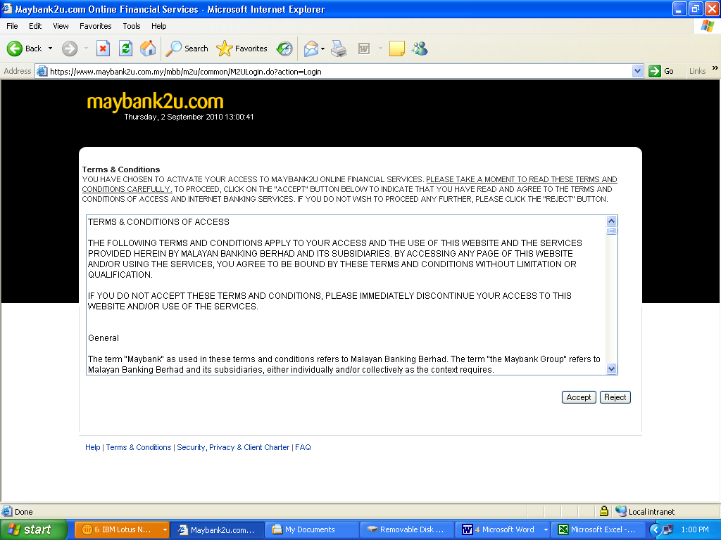

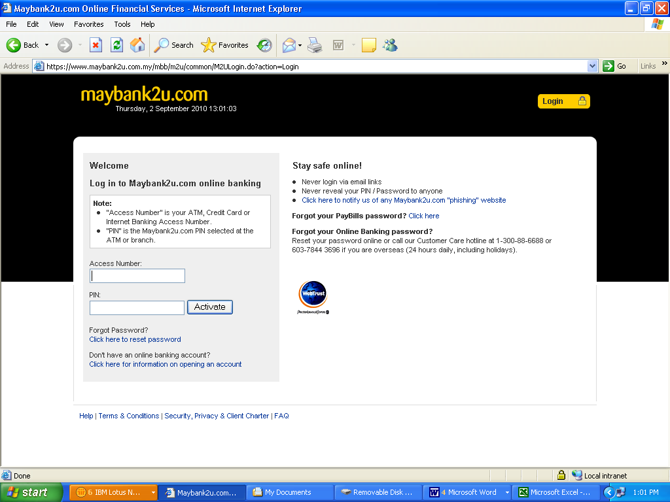

Appendix 3 – Sample of Login Screen

