SCP ID# 280
Test Title: |  | Re-label Field under Retail Internet Banking (RIB) and Business Internet Banking (BIB) – New & Favourite Interbank GIRO Transfer
Test Description: |  | To Re-label the existing “Payment Reference” to “Recipient’s Reference” and “Remarks/Message to Bene” to “Other Payment Details”
Test Functionality: |  | - IBG Screen (New and Favourite Interbank transaction)  - IBG Receipt (New and Favourite Interbank transaction)  - RIB Transaction Enquiry (New and Favourite Interbank transaction)  - BIB Transaction Enquiry (New and Favourite Interbank transaction)  - RIB Report  - BIB Report
Test Procedure: |  | - Make New and Favourite Interbank transaction  - View the changed label in IBG screen, receipt, RIB/BIB Transaction Enquiry and RIB/BIB Report
Test Result: | Pass: Fail: |  | Tested by: | Lizahwati Basirun (QA Engineer)
Reason for Failure:
Remarks: |  | Test Item 1: To test on New Interbank Transfer  Result:  Label changed as requested.  - RIB User  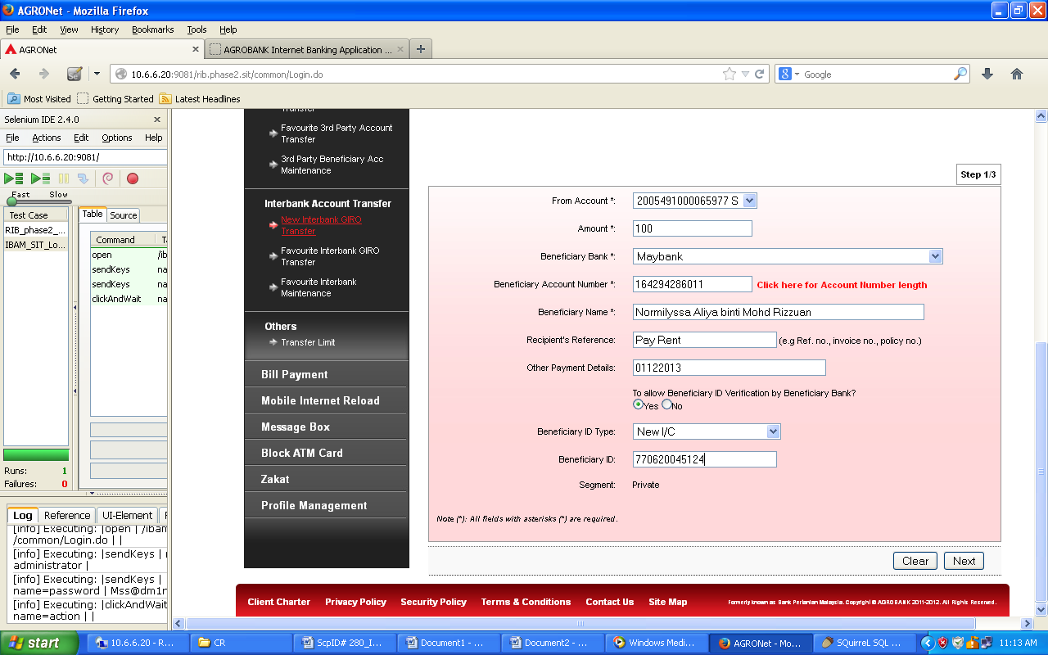  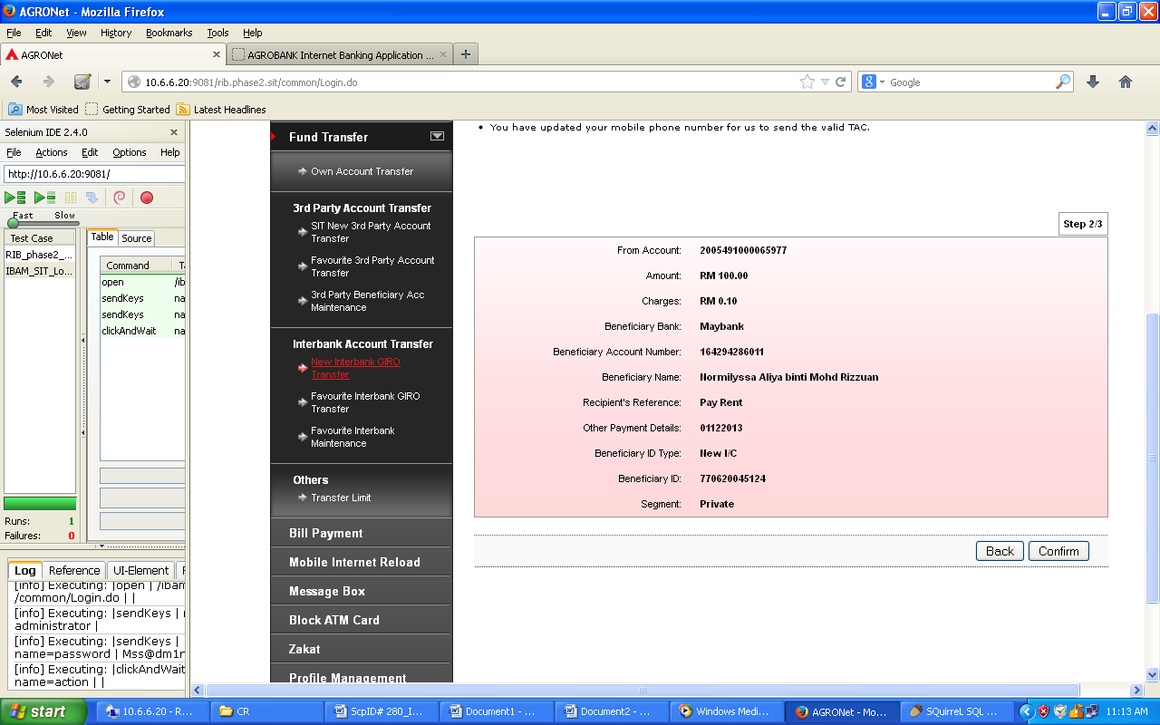  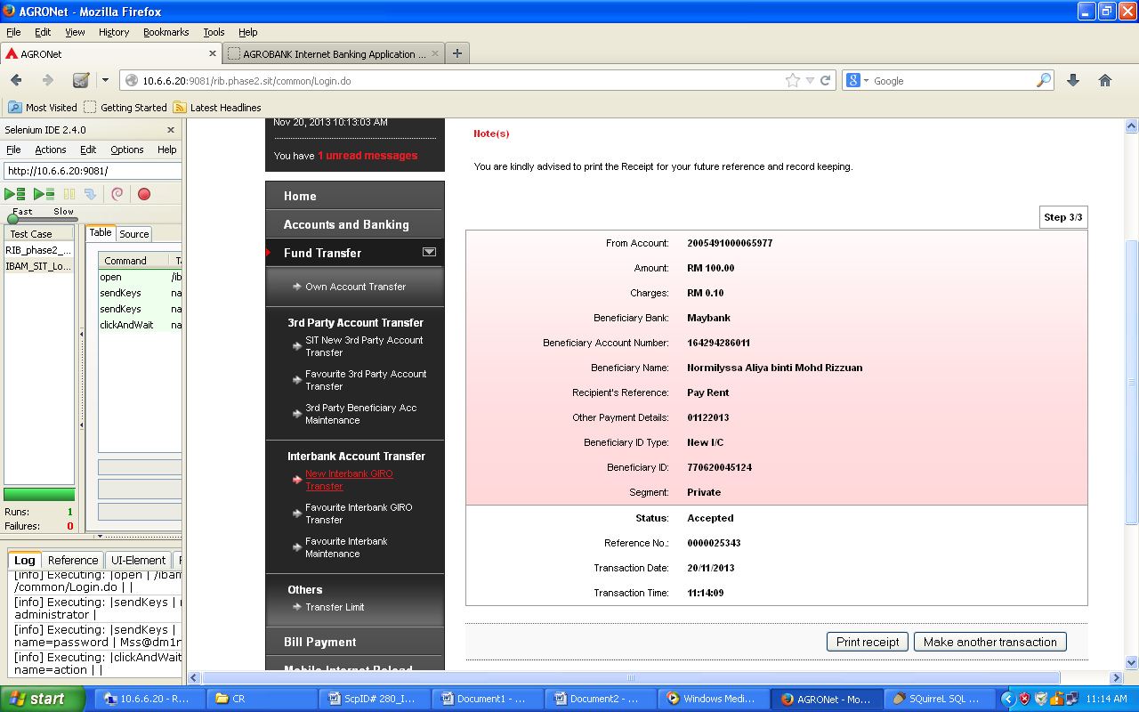  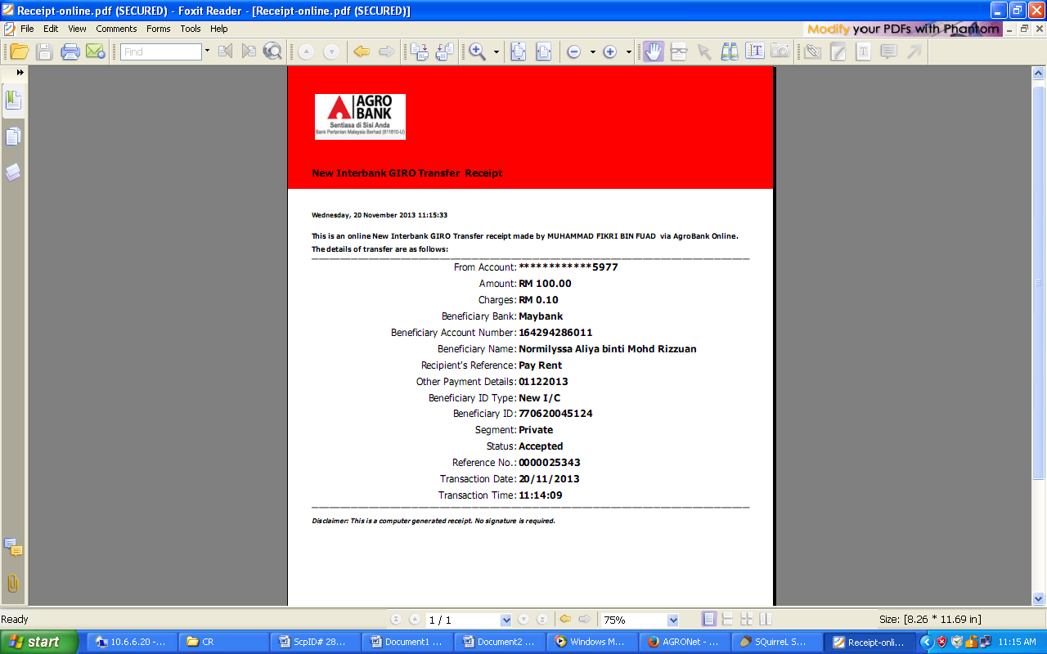  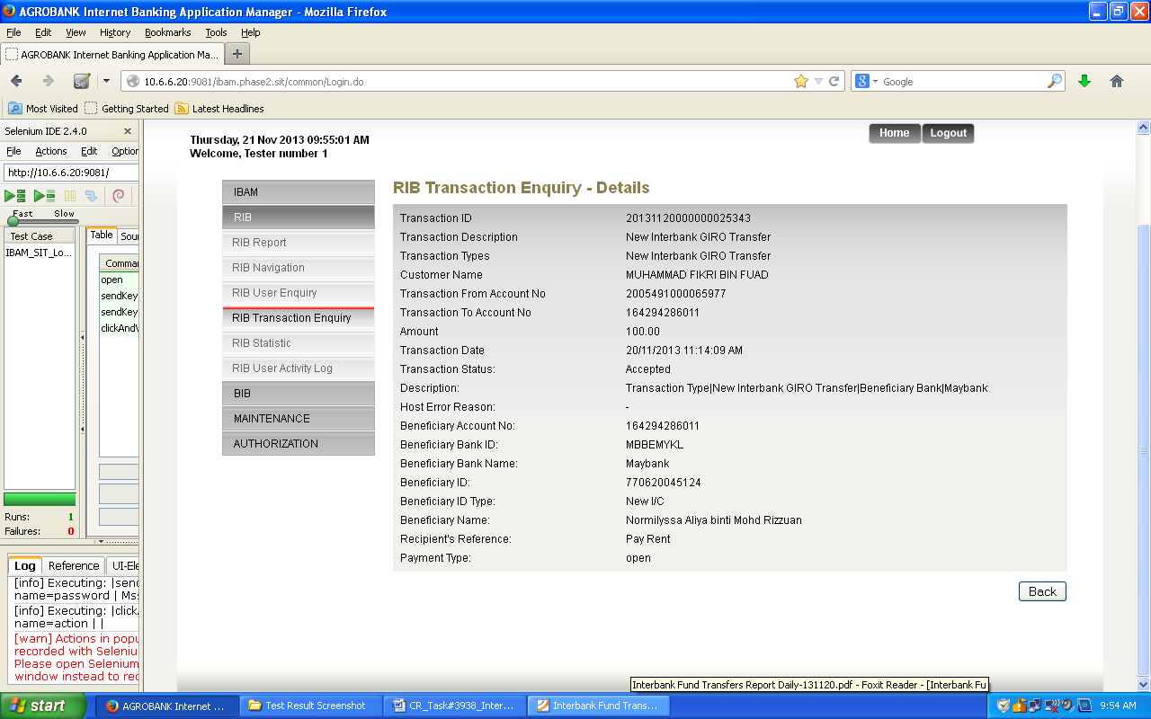  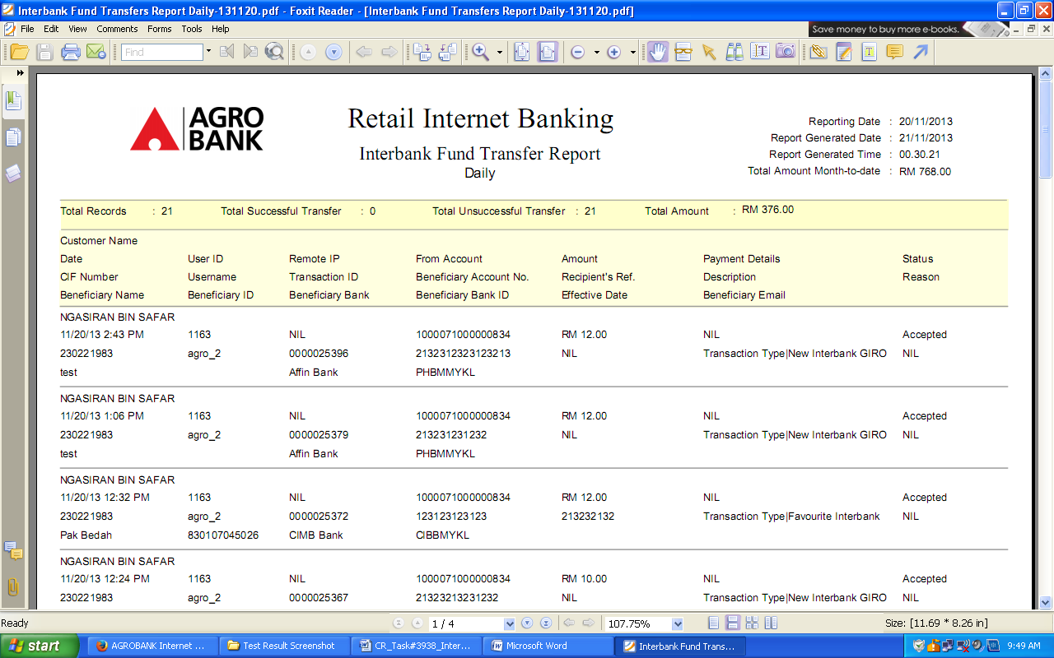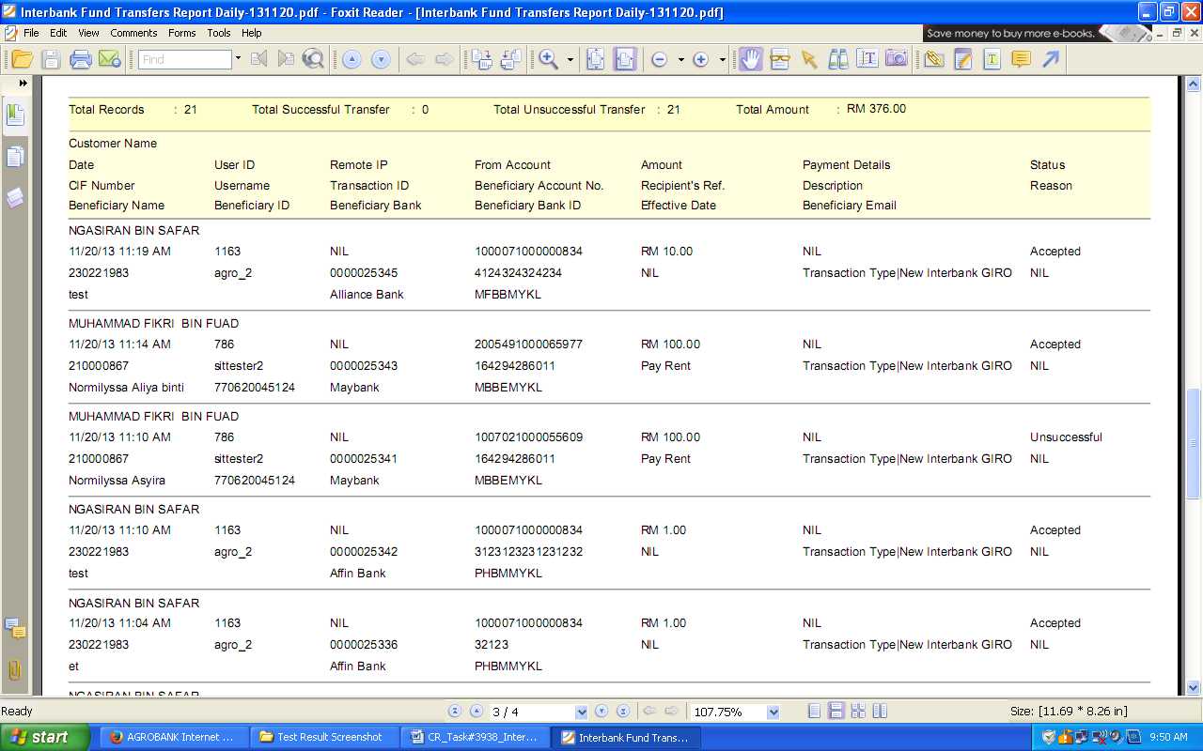  - BIB – Initiator  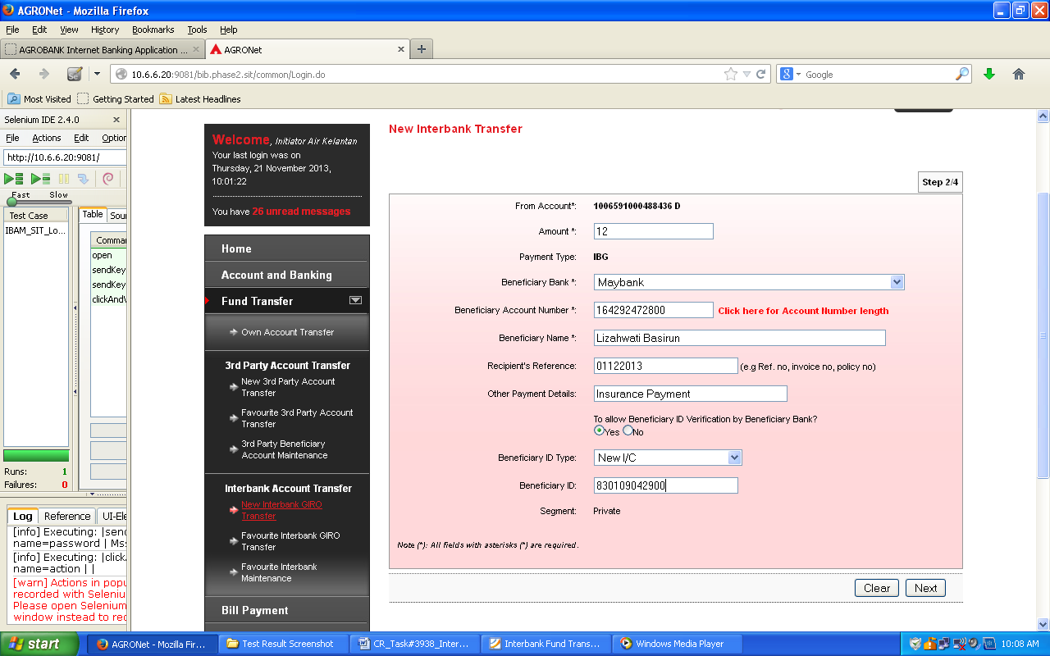  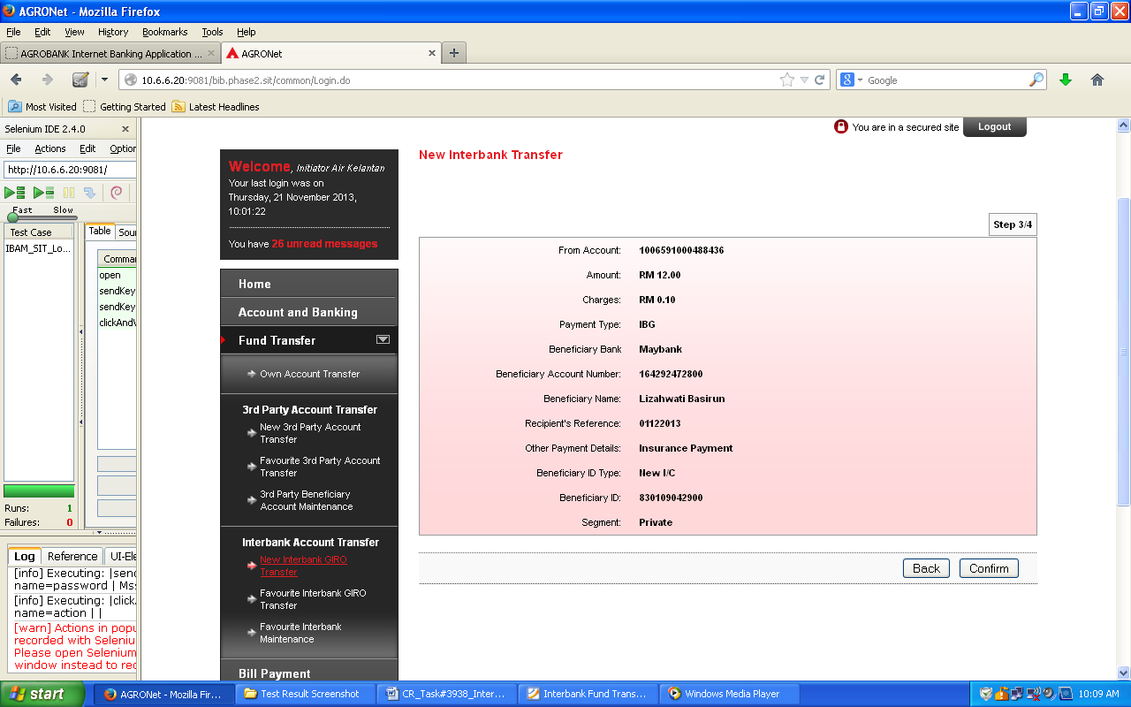  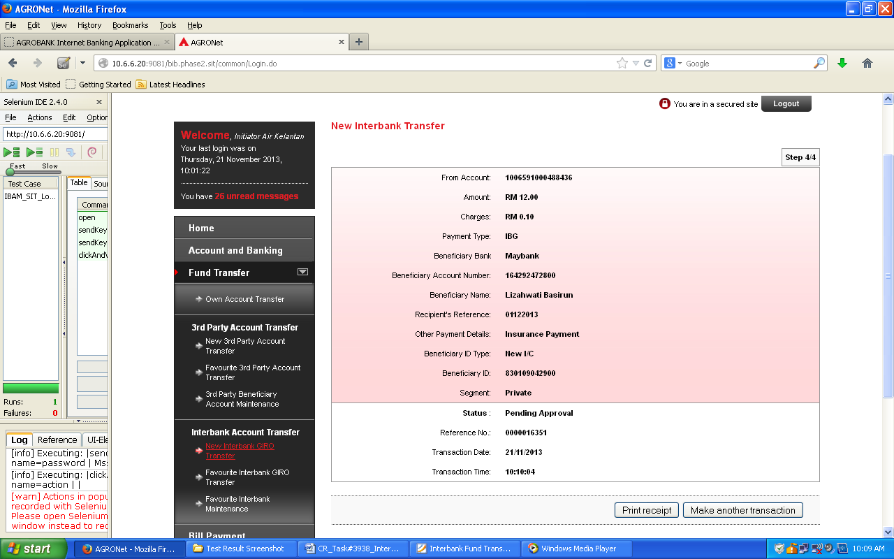  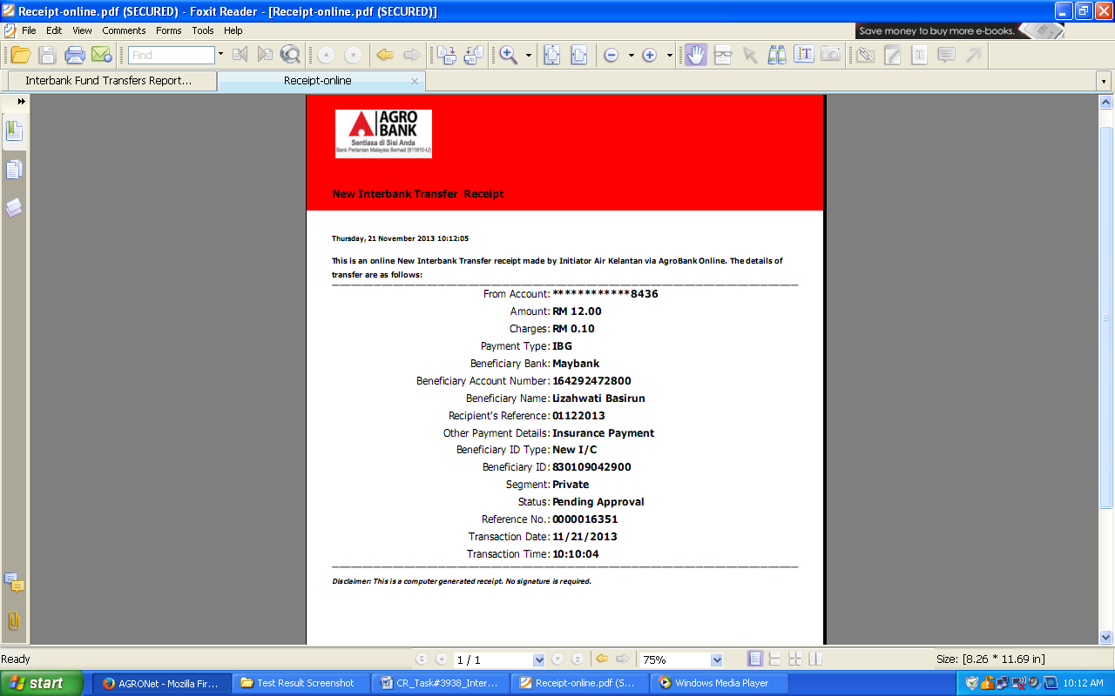  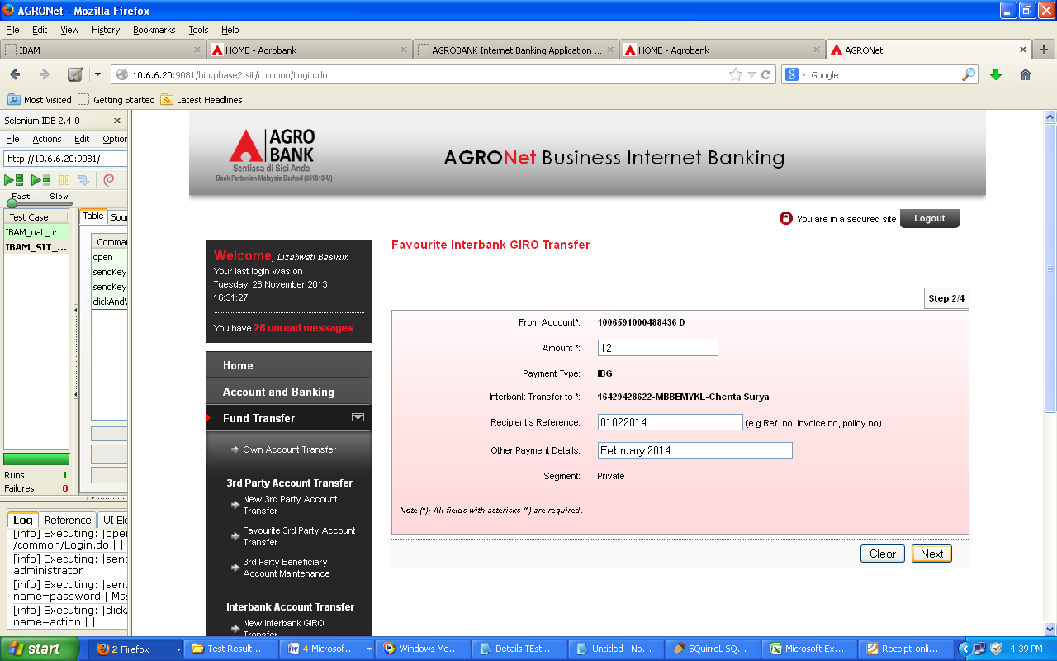  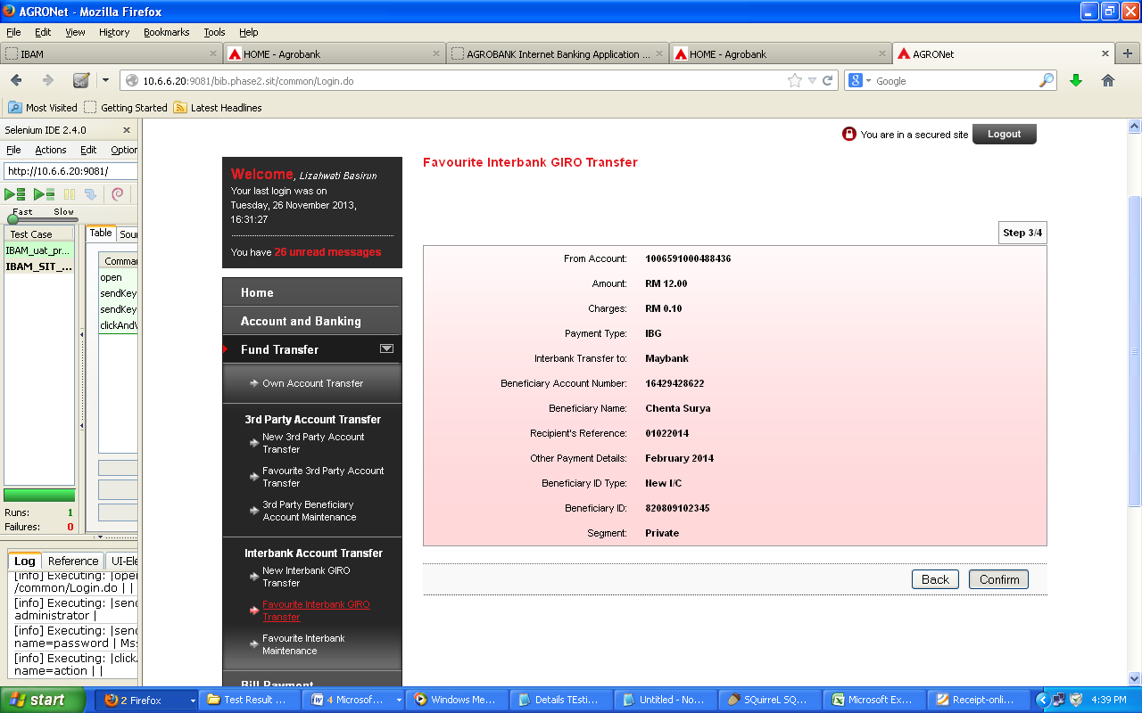  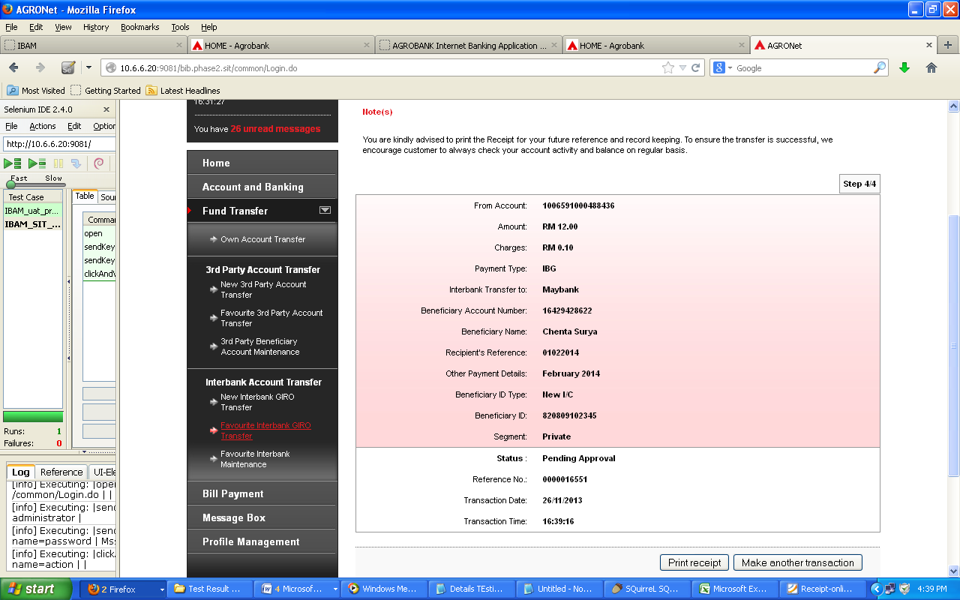  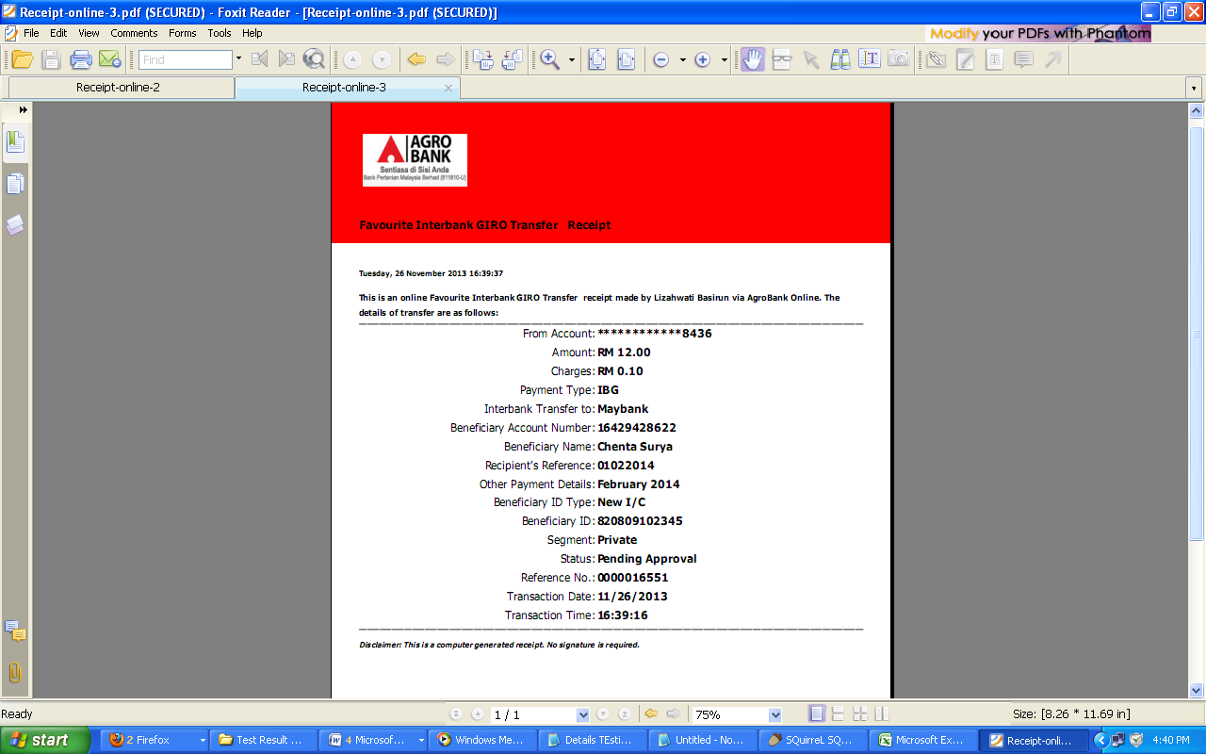  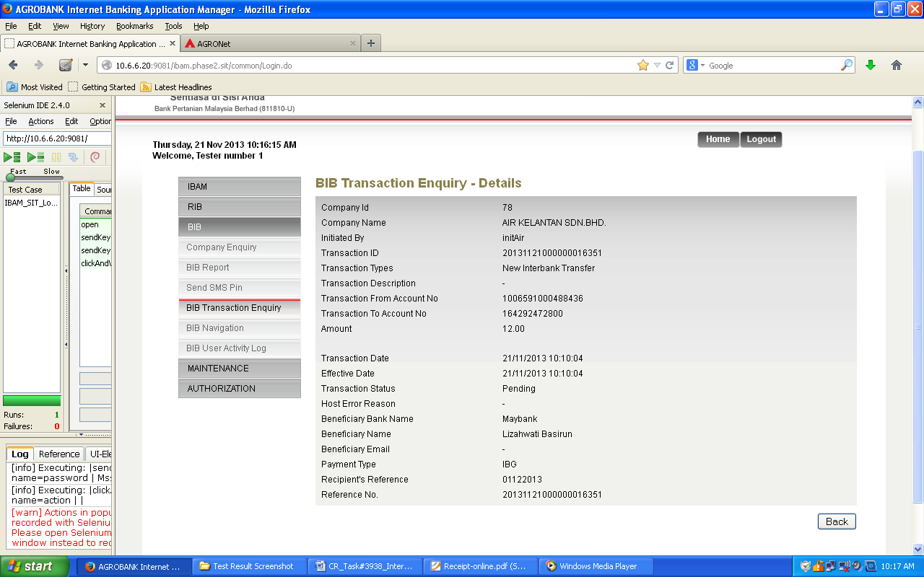  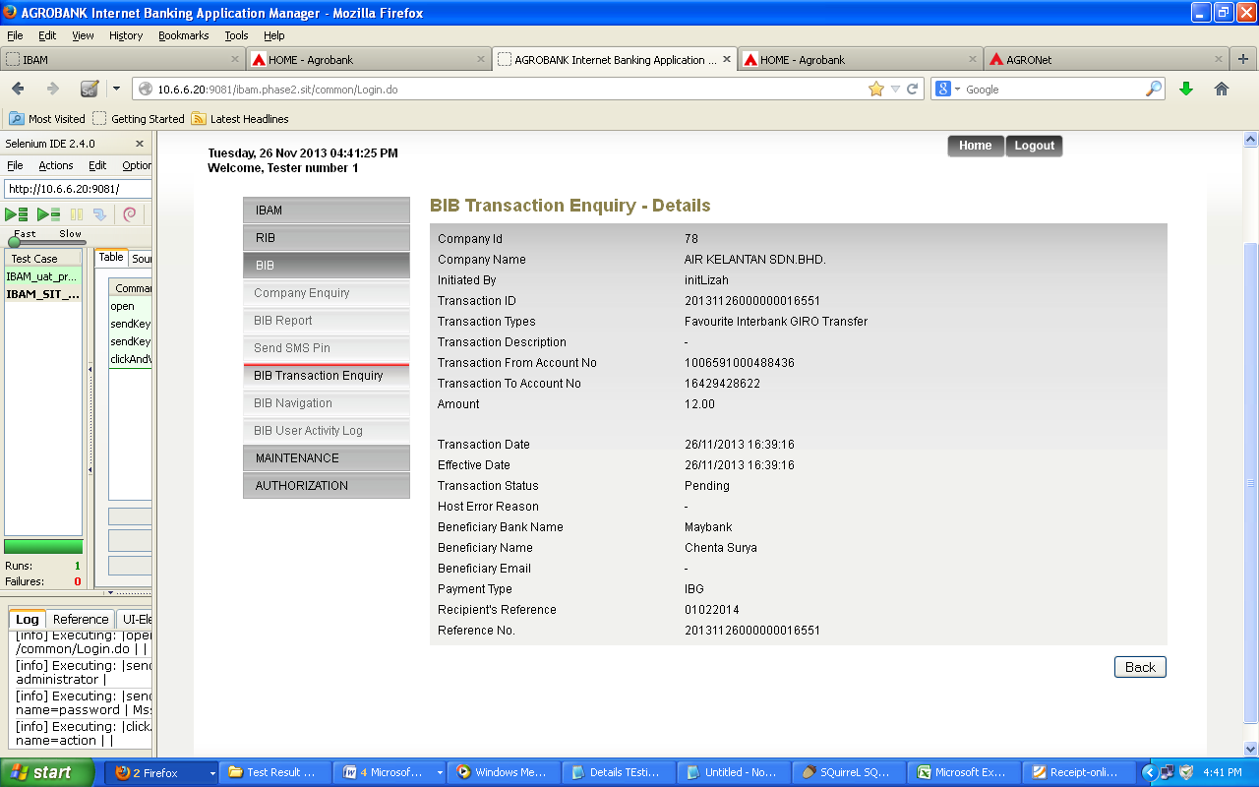  - BIB – Approver  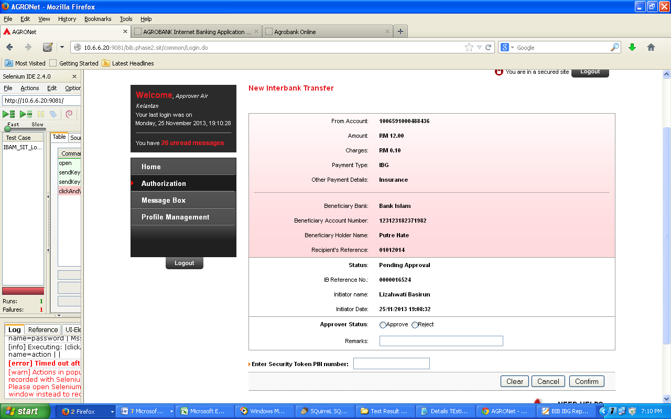  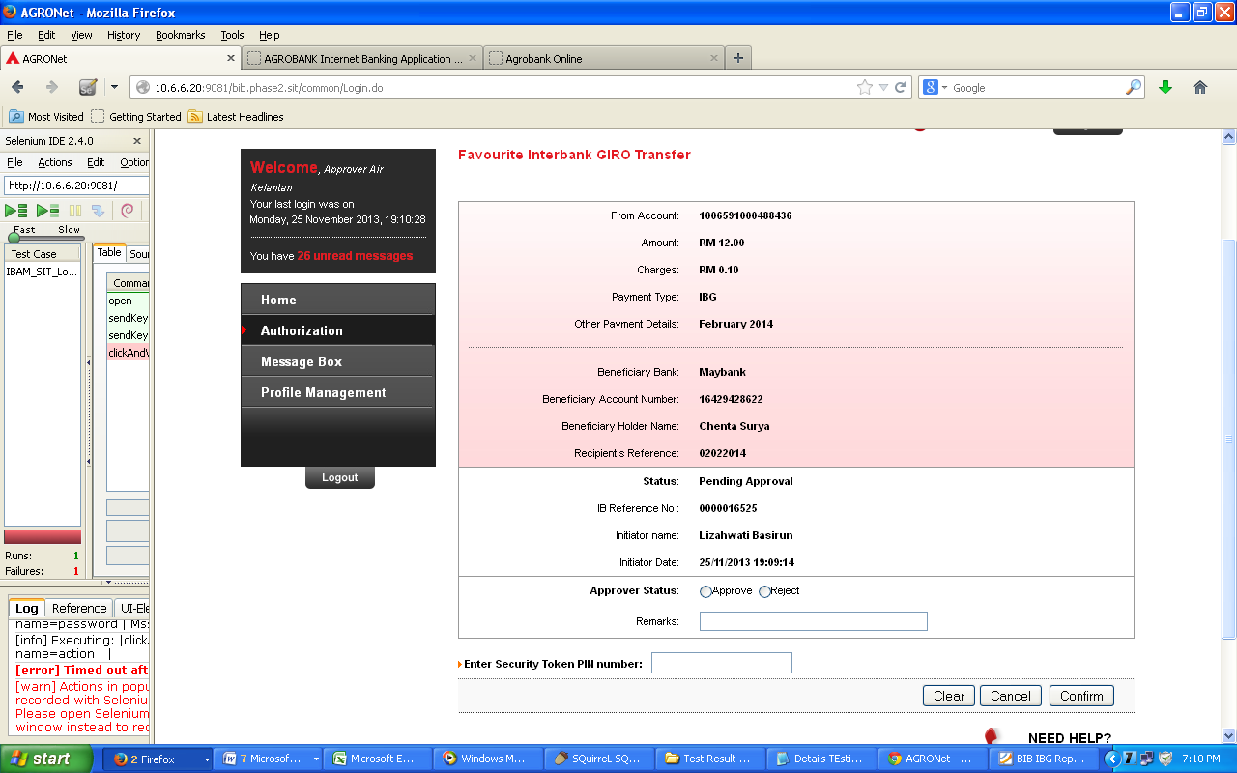  - BIB – Single User  