**Scenario B:**

IB User forgot password & security question and have changed his/her mobile number

**Resolution**

Firstly, IB User is required to visit Bank Branch and submit request to Change Mobile Number. Bank Officer performs the necessary validation and forwards the request to IBS Back Office.

Once received the request, Back Office will update IB User’s mobile number via MSS.

**MSS**

1. Admin views the requested Customer Profile. Customer status must be either “Locked” or “Unlocked” for “Change Mobile Number” button to be available. Also, Admin with rights to update user’s profile will have access to this function.

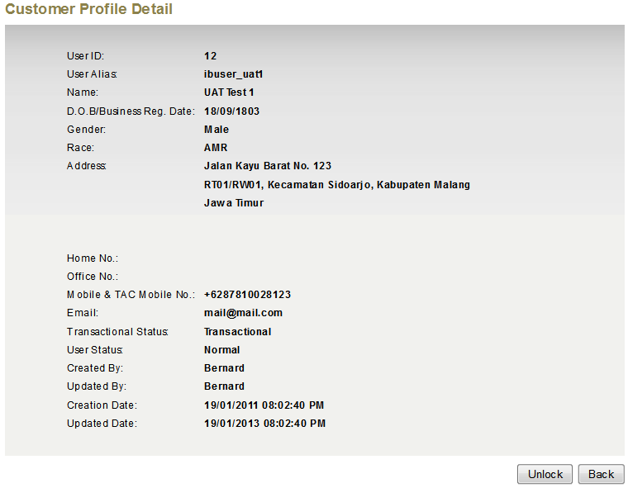

Change Mobile Number

1. Admin update the mobile number for IB Customer. The change will need to go thru “Maker/Checker” process. Once the change has been approved, MSS will send SMS to Customer’s Old Mobile Number and New Mobile Number and notification email to inform the Customer on the mobile number changes.

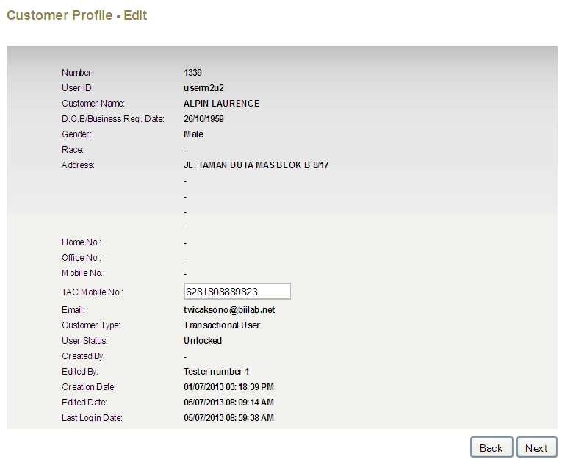

1. Customer calls Customer Support to get new TAC. Steps in Scenario A will take place.