Reset Credentials

**Scenario A:**

IB User forgot password & security question.

**Resolution:**

IB User calls Customer Support to request for TAC. This TAC will be used to reset IB User’s password and security question.

**MSS**

1. Customer Support views the requested Customer Profile. Customer status must be locked. Customer Support unlocks the Customer.

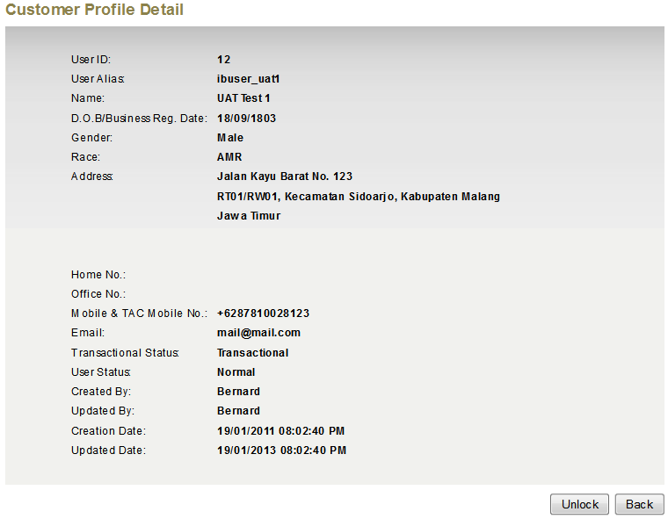

**Locked**

1. After unlocks, Customer Support can send TAC to Customer for Reset Password & Security Questions using button “Generate TAC”. TAC will be sent to the registered mobile number. "Generate TAC” will only be accessible when Customer’s Status is “Unlocked”.

