1. **E-Products > Mobile Reload – Page throw Service unavailable after click on Mobile Reload hyperlink**

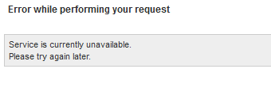

1. **E-Products > Mobile Reload Favorite - Unable to choose the package list. Drop down not function.**

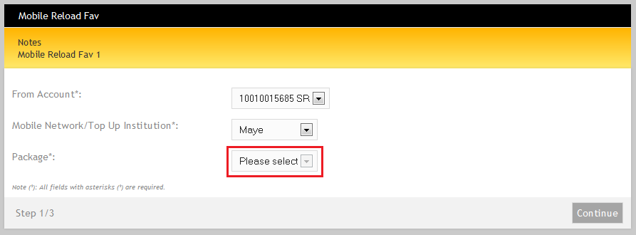

1. **E-Products > Manage Favorite Mobile Reload – Page throw Service unavailable after click on Mobile Reload hyperlink**

